**Group 7-hw3**

**Git Repository**

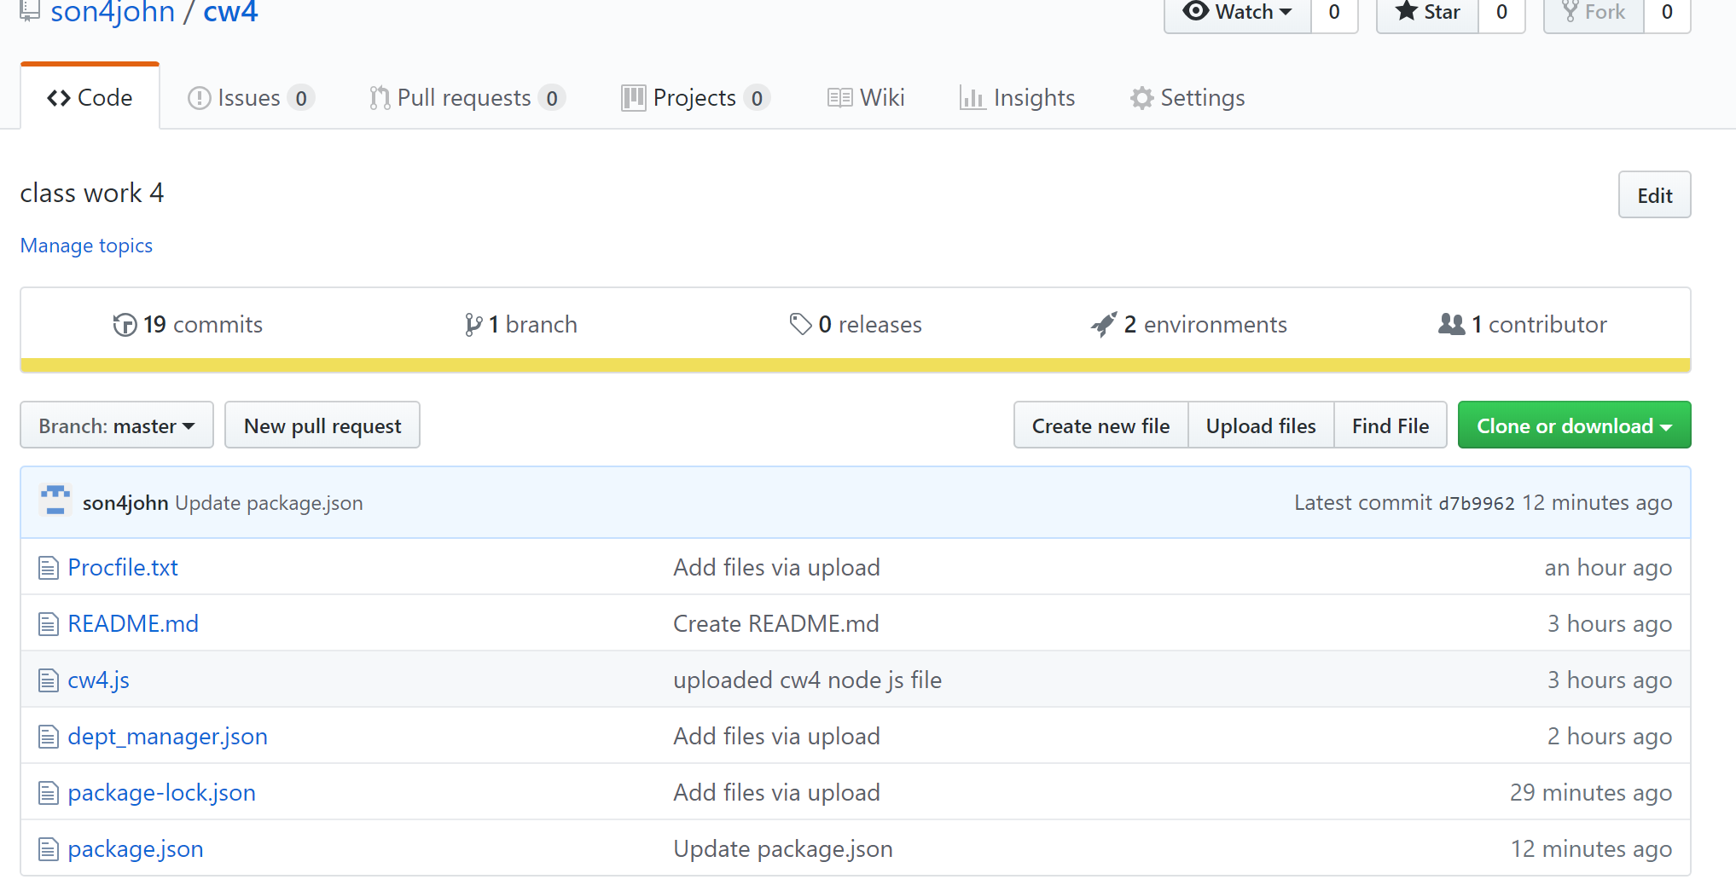

Procfile.txt

web: node cw4.js

cw4.js

|  |
| --- |
| const fs = require('fs'); // load file system modlue |
|  |  |
|  | var rawObj = fs.readFileSync('dept_manager.json') //import the raw JSON table |
|  | var parsObj = JSON.parse(rawObj); // parse the data to key value pairs |
|  |  |
|  | var stringObj = JSON.stringify(parsObj); // stringify the object |
|  | console.log(typeof stringObj); // show that is of type string |
|  | console.log(stringObj); // print the string on the console |

dept_manager.json

|  |
| --- |
| [{"emp_no":110022, "dept_no":"d001", "from_date":"1985-01-01", "to_date":"1991-10-01"}, |
|  | {"emp_no":110039, "dept_no":"d001", "from_date":"1991-10-01", "to_date":"9999-01-01"}, |
|  | {"emp_no":110085, "dept_no":"d002", "from_date":"1985-01-01", "to_date":"1989-12-17"}, |
|  | {"emp_no":110114, "dept_no":"d002", "from_date":"1989-12-17", "to_date":"9999-01-01"}, |
|  | {"emp_no":110183, "dept_no":"d003", "from_date":"1985-01-01", "to_date":"1992-03-21"}, |
|  | {"emp_no":110228, "dept_no":"d003", "from_date":"1992-03-21", "to_date":"9999-01-01"}, |
|  | {"emp_no":110303, "dept_no":"d004", "from_date":"1985-01-01", "to_date":"1988-09-09"}, |
|  | {"emp_no":110344, "dept_no":"d004", "from_date":"1988-09-09", "to_date":"1992-08-02"}, |
|  | {"emp_no":110386, "dept_no":"d004", "from_date":"1992-08-02", "to_date":"1996-08-30"}, |
|  | {"emp_no":110420, "dept_no":"d004", "from_date":"1996-08-30", "to_date":"9999-01-01"}, |
|  | {"emp_no":110511, "dept_no":"d005", "from_date":"1985-01-01", "to_date":"1992-04-25"}, |
|  | {"emp_no":110567, "dept_no":"d005", "from_date":"1992-04-25", "to_date":"9999-01-01"}, |
|  | {"emp_no":110725, "dept_no":"d006", "from_date":"1985-01-01", "to_date":"1989-05-06"}, |
|  | {"emp_no":110765, "dept_no":"d006", "from_date":"1989-05-06", "to_date":"1991-09-12"}, |
|  | {"emp_no":110800, "dept_no":"d006", "from_date":"1991-09-12", "to_date":"1994-06-28"}, |
|  | {"emp_no":110854, "dept_no":"d006", "from_date":"1994-06-28", "to_date":"9999-01-01"}, |
|  | {"emp_no":111035, "dept_no":"d007", "from_date":"1985-01-01", "to_date":"1991-03-07"}, |
|  | {"emp_no":111133, "dept_no":"d007", "from_date":"1991-03-07", "to_date":"9999-01-01"}, |
|  | {"emp_no":111400, "dept_no":"d008", "from_date":"1985-01-01", "to_date":"1991-04-08"}, |
|  | {"emp_no":111534, "dept_no":"d008", "from_date":"1991-04-08", "to_date":"9999-01-01"}, |
|  | {"emp_no":111692, "dept_no":"d009", "from_date":"1985-01-01", "to_date":"1988-10-17"}, |
|  | {"emp_no":111784, "dept_no":"d009", "from_date":"1988-10-17", "to_date":"1992-09-08"}, |
|  | {"emp_no":111877, "dept_no":"d009", "from_date":"1992-09-08", "to_date":"1996-01-03"}, |
|  | {"emp_no":111939, "dept_no":"d009", "from_date":"1996-01-03", "to_date":"9999-01-01"}] |

package-lock.json

|  |  |
| --- | --- |
|  | { |
|  | "name": "cw4", |
|  | "version": "1.0.0", |
|  | "lockfileVersion": 1 |
|  | } |

package.json

|  |
| --- |
| { |
|  | "name": "cw4", |
|  | "version": "1.0.0", |
|  | "description": "read json file", |
|  | "main": "cw4.js", |
|  | "scripts": { "start": "node cw4.js" }, |
|  | "author": "Group MIS6383 7", |
|  | "license": "ISC", |
|  | "engines": { |
|  | "node": "10.15.3", |
|  | "npm": "6.4.1" |
|  | } |
|  | } |

**Heroku**

Build Log

-----> Node.js app detected

-----> Creating runtime environment

NPM_CONFIG_LOGLEVEL=error

NODE_ENV=production

NODE_MODULES_CACHE=true

NODE_VERBOSE=false

-----> Installing binaries

engines.node (package.json): 10.15.3

engines.npm (package.json): 6.4.1

Resolving node version 10.15.3...

Downloading and installing node 10.15.3...

npm 6.4.1 already installed with node

-----> Restoring cache

- node_modules (not cached - skipping)

-----> Installing dependencies

Installing node modules (package.json + package-lock)

up to date in 0.703s

found 0 vulnerabilities

-----> Build

-----> Caching build

- node_modules (nothing to cache)

-----> Pruning devDependencies

up to date in 0.82s

found 0 vulnerabilities

-----> Build succeeded!

-----> Discovering process types

Procfile declares types -> (none)

Default types for buildpack -> web

-----> Compressing...

Done: 17.9M

-----> Launching...

Released v15

https://classwork4.herokuapp.com/ deployed to Heroku

Result

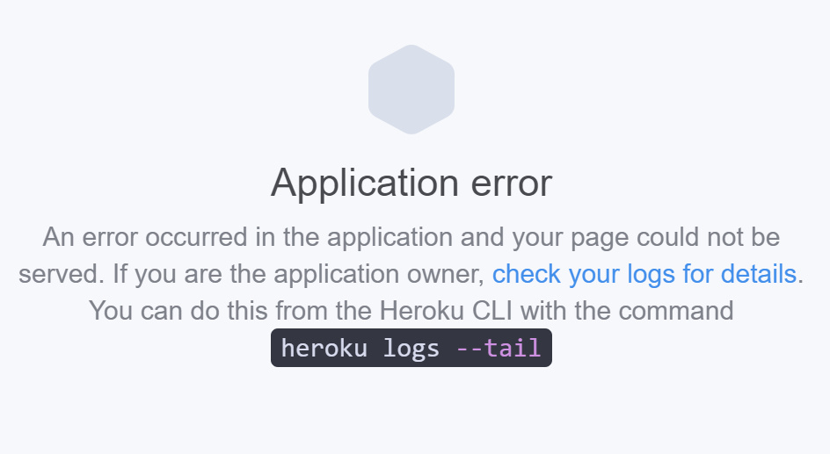

Configuration

