The problem was previous solved using a discrete time (simplest Runge – Kutta ) method.

The following values were used. (**Old parameter values)**

A (Ӷ) = 50 x (Ӷ/Ӷmax)

Beta = 106 (Adsorption rate constant. Set high so that it is diffusion limited)

Diffusivity (non-dimensional) = 10-2

Equilibrium constant = 106 (Making the process effectively irreversible)

The **main problem** with these parameter values is that the **concentration profile showed some regions with a concentration greater than 1** which is not what is expected.

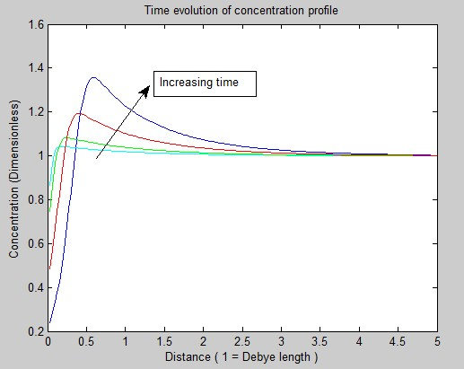

Therefore, the parameter values were changed to the following. **(new parameter values)**

A (Ӷ) = 2 x (Ӷ/Ӷmax)

Beta = 10-7 (not sure if appropriate)

Diffusivity = 10-5 m2 s-1

Kappa = 106 m-1

Radius = 10-7 m

Equilibrium constant = 106 (Making the process effectively irreversible)

But with these parameter values the **running time** to reach steady state is **very high** in the discrete time method. (Estimate = 2-4 hours for every run) Therefore the same problem was solved using the **method of lines.**

The two methods were compared with the old parameter values to check if they match.

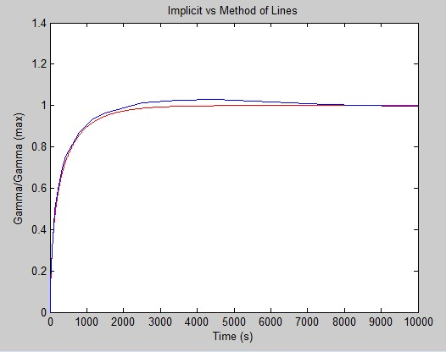

*Key :* Red – Discrete time method. Blue – Method of lines

**Observation**:

The two curves *do not match perfectly* especially in the region between 2000 and 6000 seconds.

The Blue curve (Method of lines) is rising above 1 in some regions which is physically meaningless, since the surface concentration can’t go more than Gamma(max).

**Possible explanation**: The solver used to solve the odes is ode15s which is not supposed to be a very accurate solver. The more accurate solvers like ode45 and ode23 are taking too much time to solve the problem. Need to find some other way to verify it.

But apart from the given time span the method of lines is accurate enough therefore, the following results were obtained using that.

**Variation of surface excess with kappa (Debye length)**

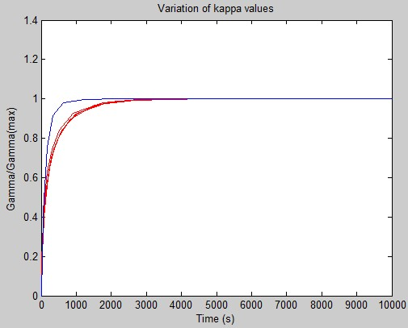

The red lines are for 5 kappa values between 103 and 107. Blue is for 102

Clearly for the range of kappa which is realistic, **there is no significant change in the surface excess with change in kappa values**.

Therefore changes in kappa values alone do not explain why addition of salt changes the final surface tension.

**Variation of surface excess with potential**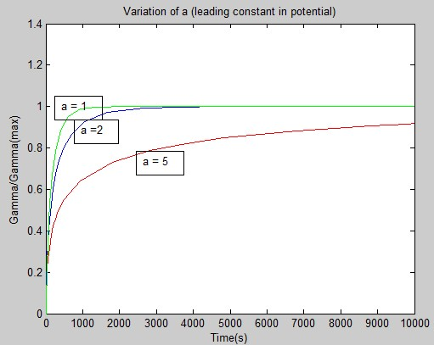

**Clearly, a** ( the constant outside potential) affects the gamma values, and how they change with time significantly.

**The concentration profile for new parameter values**

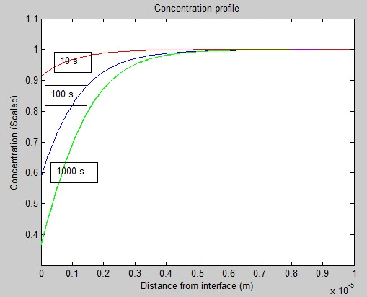

The concentration values never go above one, therefore this is a more realistic case than the one obtained using the old parameter values.