**Extension to Particles**

*The code was run after making the following assumptions*.

A (Ӷ) = 50 x (Ӷ/Ӷmax)

Beta = 106 (Adsorption rate constant. Set high so that it is diffusion limited)

Diffusivity (non-dimensional) = 10-2

Equilibrium constant = 106 (Making the process effectively irreversible)

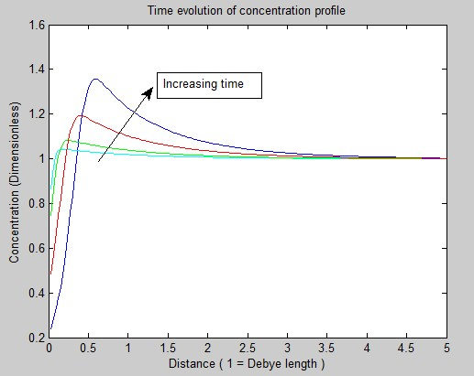

The concentration of particles is rising above the value at infinity. The following might explain.

* Diffusivities of particles are generally lower.
* We made an assumption on potential. It is dependent only on interface concentration.

We can get more accurate results by using the formulae for potential that has been already used in MacLeod.

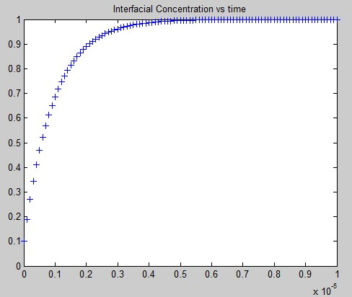

**Macleod, Radke**

Comparison of convergence method vs 1 step method

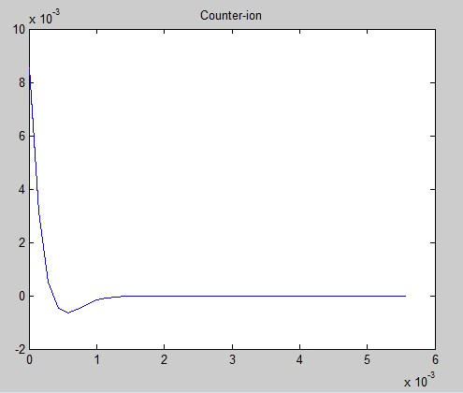

Clearly, a perfect overlap

*Zoomed in*

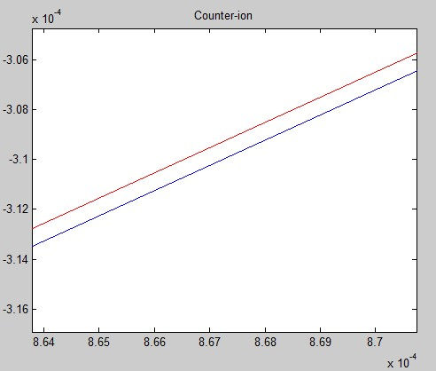

Explicit method vs implicit method

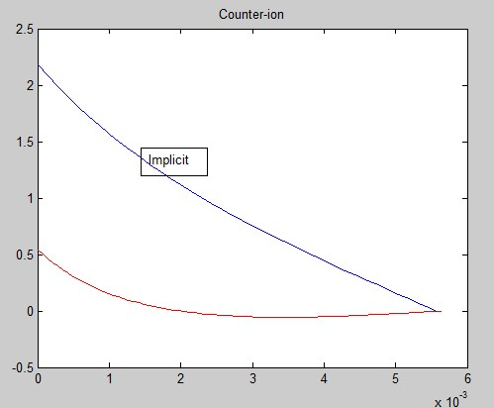

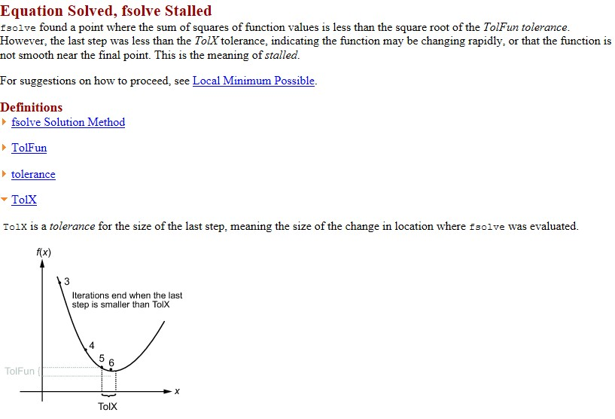

**Borwankar**

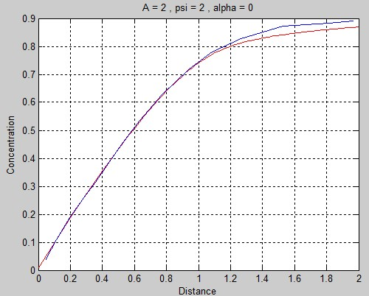

**Still unexplained (not a perfect overlap)**