*The following results are obtained when considering only* ***radiation and convection.***

*The calculations were done using assuming the following parameters*:-

Surface area = 1000 m2 kg-1

Briquette density = 1500 kg m-3

Bed velocity = 0.005 m s-1

Specific heat = 1000 kJ kg-1 K-1

Fractional radiated heat absorbed by the bed = 0.75

Surface Temperature = 1200 K

Initial Temperature = 300 K

*To calculate overall heat transfer coefficient:*

Screenshot001.jpg

Color Coding (Different air speed for different color)

Red – 0.5 m s-1

Blue- 1 m s-1

Green - 2 m s-1

Cyan - 3 m s-1

For Emissivity = 0.1

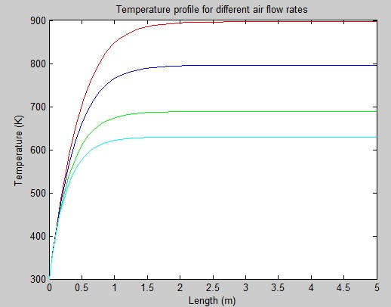

Emissivity = 0.9

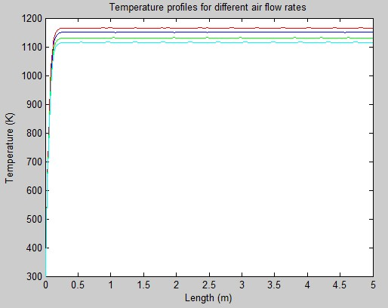

*Factors unaccounted for:*

* Heat of reactions
* Height (2D variation)
* Mass transfer (diffusion, convection)
* Conduction (Fair enough to neglect)