Comparison of Reaction model with Temperature model

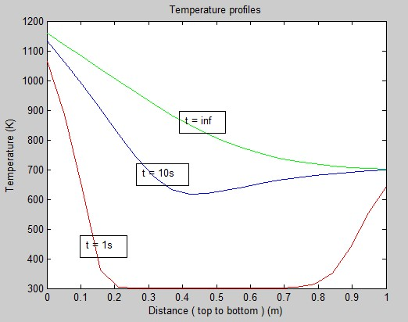

Since the algorithms used in both models are the same, there is a *perfect overlap* between the temperature profiles obtained from both of them.

Other parameters :

Kinematic viscosity of air[4] = 2 x 10-5

Density[2] = 800 kg m-3

Specific Heat Capacity[1] = 1500 J Kg-1 K-1

Emissivity of biomass[3] = 0.8

Thermal conductivity of air[4] = 0.04

Nusselt number correlation[3]:

***Nu = 2 + 0.9*Re0.5***

**References:**

1. Fredlund, B.A. (1988). *Model for heat and mass transfer in timber structures during fire.* Doctoral dissertation. Lund. Lund University, Department of Fire Safety Engineering. Sweden.
2. S. Varunkumar , N. K. S. Rajan & H. S. Mukunda, Single Particle and Packed Bed

Combustion in Modern Gasifier Stoves—Density Effects. (2011)

1. S. Varunkumar , N. K. S. Rajan & H. S. Mukunda, Universal Flame Propagation Behavior in Packed Bed of Biomass (2013)
2. Perry`s chemical engineer`s handbook.