This file contains the key observations and results for the mathematical stiffness check of the individual reactions.

*The following graph contains the temperature profiles for*:

1. Cellulose reactions only.
2. No reaction (all enthalpies = 0)

After 100 seconds

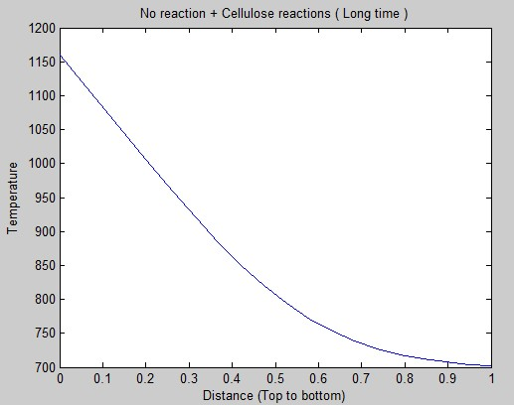

Clearly, the two **perfectly overlap**. This is expected since after 100 seconds all reactions must be completed and the bed will behave like one in which there are no reactions.

*The following graph was plot for cellulose reactions after 5 seconds.*

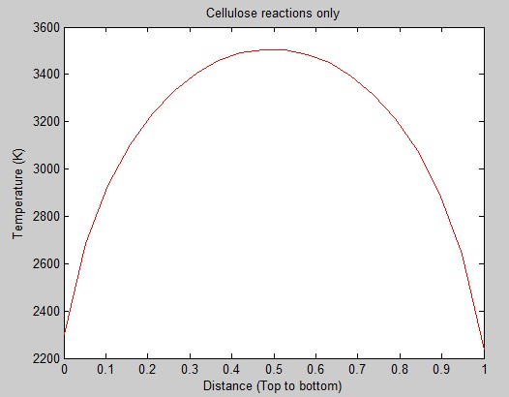

The above graph looks reasonable, since the exothermic reactions will heat up and most heat will accumulate somewhere in the middle of the bed.

*The following graph is for Lignin and Hemi-Cellulose reactions after 5 seconds*

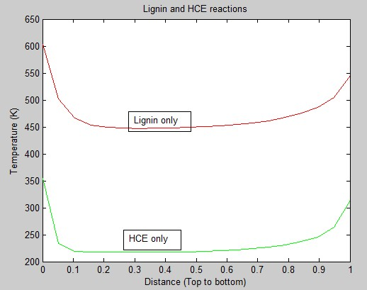

Clearly, both profiles **look incorrect**, the temperature of the top of the bed should come closer to 1200K.

* It is possible that some of the endothermic reactions are preventing the temperature for rising in **Lignin reactions only** case.
* **Hemi-cellulose reactions only** case is definitely incorrect since the tempearature cannot go below

*The following graph shows the* ***temperature versus time*** *graph*

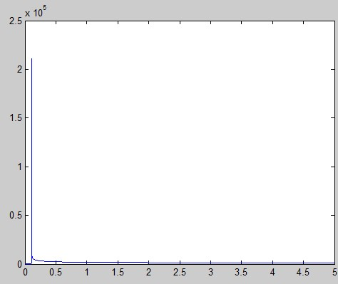

But clearly, **the temperature spike is still present for all three cases,** namely Cellulose only, HCE only, Lignin only cases. But the final temperature profile seems reasonable to reasonable accurate for Cellulose only.

Individual reactions check:

After turn on each reaction individually it is observed that all reactions can be classified into four kinds.

1. Those which do not show any temperature spike. (12 in number)
2. Those which show a temperature spike. (5 in number)
3. A few which MATLAB is unable to execute (2 in number)
4. One exception which shows high temperature (12000 K) but not exactly a spike.

Other key observations:

* All endothermic reactions are working fine.
* For exothermic reactions, the enthalpy itself is insufficient to make out whether the reaction will add stiffness. In other words, there are a few reactions which are highly exothermic but are working fine, and some which are less exothermic but are not working.

*The following graph is for endothermic reactions*

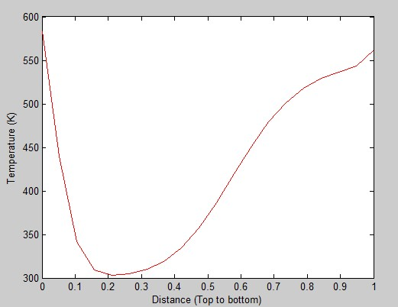

Temperature vs space

(All endothermic reactions show similar plots)

*The following graph is for exothermic reactions*

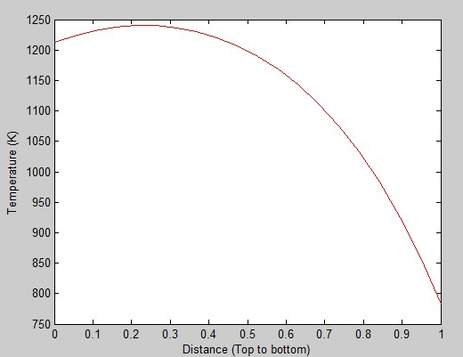

When only one reaction is turned on they do not significantly affect the temperature.

*The two cases for exothermic reactions:*

Temperature vs time graphs

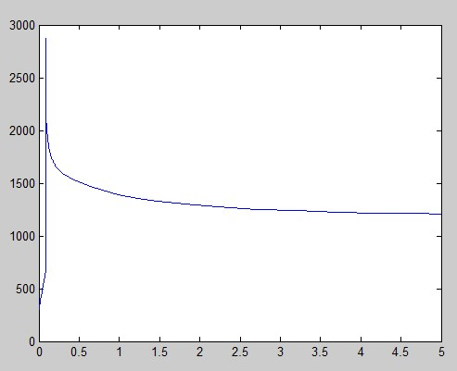



For the **third case** (the 2 reactions which can’t be solved)MATLAB is showing the following error:

Warning: Failure at t=5.097980e-02.  Unable to meet integration tolerances without reducing the step size below the

smallest value allowed (1.811166e-16) at time t.