10/12/2022 11:34:10 AM

CORPINDIA\EI13114

TE_FA_Cinema_Ticket_Details

Film Type wise information about tickets sold in Drill Down Report

This is Drill Down report in which we can can drill down by pressing on plus symbol so that it will show every details if we needed.

Film Type | film code | cinema code | tickets sold
Comedy
Comedy |  | Total | 5781
Drama
Drama |  | Total | 12766
Family
Family |  | Total | 18586
Horror
Horror |  | Total | 13570
Romance
Romance |  | Total | 1833
Science
Science |  | Total | 8769
Thriller
Thriller |  | Total | 6519

This is the bar chart that signifies the total tickets sold for each Film Type . So , It tells the which Film Type is doin good in cinemas.

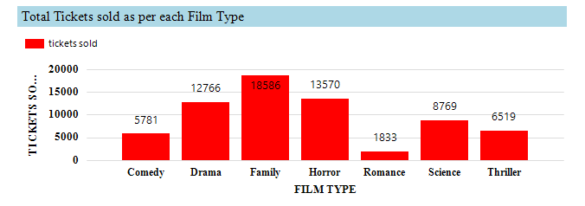
Total number of Film types in Cinema

This chart explains the total number of Film Type is present like Family , Romance ...

