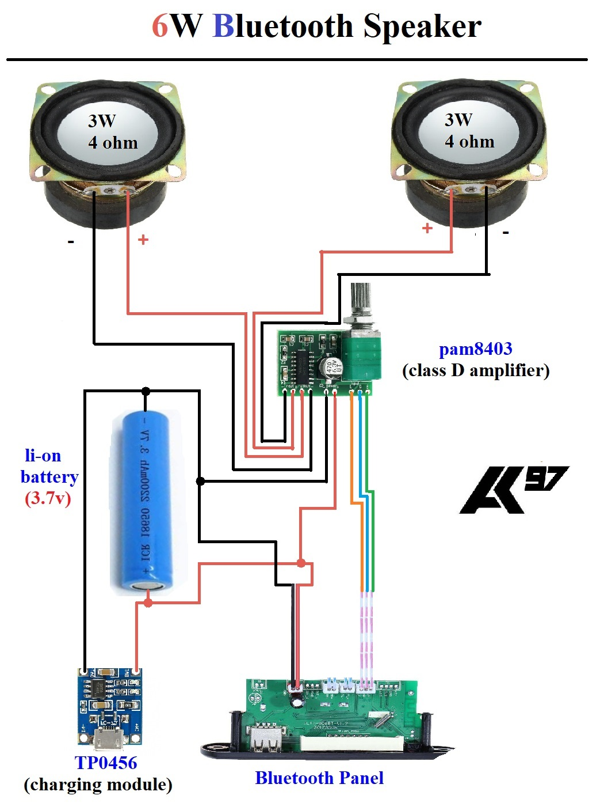

**Components**

1. Blutooth Panel

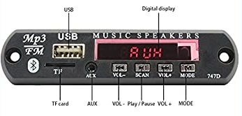

1. Amplifier (any class-D of 3.7v)

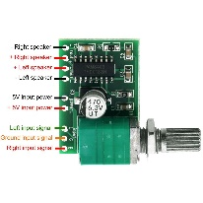

1. Charging Module

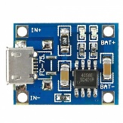

1. Li-on Battery (3.7v)

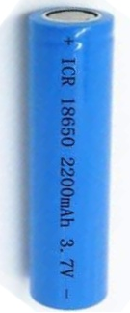

1. Speakers (3W 1.5Ω) X **2**

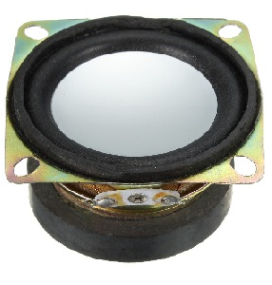

Bluetooth panel can be replaced by USB-Bluetooth adapter which can reduce the occupancy of the circuit .The best amplifier will be PAM8403 other kind of

class-B amplifiers can also be used like IC6283 and IC4440 to get better quality.

We used TP0456 Micro-USB charging module which is best compatible with 2200mAh 3.7V li-on battery better not to compromise with other charging circuit. Li-on battery can be replaced with any other mobile battery of more than 1500mAh battery. Two speakers should of lower specs of about 3W connected to separate channel separate channel either it can be of 4Ω or 8Ω based on availability. **This project can be completely done with the trash as most of the components were salvaged from electronic junk and I recommend to use old junk instead of new components .**

If you need help in salvaging components contacts [akshayk.smg@gmail.com](mailto:akshayk.smg@gmail.com)