PART TWO - Training Results

*Training - I*

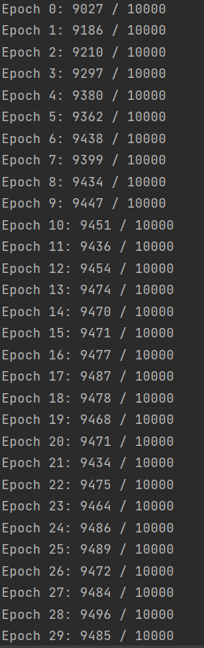

*Training - II*

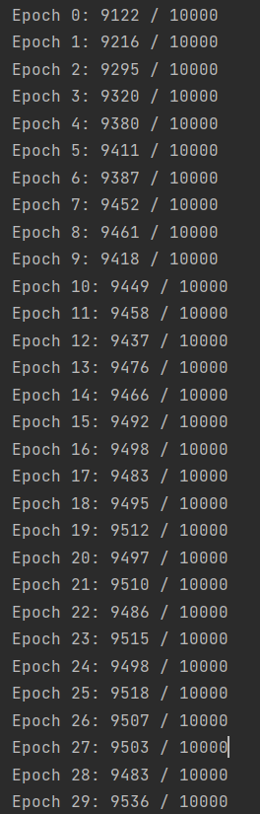

*training - iii*

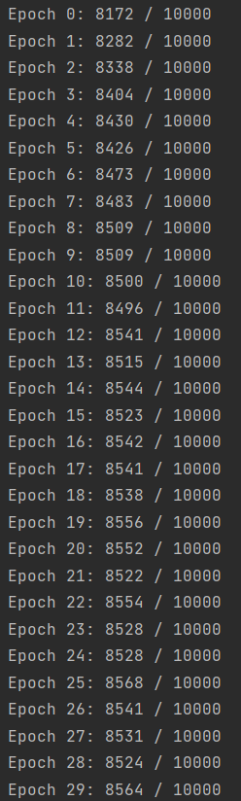

|  |
| --- |
| case I  94.85% |
| CASE II  95.36% |
| CASE III  85.64% |
| MEDIAN RESULT  91.95% |

Experimenting with different network hyper-parameters

Case-I: *Decreasing the number of hidden neurons and training*

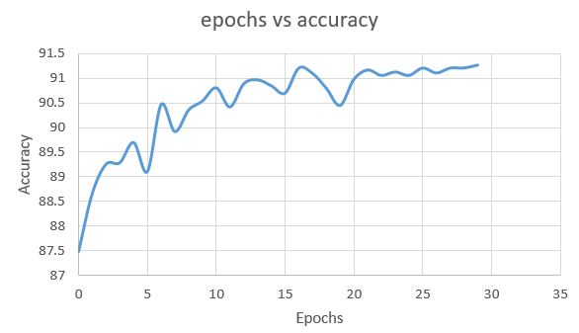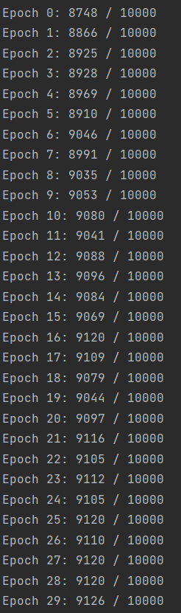

* When the hidden neurons was Deprecated to 15, A drop in the result was observed with accuracy dropping down to 91.26 % at the end of epoch 29

Case-II: *Decreasing the no. of epochs and training*

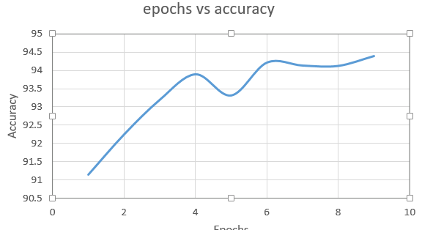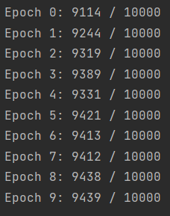

* In this case, the model was trained for 10 epochs resulting in an accuracy of 94.39 %. Lowering down the no of epochs still provided us with a stable accuracy with minor convergence

Case-III: *Decreasing the Learning rate and training*

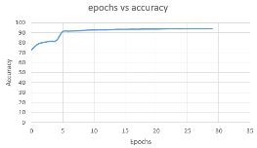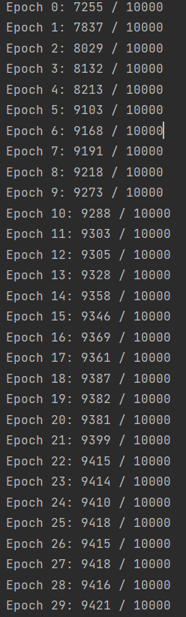

* Here, the learning rate was kept at 0.5 which suggests that the performance of the model is slowly getting better over time with the accuracy beginning at 72.55 % and giving us a classificate rate of 94.21 %

Case-IV: *Decreasing the Learning rate, Increasing the hidden neurons and training*

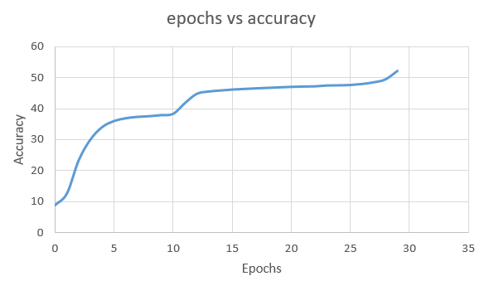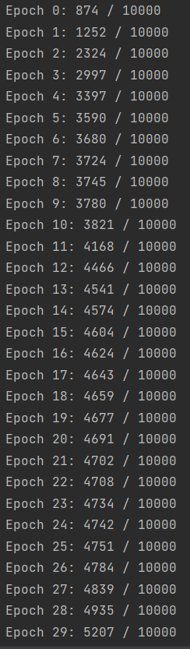

* The hidden neurons in this case is increased to 100 and learning rate is brought down to 0.05 which gave us a drastic drop in the results as the accuracy falls down to 52.07 %. This indicates that with a small learning rate, accuracy of the model increases at a snail’s pace when kept at epoch 30.

For the best configuration,

Keeping the hidden neurons at 30, learning rate at 1.0 and epochs at 10 gave us an accuracy of 94.09% while for the same configuration with the latter being 30, gave us an accuracy of 94.59% indicating a slight change in accuracy.

To conduct a similar experiment, The configuration was kept same with the only exception that learning rate was increased to 3.0.

Two cases were implemented, keeping the epoch at 50 which gave us an accuracy of 95.20% and then training the model for 10 epochs which gave us an accuracy of 93.20%. This indicates that increasing the learning gradually increases the accuracy.

Based on the above findings and experimentations, to achieve an optimum and reasonable accuracy, It is necessary to keep –

Hidden neurons at **30-50**

Learning rate at **1.0** and epoch at **30-50** (for accuracy of around **94**%) or Learning rate at **3.0** with epoch at **10-50** (for an accuracy of greater then **95**% and also to avoid overfitting)

**TAKEAWAY**

1. Increasing the hidden neurons could lead to risk of overfitting and makes the model harder to train. In certain cases, the model might learn redundant features too
2. A higher learning rate can lead to divergent behaviour forcing the model to arrive early at the optimal solution.
3. To keep a track of the model performance, it is a good practice to verify the accuracy on a test set
4. It is also important to toy with hyper-parameters to atleast get an information for further improvement of our model performance

**IDEA TO IMPROVE PREDICTION RATE**

It would be a good practice to create a validation set to test and find the optimal parameters in order to evaluate the performance of the model and ensure that the model is responsive to unfamiliar test sets