**Library Management System**

**1.** Create Users Data

Two users of my application:

1. Student

Student entries are already present in database.

Each student is uniquely identified using his/her roll number.

Each student can have at max 3 books from library.

2.Librarian

Authentication to access the Library Management System.

**2.** Student Profile for Library

All basic information about student (Personal Educational etc).

List of books student have issued(not more than 3).

Fine display if book return is late.

**3.** Book Searching

Searching of book must be faster to fulfill the enquiry about that book.

**4.** Issue/Return book

Whenever student issue a book that book must get attached to the student.

After returning the book the book must gone out of student profile.

**5.** Book Details Page

Book Details includes book ISBN number, Title, Authors, no.of copies etc

List of Students who issued this book at that time.

List of students who are in queue for that book.

**6.** Maintain Queue for Book issue

Maintain queue of students for particular book if not available. When available send mail to student to notify that book is available now.

**BUSINESS SCENARIOS:**

|  |  |
| --- | --- |
| Scenario-1 | Add New Books To Library |
| Prerequisites | * Librarian must be Authenticated. * Librarian must visit portal of addition of book entry. |
| Input | Book Details includes book ISBN number, Title, Authors, no.of copies etc. |
| Steps | 1. Go to book entry portal. 2. Add details of book in respective fields. 3. Submit the details. |
| Results | New book entry added and ready for students to issue. |

|  |  |
| --- | --- |
| Scenario-2 | Complete Book Issue Request |
| Prerequisites | * Librarian must be Authenticated. * Student must have less than 3 books issued earlier. * Book must be available in the Library. |
| Input | Student Roll number  Book ISBN number |
| Steps | 1. Search student profile using Student Roll number. 2. Add book entry into student profile. 3. Decrement number of copies count for that book. |
| Results | Book is issued for next one week. |

|  |  |
| --- | --- |
| Scenario-3 | Book Return |
| Prerequisites | * Librarian must be Authenticated. |
| Input | Student Roll number  Book ISBN number |
| Steps | 1. Search student profile using Student Roll number. 2. Remove book entry from student profile. 3. Calculate fine if return date is missed by student. 4. Increment number of copies count for that book. |
| Results | Book is returned successfully by student. |

|  |  |
| --- | --- |
| Scenario-4 | Maintain |
| Prerequisites | * Librarian must be Authenticated. |
| Input | Book ISBN number |
| Steps | 1. Go to book enquiry portal. 2. Select filter by which student want to look for book(ISBN, Title,Authors). 3. Tell student details about required book. |
| Results | Enquiry About particular book is successfully carried out. |

|  |  |
| --- | --- |
| Scenario-5 | Maintain Queue of students about the students. |
| Prerequisites Condition | * Book copy is not available in the Library. * Book is not in the database. |
| Input | Book ISBN number, Title |
| Steps | 1. Search the book which student wants. 2. If condition-1 then Add that student details into the queue. 3. If condition-2 then add that book as a suggestion for new books. |
| Results | Enquiry About particular book is successfully carried out. |

USE CASE DIAGRAM:

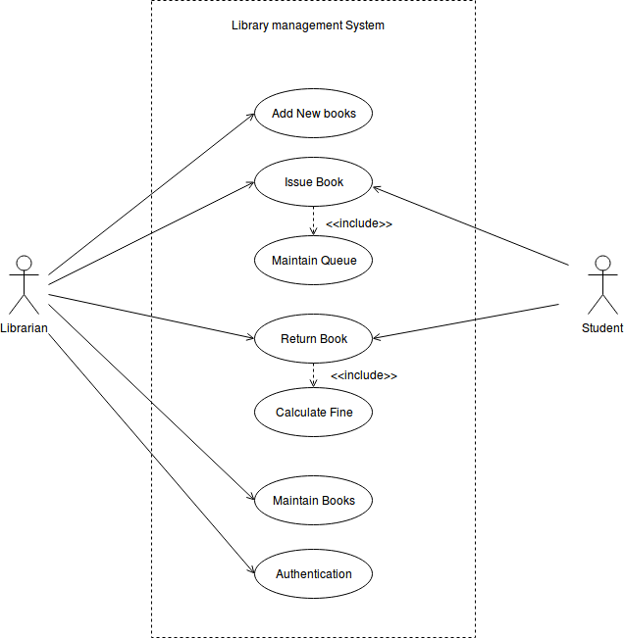

ER DIAGRAM:

