MatchUp: A Web Platform for Sports Community Engagement and Venue Booking

Akshay P Lokapur
Department of Computer Application
PES University
Bengaluru, India
akshaylokapur1003@gmail.com
Pradnya V Garde
Associate Professor
Department of Computer Application
PES University
Bengaluru, India
pradnyagarde@pes.edu

Abstract - I love playing sports. It is really hard to find people to play with or a place to play. MatchUp is a website that helps me with this problem. I can use MatchUp to create a game and invite my friends to play. I can also join games that other people have already planned in my area. If I need a court or a field I can book it on the MatchUp website. This way I do not have to call anyone or go to the place in person.For the people who own these courts and fields MatchUp is helpful too. They can list their places on the website so more people know about them. They do not have to answer phone calls all day or keep track of who's playing when. They can use the website to manage everything. They can see which games are confirmed and which ones are coming up. They can also talk to the players on the website.MatchUp is a way to bring players and venues together. It makes it easy for people to play sports and have fun in their community. MatchUp helps players, venues and organizers so everyone can enjoy sports more. MatchUp is really good, at connecting players, venues and organizers making it easy to play and manage sports in the community.

Keywords— Sports Community Platform, Venue Booking System, Real-Time Booking, Match Scheduling, Location-Based Services, Payment Gateway Integration, Web-Based Application, Sports Venue Marketplace, User Engagement System

Introduction
The way people play sports and do fun activities has changed a lot because of new digital technologies. Now people can use platforms to meet others plan events and get services from anywhere.. People who love sports still have a hard time finding good places to play, planning games and meeting other players. The old ways of doing things often involve talking to people not knowing what places are available and booking systems that do not work well which is very inconvenient and a waste of resources.
Because more and more people want to be able to manage sports in a way websites can help solve this problem. These websites can bring together players, people who own sports places and those who plan games. A single system can make it easier to find sports places, plan games and book them while also making it more fun for users with a simple and easy to use interface. Even though there are websites that let you book things there are not websites just for sports that help with managing sports places, planning games and talking to people in real time.
This research is about MatchUp: A Web Platform for Sports Community Engagement and Venue Booking which's a website that helps people who play sports talk to each other and book sports places. The main goal of MatchUp is to let users find sports places near them book time slots away and play in planned games through one simple interface. The system has things that players, sports place owners and administrators can do which helps manage resources and activities in a better way.
MatchUp has important features, such as booking sports places in real time and making sure that there are no problems with the bookings, safe online payments and showing sports places on a map. It also lets users plan games and play in them so they can. Join games that they like. The backend of the website uses FastAPI and PostgreSQL which makes it work well and quickly while the frontend uses web technologies to make it easy to use and look good.
By combining sports with web technologies and maps MatchUp wants to make it easier for people to play sports use resources in a better way and have a complete online system, for sports lovers. The website is a way to manage sports, which is efficient works well and is easy for users to navigate. MatchUp is a sports platform that helps people who love sports. It is a sports platform that makes playing sports more fun.

related work
[1] Bhagya Chembakottu, Heng Li and Foutse Khomh did a study in 2025 on sports apps for Android phones that you can get from the Google Play Store. They looked at 2,058 sports apps. Sorted them by what they can do. They also found out what sports they are for and used methods to analyze what people say about these apps. This helped them find out what people do not like about these apps. They found out that a lot of these apps have problems like being hard to use and crashing a lot. These apps also have many ads and are not reliable. The study also showed what people want from these apps.

The study by Bhagya Chembakottu, Heng Li and Foutse Khomh gives us an idea of what is going on with sports apps right now. MatchUp is trying to do things by making a platform that is easy to use and works well. MatchUp has things like booking in time and a design that is easy to understand. The platform is also fast. Does not have a lot of problems. MatchUp is trying to avoid the problems that other apps have, like being hard to use and not working right. MatchUp also has features like supporting many roles and services that work together to make people happy, with the platform.

[2] Alexander Felfernig in 2024 gave a look at recommender systems in sports. He showed how they can be used for suggesting training plans recommending events and matching players or teams.
The study looks at ways to make recommendations, such as collaborative filtering, content-based filtering and a mix of both. It also talks about how to measure if recommendations are effective.
Some big challenges in sports recommender systems are identified. These include the cold-start problem being aware of the context and keeping user data private.
The ideas and methods discussed give a base for adding smart recommendation features to sports platforms.
MatchUp uses mechanisms to get users involved and match them with others. These mechanisms can be expanded to include suggestions based on what users like what they have done before and how they interact with the platform.
This makes it easier for players to find each other and improves the experience, for users.

[3] Y. Jia in 2024 did a review on using learning in sports. The review looked at things like tracking player movements checking how well players perform and predicting injuries. The study used data from sensors and videos and deep learning models like Convolutional Neural Networks and Recurrent Neural Networks.
The study found that using analytics in sports can be really useful. For MatchUp this means we can add things like tracking player performance analyzing player data and checking if a player might get injured. Now MatchUp is about booking and community but adding data analytics can make it more fun for users and make the platform better.
The study also talked about some challenges. These include processing data in time dealing with different types of data and making sure the models work well across different sports.
The findings from this study provide insights into the potential of integrating analytics within sports platforms like MatchUp. These concepts can be extended to enhancements such, as performance tracking, player analytics and basic injury risk indicators. While the current system focuses on booking and community engagement the inclusion of data-driven analytics can further enrich user experience and platform capabilities.

[4] The people at German J. D., et al. Did a study in 2024. They wanted to make a system for booking sports facilities. This system is supposed to make it easier to book things at the time and make people happy with how it works. The system has things like being able to see what time slots are available getting a confirmation away prices that are easy to understand and rules about cancelling that make sense.
People like it when they can book things in a way that's easy to understand. They like calendars that are organized and steps that they can follow. This makes it easier for them to use the system. They are happier with it.
The things that German J. D., et al. Found out are really helpful, for making MatchUps booking part. MatchUp does things like show what time slots are available now and makes sure that people do not book the same time by mistake. It also has a way of scheduling that's easy to use and prices that are clear. MatchUp makes sure that people can pay securely and that the steps to book something are easy to follow. This makes the system more reliable. People trust it more.

[5] Angosto, S. (2024) Did a thorough review to figure out what makes people use fitness apps and keep using them. The study found out that things like how useful the app's how easy it is to use talking to other people and getting into a routine are really important for keeping people interested and using the app. It turns out that apps that're easy to use let people connect with others and have features that motivate them are more likely to keep people using them for a long time.
These ideas are really helpful for designing MatchUp. MatchUp is designed to be simple and easy to use. It has features that help people talk to each other like playing matches and joining a community. MatchUp can also be made fun with things like tracking what people do keeping track of how many days in a row they use it and giving them rewards, which can help keep people using MatchUp and make them more excited, about it.

[6] The people who made Elo-MMR, Ebtekar, A. And Liu, P. they did this in 2024. Elo-MMR is a way to rate players in competitions with lots of players. It is better than the ways of rating players like Elo and Glicko. This new way can handle games with players and it is more accurate. It makes sure that players are matched with others who're just as good so it is fair.
The ideas in this study are really important for making MatchUp better. We can use these ideas to make sure that players are matched with others who're just as good at the game. This will make the games more fun and fairer. Players will be happy because they will be playing with others who're just as good as they are. This will make the sports community a better place, where everyone can have fun and compete with others who're just as good as Elo-MMR. The people who made Elo-MMR, Ebtekar, A. And Liu, P. they showed that Elo-MMR is better, than the ways of rating players and we can use this to make MatchUp better.

[7] Fan, G., et al. (2023) Looked into how re-matchmaking strategies affect fairness and user satisfaction in team-based games.
They found out that re-balancing teams right before a match starts makes the game fairer.It also makes players happier and more likely to keep playing.The study did this by checking how player skills are spread out and how teams are put together.

This way the game becomes more fun and competitive. These findings are really important for MatchUp’s match features. MatchUp can use these ideas to balance teams in sports, like football and cricket.This way players compete fairly matches are better. People want to keep playing.

[8] Kang, H. And his team looked at how match results affect player retention in gaming. They found that unfair matches make users unhappy and more likely to leave. By studying player behavior and match results they showed that balanced gameplay is key, to keeping users engaged and the platform sustainable.
This study clearly shows that sports platforms need matchmaking systems. MatchUp uses skill-based pairing and balanced teams to make sure matches are fair. This approach makes matches better. Keeps users happy and engaged on the platform.

Methodology
The MatchUp platform is designed as a web-based sports community and venue booking system that enables users to discover venues, organize matches, and manage bookings through a unified interface. The proposed methodology follows a modular client–server architecture integrating real-time booking, matchmaking, payment processing, and location-based services. The system is designed to ensure usability, scalability, and efficient resource management. The platform also incorporates role-based functionalities to support players, venue owners, and administrators in managing activities efficiently. Additionally, the modular design enables easy integration of future enhancements such as recommendation systems and performance analytics.

System Architecture
The system is made up of parts and it uses a simple idea of clients and servers. You can see what it looks like in Figure 1. We broke it down into parts like the presentation, service, business logic and data layers. This makes it easy to work with and understand.
The presentation layer is the part that users see. It is made using React.js. It has two parts, one for users and one for owners. It has forms and dashboards and other things that let users put in information look at venues and manage bookings in a way that's easy to use.
The service layer is like a helper that lets the frontend and backend talk to each other. It uses something called Axios to make sure they can communicate. It also makes sure that only the right people can get to the information by using tokens
The business logic layer is the brain of the system. It is made using FastAPI. It does all the work like making sure users are who they say they are checking if bookings are okay managing matches and making sure only the right people can do certain things. This layer makes sure everything follows the system rules.
The data layer is where we store all the information. We use a kind of database to store information, about users, owners, bookings and matches. The system is made in a way that makes it easy to add things fix problems and make sure all the parts work well together. The System Architecture of the system is what makes it work well.
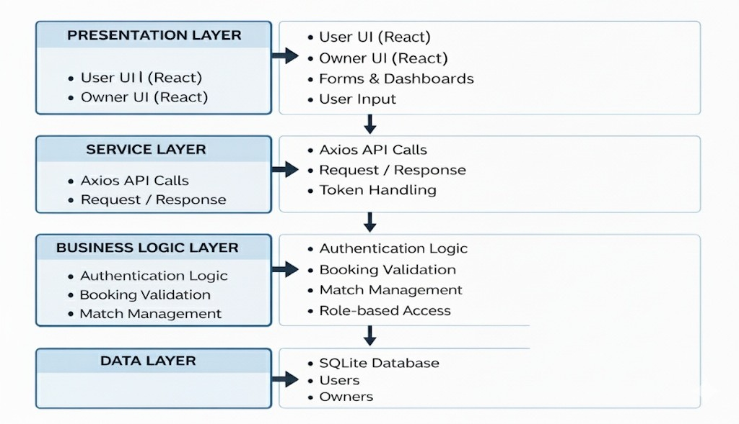
Fig. 1: System Architecture of MatchUp

Venue Booking Model
The Venue Booking Module is made to make it easy for people to reserve sports facilities. This system has a real-time venue booking mechanism that lets users pick time slots and confirm reservations easily. Users can select a venue the type of sport the date and how long they want to book it for. They do this through an interface that calculates the booking details and the cost.
The system takes the information that users enter and changes the date and time into a format. It checks to make sure everything is correct before it is sent. The system also checks for conflicts to make sure that there are not two bookings at the time for the same venue. This is fair. Helps to prevent problems, with the schedule.
When everything is checked the booking request is. Then it goes to the payment stage. If the payment is okay then the booking is. Stored. This way of booking reduces the amount of work that people have to do. Makes things more accurate. It also makes it easier for users to book a venue. The Venue Booking Module makes things more reliable and efficient by checking everything in time and confirming bookings automatically. This helps with managing sports venues.

Recommendation System
The MatchUp platform uses a way to suggest things to users that they might like. This way helps users find matches and venues that're right for them. The platform looks at what users have done like what sports they searched for what venues they looked at what they booked and what matches they joined.
These things that users do are called signals. The platform uses them to figure out what users like. Then it uses some rules to suggest venues, matches and sports activities that might be good for them. The platform tries to match what users are interested in with what venues offer what sports they have and when they are available.
This way of doing things makes it possible to give users personalized suggestions without using much computer power. It is good for websites that need to work and do not have a lot of data. The platform is designed to be simple, fast and easy to use with systems. This means users get suggestions without slowing down the platform.
The MatchUp platform focuses on keeping things easy and fast. It makes sure users get suggestions that make sense to them. The platform uses what users do to make these suggestions. It looks at searched sports, viewed venues, booking history and match participation to do this.
The system matches user interests with venue attributes and sport types. It also looks at time availability to generate suggestions. This approach enables personalization while maintaining low system overhead. It is suitable for real-time web applications, with data availability.
The design prioritizes simplicity and responsiveness. It ensures ease of integration so users receive suggestions without impacting system performance. The MatchUp platform incorporates a lightweight recommendation mechanism. This mechanism enhances user engagement and assists in discovering venues and matches.

Location-Based Services and Distance Estimation
The platform has a feature that helps users find venues near their location and makes it easier for them to decide.
It looks at where the user's where the venues are to give suggestions
* It gets the users location from their browser.
* Venue locations are stored in the database as latitude and longitude.
The system estimates how away a venue is from the user.
It uses mapping services to do this. If that does not work it uses a formula to calculate the distance.
With this information it shows users venues that're nearby.
This helps users pick a location to book.
This way of doing things makes it easy to filter venues by location .
It helps users make decisions when booking sports venues.
The system provides location-based service to facilitate sports venue discovery and improve user decision-making.
E. Payment Processing and Booking Confirmation
When you make a booking request the system uses a way to handle payments. This means you can trust that your money will be handled correctly. The system works with a company to process payments. You will use their payment page to complete your transaction.
After you pay the system checks to make sure everything is okay. It uses codes to verify the payment and make sure nobody is trying to cheat.
If everything checks out your booking will be marked as confirmed. The system will then save all the details of your booking. The system keeps track of all payments and bookings. This means you can look back at your booking history and see everything clearly.
The system does all of this automatically so people do not have to get involved. This makes the whole process more reliable. Ensures that all the information is consistent. The booking platform is safe and easy to use because it handles payments and bookings in a way.

IMPLEMENTATION
The MatchUp platform is a website that was made using React.js for the parts that users see and FastAPI for the parts that work behind the scenes. We used React.js to make the website look good and be easy to use and FastAPI to handle the work that the website needs to do. The MatchUp platform has parts for players and people who own venues so each group can only see the things they need to see like booking a place managing a match and taking care of a venue.

The backend of the website uses PostgreSQL to store all the information about users, venues, bookings and matches. We made sure that only the right people can get into the website and do the things they are allowed to do. When someone logs in they can only do the things that're okay for their role. The backend does all the work, like making sure a booking is okay checking for problems and coordinating matches.
The MatchUp platform has a real-time booking system that lets users pick a venue choose a time and book it. We check the date and time to make sure they are correct before we store them. We also make sure that people cannot book the place at the same time.
We use maps to help users find venues and see where they are. We use the venues address to show it on the map so users can pick a place that's easy to get to.
When someone books a venue they pay through Razorpay. We make sure the payment is safe and only update the booking when the payment is complete. This way we know that the booking is real and the user has paid.
The MatchUp platform uses web technologies, safe payments and maps to make a website that is easy to use and works well for people who like sports. The website helps users work together. Makes it easy, for them to book venues and play matches. The MatchUp platform is a place for people to find and book venues and for venue owners to manage their places. The MatchUp platform makes it easy for users to do what they need to do. It helps everyone have a good time.

Results and discussion
The MatchUp platform was put in place. It worked well as a website. People looked at how it worked and how fast it was. They checked the parts of the system like booking a place paying for things finding places and managing matches. The system worked steadily. Handled requests quickly. It also made sure that information was shared correctly between the parts that people see and the parts that are, behind the scenes.
A. Checking the Venue Booking Part. The part that lets people book venues was tested by pretending that many users were trying to book places, times and sports. The system took the bookings correctly. Checked that the date and time were okay before they were finalized. It also stopped people from booking a time that was already taken by someone. The whole process of booking a place including picking a time figuring out the cost and getting confirmation worked smoothly. Made it easier for people to book without having to do a lot of extra work. Sometimes it was a bit slow when a lot of people were using it. Overall, the MatchUp platform worked consistently and reliably.
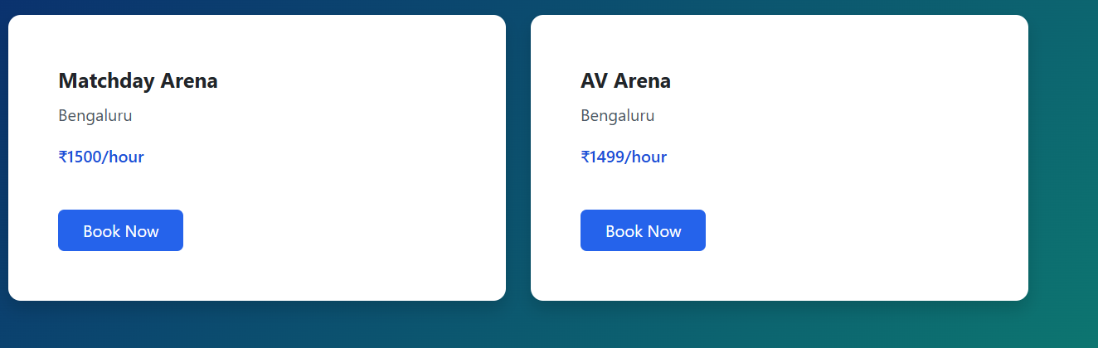

Fig. 2:Landing Page.

B. Landing Page
This landing screen communicates the main goal of the platform finding and booking sports venues nearby. It uses a simple call-to-action to guide users toward getting started. The design focuses on clarity and first-time user experience.


Fig. 3: Landing Page

C. User Dashboard
The user dashboard provides a personalized overview of sports activity. It displays statistics such as matches hosted, matches joined, upcoming games, and monthly booking trends. Quick-action buttons allow users to create matches or explore venues easily

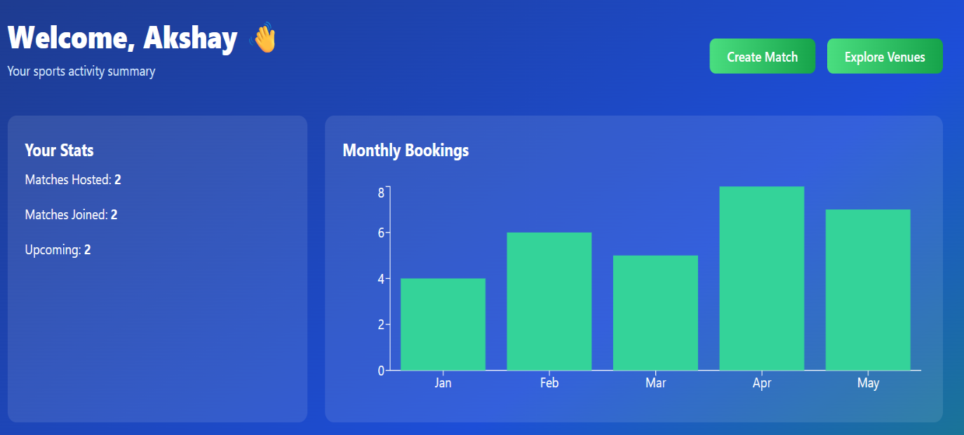
Fig. 4: User Dashboard

D. Owner Dashboard
This section allows venue owners to view all bookings made for their venues. It includes booking date, time, user details, amount paid, and booking status. The screen helps owners efficiently manage and track reservations.

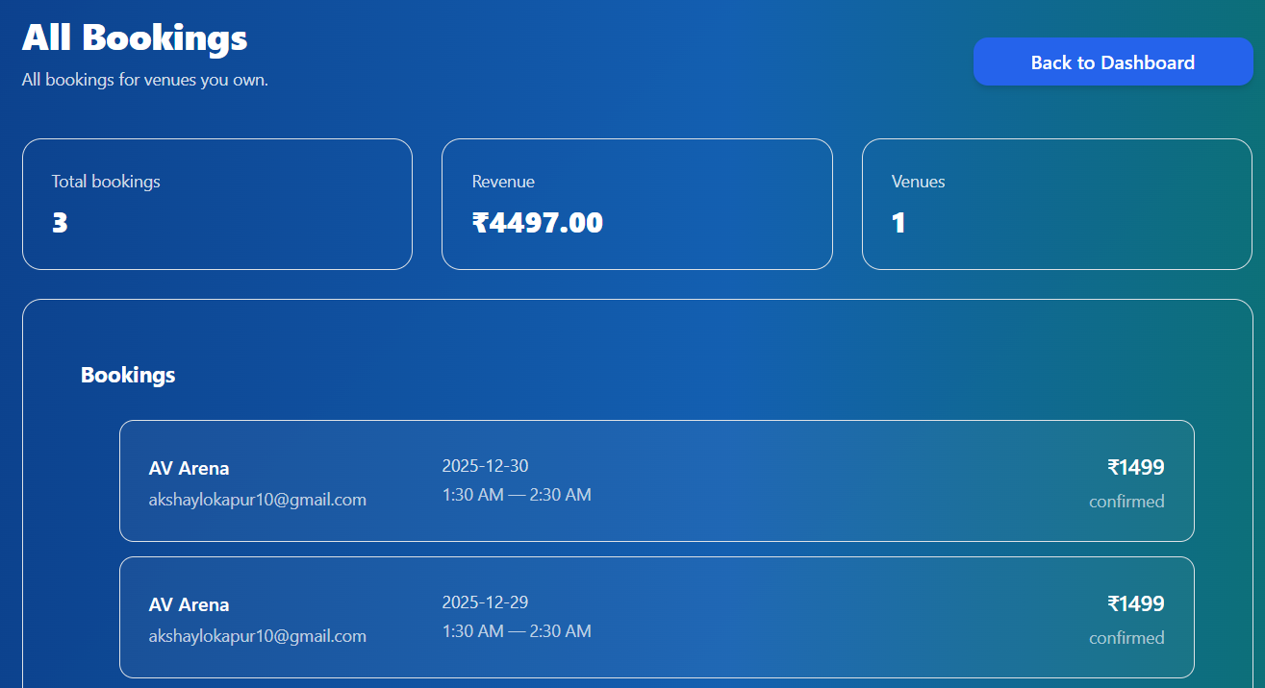
Fig. 5: Owner Dashboard

Conclusion

This paper presented MatchUp, a web-based platform designed to enhance sports community engagement and simplify venue booking processes. The system integrates key functionalities such as real-time venue booking, match organization, location-based services, and secure payment processing to provide a unified and efficient user experience. By enabling users to discover venues, schedule matches, and complete transactions within a single platform, the system reduces manual effort and improves accessibility.

By incorporating structured booking workflows and intuitive user interfaces, the platform simplifies reservation management and minimizes scheduling conflicts through automated validation mechanisms. The lightweight recommendation and location-based modules demonstrate that meaningful personalization and efficient venue discovery can be achieved without relying on computationally intensive algorithms. The integration of secure payment services ensures reliable transaction handling and enhances user trust.

The implementation confirms the functional reliability of core modules, including booking management, payment verification, and location-based services. Overall, MatchUp demonstrates that a scalable, modular web-based architecture can effectively support sports community interactions, optimize resource utilization, and provide a seamless digital solution for sports venue management and participation.

References

[1] B. Chembakottu, H. Li, and F. Khomh, “A Large-Scale Exploratory Study of Android Sports Apps in the Google Play Store,” arXiv, 2025.

[2] A. Felfernig, “Sports Recommender Systems: Overview and Research Directions,” Springer, 2024.

[3] Y. Jia, “A Narrative Review of Deep Learning Applications in Sports,” PMC, 2024.

[4] J. D. German et al., “An Online Reservation System for Sports Facilities,” Proc. ACM Conf., 2024, doi: 10.1145/3647782.3647814.

[5] S. Angosto, “Understanding Intention to Use Fitness Apps: A Systematic Review,” Humanities and Social Sciences Communications, Nature, 2024, doi: 10.1057/s41599-023-02011-3.

[6] A. Ebtekar and P. Liu, “Elo-MMR: A Rating System for Massive Multiplayer Competitions,” Proc. Web Conf. (WWW), 2024, doi: 10.1145/3442381.3450091.

[7] G. Fan et al., “Re-Matchmaking to Improve Fairness and Satisfaction in Team Games,” Proc. ACM CSCW, 2023, doi: 10.1145/3686978.

[8] H. Kang et al., “Match Outcomes and Player Churn in Competitive Play,” Heliyon, Elsevier, 2023, doi: 10.1016/j.heliyon.2024.e24891.

