Spring Boot Server less Architecture using AWS Lambda | Spring Cloud Function

1)Functions Exposed

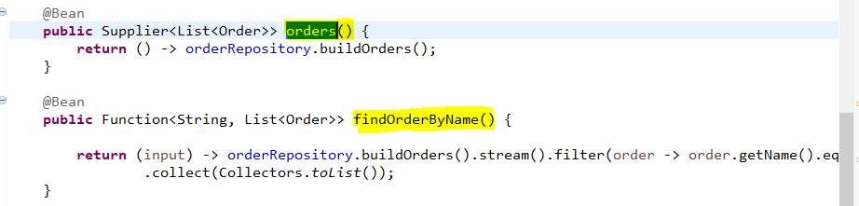

2)Handler Class

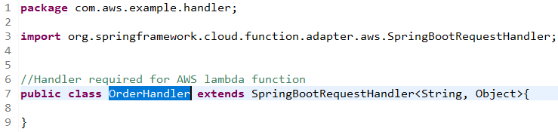

3)Handler class configuration

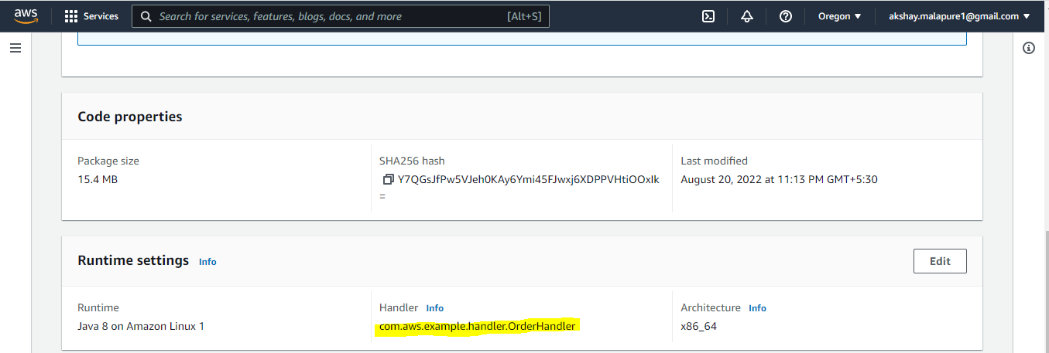

4)findOrderByName Function Configured

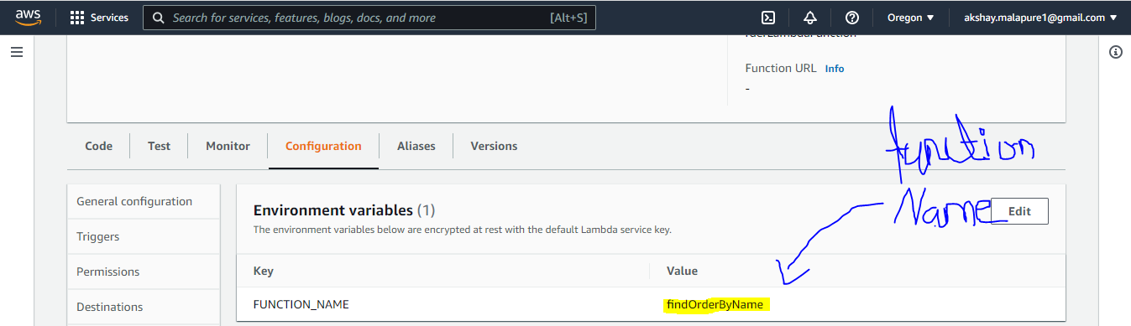

5)findOrderByName Input and Output

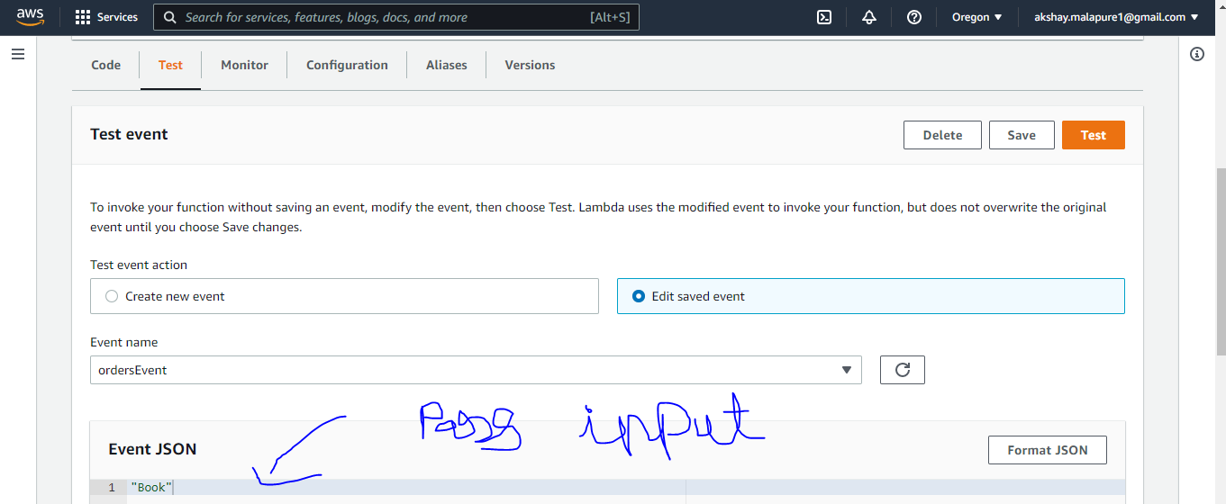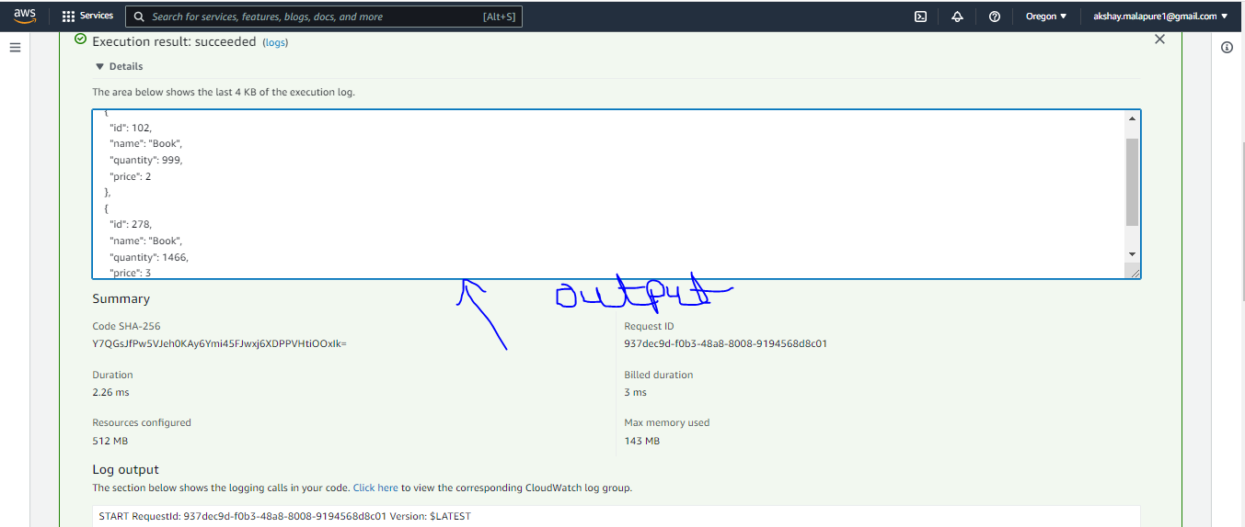

6)Testing Orders function

