**Client Server Authentication**

Authentication

All the message transmission between the client and the server are encoded with Unicode Transformation Format-8 also known as UTF-8 encoding/decoding method. It is most commonly used encoding method in python.

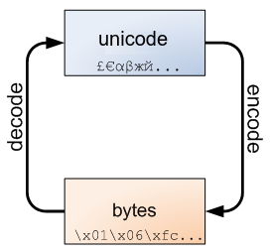

UTF-8 uses the two basic rules:

* If the code point is < 128, it’s represented by the corresponding byte value.
* If the code point is >= 128, it’s turned into a sequence of two, three, or four bytes, where each byte of the sequence is between 128 and 255.

UTF-8 has several convenient properties:

* It can handle any Unicode code point.
* A Unicode string is turned into a sequence of bytes containing no embedded zero bytes. This avoids byte-ordering issues, and means UTF-8 strings can be processed by C functions such as strcpy() and sent through protocols that can’t handle zero bytes.
* A string of ASCII text is also valid UTF-8 text.
* UTF-8 is fairly compact; the majority of commonly used characters can be represented with one or two bytes.
* If bytes are corrupted or lost, it’s possible to determine the start of the next UTF-8-encoded code point and resynchronize. It’s also unlikely that random 8-bit data will look like valid UTF-8.

An example of UTF-8 Encoding:

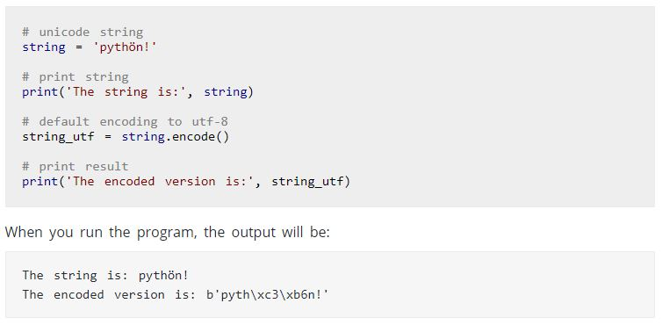

For authenticating the user we are checking with the Data Base Records if the user is valid we are sending the success result from server else the invalid false message will be send.

**Snapshots of the Client-Server Communication**

**Case 1:** When user is valid

1. Starting the server

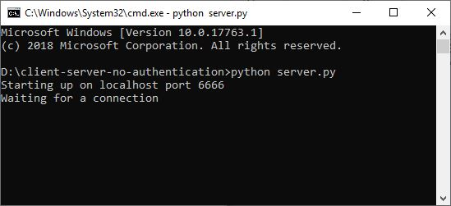

1. Initiate client call

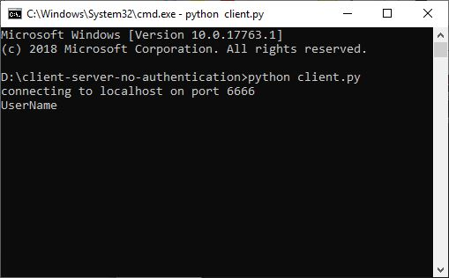

1. Provide the credentials

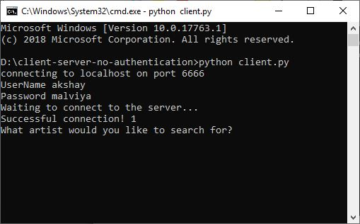

1. Once the user is authenticated, server shows success message

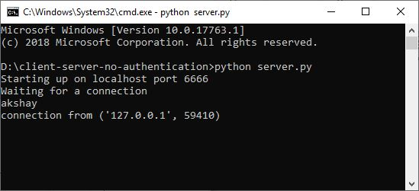

1. Send the request of artist you want to search the song

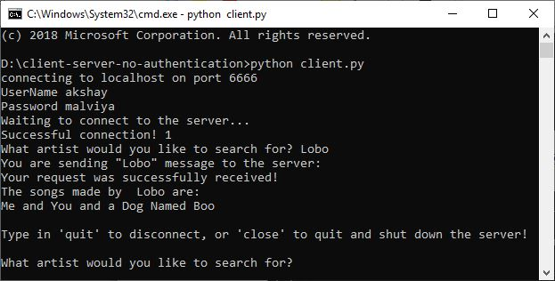

1. Server will response by name of song

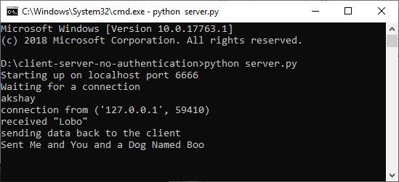

1. Now you can disconnect from server by close command

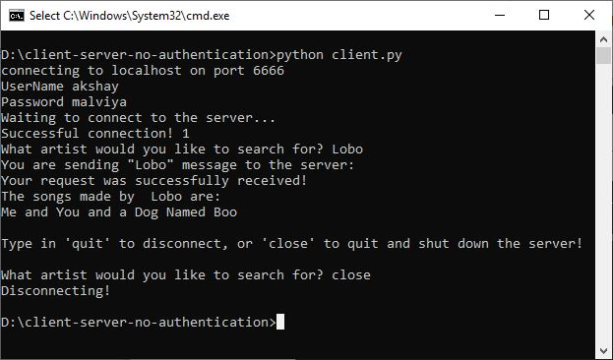

server

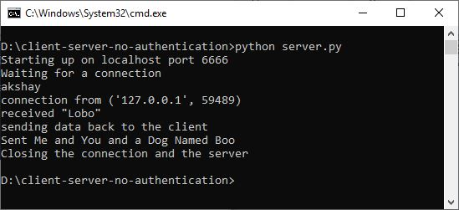

**Case 2:**  When user is invalid

1. Starting the server

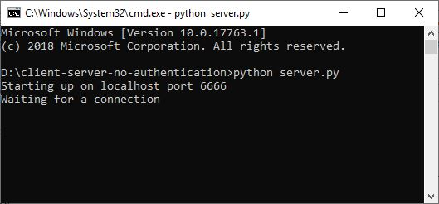

1. User authentication by wrong credential

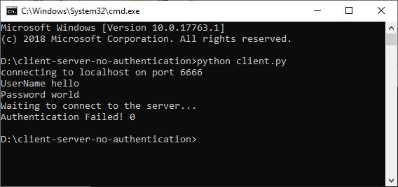

Server

