**Python**

**Exercises**

The code must be submitted under your name in GitHub in a repository called Python. Work individually.

Each file will have the name: exerciseX.py where X is the exercise number. You will have 13 files at most.

Do not commit code that does not compile. The code that you commit should have been tested. -10 points for code that does not compile on the top of your grade.

You will provide a hardcopy with your code to Dr. Scharff on 12/4.

**Exercise 1**

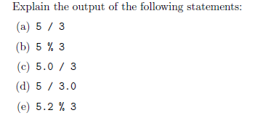

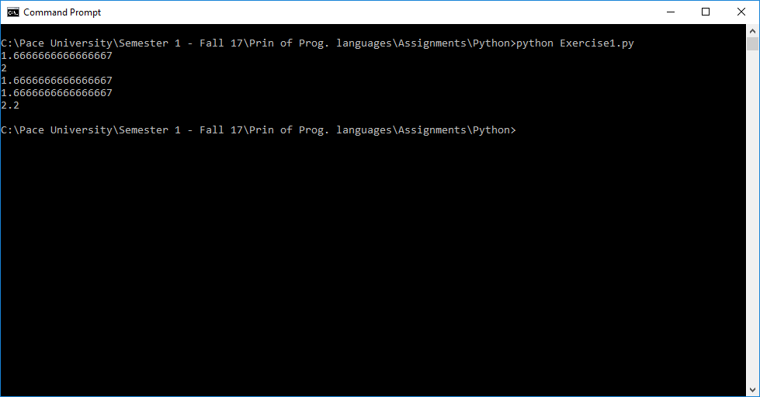

/ operator divides number and % returns the mod

**Exercise 2**

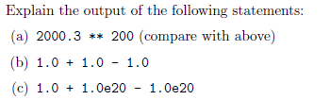

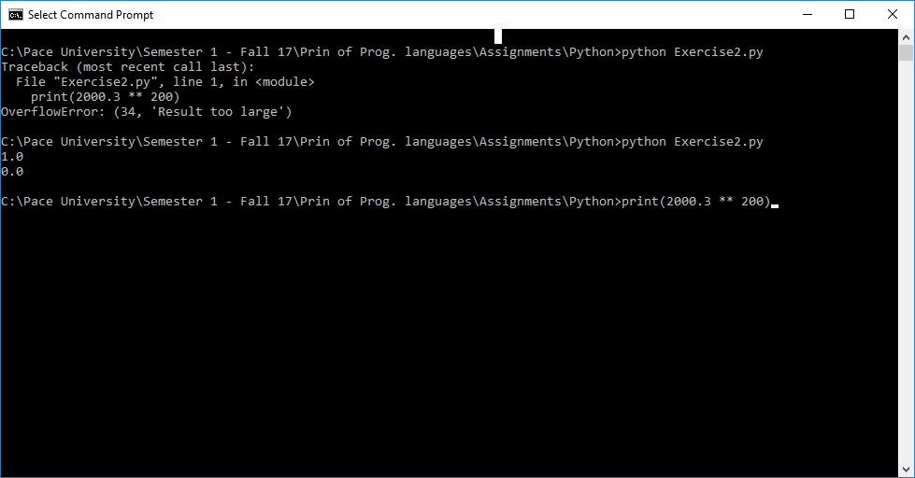

Explanation**:**

1. The output throws OverflowError : because the result is too large.
2. Gives the output of the equation

**Exercise 3**

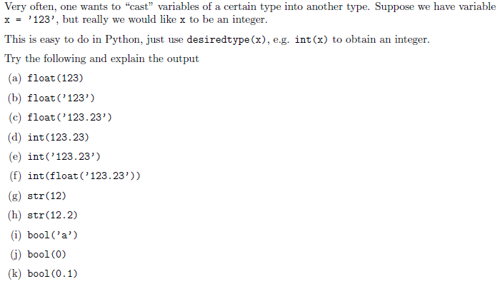

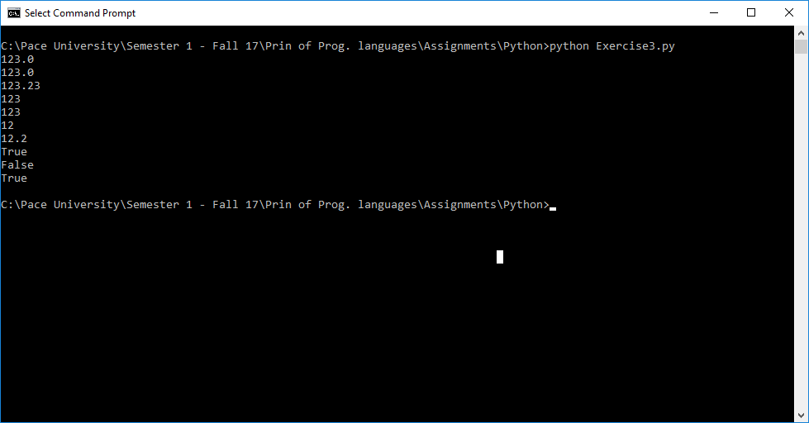

**Exercise 4**

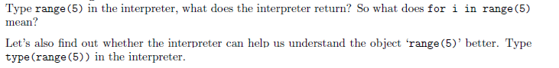

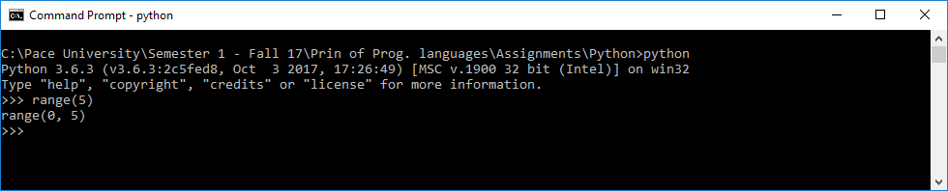

i means it’s a counter for the for loop from 0 to 5

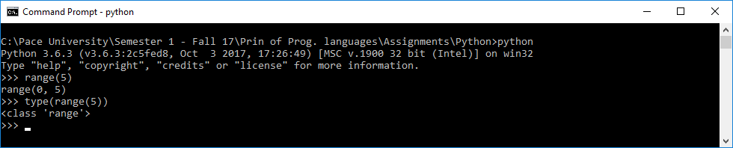

Yes. The interpreter says the range is class.

**Exercise 5**

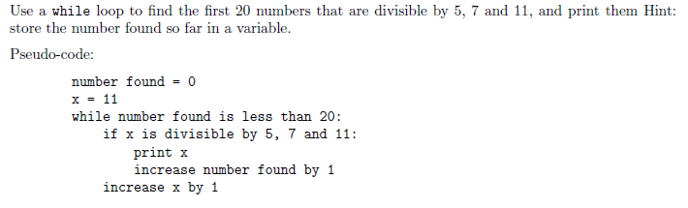

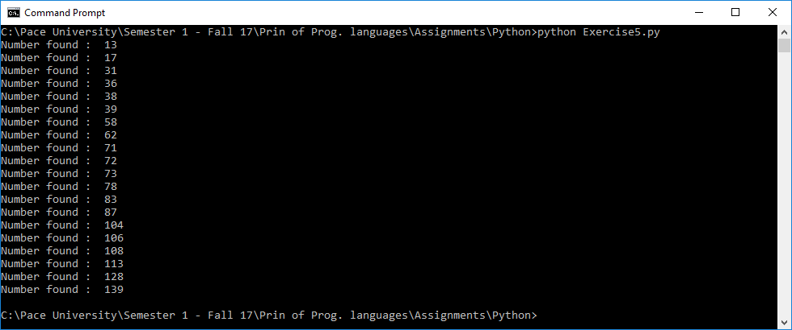

**Exercise 6**

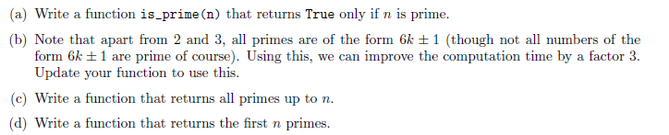

6a

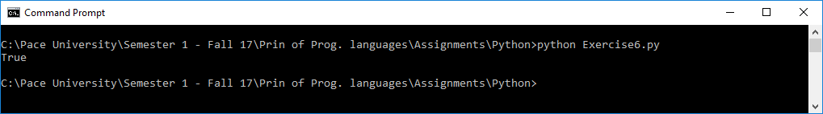

6c

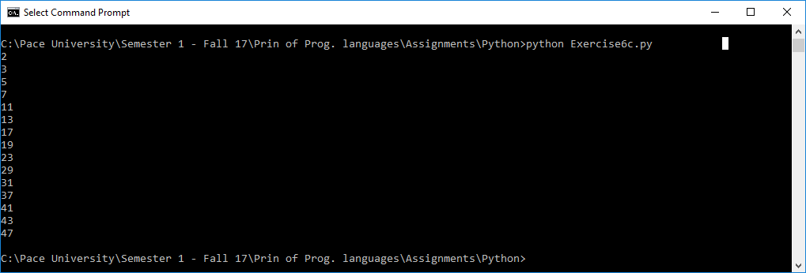

6d

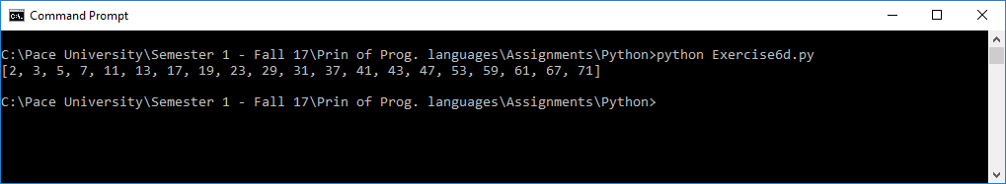

**Exercise 7**

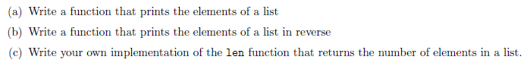

7a

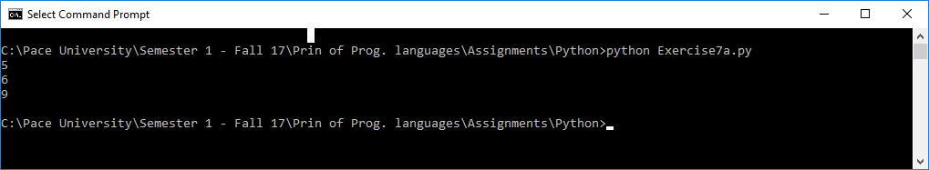

7b

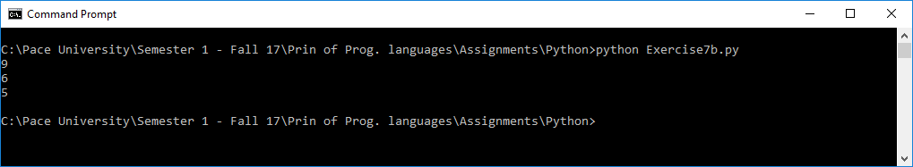

7c

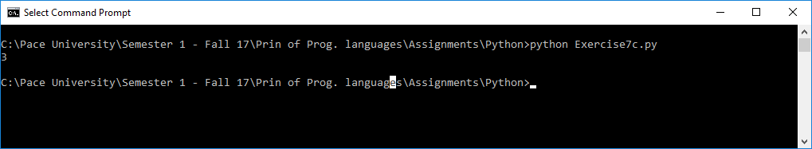

**Exercise 8**



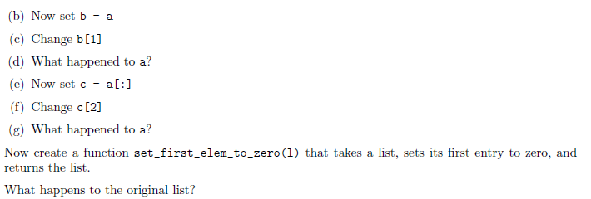

8d) List a Changed while changing the value at index 1 of b.

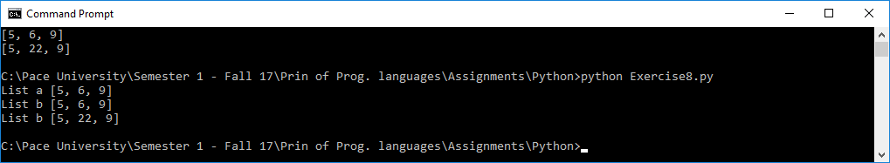

8g) List a remains unchanged even after changing the value at index 2 of list c

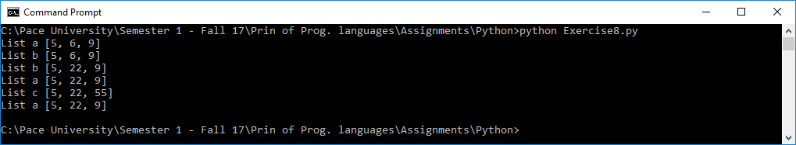

8i) original list also changed

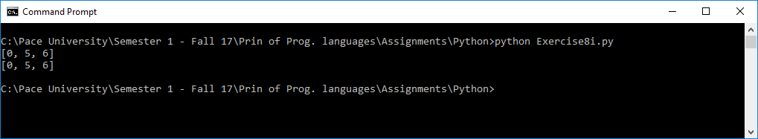

**Exercise 9**



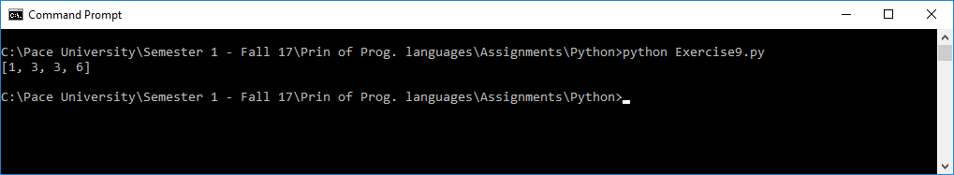

**Exercise 10**

Use mathplotlib

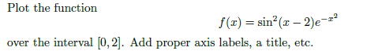

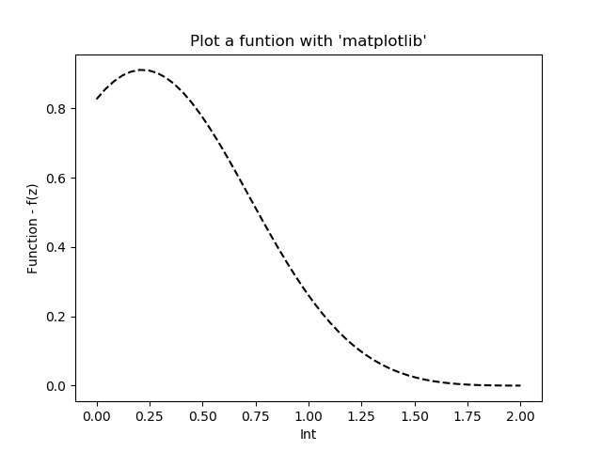

**Exercise 11**



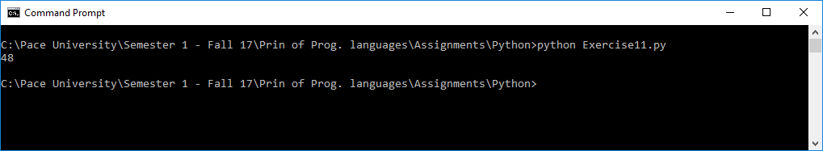

**Exercise 12**

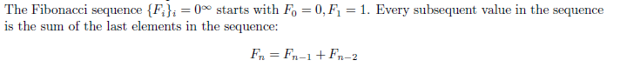

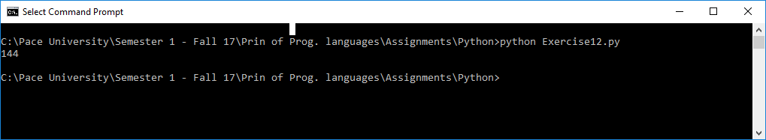

**Exercise 13**

Write a Python program that extracts the email addresses of a file. An email file emails.txt is provided to test your program.

<http://rubular.com/> is a site that can be useful to get familiar with regular expressions.

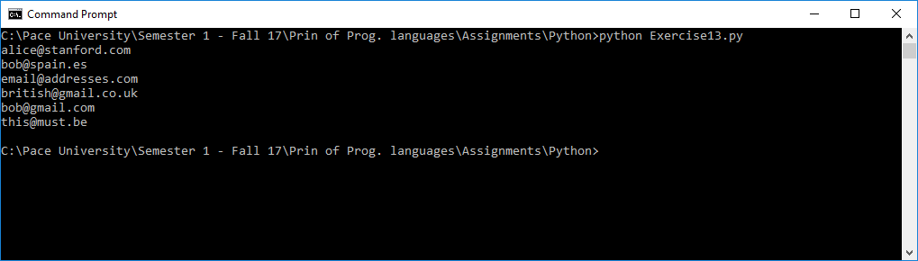

**References**

Stanford courses on Python <https://web.stanford.edu/~schmit/cme193/exercises.html>