* Instructions to use the application:

1. Run bundle install on the project
2. Check if rails is up and running then run rails ‘db:seed’ command
3. Run the URL : <http://localhost:3000/orderdetails>
4. You should be able to see the following screen

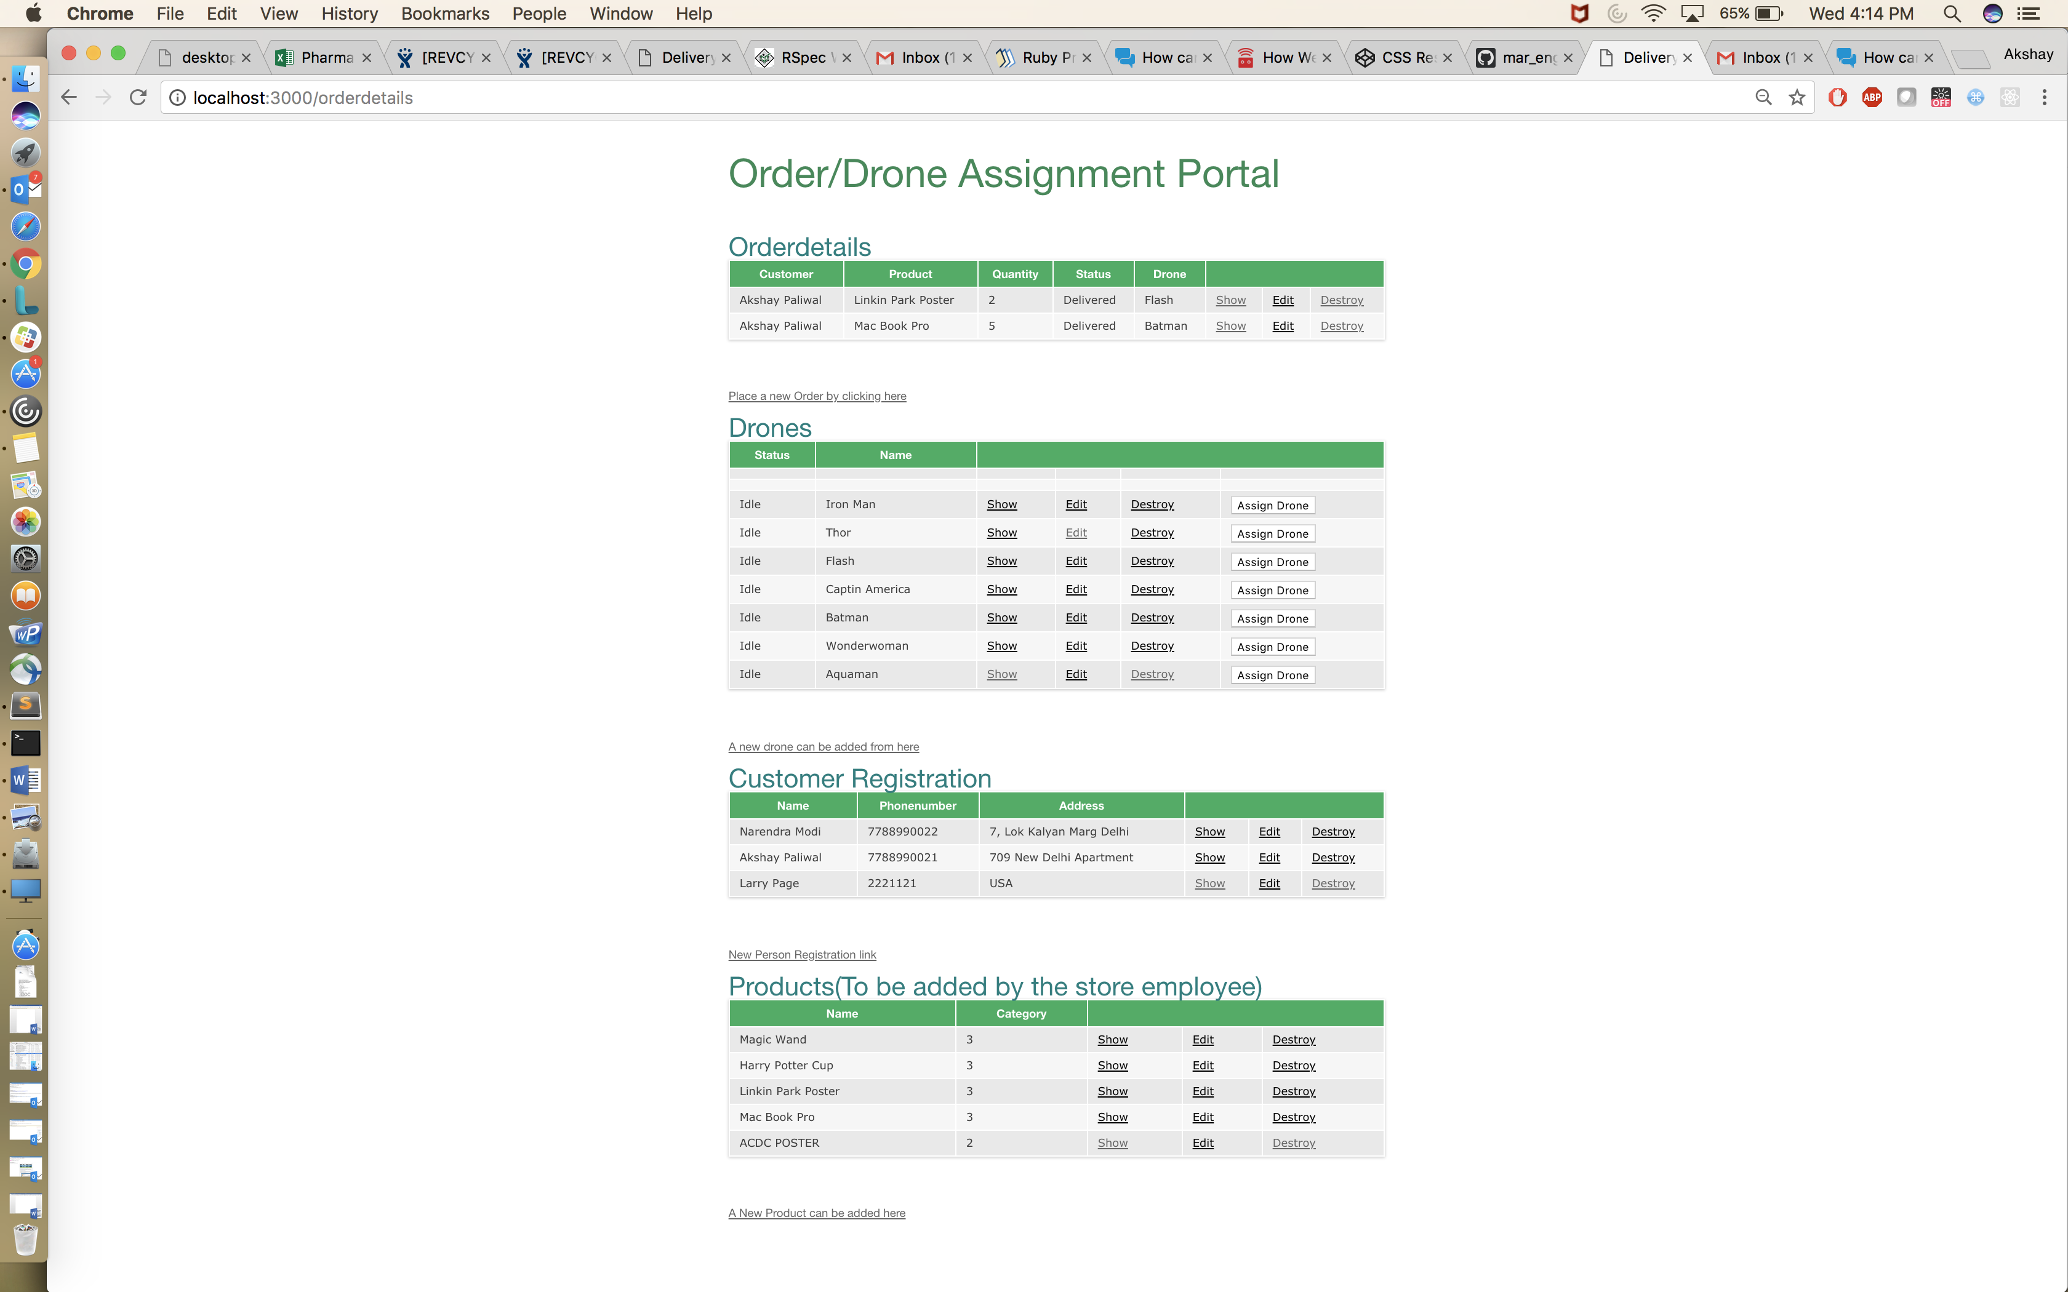

1. Create a new order . Click on creating a new order .
2. You will be able to see the following window :

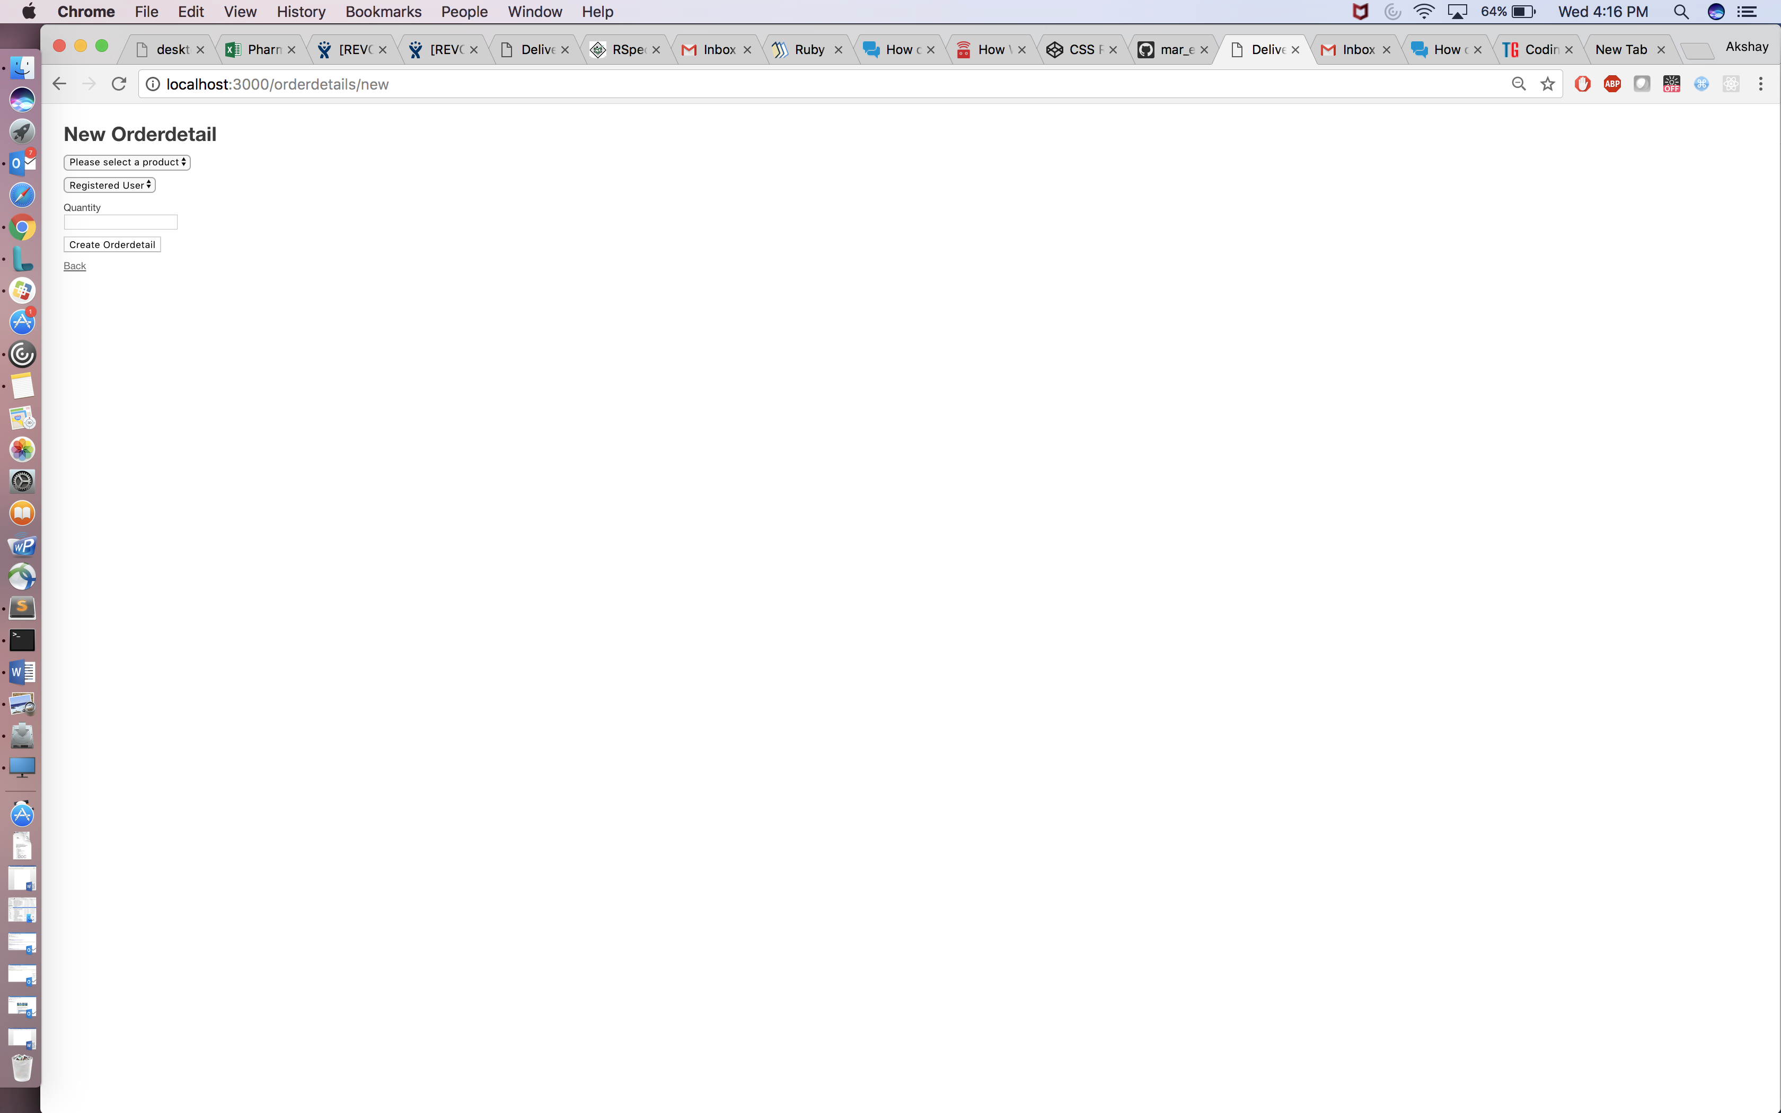

1. Add the order details
2. Now click on back once you get a confirmation
3. From the list of the drones you can now assign a drone
4. Drone status will change to assign

Now using Threads we are giving a waiting for some amount of time for the status to change once status of drone is picked up the order status will change too to enroute.

Then the drone will reach the location and then deliver the item then the order status will change to delivered.  
Following the same the drone will be on it’s way back and be idle again indicating it can be used again .

For now, we are just using a sleep method inside the thread to give a delay in the status change.

Drone status :

1."Idle" : can be assigned :

2 "Assigned" : assigned an order

3 "Picked up enroute" : order status also changed to enroute along with dron’es status

4 "Reached"

5 "Delivered": order status also changes

6 "Way Back"

7"Reached Hub"

Also, please note for now please note I am refreshing the page through javascript sleep functionality to get the real time status .

1. Other than the same we can register new customers.

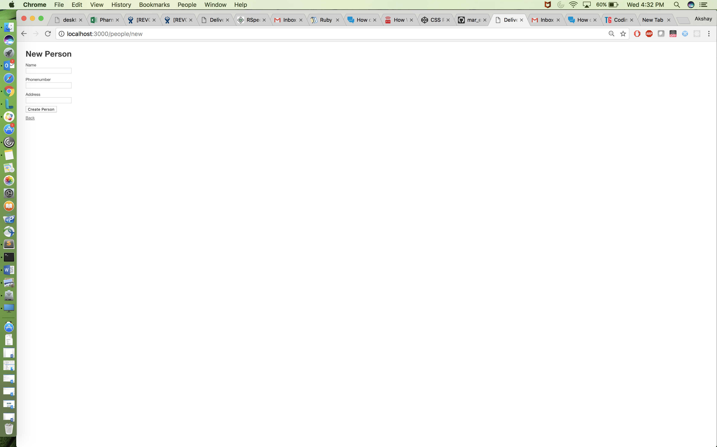

1. We can add more products to choose from.

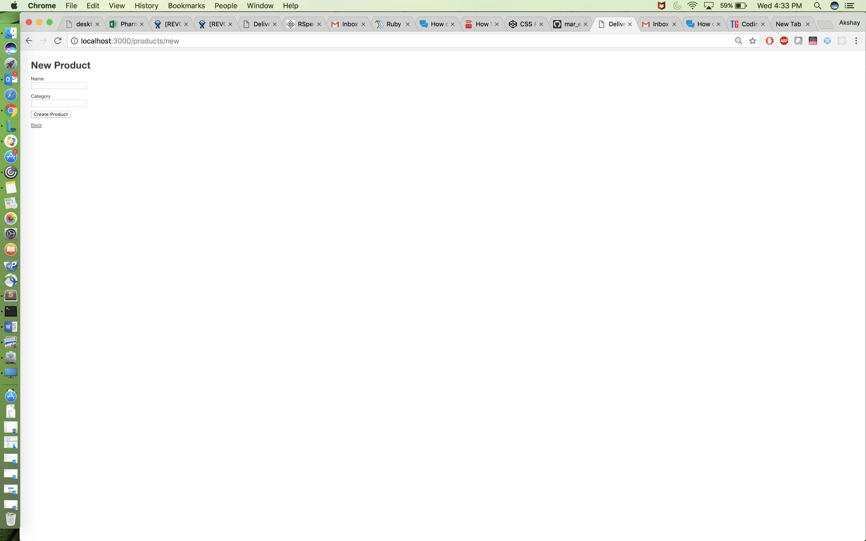

Database/Schema

1. Orders

|  |  |  |  |
| --- | --- | --- | --- |
| Order_id | Drone_id | Person_id | Status |
| Primary_key | Foreign_key(Table: Drone) | Foreign_key(Table: Person) | Integer value with the following:  1: Order Created  2: Dispatched  3: Delivered |

1. Drone

|  |  |  |
| --- | --- | --- |
| Drone_id | Status | Name |
| Primary_key | Integer values with the following:   1. Idle 2. Assigned 3. Picked Up Enroute 4. Reached 5. Delivered 6. Way Back 7. Reached Hub | Name of the Drone |

1. Product

|  |  |  |
| --- | --- | --- |
| Product_id | Product_name | Category |
| Primary_key | Name of the item | Integer |

1. OrderDetail

|  |  |  |  |
| --- | --- | --- | --- |
| Orderdetail_id | Order_id | Product_id | quantity |
| Primary_key | Foreign_key(Table: Order) | Foreign_key(Table: Product) | integer |

1. Person

|  |  |  |  |
| --- | --- | --- | --- |
| Person_id | Address | Phone Number | Name |
| Primary_key | String | String | String |