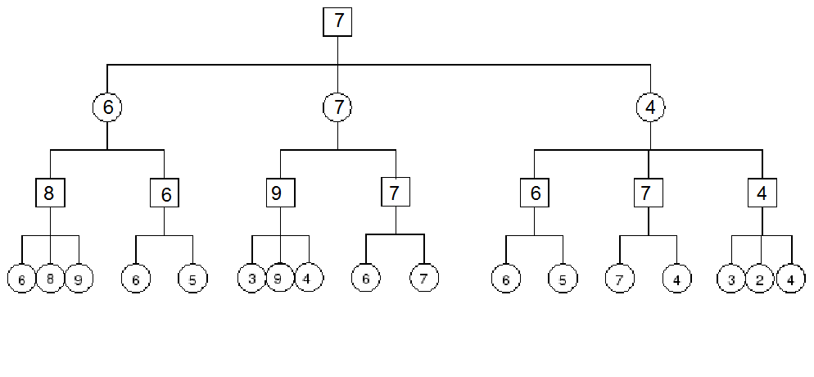
Q (1.1)

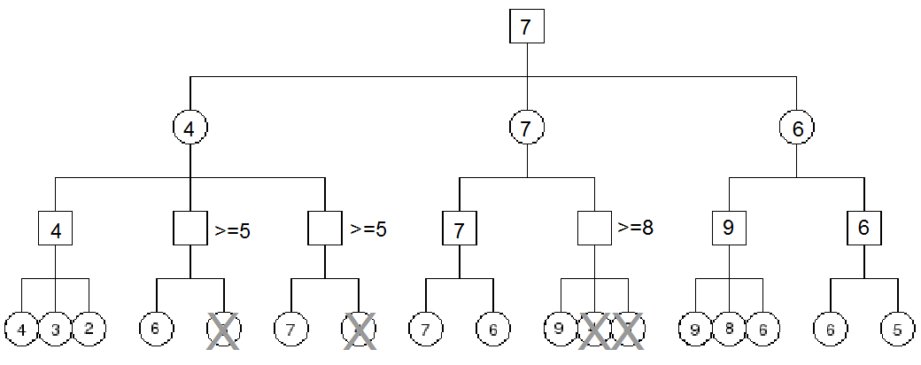
Q (1.2)

Q (2.1) FALSE
In a fully observable game knowing the opponent's strategy helps. Already possessing knowledge of all the possible states and the current state of the game, if the opponents strategy is known the player can better traverse the game-state tree to maximize their payoff. If the opponent's strategy is not known the player may end up making suboptimal moves.

Q (2.2) FALSE
In a partially observable game, we employ Monte Carlo method of learning strategies of the opponent to maximize the payoff for the player. This way of learning strategies is not complete and does encounter deviations of the opponents from the assessed strategies, in spite of numerous runs. If we were to know the strategy of the opponent correctly it would help us improve an agent's performance in partially observable zero-sum games too.

Q (2.3) FALSE
Given unlimited resources, the backgammon agent may-be able to compute the entire game-state tree inclusive of all the chance nodes for all dice rolls made by it and the opponent. But this does not guarantee victory for the agent since the game depends on chance i.e. the roll of a dice. The agent cannot possibly maximise it's payoff in the game since the agent cannot control what the dice rolls. Hence this is a false proposition.

Q (3.1)
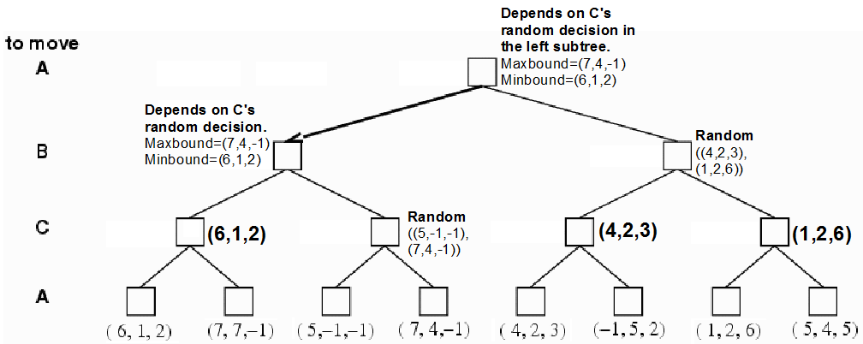

Q (3.2)
The primary problem arises from the fact that three person games are non-zero sum games. Issues in using any adaptation of minimax are due to this fact. Considering the above game tree, for a player if all legal moves at any given point during the game evaluate to the same utility for her, the problem is that of tie breaking. For tie-breaking the player can:
- Assuming every player is on their own, randomly choose any of the legal moves. For example, in the example above player C stands to achieve utility of -1 irrespective of whether it moves to state (5,-1,-1) or (7,4,-1). Thus, C can choose it's move randomly without jeopardizing it's maximizing strategy. But C's choice will decide B's move up the game tree. Thus the randomization renders C's decision node equivalent to a chance node for B. Minimax is not directly applicable in case of chance nodes.
- Construe this as a zero-sum games by using the notion that every player uses a strategy to maximize her gain and also minimize gains for all other players. Thus, when every player considers the set of it's opponents as one singular enemy, the problem appears to be solvable using an adaption of the min-max. For the case discussed above, player C can choose to move to state (5,-1,-1) rather than (7,4,-1) because the former choice minimizes payoff for both A and B. But the pure min-max theorem still does not apply after this is done. The min-max theorem says that the in case of 2-player games the guaranteed payoff is equal to the threat value. Even though the above problems seems to have reduced to a 2-player game, the above equality does not hold. There exists a difference in the guaranteed payoff and threat value of payoff as suggested by the min-max theorem, since the opponents who are considered a singular entity may choose to function like one by collaborating. This difference is proportional to the degree of collaboration between the opponents that the player construes as a singular enemy. Also correlated strategies or combined utility functions may not be static and may change as the game progresses, since collaborations may be forged and broken as the game progresses.

