Project Report

IMAGE-BASED AGE AND GENDER CLASSIFICATION WITH CONVOLUTIONAL NEURAL NETWORKS (CNN)



Project Report submitted on the fullfilment of the requirements of Post graduate Diploma in Machine Learning

Authors: Co-Ordinator:
Akshay Potdar (220960925036) Ms. Roopa Panikar – Course Coordinator
Pranita Dibe (220960925037) Ms. Soorya (CDAC)
Pratiksha Salunke (220960925038) Ms. Divya Das (CDAC)
Punawesh Sawant (220960925039)
Tushar Salve (220960925040)

Sr. No. | Table of Contents | Page No.
1. | Abstract
2. | Introduction
3. | Literature Survey
4. | Proposed System
4.1 | Dataset pre-processing
4.2 | Feature Extraction
4.3 | Models used
5. | Discussion and Results
5.1 | Output obtained
5.2 | Evaluation measures used
6. | Conclusion
7. | References

- Abstract

Age and gender characteristics can be applied in various fields such as retail for contextual advertising for particular groups of customers. Our goal here is to create a program that will predict the gender and age of the person using an image. But predicting age might not be as simple as you think, why? You might be thinking that age prediction is a regression problem, right? And you would be right in thinking so. However, there are many uncertainties that researchers have faced when they treated this as a regression problem, like camera quality, brightness, climate condition, background, etc.
Key Words: Convolutional Neural Network, Machine learning, Age classification, Gender Detection.

- Introduction

Age and gender play fundamental roles in social interactions. Languages reserve different salutations and grammar rules for men or women, and very often different vocabularies are used when addressing elders compared to young people. Despite the basic roles these attributes play in our day-to-day lives, the ability to automatically estimate them accurately and reliably from face images is still far from meeting the needs of commercial applications. This is particularly perplexing when considering recent claims to super-human capabilities in the related task of face recognition. Past approaches to estimating or classifying these attributes from face images have relied on differences in facial feature dimensions or “tailored” face descriptors. Most have employed classification schemes designed particularly for age or gender estimation tasks, including and others. Few of these past methods were designed to handle the many challenges of unconstrained imaging conditions. Moreover, the machine learning methods employed by these systems did not fully exploit the massive numbers of image examples and data available through the Internet in order to improve classification capabilities. In this paper we attempt to close the gap between automatic face recognition capabilities and those of age and gender estimation methods. To this end, we follow the successful example laid down by recent face recognition systems: Face recognition techniques described in the last few years have shown that tremendous progress can be made by the use of deep convolutional neural networks (CNN). We demonstrate similar gains with a simple network architecture, designed by considering the rather limited availability of accurate age and gender labels in existing face data sets. We test our network on the newly released Adience benchmark for age and gender classification of unfiltered face images.
We show that despite the very challenging nature of the images in the Adience set and the simplicity of our network design, our method outperforms existing state of the art by substantial margins. Although these results provide a remarkable baseline for deep-learning-based approaches, they leave room for improvements by more elaborate system designs, suggesting that the problem of accurately estimating age and gender in the unconstrained settings, as reflected by the Adience images, remains unsolved. In order to provide a foothold for the development of more effective future methods, we make our trained models and classification system publicly available.

- Literature survey

In this section, we briefly review the age and gender classification literature and describe both the early methods. The main aim of this method is fixing age and gender classification and checking the accuracy of the model for his or her images. The paper gives us information about the technology used in the gender detection model. The models using an algorithm for detecting an image pose prediction and recognition of his or her images using convolutional neural network algorithm it enhances performance and high face detector for improving the speed of the model significantly better in performance and performing many more tasks.
Abhijit Das, Antitza Dantcheva and Francois Bremond Mitigating Bias in Gender, Age and Ethnicity classification [1], they proposed a system using multi-task CNN approach which was ranked first in the BEFA challenge of European Conference on Computer Vision (ECCV). The model used by them was FaceNet and ResNet. The accuracy they got for race was 84%, gender was 94% and age was 72%.Philip Smith, Cuixian Chen Transfer Learning with Deep CNNs for Gender Recognition and Age Estimation [2], in this they replaced the 1000 class predefined layer by ImageNet with a prediction layer of 101 classes for age prediction. In this the transfer learning is detected by the help VGG-19 and VGG-Face. MAE achieved 4.10 years which helped in improving the age estimation model. 96% accuracy was achieved with the help of VGG-19.Sepidehsadat Hosseini, Seok Hee Lee, Hyuk Jin Kwon, Hyung Ii Koo and Nam Ik Cho Age and Gender Classification Using Wide Convolutional Neural Network and Gabor Filter [3], they used a wide CNN Gabor filter and the image input shaped to 227x227. The accuracy they got for age is 61% and gender is 88%

- Proposed system

Data pre procesing

a) Checking for missing values in dataset.
b) Calculation of various aggregation functions.
c) Treating the missing
d) Overall data description and analysis

Feature Extraction

Our Dataset is:

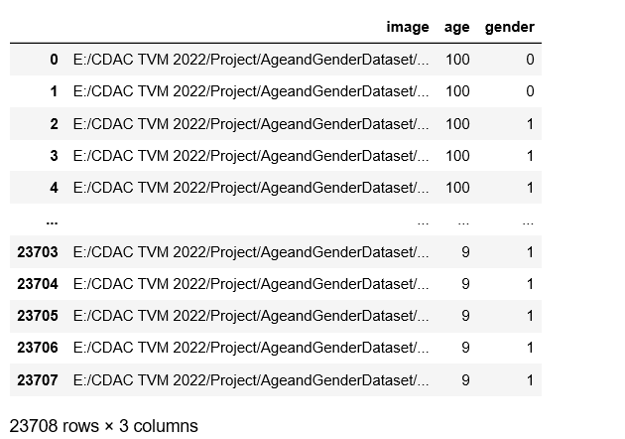

Model used

- Discussion and Result

- Conclusion

Though many previous methods have addressed the problems of age and gender classification, until recently, much of this work has focused on constrained images taken in lab settings. Such settings do not adequately reflect appearance variations common to the real-world images in social websites and online repositories. Internet images, however, are not simply more challenging: they are also abun-
dant. The easy availability of huge image collections provides modern machine learning based systems with effectively endless training data, though this data is not always suitably labeled for supervised learning. Taking example from the related problem of face recognition we explore how well deep CNN perform on these tasks using Internet data. We provide results with a lean deep-learning architecture designed to avoid overfitting due to the limitation of limited labeled data. Our network is “shallow” compared to some of the recent network architectures, thereby reducing the number of its parameters and the chance for overfitting. We further inflate the size of the training data by artificially adding cropped versions of the images in our training set. The resulting system was tested on the Adience benchmark of unfiltered images and shown to significantly outperform recent state of the art. Two important conclusions can be made from our results. First, CNN can be used to provide improved age and gender classification results, even considering the much smaller size of contemporary unconstrained image sets labeled for age and gender. Second, the simplicity of our model implies that more elaborate systems using more training data may well be capable of substantially improving results beyond those reported here.

- References

[1] Abhijit Das, Antitza Dantcheva and Francois Bremond Mitigating Bias in Gender, Age and Ethnicity classification.
Link:
https://www.researchgate.net/publication/328031032_Mitigating_Bias_in_Gender_Age_and_Ethnicity_Classification_a_Multi-Task_Convolution_Neural_Network_Approach

[2] Philip Smith, Cuixian Chen Transfer Learning with Deep CNNs for Gender Recognition and Age Estimation.
Link:
https://arxiv.org/pdf/1811.07344.pdf

[3] Sepidehsadat Hosseini, Seok Hee Lee, Hyuk Jin Kwon, Hyung Ii Koo and Nam Ik Cho Age and Gender Classification Using Wide Convolutional Neural Network and Gabor Filter.
Link:
https://www.researchgate.net/publication/325495265_Age_and_gender_classification_using_wid_convolutional_neur%20al_network_and_Gabor_filter

- Dataset Reference

Dataset -https://www.kaggle.com/datasets/ttungl/adience-benchmark-gender-and-age-classification

