ASSIGNMENT:1

Slate username:ghatge

Code:

--------------------------------------------------------

-- File created - Thursday-June-18-2020

--------------------------------------------------------

--------------------------------------------------------

-- DDL for Procedure ASSIGNMENT_CURSOR

--------------------------------------------------------

set define off;

CREATE OR REPLACE EDITIONABLE PROCEDURE "S4_GHATGE"."ASSIGNMENT_CURSOR" AS

BEGIN

DECLARE

cursor myCursor is

SELECT * FROM patients;

currRow patients%ROWTYPE;

BEGIN

open myCursor;

LOOP

fetch myCursor into currRow;

exit when (myCursor%NOTFOUND);

DBMS_OUTPUT.put_line(currRow.fname || ',' || currRow.Lname);

IF currRow.aptno IS NULL

THEN

DBMS_OUTPUT.PUT_LINE(currRow.streetno || ' ' || currRow.addr1 || ' ' || currRow.addr2 );

DBMS_OUTPUT.PUT_LINE(currRow.city || ',' || currRow.prov || ',' || currRow.postalcode );

ELSE

DBMS_OUTPUT.PUT_LINE('#' ||currrow.aptno || '-' || currRow.streetno || ' ' || currRow.addr1 || ' ' || currRow.addr2 );

DBMS_OUTPUT.PUT_LINE(currRow.city || ',' || currRow.prov || ',' || currRow.postalcode );

END IF;

IF (currRow.age > 40)

THEN

DBMS_OUTPUT.put_line('DEAR MR/MRS ' || currRow.lname || ',');

ELSE

DBMS_OUTPUT.put_line('DEAR ' || currRow.fname || ',');

END IF;

DBMS_OUTPUT.put_line('Thank you for being our patient. We wish you and your family a very nice holiday season and look ');

DBMS_OUTPUT.put_line('forward to seeing you again in the new year');

DBMS_OUTPUT.put_line('Sincerly,');

DBMS_OUTPUT.put_line('Dr Keith Black');

DBMS_OUTPUT.put_line('-----------------------------------------------------------------------------');

END LOOP;

close myCursor;

END;

END ASSIGNMENT_CURSOR;

/

Table:

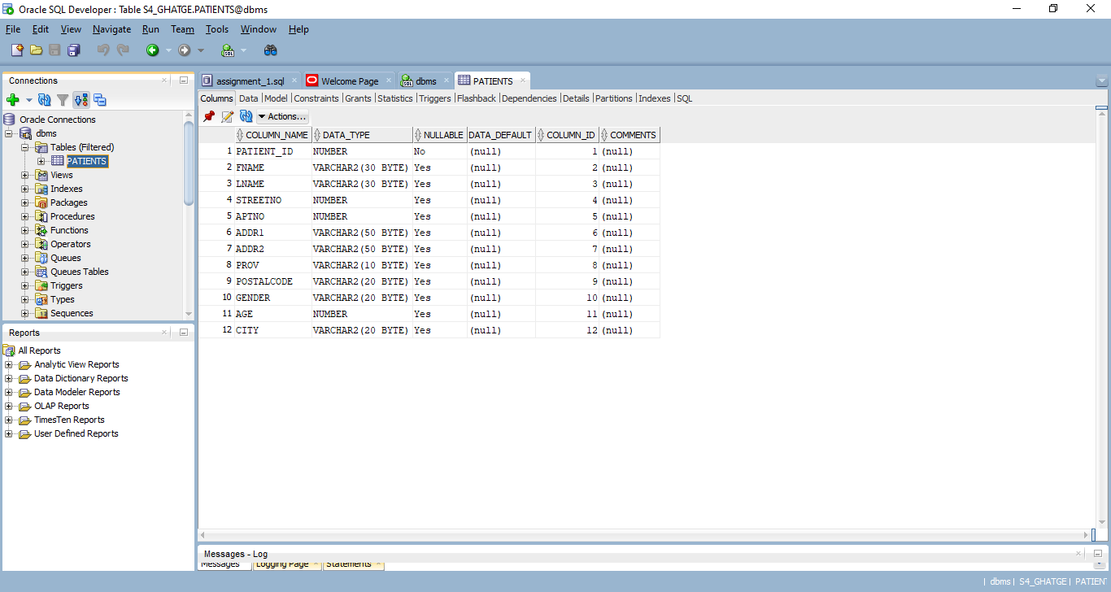

Table Data:

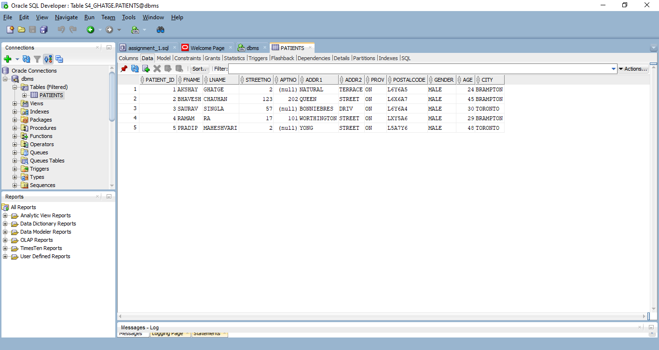

Output:

