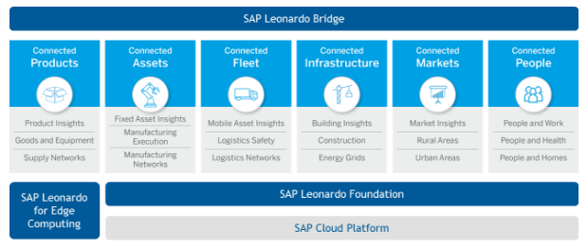

We talk about all these 6 platforms. Connected Products, Connected Assets, Connected Fleet, Connected Infrastructure, Connected Markets, Connected People.

Leonardo is the ‘platform’ to connect business processes with IoT devices. It turns Things to Outcomes – it takes data from those devices and, via analysis and visualisation, produces an Action (eg reset traffic light sequence, send engineer, order more stock) which produces an Outcome (eg reduced congestion, minimise production losses, increase revenue). The connected systems need not be SAP applications and need not be ERP.

The Leonardo Edge component (if used) resides on a Gateway (Raspberry PI, PC, etc) and is intelligent. This means upstream data – data from the device – is not just relayed by the gateway, but can be stored, analysed and actions taken immediately. This approach reduces data traffic – which in some cases may be a financial cost – but also reduces reaction time. If a sensor has suddenly spiked then a rapid response to shutdown the machine, reduced power or rpm may mean the difference between investigation and complete failure. In such a situation the recent device data can then be sent to the Foundation layer for detailed analysis. With, of course, a work order created and appropriate engineer scheduled depending on the analysis.

However, if you are looking to buy for instance Connected Products – it doesn’t work like that – you need to buy the individual components for your specific solution.

Lastly we get to the Leonardo Bridge. This is not an integration layer. This has been described as being like the “Starship Enterprise Bridge”. The component is not yet available, but it is proposed that it will be the control centre. The area to which all information is fed, analysis is available and decisions can be made. Maybe even Photon Torpedoes fired.

The first SAP Leonardo Centers were opened in New York and Paris, with others planned for Sao Leopoldo, Brazil and Bangalore, India.

SAP Leonardo

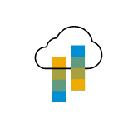 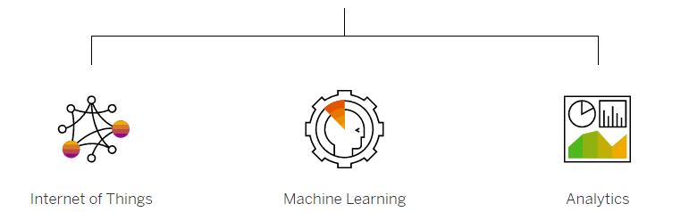

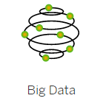 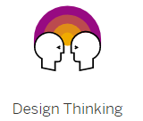 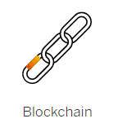

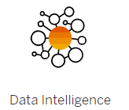

Companies using SAP Leonardo

