**CRYPTOPIA**

### PROJECT REPORT

#### Submitted by

**Sanyam Gupta (2210993842)**

**Pratham Gupta (2210993827)**

**BE-CSE (Artificial Intelligence)**

***Guided by***

**Dr. Amanpreet Singh**

**CHITKARA UNIVERSITY INSITUTE OF ENGINEERING & TECHNOLOGY**

**CHITKARA UNIVERSITY, RAJPURA**

**TABLE OF CONTENTS**

**TOPICS PAGE NO.**

Abstract……………………………………………. 3

1. Acknowledgement……………………………... 4
2. Chapters:

2.1 Introduction………………………………… 5

2.2 Basic Architecture…………………………. 7

2.3 Technical Details…………………………... 8

2.4 Problem Formulation………….…………… 11

2.5 Methodology……………………..………… 12

2.6 Flowchart…………………………………... 15

2.7 Software/Hardware Requirements……….… 16

2.8 Code………..………………………………. 16

2.9 Results…...…………………………………. 20

1. Conclusion:

3.1 Future Scope……………………………….. 21

3.2 Conclusion…………………………………. 21

3.3 References………………………………….. 21

3.4 Project Domain…………………………….. 21

**LIST OF FIGURES**

|  |  |  |  |
| --- | --- | --- | --- |
| S. NO. | LIST OF FIGURES | NAME | PAGE NO. |
| 1 | 1 | Project Distribution Chart | 6 |
| 2 | 2 | Basic Architecture | 7 |
| 3 | 3 | Flowchart | 15 |
| 4 | 4 | Result | 20 |

**ABSTRACT**

Cryptocurrencies have become an increasingly popular investment option over the past decade, with the total market capitalization of all cryptocurrencies reaching over $2 trillion in April 2021. However, buying and selling cryptocurrencies can be a complex and intimidating process, especially for beginners. Crypto exchanges provide a solution by creating an online marketplace where users can trade various cryptocurrencies in a secure and user-friendly environment.

The objective of this college project is to design and develop a crypto exchange website that provides a seamless platform for users to buy, sell, and trade cryptocurrencies. The website will be developed using modern technologies and programming languages, including blockchain, smart contracts, and web development frameworks. It will include a range of features and functionalities that will allow users to easily navigate the platform and perform transactions with confidence.

The website will feature an intuitive user interface, allowing users to easily create an account, deposit funds, and start trading cryptocurrencies. The platform will also include robust security measures to ensure the safety of users' funds and personal information. This will include features such as two-factor authentication, SSL encryption, and cold storage for storing users' funds.

To help users make informed trading decisions, the website will provide a range of trading tools and analytics. This will include real-time market data, price charts, and technical indicators, as well as the ability to set stop-loss and take-profit orders. Additionally, the website will provide educational resources and support to help users learn about cryptocurrencies and trading strategies.

The project will explore various aspects of building a crypto exchange website, including the implementation of order matching algorithms, integrating payment gateways, and complying with regulatory requirements. By creating a functional and secure crypto exchange website, this project aims to demonstrate the potential of crypto exchanges in the modern financial landscape and provide a practical solution for those interested in cryptocurrencies.

1. ACKNOWLEDGEMENTS

With immense pleasure we, **Sanyam Gupta** and **Pratham Gupta** are  
presenting “CRYPTOPIA” project report as part of  
the curriculum of ‘ BE-CSE (AI) ’.

I would like to express my sincere thanks to **Dr. Amanpreet Singh**, for his/her valuable guidance and support in completing my project.

I would also like to express my gratitude towards our dean **Dr. Sushil Narang** for giving me this great opportunity to do a project on “CRYPTOPIA”. Without their support and suggestions, this project would not have been completed.

Signature: **……………...**

Name: **Sanyam Gupta** Name: **Pratham Gupta**

Roll No: **2210993842** Roll No: **2210993827**

**2.1 INTRODUCTION**

What’s Cryptopia and how Cryptocurrency works?..

* Cryptocurrency is a revolutionary digital currency that operates independently of any government or financial institution. It is designed to be a decentralized and secure form of currency, using advanced cryptography to keep transactions safe and transparent.
* The creation of cryptocurrency involves a complex process known as mining, which involves solving mathematical equations and verifying transactions on the blockchain network. The blockchain is a public ledger that records all transactions and ensures their validity, making it a highly secure and transparent system.
* Cryptocurrencies offer a range of benefits over traditional fiat currencies, such as low transaction fees, fast processing times, and a high level of privacy and security. They can be bought and sold on cryptocurrency exchanges, and can also be used to purchase goods and services online.
* However, the world of cryptocurrency is also highly volatile and constantly evolving. The value of cryptocurrencies can fluctuate widely in a short period of time, making it a risky investment. Additionally, regulation and adoption of cryptocurrencies vary widely across different countries and jurisdictions, adding to the complexity of this exciting and rapidly changing field.
* Cryptocurrency exchanges and trading platforms are digital marketplaces where users can buy, sell, and trade various cryptocurrencies. These platforms offer a convenient and efficient way to exchange digital assets, and are designed to be user-friendly for both novice and experienced traders.
* To use a cryptocurrency exchanger, users typically need to create an account and go through a verification process. Once verified, they can deposit funds into their account using a variety of payment methods. These funds can then be used to buy or sell cryptocurrencies at market-driven prices.
* Each exchange offers different features, such as trading pairs, order types, and charting tools, to help traders analyze and execute their trades. Some exchanges even offer margin trading and futures trading for advanced users.
* However, trading cryptocurrencies can be risky due to the high volatility of the market. Therefore, it's important for traders to conduct their own research and make informed decisions when investing. They should also take necessary security measures, such as using two-factor authentication and keeping their private keys secure, to protect their assets from potential hacks or theft.

**Figure 1**

**PART WISE PROJECT DISTRIBUTION**

* 1. **Basic Architecture**

The basic architecture of a crypto exchange website consists of multiple components that work together to provide a secure and reliable platform for users to trade cryptocurrencies. Here are the key components:

* **Front-end**: Displays real-time data and allows users to interact with the exchange through a user-friendly interface.
* **Back-end**: Handles user authentication, executes trades, and interacts with the database and other components of the exchange.
* **Database**: Stores user account information, transaction history, and other critical data related to the exchange.
* **Order matching engine**: Matches buy and sell orders in real-time, executes trades, and ensures the exchange operates efficiently and reliably.
* **Wallets**: Store user funds securely and ensure quick access to funds for trading purposes.
* **APIs**: Facilitate communication between the exchange and external services such as payment processors, trading bots, and other platforms.

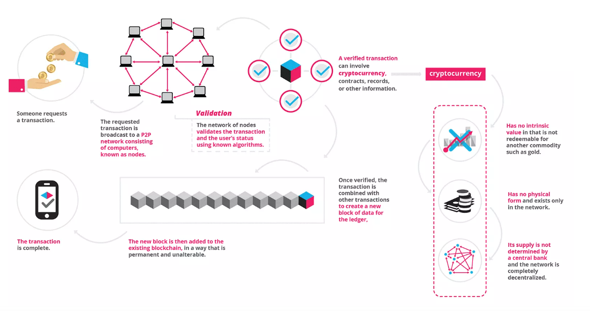

**Figure 2**

**Basic Architecture**

* 1. **Technical Details**
* **HTML**: HTML, or Hypertext Markup Language, is the standard markup language used to create web pages. It is a text-based language that is used to describe the structure and content of a web page. HTML documents are made up of a series of tags, which are used to define different elements on the page.

For example, the <html> tag is used to define the start and end of the HTML document, while the <head> tag is used to contain information about the document, such as the page title and any stylesheets or scripts. The <body> tag is used to define the main content of the page, and can contain a variety of different tags to define different elements such as headings, paragraphs, lists, images, and links.

HTML is a versatile language that can be used to create a wide range of different web pages, from simple static pages to complex interactive web applications. It is designed to be easy to learn and use, and there are many resources available online to help beginners get started with HTML.

Some key features of HTML include:

1. A wide range of different tags for defining different types of content and structure.
2. The ability to create links between pages using the <a> tag.
3. The ability to embed images and other media using the <img> and <video> tags.
4. The ability to create lists using the <ul> and <ol> tags.
5. The ability to add styles and formatting to pages using CSS.

* **CSS**: CSS, or Cascading Style Sheets, is a style sheet language used to describe the presentation of HTML (or XML) documents. In other words, while HTML is used to define the structure and content of a web page, CSS is used to define how that content should be displayed.

CSS works by defining styles for different elements on the page, such as fonts, colors, spacing, and layout. CSS styles can be defined in several ways, including:

1. Inline styles: Styles can be defined directly within the HTML tags using the "style" attribute.
2. Internal styles: Styles can be defined within the "head" section of an HTML document using the "style" tag.
3. External styles: Styles can be defined in a separate CSS file and linked to the HTML document using the "link" tag.
4. One of the key benefits of using CSS is that it allows you to separate the presentation of a web page from its content. This makes it much easier to make global changes to the design of a website, as you can simply update the CSS file instead of having to modify each individual HTML page.

Some key features of CSS include:

1. The ability to define styles for different types of HTML elements, such as headings, paragraphs, and links.
2. The ability to define styles for different states of an element, such as when it is hovered over or clicked.
3. The ability to create complex layouts using positioning, floats, and flexbox.
4. The ability to define responsive styles that adapt to different screen sizes and devices.

* **JavaScript**: JavaScript is a high-level programming language that is primarily used to create interactive and dynamic web pages. It is often referred to as a client-side language because it is executed on the client's web browser rather than on the web server.

JavaScript is used to add functionality to web pages, such as creating pop-ups, drop-down menus, and slide shows, and it is also used to validate user input on web forms. Additionally, JavaScript can be used to manipulate the Document Object Model (DOM) of a web page, which allows developers to modify the structure and content of a page dynamically.

Some key features of JavaScript include:

1. Event-driven programming: JavaScript code can be executed in response to user actions, such as mouse clicks and keyboard input.
2. Object-oriented programming: JavaScript supports object-oriented programming concepts, such as classes, inheritance, and encapsulation.
3. Asynchronous programming: JavaScript code can be written to execute asynchronously, which means that it can run in the background while other code is executing.
4. JavaScript is widely used in web development and is supported by all major web browsers. In recent years, JavaScript has also been used on the server side through the use of technologies such as Node.js.
   1. **Problem Formulation**

* The goal of the Cryptopia project is to create a cryptocurrency exchange website that provides users with a user-friendly interface, fast order execution, reliable security measures, and access to a wide range of cryptocurrencies.
* Cryptopia project aims to meet the needs of both novice and experienced traders, and contribute to the growth and development of the crypto industry.
* The core components of the project are exchange, including the front-end, back-end, wallets and APIs.
* Database and Order Matching Engine will be implemented in future.
* Key Features of Cryptopia:

1. User-friendly interface: A platform that is easy to use, navigate and understand for users of different technical backgrounds.
2. Secure payment gateway: A secure payment gateway that enables users to buy, sell and trade cryptocurrencies without the fear of fraud or hacking.
3. Support for multiple cryptocurrencies: The platform should support a wide range of cryptocurrencies to provide users with more options for trading.
4. Real-time market data: The platform should provide real-time market data and insights to help users make informed decisions while trading.
5. Mobile compatibility: The platform should be mobile-friendly and accessible on different devices to provide users with more flexibility and convenience.

* Usage of Crypto:

1. Payment: Cryptocurrencies can be used to buy goods and services from merchants that accept them as a form of payment. Some online retailers and service providers have started accepting cryptocurrencies as a form of payment.
2. Investment: Cryptocurrencies can be bought and held as an investment, with the potential for price appreciation over time. Many investors see cryptocurrencies as a hedge against inflation and a diversification tool for their investment portfolios.
3. Trading: Cryptocurrencies can be traded on cryptocurrency exchanges for other cryptocurrencies or fiat currencies. Traders can speculate on price movements and make profits by buying low and selling high.
4. Fundraising: Cryptocurrencies can be used for fundraising through initial coin offerings (ICOs) or token sales. This allows startups and businesses to raise funds from investors without going through traditional fundraising channels.
5. Privacy: Cryptocurrencies can be used for private transactions, allowing users to keep their financial activities hidden from the public eye.
   1. **Methodology**
6. A cryptocurrency exchange is an online marketplace where you can buy, sell, and trade cryptocurrencies, like bitcoin, Ethereum, and other altcoins. In many cases, you can buy and sell crypto for fiat currency, but some exchanges only allow crypto-for-crypto trading. Some exchanges are centralized, some are decentralized; some have your favourite crypto coins, others don’t; some are more accessible to beginners, others cater to experienced traders.
7. “**Cryptopia**”project is based on **HTML**, **CSS** and **JavaScript** which forms the basis of **Web Development.**
8. Our project aims is to create a cryptocurrency exchange website that provides users with a user-friendly interface, fast order execution, reliable security measures, and access to a wide range of cryptocurrencies.
9. Cryptopia provides the following features:

* **User-friendly interface**:

The user interface of a cryptocurrency exchange website should be designed to cater to users of varying technical backgrounds. The website should have clear and concise labels and instructions, with intuitive navigation and easy-to-understand features. It is also essential to ensure that the website is visually appealing, with a modern design that reflects the brand and values of the platform. In addition, usability testing and user feedback can be used to refine the user interface and improve the user experience.

* **Secure payment gateway**:

The payment gateway of a cryptocurrency exchange website should be designed to ensure maximum security and prevent any fraudulent activities. This involves implementing strong security measures, such as multi-factor authentication, SSL encryption, and DDoS protection, to ensure that user data and payment information are kept safe. It is also essential to comply with industry standards and regulations, such as PCI-DSS, to provide users with maximum protection. Moreover, regular security audits and updates should be conducted to identify and fix any vulnerabilities.

* **Support for multiple cryptocurrencies**:

To support multiple cryptocurrencies, a cryptocurrency exchange website should have a robust and scalable infrastructure, with an efficient order matching engine and liquidity pools. The platform should support a wide range of cryptocurrencies, including major coins such as Bitcoin and Ethereum, as well as emerging coins with high potential. It is also essential to provide users with real-time updates on the prices and trading volumes of different cryptocurrencies, as well as advanced trading tools such as stop-loss orders and margin trading.

* **Real-time market data**:

Real-time market data is crucial for a cryptocurrency exchange website, as it provides users with valuable insights into the market trends, prices, and trading volumes of different cryptocurrencies. The website should integrate with different data sources, such as market APIs and news feeds, to provide users with up-to-date information. The market data should also be presented in a clear and easy-to-understand format, with charts, graphs, and other visual aids. Advanced features such as price alerts and technical analysis tools can also be added to help users make more informed decisions.

* **Mobile compatibility**:

A cryptocurrency exchange website should be designed to be mobile-friendly, with a responsive design that adapts to different screen sizes and resolutions. This involves optimizing the website for mobile devices, with a clean and easy-to-use interface that provides a seamless trading experience. Mobile apps can also be developed to provide users with a more convenient way to access the platform, with features such as push notifications and mobile trading tools. It is also essential to ensure that the website and mobile apps are regularly updated to fix any bugs or issues that may arise.

1. Features of a Crypto Exchange Website:

* **Front-end**:

The front-end of a crypto website is the user-facing part of the website that users interact with directly. It typically consists of the website's layout, design, and user interface, which are built using front-end technologies such as HTML, CSS, and JavaScript. The front-end of a crypto website must be designed to be user-friendly, intuitive, and responsive, so that users can easily navigate the website and complete their transactions.

* **Back-end**:

The back-end of a crypto website is the part of the website that handles server-side processing and database interactions. It typically consists of server-side programming languages such as PHP, Python, or Node.js, as well as database management systems such as MySQL or MongoDB. The back-end of a crypto website is responsible for handling user authentication, storing user account information and transaction records, and executing transactions.

* **Database**:

The database of a crypto website is where all user information and transaction records are stored. Cryptocurrency websites typically use either a relational database such as MySQL or PostgreSQL, or a NoSQL database such as MongoDB or Couchbase. The database of a crypto website must be designed to handle high volumes of traffic and transaction data, and must be secure to prevent unauthorized access or tampering.

* **Payment gateway**:

The payment gateway of a crypto website is responsible for processing cryptocurrency transactions, such as buying and selling coins or tokens. It typically integrates with a third-party service such as Coinbase or BitPay to facilitate secure and reliable transactions. The payment gateway must be designed to handle high volumes of transactions, be secure and reliable, and provide users with a seamless and user-friendly experience.

* **Security**:

Given the potential for fraud and hacking in the cryptocurrency industry, security is of utmost importance in the architecture of a crypto website. This may include measures such as SSL encryption, two-factor authentication, and regular security audits to identify and address vulnerabilities. The security of a crypto website must be designed to protect user information and transactions from unauthorized access, hacking, or theft.

* **Scalability**:

As the website grows and attracts more users, it must be able to handle increased traffic and transaction volume. This may involve using cloud-based infrastructure such as Amazon Web Services or Microsoft Azure, or implementing load-balancing techniques to distribute traffic across multiple servers. The scalability of a crypto website must be designed to ensure that the website can handle high volumes of traffic and transaction data without experiencing downtime or performance issues.

* 1. **FLOWCHART**

Buy Crypto Online

Enter your purchase limit

No

Yes

Validates

Sell Online

Show the Trade Orders

Choose the Trade

Seller gives amount based on Trade limit

Conversation

Open Seller Order Contact

Submit Account Details

Seller marks for Payment

Buyer View Contact

Open Placed in Buyer Contact

Order’s completed successfully

Validates

Seller Releases Crypto to User

Yes

No

Seller Releases Crypto

Yes

Decision

Seller and Buyer Conversation

Buyer can open Dispute

Admin releases Crypto after analyzing

Admin Control

No

**Figure 2**

**Flowchart**

**2.7 SOFTWARE,HARDWARE REQUIREMENTS**

**Software required:**

➤Any web browser like Chrome, Brave etc.. or Visual Studio Code.

**Hardware required:**

➤ Keyboard

➤ Mouse

**2.8 CODE**

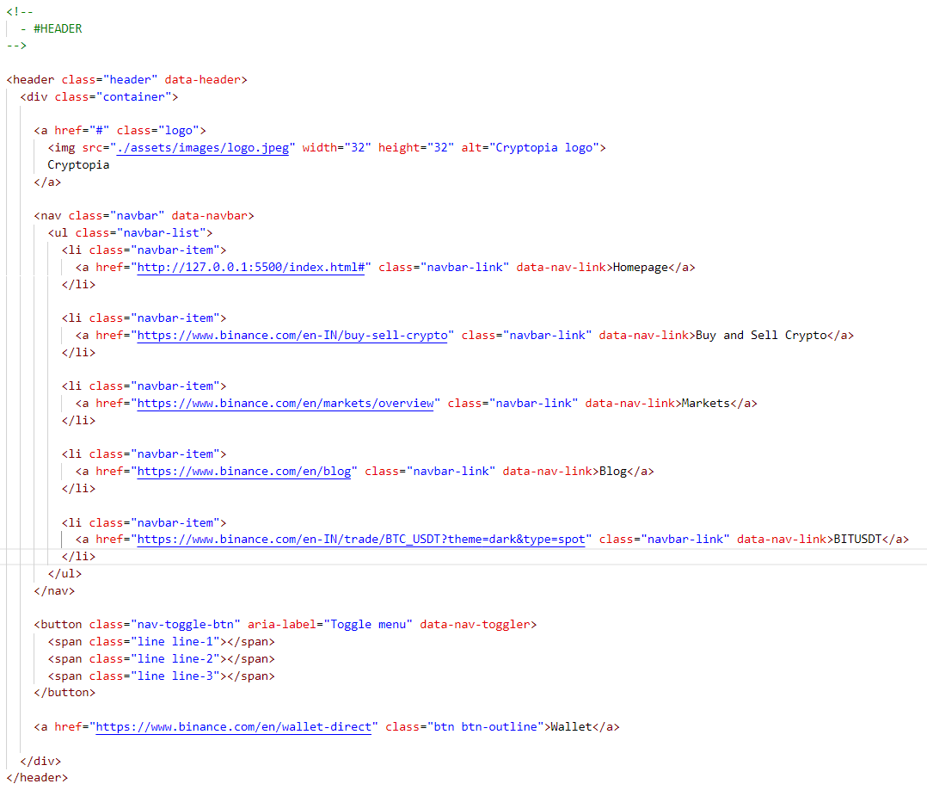

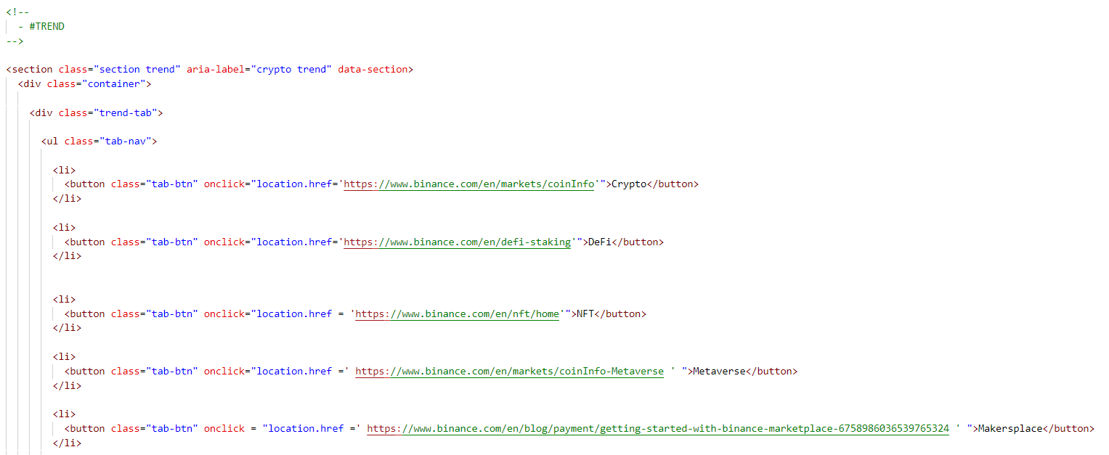

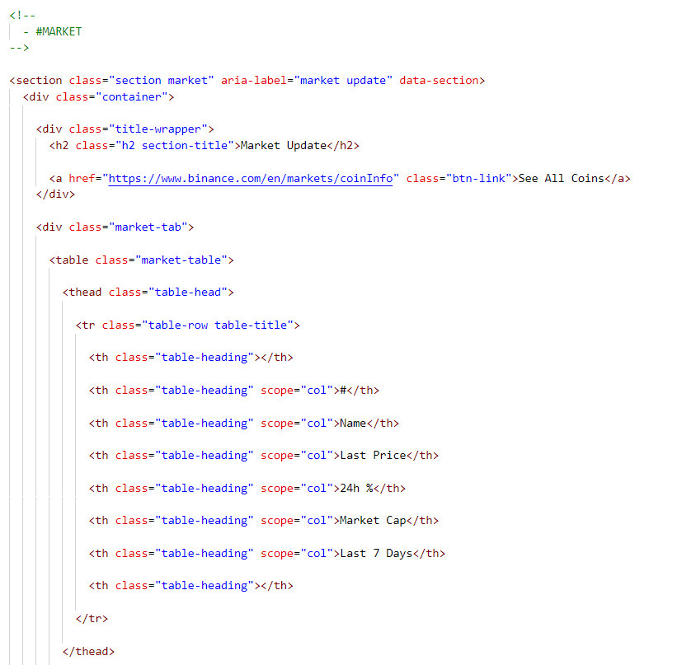

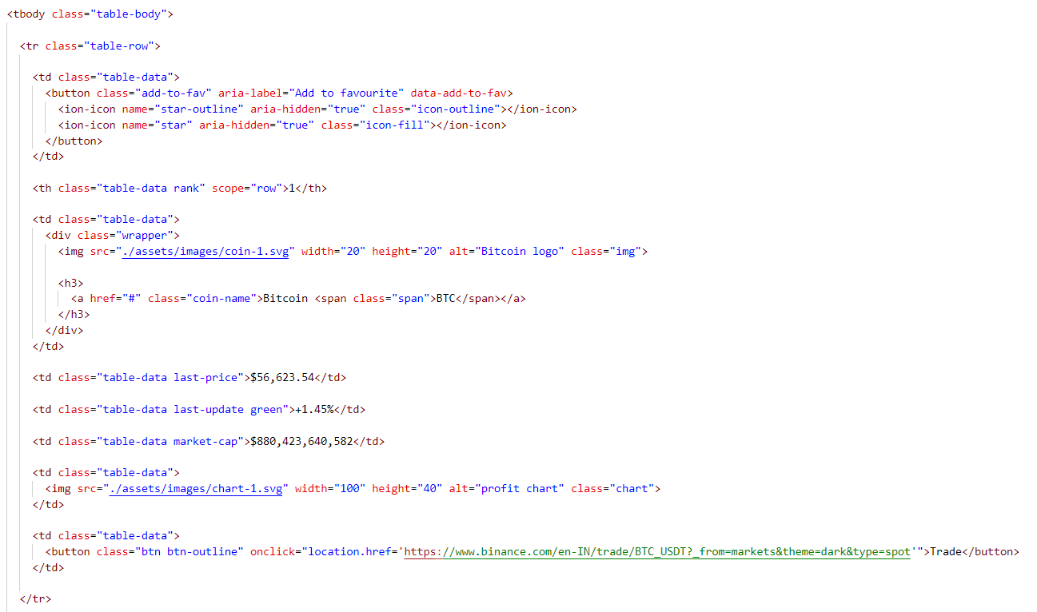

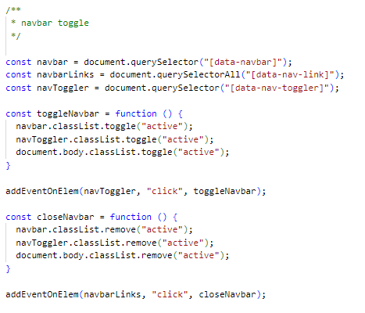

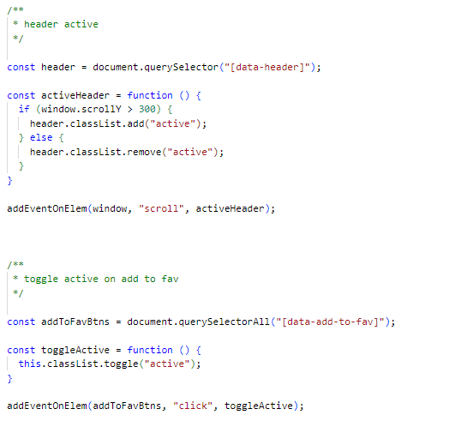

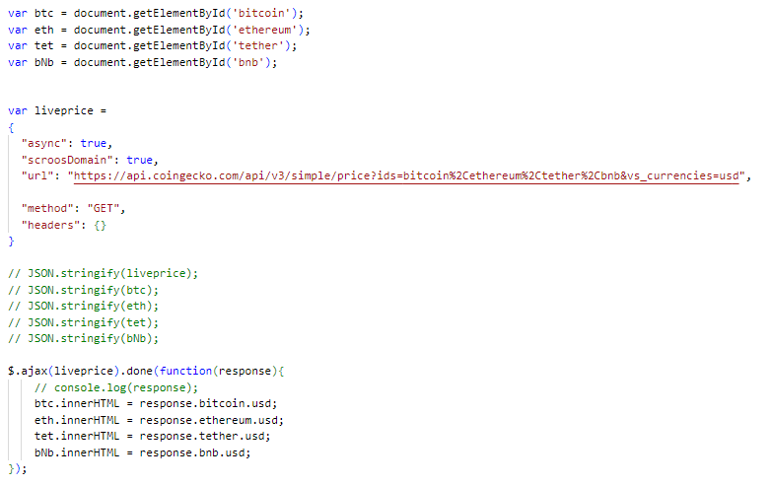

* 1. **RESULTS**

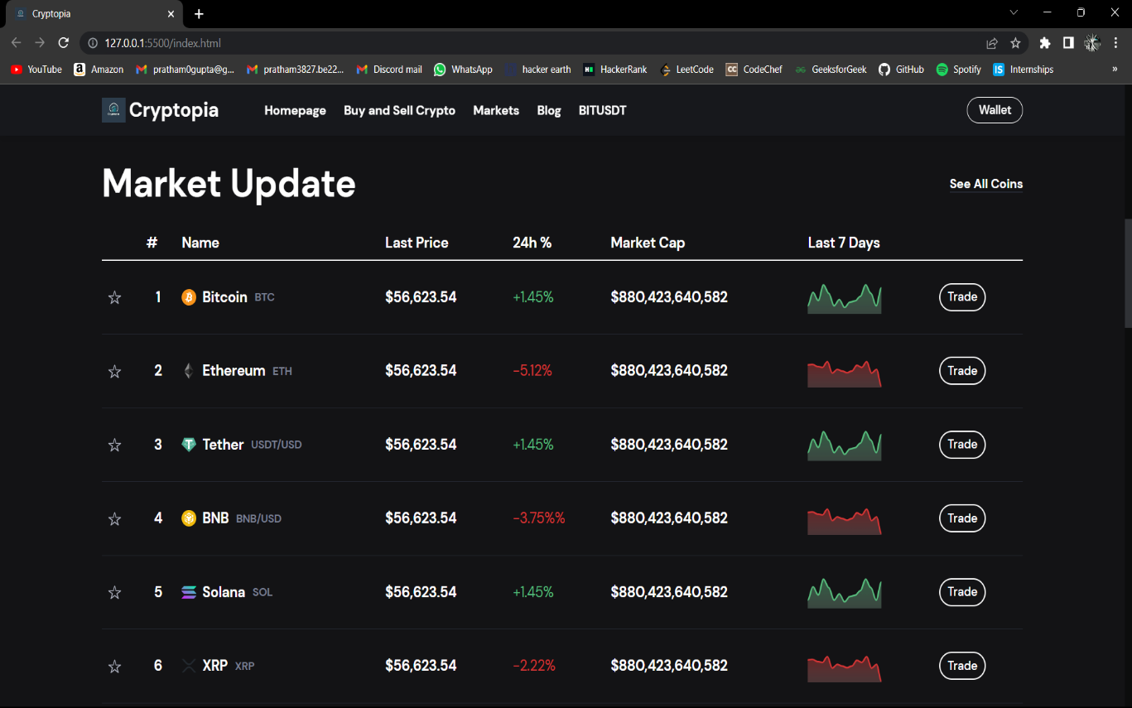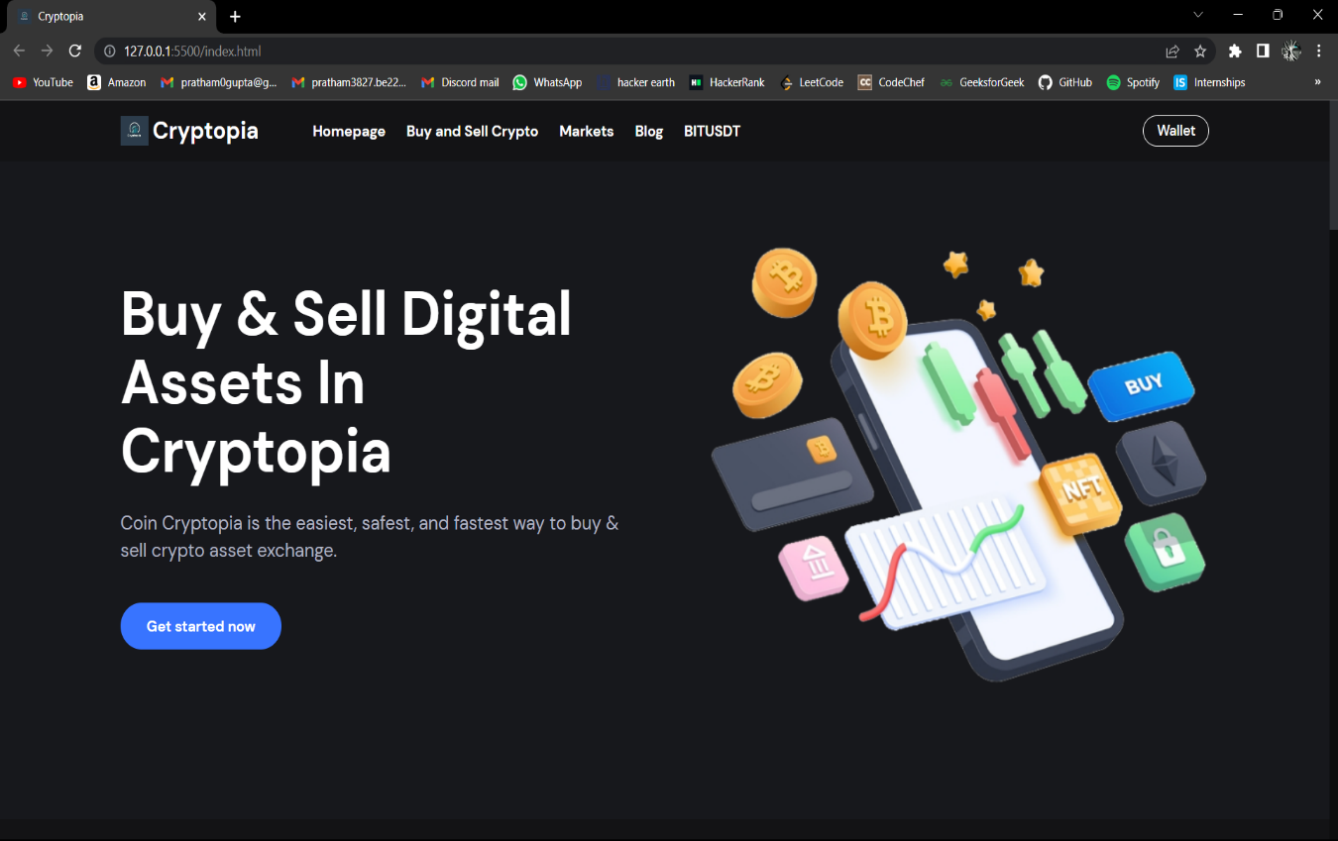

**Figure 4**

**Output**

* 1. **FUTURE SCOPE**
* Expand the platform's functionality to support more cryptocurrencies and integrate with more external wallets, thus providing users with more flexibility and options for trading.
* Enhance the platform's security features by incorporating advanced security measures such as biometric authentication, hardware wallets, and multi-signature authentication.
* Incorporating machine learning and artificial intelligence algorithms to provide users with personalized investment recommendations and insights.
* Incorporating features such as real-time market data, price alerts, and trading notifications, thus enhancing the user experience.
  1. **CONCLUSION**

In conclusion, the adoption of cryptocurrency has increased significantly in recent years, and it has become essential to have a secure and user-friendly platform for buying, selling, and trading digital assets. The college project aimed to design and develop such a platform by addressing the challenges and limitations of existing platforms and complying with regulatory requirements. The project focused on key features such as user-friendly interface, secure payment gateway, support for multiple cryptocurrencies, real-time market data, transparency, integration with external wallets and mobile compatibility. The project aimed to provide a secure, efficient, and user-friendly experience for investors and contribute to the adoption of cryptocurrencies into traditional financial systems.

* 1. **REFERENCES**
* **GeeksForGeeks -** [**https://www.geeksforgeeks.org/fullscreen-api-using-javascript/**](https://www.geeksforgeeks.org/fullscreen-api-using-javascript/)
* **Github.io -** [**https://github.com/**](https://github.com/)
* **CoinGecko API -** [**https://www.coingecko.com/en/api/documentation**](https://www.coingecko.com/en/api/documentation)
* **YouTube -** [**https://youtu.be/VDLpDSZ88MM**](https://youtu.be/VDLpDSZ88MM)
* **Vercel -** [**https://vercel.com/**](https://vercel.com/)
  1. **Project Domain**

[cryptopia-eight.vercel.app](https://cryptopia-eight.vercel.app/)