1. Design a web page using CSS displaying following rules:
   1. In-line CSS to change colors of certain text portion, bold, underline and italics certain words.
   2. Group paragraphs into single class and add styling information to the class in CSS.
   3. Style elements using ID selector.
   4. Set a background image for both the page and single elements on the page. Control the repetition of the image with the background-repeat property.

**CODE:**

<!DOCTYPE html>

<html>

<head>

<title>Auction</title>

<style type="text/css">

input{

font-size:0.55em;

}

body {

background-image: url("auction.jpg");

background-repeat: no-repeat;

background-size: cover;

color: brown;

}

</style>

</head>

<body>

<div style="font-style: italic;font-size: 40px">Welcome <div>

<div style="text-decoration: underline; font-size: 0.8em;color:black;">We have over 5000 products.</div>

<form class="form">

Name:<input type="text"><br>

Registration Number:<input type="text"><br>

<input id="sub" type="submit">

</form>

</body>

</html>

**OUTPUT:**



2.Design a web page with following layout using positioning property of css( without using <table> tag). Also make use of fonts, background colors, border and other required css properties for styling the webpage.

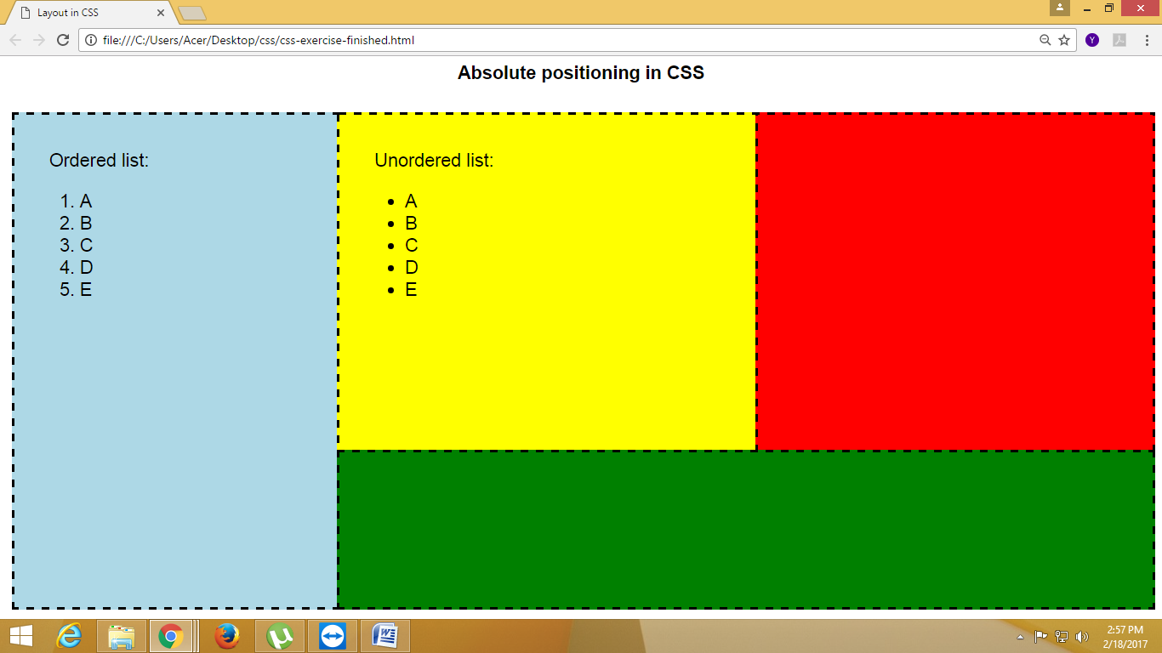

**CODE**:

<!DOCTYPE html>

<html>

<head>

<title>Absolute positioning</title>

<style type="text/css">

.ol{

width:20%;

height: 88.5%;

position: absolute;

background: #87ceeb;

border:dashed;

padding:5% 0% 0% 5%;

}

.ul{

width:40%;

height: 50%;

margin-left:20%;

position: absolute;

background: yellow;

border:dashed;

padding:5% 0% 0% 5%;

}

.red{

width:40%;

margin-left: 60%;

height: 50%;

position: absolute;

background: red;

border:dashed;

}

.green{

width: 80%;

height: 50%;

margin-top: 22%;

margin-left: 20%;

position: absolute;

background: green;

border:dashed;

}

</style>

</head>

<body>

<p style="text-align: center"><b>Absolute positioning in CSS</b></p>

<div class="ol">

Ordered list

<ol>

<li>A</li>

<li>B</li>

<li>C</li>

<li>D</li>

<li>E</li>

</ol>

</div>

<div class="ul">

unordered List

<ul>

<li>A</li>

<li>B</li>

<li>C</li>

<li>D</li>

<li>E</li>

</ul>

</div>

<div class="red"></div>

<div class="green"></div>

</body>

</html>

**OUTPUT:**

