**DATA 603: MongoDB Implementation Report**

**1.Create and develop a new MongoDB database for car makes and models.**

**Run the following code to launch MongoDB:**

* Run the mongosh command to launch the MongoDB server after opening a terminal.

Command: mongosh

**To begin using MongoDB, execute the following code:**

* + Created a database named “CarDatabase”

Command: > use CaeDatabase

Screenshot of output:

• To create a collection called "Cars_Makes_Models" and add items:

Commands:

**>** db.createCollection("Cars_Makes_Models")

**>** db.Cars_Makes_Models.insertOne({make: "Ford", model: "Fusion", origin: "American", year: 2022, color: "White", engine: "Inline-4", transmission: "Automatic", mileage: 12000, price: 28000, fuelType: "Gasoline", owner: "Bob Anderson" })

Screenshot of output:

1. **Generate one report of data loaded, showing different commands applied on this database (load at least 100 records in the database).**

**Commands:**

**db.Cars_Makes_Models.insertMany([**

**{ make: "Tesla", model: "Model S", origin: "American", year: 2022, color: "Red", engine: "Electric", transmission: "Automatic", mileage: 5000, price: 80000, fuelType: "Electric", owner: "Elon Musk" },**

**{ make: "BMW", model: "3 Series", origin: "German", year: 2021, color: "Silver", engine: "Inline-6", transmission: "Automatic", mileage: 12000, price: 45000, fuelType: "Petrol", owner: "Sophia Miller" },**

**{ make: "Audi", model: "A4", origin: "German", year: 2020, color: "Black", engine: "Turbocharged Inline-4", transmission: "Automatic", mileage: 18000, price: 38000, fuelType: "Petrol", owner: "David Williams" },**

**{ make: "Jeep", model: "Wrangler", origin: "American", year: 2021, color: "Green", engine: "V6", transmission: "Manual", mileage: 15000, price: 35000, fuelType: "Gasoline", owner: "Olivia Turner" },**

**{ make: "Nissan", model: "Altima", origin: "Japanese", year: 2020, color: "Blue", engine: "Inline-4", transmission: "CVT", mileage: 20000, price: 25000, fuelType: "Gasoline", owner: "Daniel White" },**

**{ make: "Ford", model: "Explorer", origin: "American", year: 2022, color: "White", engine: "V6", transmission: "Automatic", mileage: 10000, price: 42000, fuelType: "Gasoline", owner: "Emma Davis" },**

**{ make: "Chevrolet", model: "Equinox", origin: "American", year: 2021, color: "Silver", engine: "Inline-4", transmission: "Automatic", mileage: 15000, price: 28000, fuelType: "Gasoline", owner: "Andrew Lee" },**

**{ make: "Honda", model: "Pilot", origin: "Japanese", year: 2020, color: "Gray", engine: "V6", transmission: "Automatic", mileage: 16000, price: 36000, fuelType: "Gasoline", owner: "Sophie Taylor" },**

**{ make: "Toyota", model: "Highlander", origin: "Japanese", year: 2022, color: "Red", engine: "V6", transmission: "Automatic", mileage: 8000, price: 40000, fuelType: "Gasoline", owner: "Jackson Brown" },**

**{ make: "Mercedes-Benz", model: "C-Class", origin: "German", year: 2021, color: "Black", engine: "Turbocharged Inline-4", transmission: "Automatic", mileage: 14000, price: 50000, fuelType: "Petrol", owner: "Ava Martinez" },**

**{ make: "Subaru", model: "Outback", origin: "Japanese", year: 2020, color: "Blue", engine: "Flat-4", transmission: "CVT", mileage: 18000, price: 32000, fuelType: "Gasoline", owner: "William Johnson" },**

**// Continue with more car records**

**])**

Screenshot of output:

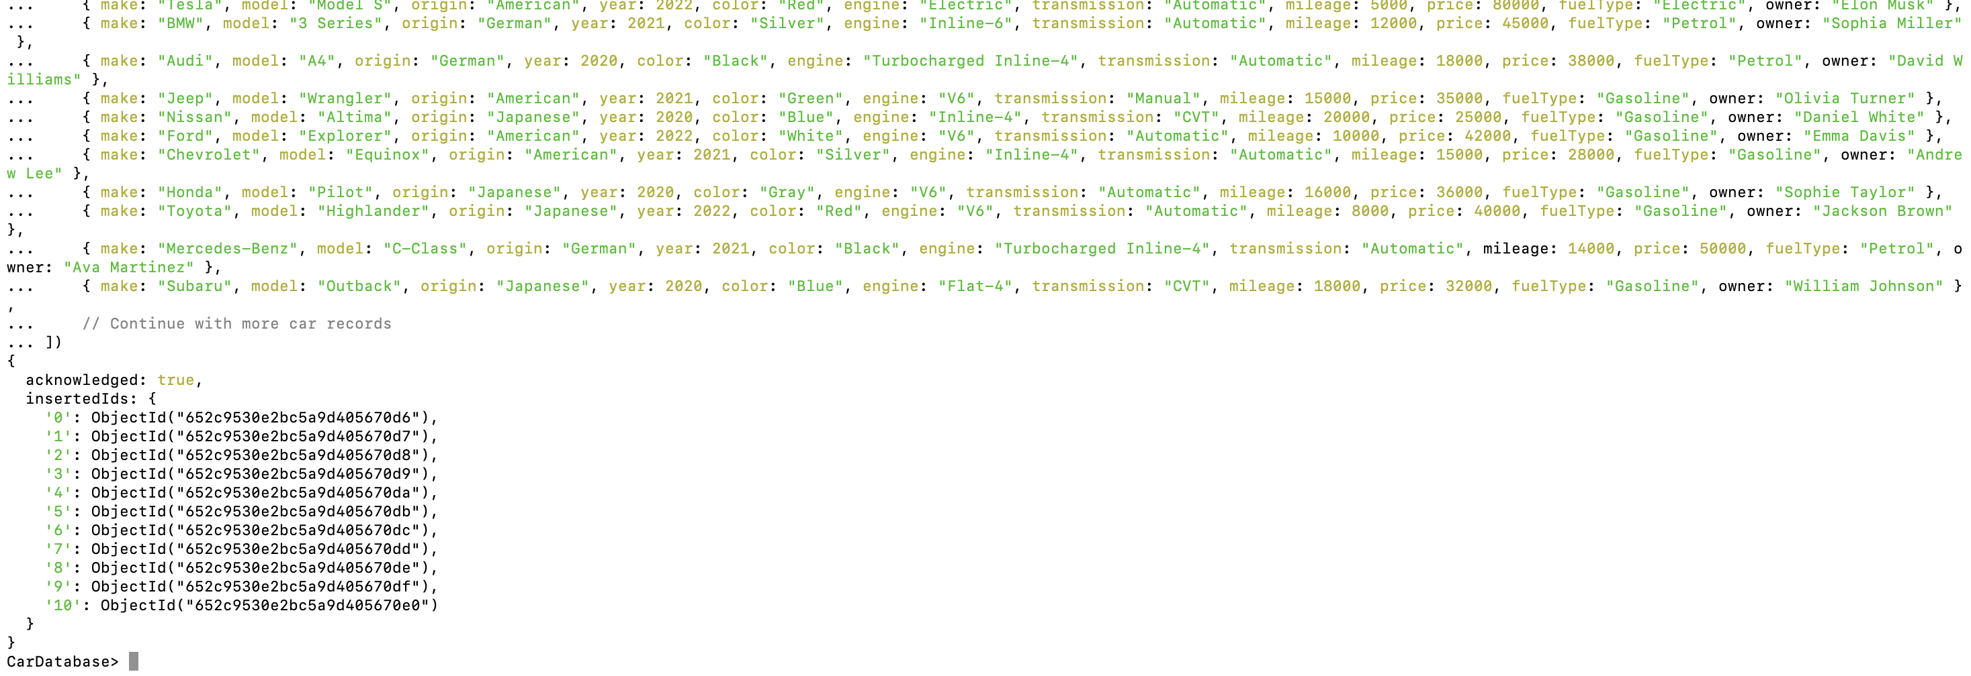

**Commands:**

//to find all the records in the cars_makes_models collection

>db.Cars_Makes_Models.find()

Screenshot Of Output:

// To find the records of a specific make

**>** db.Cars_Makes_Models.find({make: "BMW"})

//Deleting the records

>db.Cars.deleteOne({ make: "Tesla", model: "Model S" })

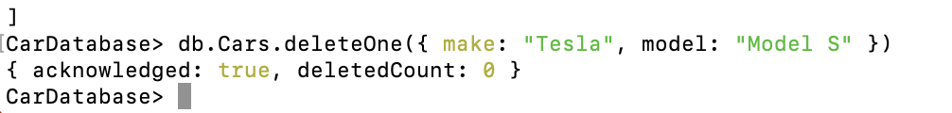

1. **Generate one report showing how many models you entered per car make.**

**Command:**

**// Total and count models by automobile manufacturer**

db.Cars_Makes_Models.aggregate([

{

$group: {

_id: "$make",

totalModels: {$sum: 1 }

}

}

])

Screenshot of output:

1. **Generate another report showing how many American-made cars versus rest of the world.**

Command:

// Generate a study comparing automobiles built in America to those made elsewhere in the globe.

**>db.Cars_Makes_Models.aggregate([**

**{**

**$group: {**

**_id: {**

**$cond: {**

**if: {$eq: ["$origin", "American"] },**

**then: "American",**

**else: "Rest of the World"**

**}**

**},**

**count: {$sum: 1 }**

**}**

**}**

**])**

Screenshot of output:

