RSLI Data Lineage & Hop Reduction Recommendation
High-Level Process Flow Overview

July 2026

1 Data Lineage Extraction Flow
This flow extracts column-level data lineage for 10 target RPT claims tables by tracing TIDAL orchestration jobs through shell scripts into PL/SQL objects. Outputs drive lineage graphs and feed the hop reduction analysis.

1.1 Flow Diagram
[ Diagram 1 — Data Lineage Extraction Flow ]

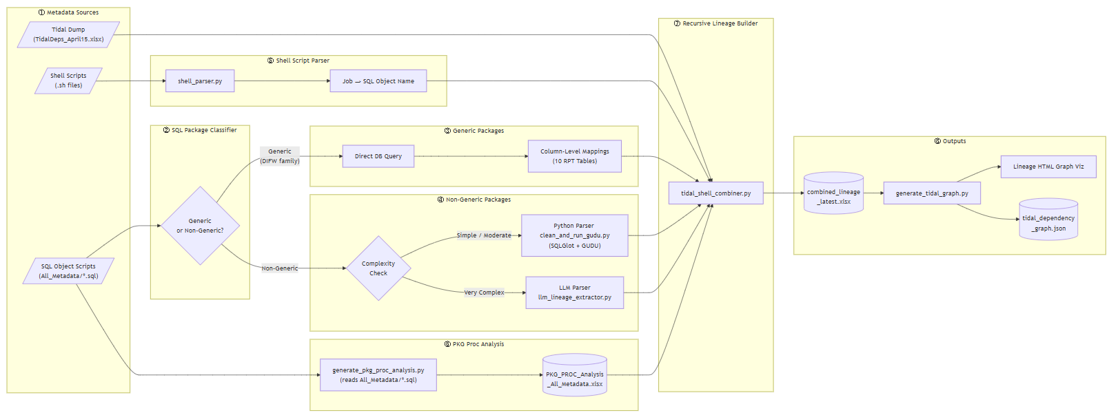

1.2 Flow Summary
The pipeline has eight stages. Data flows from left to right, with all parsed outputs converging into the Recursive Lineage Builder before generating the final graph and Excel artefacts.
- ① Metadata Sources — Three inputs: TIDAL job dump (TidalDeps_April15.xlsx), shell scripts (.sh), and PL/SQL object scripts (All_Metadata/*.sql).
- ② SQL Package Classifier — Each SQL object is classified as Generic (PKG_GRP_LOAD_DIFW / _PD dispatcher packages) or Non-Generic.
- ③ Generic Packages — Column mappings are retrieved by querying the database directly. No SQL parsing needed.
- ④ Non-Generic Packages — Complex scripts go to Azure OpenAI (GPT-5-Mini). Simple/moderate scripts are parsed by Python (SQLGlot + GUDU parsers).
- ⑤ Shell Script Parser — Resolves which SQL object each TIDAL job calls. Handles 9 shell invocation patterns (PKG.main, EXECUTE IMMEDIATE, MV refresh, etc.).
- ⑥ PKG Proc Analysis — Reads All_Metadata/*.sql to map each package's internal
procedure call structure (orchestrator vs self-contained vs independent).
Outputs PKG_PROC_Analysis_All_Metadata.xlsx, which is consumed by the Recursive
Lineage Builder to expand PKG.main rows into individual child proc rows.
- ⑦ Recursive Lineage Builder — Walks the TIDAL dependency chain from each RPT root job, joining shell output + column lineage (LLM & Python) + TIDAL metadata (depth, runtime) + + PKG proc analysis.
- ⑧ Outputs — tidal_dependency_graph.json, combined_lineage_latest.xlsx, and interactive HTML lineage graphs.

1.3 Scripts in This Flow
Script | Role in Flow | What It Does
shell_parser.py | Shell Parsing | Parses .sh wrapper scripts to map TIDAL jobs to their SQL objects. Recognises 9 shell invocation patterns.
generate_pkg_proc_analysis.py | PKG Proc Analysis | Reads All_Metadata/*.sql to map each package's internal procedure call structure.  (orchestrator vs self-contained vs independent).
clean_and_run_gudu.py | Python based Parser | Clean Oracle PL/SQL scripts for data lineage analysis via Gudu SQLFlow & SQLGlot.
llm_lineage_extractor.py | LLM based Parser | LLM-based SQL lineage extractor — fallback for files Python (Gudu+ SQLGlot) couldn't process.
tidal_shell_combiner.py | Lineage Combiner | Joins five data sources to build a unified column-level lineage map across 10 RPT tables
generate_tidal_graph.py | Recursive Builder &  Graph Visualizer | Creates dependency graph (tidal_dependency_graph.json) and interactive HTML page for lineage visualization.
Note: lm_lineage_extractor.py script uses an LLM prompt that parses Oracle PL/SQL code to extract column-level lineage, resolve source-to-target mappings, and identify transformations across DML, CTAS, and dynamic SQL statements. The output is generated as structured JSON for lineage analysis and visualization.

2 Hop Reduction Recommendation Flow
This flow identifies opportunities to eliminate or consolidate unnecessary pipeline hops — reducing TIDAL job count, execution time, and maintenance complexity. It runs in two phases: LLM-based script summarisation followed by graph-and-lineage-driven automated analysis across 14 detector categories.

2.1 Flow Diagram
[ Diagram 2 — Hop Reduction Recommendation Flow]

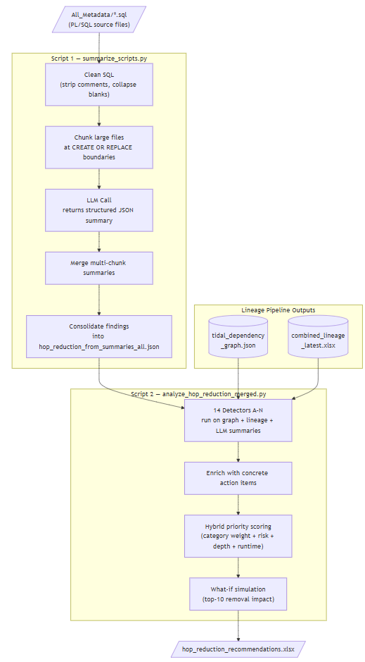

2.2 Flow Summary
- Stage 1 — Script Summarisation (summarize_scripts.py): Each PL/SQL script is cleaned (comments stripped), chunked if large, and sent to Azure OpenAI. The LLM returns a structured JSON summary with hop-reduction opportunities, performance bottlenecks, and logic risks. Outputs: script_summaries_all.json and hop_reduction_from_summaries_all.json.
- Stage 2 — 14-Detector Analysis (analyze_hop_reduction_merged.py): Loads the TIDAL dependency graph, combined lineage, and LLM summaries. Runs 14 independent detectors (A–N) covering patterns such as redundant loads, pass-through hops, near-duplicate procedures, serial chains, stale intermediates, and MV elimination.
- Post-processing: Results are standardised, deduplicated across detectors, enriched with concrete action items, and scored by a hybrid priority algorithm (category weight + risk + critical-path depth + estimated runtime savings).
- Output: hop_reduction_recommendations.xlsx — a multi-sheet Excel workbook (one for each RPT table) with prioritized recommendations, execution wave assignments (WAVE_1 → GLOBAL), a what-if simulation, and an Action Items quick-reference sheet.

2.3 Scripts in This Flow
Script | Role in Flow | What It Does
summarize_scripts.py | Stage 1 — LLM Summariser | Sends each PL/SQL file to LLM, collects structured JSON summaries, and consolidates hop-reduction findings. Supports --resume, --dry-run, --workers for parallel execution.
analyze_hop_reduction_merged.py | Stage 2 — 14-Detector Engine | Runs all 14 detectors against the TIDAL graph and lineage data. Handles standardisation, dedup, evidence attachment, scoring, simulation, and Excel output in a single script.
Note: script_summarizer.py script uses an LLM prompt to analyze Oracle PL/SQL code and produce structured insights on lineage, process flow, dependencies, and performance. It highlights optimization opportunities, hop-reduction candidates, and refactoring recommendations for ETL and data engineering workflows.

2.4 The 14 Detectors (A – N)
Each detector targets a specific inefficiency pattern in the TIDAL pipeline. Detectors A–E and G–N are based on verified graph and lineage data; Detector F relies on LLM signals from Stage 1.
ID | Category | Pattern Detected | Risk
A | Redundant Multi-Source Load | Multiple jobs write to the same target table where a single parameterised procedure could handle all variants. | MEDIUM
B | Pass-Through / Update-in-Place | Jobs that read and write the same table (in-place update), or single-producer chains with ≥5 unchanged pass-through columns. | MEDIUM
C | Near-Duplicate / OFFSET Procedures | Job groups loading the same target with ≥85% Jaccard-similar column sets (e.g. OFFSET1/2/3 variants). Consolidate into one parameterised procedure. | LOW
D | Serial Orchestration Chain | Sequential chains of jobs with no column-level data dependency — safe to parallelise in TIDAL to reduce critical-path depth. | LOW
E | MV Elimination | Materialised views with a single downstream consumer, especially where the consumer uses <50% of MV columns. Cross-RPT shared MVs flagged as GLOBAL. | MEDIUM
F | LLM-Identified Issues | Redundancy signals, performance concerns (full scans, missing indexes), and logic risks (bugs, mismatches) surfaced by LLM during Stage 1. | HIGH
G | Duplicate Column-Lineage Paths | Identical SRC.col → TGT.col mappings produced by two or more different jobs — only one job needs to perform each write. | MEDIUM
H | Stale Intermediate Tables | Tables written but never consumed downstream in any RPT lineage (globally confirmed dead writes). | LOW
I | Cyclic Refresh Dependencies | Circular dependency loops in the TIDAL graph that can cause scheduler deadlocks or forced timeout breaks. | HIGH
J | Over-Fanout Materialised Views | MVs feeding an unusually high number of downstream consumers, creating bottlenecks. | MEDIUM
K | Repeated Transformations | Identical SRC→TGT column transformation logic applied by multiple jobs — candidate for a shared transformation layer. | MEDIUM
L | Overlapping Preprocessing | Multiple jobs performing overlapping pre-processing (dedup, filter, aggregate) on the same target, creating redundant intermediate work. | MEDIUM
M | Orchestration Edge Without Data Handoff | Dependency edges where upstream-written tables and downstream-read tables share no intersection — a likely legacy scheduler artefact. | MEDIUM
N | Post-Consumption Update Pattern | A table is consumed by Job B to produce output T, while Job C updates the same table after B — update may arrive too late for B's output. | MEDIUM

3 How the Two Flows Connect
The lineage extraction flow is a prerequisite for hop reduction analysis. Two artefacts produced by the lineage pipeline are consumed directly by Stage 2 of the hop reduction flow:
- tidal_dependency_graph.json — provides the job-level dependency graph (nodes, links, depth, avg_runtime, category) that detectors traverse.
- combined_lineage_latest.xlsx — provides column-level evidence (SRC_TABLE, TGT_TABLE, SOURCE_COL, TARGET_COL, FULL_OBJECT, IS_PARAMETERIZED) that detectors use to classify and score each pattern.

