FINAL REPORT
Capstone Project
SUPPLY CHAIN MANAGEMENT : PROJECT NOTES

Table of Contents
1. Introduction ………………………………………………………………………… 4-5
  - Project Background Problem Statement
  - Objectives
- Exploratory Data Analysis (EDA) ……………………………………………… 5-8
  - Key Business Insights
  - Univariate Analysis
  - Bivariate Analysis
  - Correlation Analysis
- Data Cleaning and Pre-processing …………………………………………. 9-12
  - Removal of Unwanted Variables
  - Missing Value Treatment
  - Outlier Treatment
  - Data Preparation
- Model Building …………………………………………………………………12-14
  - Model Comparison Table
  - Effort to Improve Model Performance
- Model Validation ………………………………………………………………... 14-15
  - Validation Approach
  - Evaluation Metrics
  - Model Comparison Results
- Final Interpretation & Recommendations …………………………………….16
  - Key Findings
  - Business Recommendations
- Conclusion …………………………………………………………………………..17
- Appendix ………………………………………………………………………… 18-22
  - Code Repository (Raw Code & Outputs)
  - Additional Figures & Tables

- Introduction

  - Defining the Problem Statement
A well-known FMCG company entered the instant noodles market two years ago. However, it is currently facing a serious imbalance between demand and supply across different regions:
- In high-demand areas, supply is insufficient, resulting in missed sales opportunities.
- In low-demand areas, excess supply is leading to inventory holding costs and wastage.
This inefficiency in distribution is causing operational losses and dissatisfaction within the supply chain. Hence, there is a strong need for a more data-driven approach to supply planning.
1.2. Need for the Study
To address the demand–supply mismatch, the company aims to optimize its supply chain through predictive modeling. The objectives of this project are to:
- Optimize shipment quantities for each warehouse based on regional demand patterns.
- Reduce excess inventory in low-demand regions and minimize stockouts in high-demand regions.
- Lower operational costs while improving customer satisfaction.
- Leverage historical shipment and demand data to build a predictive model that recommends the ideal shipment weight per location.
By achieving these goals, the company will move toward more informed, accurate, and proactive supply decisions, leading to improved efficiency and business performance.
1.3. Business and Social Opportunity
This project presents significant opportunities, both business and social:
- Business Impact:
  - Identify high-demand regions to enable focused advertising and promotions.
  - Reduce inventory costs and maximize sales by minimizing over- and under-supply.
  - Provide a framework for scalable, data-driven supply chain planning.
- Social Impact:
  - Ensuring better product availability in demand-heavy regions improves customer satisfaction.
  - Reducing wastage in low-demand areas contributes to sustainable supply chain practices.
Successful implementation in this pilot phase will also create opportunities to extend the approach to full-scale company data, enabling more advanced, scalable solutions in the future.

- Exploratory Data Analysis (EDA)
The EDA focused on identifying demand–supply imbalances, understanding variable distributions, and detecting key drivers of shipment volumes.
2.1. Key Business Insights
- Supply Imbalance: Some zones consistently receive higher shipments regardless of demand; urban warehouses get slightly more than rural, while ownership type shows no major differences.
- Business Implication: This mismatch causes stockouts in high-demand regions and excess inventory in low-demand areas.
- Recommendation: Build a predictive model to optimize shipments and use clustering to segment warehouses by demand, risk, and location.
2.2. Univariate Analysis
- Numerical Variables
  - Variables such as num_refill_req_l3m, distributor_num, and dist_from_hub show fairly uniform or symmetric distributions.
  - Features like retail_shop_num, workers_num, and govt_check_l3m exhibit right-skewed distributions with visible outliers.
  - Target variable product_wg_ton is right-skewed but shows no significant outliers.
  - Binary features (flood_impacted, flood_proof, temp_reg_mach, electric_supply) are heavily imbalanced, with most values concentrated in a single category.
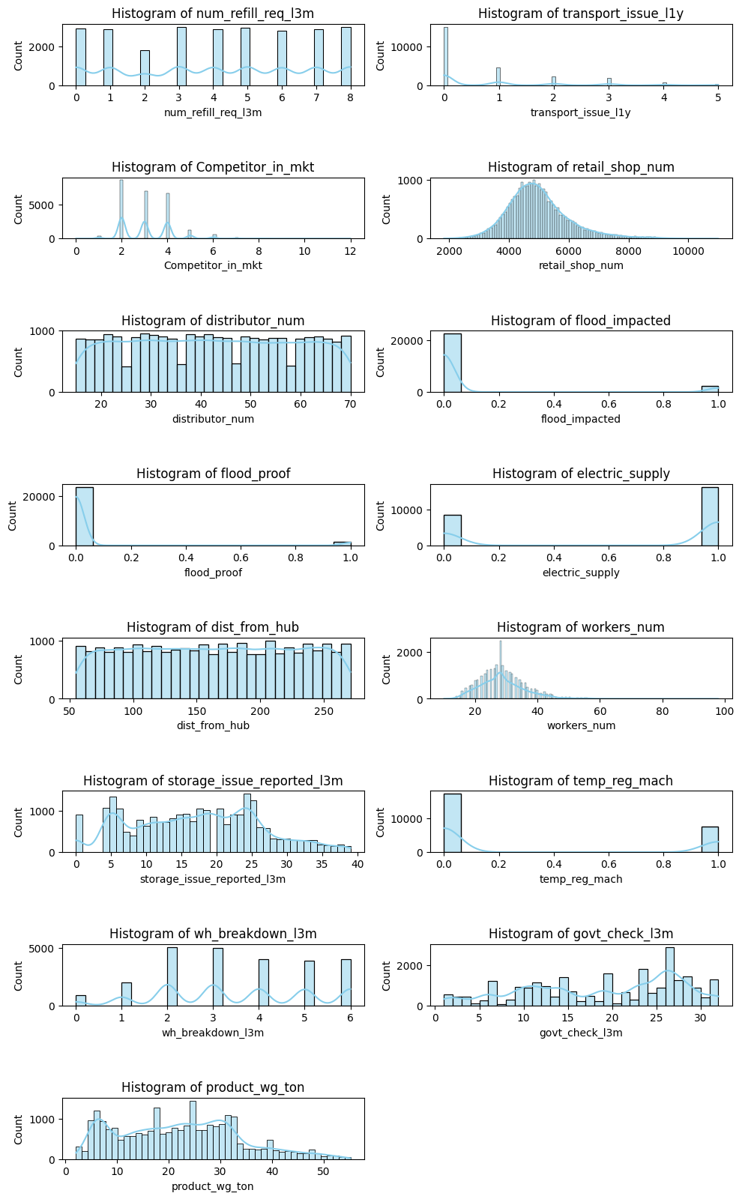
- Categorical Variables
  - Location_type: Heavily imbalanced → majority rural.
  - WH_capacity_size: Fairly balanced → Large & Mid dominate.
  - Zone: North & West dominate, East has the least warehouses.
  - Regional Zone: Zone 6 has highest concentration, followed by Zones 5 & 4.
  - Ownership: Slightly more company-owned warehouses.
  - Government Certification: evenly distributed, Category C most frequent.
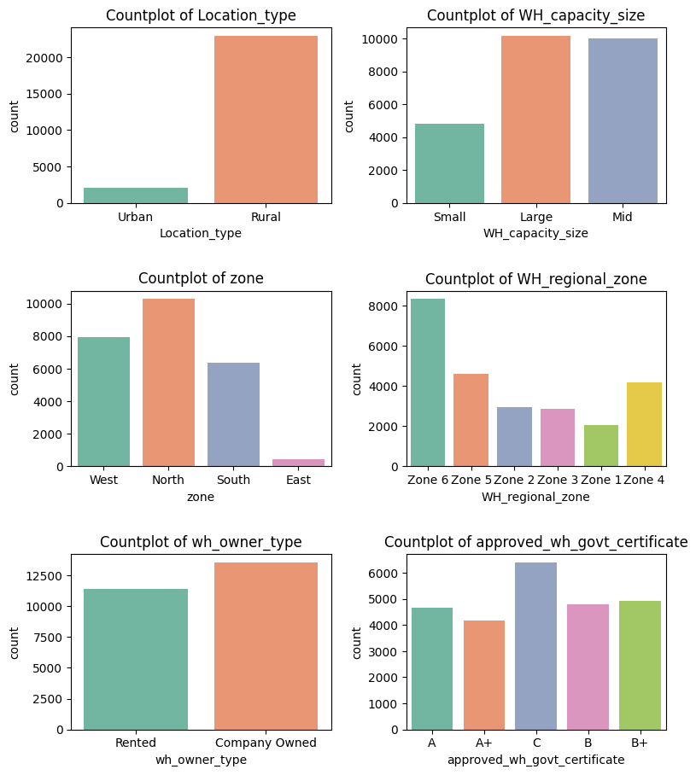

2.3. Bivariate Analysis
Categorical vs Target (product_wg_ton)
- Zone: Shipments are fairly consistent (20–30 tons median), suggesting uniform allocation across regions.
- Location_type: Urban warehouses receive slightly higher shipments, but both fall within 20–30 tons.
- Ownership: Rented vs. company-owned warehouses show similar shipment distributions.
Numerical vs Target
- Retail Shops vs Product Weight: Positive relationship up to ~9,000 shops. More shops → more shipments.
- Distance from Hub vs Product Weight: Positive relationship; farther warehouses tend to receive larger shipments.
Risk Factors vs Target
- Warehouses without electricity or temperature control still receive high shipments, which may cause risks.
- Flood-impacted zones receive less supply → showing some risk consideration.
- Government checks do not reduce supply significantly.
- Areas with more distributors manage supply better, even with competitors present.

2.4. Correlation Analysis
- product_wg_ton strongly correlates with storage_issue_reported_l3m (0.99), indicating higher shipments cause storage issues.
- Moderate links exist between stock levels, warehouse breakdowns, and supply volumes.
- Mild negative correlation with transport issues suggests larger shipments may reduce logistical problems.
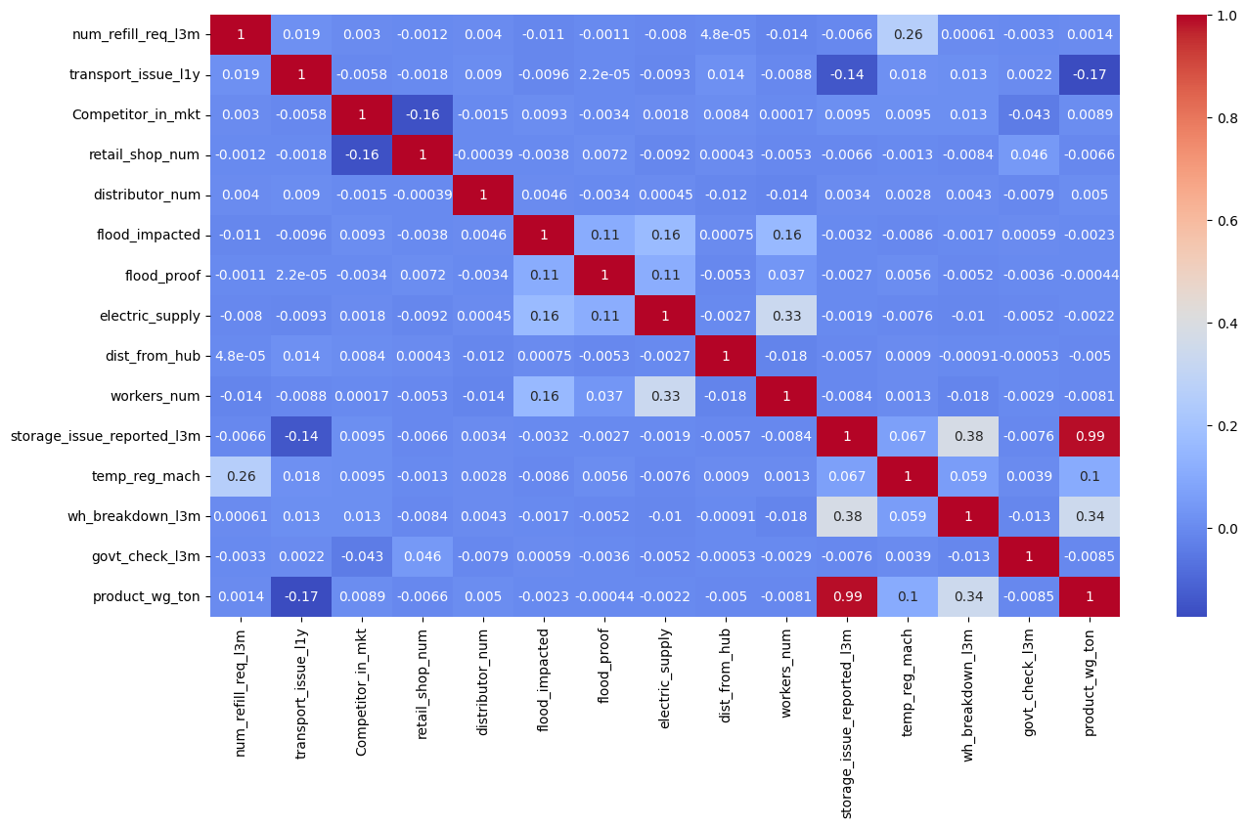
Business Implication: Higher shipments increase storage issues and breakdowns, suggesting a need for capacity-based shipment planning.
3. Data Cleaning and Pre-processing
Data cleaning and preprocessing were performed to ensure the dataset was reliable, consistent, and suitable for predictive modeling.

3.1. Removal of Unwanted Variables
- Ware_house_ID and WH_Manager_ID were dropped as they are unique identifiers and provide no predictive value.
3.2. Missing Value Treatment
- wh_est_year → 47.52% missing, removed due to high null proportion and low business relevance.
- workers_num → 3.96% missing, imputed with median (less sensitive to outliers).
- approved_wh_govt_certificate → 3.63% missing, imputed with mode (categorical variable).
After treatment, the dataset contained no missing values.
3.3. Outlier Treatment
- Outliers detected in variables such as transport_issue_l1y, Competitor_in_mkt, retail_shop_num, flood_impacted, and workers_num.
- The IQR method was applied to cap extreme values, preserving all records while reducing skewness.
- Post-treatment distributions showed improved consistency in boxplots.
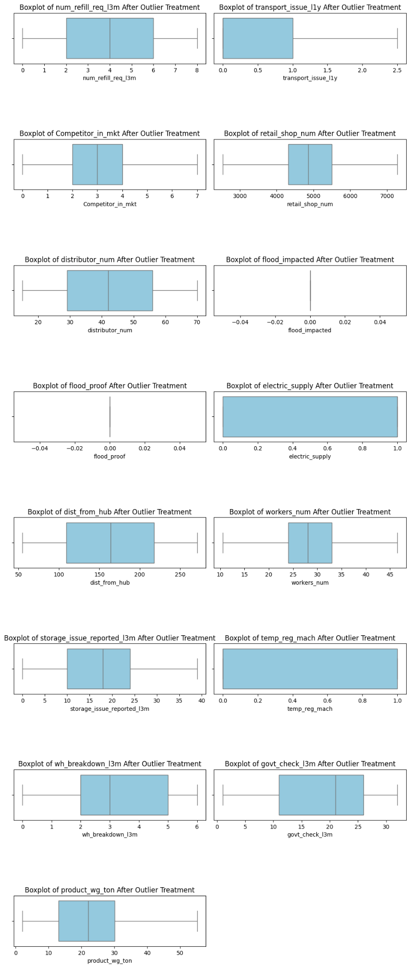
3.4. Data Preparation
- Encoding:
  - One-Hot Encoding → zone, Location_type, wh_owner_type, WH_regional_zone.
  - Label Encoding → binary categories (WH_capacity_size, approved_wh_govt_certificate).
- Scaling: Standardization applied to numerical variables to ensure uniform feature scale.
- Train–Test Split: Dataset divided into 80% training and 20% testing to evaluate model performance fairly.
4. Model Building
To predict product_wg_ton, multiple regression models were built and compared. The primary evaluation metric chosen is Mean Absolute Percentage Error (MAPE), as it provides an interpretable measure of average prediction error in percentage terms.
- Linear Regression
  - MAPE: 13.83%.
  - Established as a strong baseline model with good fit (R² = 0.95).
  - Low MSE and MAE values confirm reliable predictions.
  - However, noticeable errors exist at lower weight ranges (0–15 tons).
  - Served as a benchmark for comparison with more advanced models.
- Ridge Regression
  - MAPE: 11.35%
  - Slightly better than Linear Regression, but weaker than Ridge.
  - Simplifies the model by shrinking less important coefficients.
  - Provides easier interpretability but at the cost of some accuracy.
  - Balanced trade-off between simplicity and predictive power.
- Support Vector Regression (SVR)
  - MAPE: 6.13%.
  - Significant improvement over Linear, Ridge, and Lasso.
  - Achieved R² = 0.99, indicating very high accuracy.
  - Minor variance observed in low-weight predictions, but overall performance is excellent.
  - Outperformed linear models with strong predictive accuracy.
- Random Forest Regressor
  - MAPE: 4.57% (Best)
  - Lowest error among all models tested, with excellent prediction across all ranges.
  - Handled both low and high weight predictions effectively, showing consistent performance.
  - Outperformed SVR slightly, especially in the lower range.
  - Selected as the final model, due to the lowest MAPE and highest robustness.
4.1. Model Comparison Table
Model | MSE | RMSE | MAE | R2 | MAPE (%)
Linear Regression | 6.5431 | 2.5562 | 1.8153 | 0.9512 | 13.83
Ridge Regression | 3.0938 | 1.7589 | 1.3040 | 0.9769 | 9.07
Lasso Regression | 4.5751 | 2.1390 | 1.6630 | 0.9658 | 11.35
SVR | 1.4774 | 1.2155 | 0.9261 | 0.9890 | 6.13
Random Forest | 0.8707 | 0.9331 | 0.6979 | 0.9935 | 4.57
Based on the comparison, Random Forest provided the best overall performance and was chosen for further optimization.
4.2. Effort to Improve Model Performance
- Baseline Selection: Linear Regression was initially built as a benchmark to understand the basic relationship between features and product_wg_ton.
- Regularization: To address multicollinearity and reduce overfitting, Ridge and Lasso Regression were tested. Ridge performed better by controlling coefficient magnitudes, while Lasso helped in feature selection.
- Non-Linear Methods: Since linear models could not fully capture complex relationships, advanced models were explored. Support Vector Regression (SVR) improved predictive accuracy significantly, reducing MAPE to 6%.
- Ensemble Learning: To further enhance performance, Random Forest Regressor was implemented. By combining multiple decision trees, it reduced variance and improved generalization, achieving the lowest error (MAPE = 4.57%).
- Hyperparameter Tuning: Random Forest was fine-tuned using GridSearchCV, optimizing tree depth, number of estimators, and minimum samples per split/leaf. This effort reduced prediction error and ensured model stability across all product weight ranges.

5. Model Validation
To ensure that the selected model (Random Forest Regressor) was both accurate and reliable, multiple validation techniques were applied:

5.1. Validation Approach
- Cross-Validation
  - A 10-fold cross-validation approach was used to evaluate performance consistency.
  - This reduced the risk of overfitting and provided a fair estimate of the model’s generalization ability.
- Hyperparameter Tuning
  - Conducted using GridSearchCV, testing 160 parameter combinations (number of trees, maximum depth, minimum samples per split/leaf, etc.).
  - This tuning process optimized model complexity and reduced variance.
5.2. Evaluation Metrics
- Best Cross-Validation R² Score: 0.952
- Test R² Score: 0.955
- The small gap between train and test scores confirmed model stability.
5.3. Model Comparison Results
Train vs. Test Performance Plot
- The comparison showed that training and test curves were closely aligned.
- This indicated that the model generalized well to unseen data without significant overfitting.

6. Final Interpretation & Recommendations
6.1. Key Findings
- Random Forest Regressor emerged as the best-performing model with a Test R² of 0.955 and MAPE of 4.57%, indicating strong predictive accuracy and generalization.
- Linear and Ridge regressions served as reliable baselines but underperformed compared to ensemble models.
- SVR showed excellent accuracy but was slightly less stable than Random Forest.
- Model validation through 10-fold cross-validation and hyperparameter tuning confirmed low overfitting and high reliability.
6.2. Business Recommendations
- Adopt Random Forest Regressor as the predictive engine for shipment planning.
- Use model predictions to allocate optimal shipment weights per warehouse, minimizing understocking and overstocking.
- Leverage insights to balance supply across regions, improving customer service and reducing logistics costs.
- Integrate the model into the supply chain decision-making system for real-time planning and forecasting.
- Extend the framework to future demand forecasting and scenario planning, enabling proactive responses to market fluctuations.
7. Conclusion
The project successfully developed a predictive model to optimize shipment weight distribution. By implementing the Random Forest Regressor, the company can achieve:
- Reduced shipment imbalances across warehouses.
- Improved efficiency in transportation and storage.
- Enhanced decision-making for sustainable supply chain operations.
This data-driven approach provides a scalable and adaptable solution, aligning operational efficiency with business goals.

8. Appendix
8.1. Treating Outliers
def outlier_treatment(col,df):
Q1 = np.nanpercentile(df[col],25)
Q3 = np.nanpercentile(df[col],75)
IQR = Q3 - Q1
lower_limit = Q1 - 1.5 * IQR
upper_limit = Q3 + 1.5 * IQR
df[col] = np.where(df[col] > upper_limit, upper_limit, df[col])
df[col] = np.where(df[col] < lower_limit, lower_limit, df[col])
return df
num_cols = df.select_dtypes(include=['int64','float64'])
for col in num_cols.columns:
df = outlier_treatment(col,df)
num_cols = df.select_dtypes(include=['int64', 'float64']).columns\
plt.figure(figsize=(10, len(num_cols)*3))
for i, col in enumerate(num_cols, 1):
plt.subplot(len(num_cols), 2, i)
sns.boxplot(data=df, x=col, color='skyblue')
plt.title(f'Boxplot of {col} After Outlier Treatment')
plt.tight_layout()
plt.subplots_adjust(hspace=1.5)
plt.show()
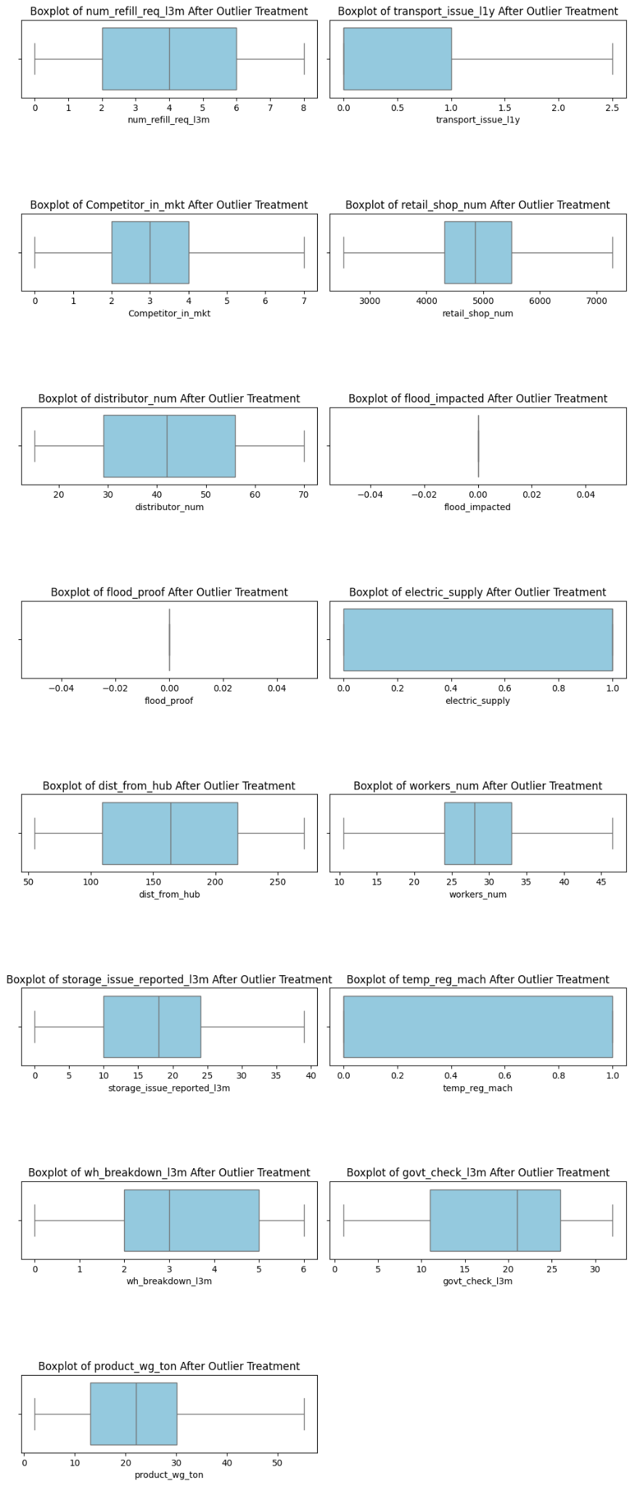
8.2. Hyperparameter tuning on Random forest
grid_params = {
'max_depth' : [2,5,10,20],
'min_samples_leaf' : [5,10,20,50],
'max_features' : ['sqrt', 'log2'],
'n_estimators' : [10,25,50,100,200]
}
grid_search = GridSearchCV(
estimator = RandomForestRegressor(),
param_grid = grid_params,
cv = 10,
verbose = 1,
n_jobs = -1,
return_train_score = True
)
# Fit the model
grid_search.fit(X_train, y_train)
print('Best Score', grid_search.best_score_)
print('Best param', grid_search.best_params_)
best_model = grid_search.best_estimator_
y_pred = best_model.predict(X_test)
print("Test R2 Score:", r2_score(y_test, y_pred))
test_scores = grid_search.cv_results_['mean_test_score']
train_scores = grid_search.cv_results_['mean_train_score']
plt.plot(test_scores, label='Test R²')
plt.plot(train_scores, label='Train R²')
plt.title("Train vs Test Performance (GridSearchCV)")
plt.xlabel("Model Iteration")
plt.ylabel("R² Score")
plt.legend(loc='best')
plt.show()
