**ML LAB TEST – 2**

**Name: Akshay S Bharadwaj Date: 14/06/2021**

**USN: 1BM18CS011 Section: 6A**

**Question:**

Implement the Linear Regression algorithm in order to fit data points. Select appropriate data set for your experiment and draw graphs.

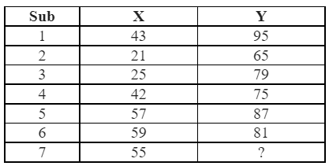

**Program:**

In [1]:

**import** **numpy** **as** **np** *# linear algebra*

**import** **pandas** **as** **pd** *# data processing, CSV file I/O (e.g. pd.read_csv)*

**import** **matplotlib.pyplot** **as** **plt**

**import** **os**

**for** dirname, _, filenames **in** os.walk('/kaggle/input'):

**for** filename **in** filenames:

print(os.path.join(dirname, filename))

In [2]:

**def** coefficient(x,y):

n = np.size(x)

meanx = np.mean(x)

meany = np.mean(y)

SS_xy = np.sum(y*x) - n*meany*meanx

SS_xx = np.sum(x*x) - n*meanx*meanx

t1 = SS_xy/SS_xx

t0 = meany - t1*meanx

**return** (t0,t1)

In [3]:

**def** plot_line(x,y,t):

plt.scatter(x, y, color = 'blue', marker = 'o', s = 30)

ypred = t[0] + t[1]*x

plt.plot(x, ypred, color = 'red')

plt.xlabel('X')

plt.ylabel('Y')

plt.show()

In [4]:

**def** main():

x1,y1 = [],[]

with open('../input/ml-lab2/dataset.csv', 'r') as csvinput: #Taking csv file input

next(csvinput)

for row in csv.reader(csvinput):

i,j = row[0],row[1]

x1.append(i)

y1.append(j)

x = np.array(x1).astype(np.float)

y = np.array(y1).astype(np.float)

print("X: ",x,"\nY: ",y)

t = coefficient(x,y)

print("The estimated coefficients are: **\n**t0 = **{}** **\n**t1 = **{}**".format(t[0],t[1]))

plot_line(x,y,t)

h = t[0] + t[1]*55

print("Predicted value of y for (x = 55):", h)

In [5]:

main()

**Output:**

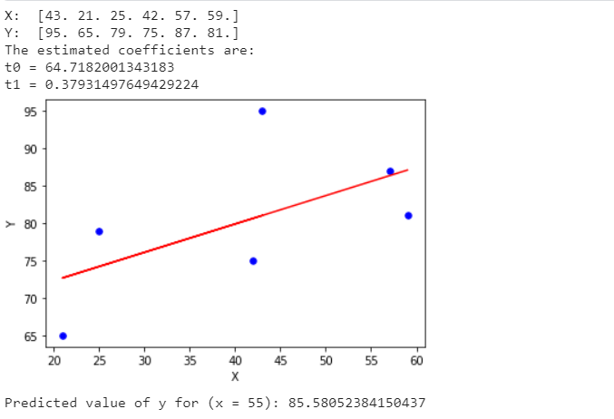

**Final predicted value for y when x = 55 using linear regression algorithm = 85.58**