Surette Nexus — System Design
Table of Contents

System design
How Surette Nexus is built to stay fast, correct and observable as it grows: from one laptop, to a small Docker host, to a Kubernetes cluster. Everything here is free/open-source software; nothing requires a paid service.
What’s verified. The application code (rate limiting, caching, idempotency, circuit breakers, queue, outbox, WebSockets, health checks, logs, metrics) is covered by automated tests. The full Docker Compose stack (two web instances, worker, WebSocket server, Postgres, Valkey, nginx gateway) has been built and run locally, and the browser tests pass through the gateway. Alert rules, Alertmanager routing and Kubernetes manifests pass their official validators, and the GitHub Actions CI pipeline passes on GitHub. Not yet run: a real Kubernetes cluster, the Prometheus/Grafana/Loki containers, and the deploy workflow (they need hosting). See Verification status.

1. Goals and constraints
Goal | What it means here
Correct first | Money in integer cents, PostgreSQL row-level security on every request, no duplicate leads or deals from retries, no lost events
Fast for visitors | Public pages and listing APIs answer from cache; images are pre-sized WebP; live updates are pushed instead of polled
Degrade, don’t fail | If AI, FRED, Census, the dispatcher, Redis or a webhook receiver is down, the site keeps working with fallbacks
Scale horizontally | Every process is stateless; shared state lives in Postgres (and optionally Redis); any number of replicas
Observable | Every request has an id, a structured log line and metrics; every alert has a runbook
Free / OSS | Postgres, Valkey (Redis-compatible), nginx, Prometheus, Grafana, Loki, Alertmanager, KEDA, CloudNativePG, Ollama
Expected load is modest (a regional brokerage: hundreds to low thousands of visitors a day), so the design favours few moving parts now with a clear path to more when numbers justify it.

2. Architecture
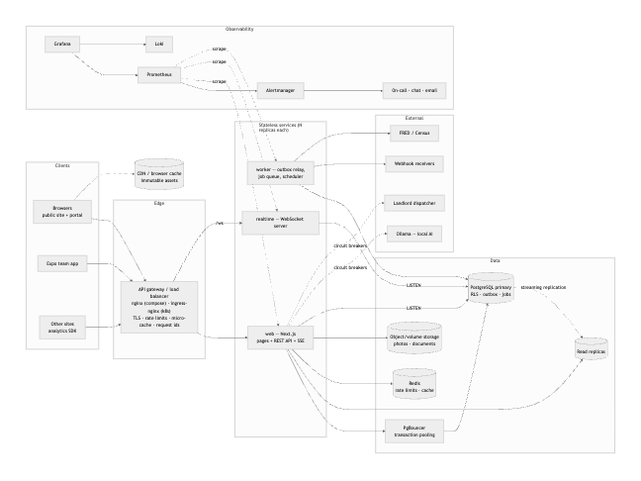
Component | Responsibility | State | How it scales
web (Next.js) | Pages, REST API, SSE stream, request auth, RLS-scoped queries | none (L1 cache only) | HPA on CPU/memory, 3 to 20 replicas
realtime | WebSocket live updates | open sockets only | HPA on CPU; each replica LISTENs to Postgres directly
worker | Outbox relay, job processing, scheduled jobs | none | KEDA on queue depth, 2 to 10 replicas; SKIP LOCKED makes them safe to run in parallel
gateway | TLS, routing, rate limits, micro-cache, request ids | cache (disposable) | Cloud LB / ingress controller replicas
PostgreSQL | Source of truth, RLS, outbox, queue, idempotency keys | durable | Vertical first; read replicas; partitioning for analytics
PgBouncer | Connection pooling (transaction mode) | none | 2 replicas
Redis (optional) | Shared rate-limit counters, shared cache, invalidation pub/sub | disposable | Single node is plenty; managed Redis for HA
Code map: web/src/lib/server/* (one module per concern, named below), web/scripts/worker.ts, web/scripts/realtime.ts, deploy/ (gateway, Kubernetes, observability), .github/workflows/.

3. Life of a request
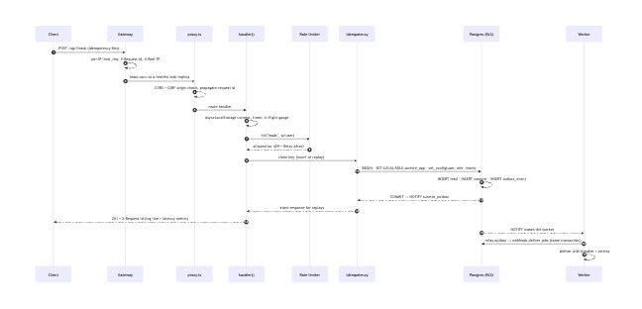

4. API gateway and load balancing
Where: deploy/nginx/nginx.conf (Docker Compose) and deploy/k8s/base/ingress.yaml (ingress-nginx).
- Routing: /ws goes to realtime (WebSocket upgrade, 1 h timeouts); /api/events goes to web with buffering off (SSE); /api/properties/upload streams bodies up to 1.2 GB with no request buffering; everything else goes to web.
- Load balancing: least_conn across replicas, upstream keep-alive, passive health checks (max_fails=3 fail_timeout=10s). In Kubernetes, readiness probes remove unhealthy pods from the Service.
- Retries: another replica is tried only on connection errors and 502/503, and only for idempotent methods. nginx never retries POST/PATCH unless told to with non_idempotent, and we don’t. Clients retry writes safely with Idempotency-Key (§8).
- Identity: the gateway overwrites X-Real-IP with the address it saw (the app trusts only this header for per-IP limits) and sets or keeps X-Request-Id.
- Protection: /api/metrics returns 404 at the nginx gateway. Under ingress-nginx it is reachable but needs METRICS_TOKEN in production, and Prometheus scrapes pods on the private network. The app adds security headers itself, so they are the same behind any gateway.

5. Rate limiting
Two layers:
Layer | Where | Key | Purpose
Coarse | Gateway (limit_req) | client IP | Absorb floods before they reach Node: 20 r/s for the API, 10 r/min for login and sign-up, 10 r/s for analytics
Precise | App (lib/server/limiter.ts) | endpoint + user id (signed in) or IP | Business limits, shared across all replicas
App limits (fixed window): login 20 per 15 min, sign-up 10 per hour, contact/leads 6 per hour, showings 8 per hour, concierge 30 per 10 min, ops assistant 60 per minute, Dual-Move share 5 per hour, analytics 240 per minute, maintenance 5 per 15 min.
- Store: Redis (INCR + PEXPIRE) when REDIS_URL is set; otherwise an UNLOGGED Postgres table (rate_limit_counters, one upsert per hit), so limits stay shared across replicas without Redis. In-memory is for development only.
- Responses: 429 with Retry-After and RateLimit-Limit/Remaining/Reset.
- Fail open: if the shared store is unreachable, limits fall back to per-process memory. A limiter outage must not take the site down. Account lockout (8 failures, then 15 minutes) still protects logins.
- Why fixed window: simple and cheap, and the bursts at window edges are small at these limits. A sliding-window log is a drop-in change in limiter.ts if needed.

6. Caching
Layer | What | TTL / invalidation
Browser/CDN | /_next/static/*, /media/* (content-hashed WebP renditions) | 1 year, immutable
Gateway micro-cache | Anonymous GET /api/properties, /api/market | s-maxage from the app (15 s / 10 min) + stale-while-revalidate; bypassed when a session cookie or Authorization header is present; proxy_cache_lock collapses concurrent misses
App L1 (in-process LRU, 500 entries) | Public listings, cities, team, team directory, market series | 60 s / 5 min / 10 min; dropped instantly when the Postgres change feed reports a listing or photo change
App L2 (Redis, optional) | Same keys, shared across replicas | Tag sets (cachetag:listings), deleted on change; pub/sub tells other replicas to drop L1
Database | Shared buffers, indexes | —
Rules: only anonymous/public data is cached. Anything that depends on who is signed in always reads through RLS. Concurrent misses for a key share one load (request coalescing), so a popular entry expiring doesn’t cause a stampede. Code: lib/server/cache.ts, lib/server/live-cache.ts.

7. Event-driven architecture and the message queue

Transactional outbox
Business code records domain events in the same transaction as the change (publishEvent(db, …) in lib/server/events.ts). An event exists if and only if the change committed. There is no “saved the lead but lost the notification” (dual-write) bug.
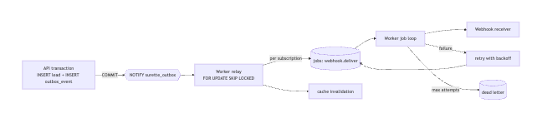
Event catalog: lead.created, deal.created, deal.stage_changed, showing.requested, showing.updated, listing.published, listing.updated, media.uploaded, collection.activity.

Job queue
A durable queue on PostgreSQL (lib/server/jobs.ts, table jobs):
- Workers claim with FOR UPDATE SKIP LOCKED, so any number of replicas can pull from the same queue without double-processing (tested).
- Retries: exponential backoff with jitter (5 s, 20 s, 80 s, … capped at 1 h). After max_attempts a job is marked dead; that alerts and links to its runbook, and the job can be re-queued with one SQL statement.
- Visibility timeout: jobs stuck in running (a crashed worker) are released after 5 minutes.
- Dedupe keys: at most one queued or running job per key (for example one market refresh per day).
- Wake-ups: NOTIFY surette_jobs starts work within milliseconds; polling every 2 s is the safety net.
- Queues: default, webhooks and maintenance keep slow webhook receivers from starving other work.
- Scheduler: the worker holding a Postgres advisory lock enqueues recurring jobs (hourly cleanup, daily analytics purge, daily market refresh, monthly government data refresh). Per-period dedupe keys make a split brain harmless.
Delivery semantics: at-least-once. Consumers are idempotent: webhook deliveries carry a stable X-Surette-Delivery id, and job dedupe keys block duplicate enqueues.
Why Postgres instead of Kafka/RabbitMQ (for now): it’s already there, it’s transactional with the business data (no outbox-to-broker gap), and it easily handles thousands of jobs per minute. Switch when sustained throughput reaches tens of thousands of messages per second, or when many independent consumers need replay. The outbox then feeds the broker (Debezium CDC or the relay publishing to NATS JetStream or RabbitMQ) without changing business code.

8. Idempotency
Mechanism | Where | Protects against
Idempotency-Key header | POST /api/leads, /api/showings, /api/deals, /api/deals/:id/drafts, /api/deals/:id/documents, /api/properties/upload, /api/dual-move/share | Double-clicks, mobile retries, gateway timeouts creating duplicates
Analytics event_id (UUID per event) | /api/analytics/collect | SDK resending a batch (ON CONFLICT DO NOTHING)
Webhook delivery id | worker | Receivers processing a retried delivery twice
Job dedupe keys | queue | Duplicate scheduled jobs and fan-out
Business duplicate rule | leads | Same person and property within 24 h becomes a note, not a new lead
Contract (lib/server/idempotency.ts): keys are 8 to 128 characters, scoped per user (or per IP when anonymous), and kept for 24 h. - Repeat: returns the stored response with Idempotent-Replayed: true. - Same key, different body: 422. - Repeat while the original is still running: 409. - Failure: 5xx responses and exceptions release the key, so the client can retry.
A take-over of an expired key is a single atomic upsert, so two simultaneous first requests can’t both run. JSON bodies are hashed. Multipart uploads stream straight to storage, so they are keyed on content type and length instead.

9. Resilience: circuit breakers, timeouts, retries
lib/server/circuit-breaker.ts has three states. Closed counts failures. Open fails fast for a cool-down. Half-open lets one trial call through. Every call also gets a timeout.
Dependency | Breaker | Threshold / cool-down / timeout | Fallback while open
Ollama (local AI) | ollama | 3 / 30 s / 12 s | Deterministic built-in answers (always correct, less chatty)
FRED | fred | 5 / 5 min / 20 s | Last stored observations, shown with their date
Census, BLS, FHFA downloads | gov-data | 6 / 5 min / 120 s | Previous government data stays; the error is recorded on the series
Census ACS | census | 5 / 5 min / 20 s | Same
Landlord dispatcher | dispatcher | 4 / 30 s / 12 s | “Temporarily unavailable — call the office” (4xx answers don’t count as failures)
Each webhook host | webhook:<host> | 5 / 60 s / 8 s | Job retried later with backoff
Other patterns: - Bulkheads: background work runs in a separate process, and webhooks have their own queue. - Statement timeout: 15 s per database statement, so a runaway query can’t hold a connection forever. - Graceful shutdown: web pods sleep 10 s in preStop so the load balancer drains them. Workers stop claiming and finish in-flight jobs for up to 25 s. The realtime server closes sockets with code 1012, and clients reconnect to another replica with backoff and jitter.

10. Real-time: WebSockets and SSE
Database triggers NOTIFY surette_events on every change to listings, photos, showings, collections, leads and deals, no matter who made the change. Both transports apply the same visibility rules (lib/server/live-filter.ts) and send only ids. Clients re-fetch through the API, where RLS applies.
 | WebSocket (/ws, realtime service) | SSE (/api/events, web)
Used by | Browsers when NEXT_PUBLIC_REALTIME_URL is set; the mobile app can use it too | Fallback after 3 failed WebSocket attempts, or when not configured
Auth | Session cookie (Origin must be our site, which blocks cross-site WebSocket hijacking) or a bearer.<token> subprotocol for native apps, so tokens never appear in URLs or logs | Session cookie
Liveness | Protocol ping every 25 s; dead peers terminated | Comment every 20 s
Protection | Max 20 connections per IP, 4 KB frames, slow consumers dropped at 1 MB buffered | Gateway connection limit
Scaling: each replica holds one LISTEN connection to Postgres, so there is no shared broker and replicas scale independently. LISTEN needs a session connection, so it uses DATABASE_DIRECT_URL and bypasses PgBouncer. At very high fan-out (many thousands of sockets per replica), add Redis pub/sub between the database listener and socket servers.

11. Database: indexing and scaling
Indexes (migrations 001, 002 and 005) follow the actual query patterns:
Query | Index
Public listing grid (status, featured, newest) | properties_public_idx (status, is_featured DESC, published_at DESC)
Filters (type, beds, price) | properties_filter_idx, partial properties_price_idx … WHERE status='active'
City filter lower(city) = lower($1) | expression index properties_city_idx (lower(city), status)
Concierge fuzzy town match | trigram GIN properties_city_trgm_idx
Keyword search | GIN on search_vector
Deadline agenda (open items by due date) | partial … WHERE completed_at IS NULL / WHERE status='open'
Lead duplicate check (email/phone within 24 h) | partial leads_email_idx, leads_phone_idx
Follow-ups due | partial leads_follow_up_idx
Job claiming | partial jobs_ready_idx (queue, priority DESC, run_at, id) WHERE status='queued'
Outbox relay | partial outbox_unpublished_idx WHERE published_at IS NULL
Analytics time ranges (append-only, huge) | BRIN on occurred_at (tiny, fast for ranges) + B-tree for project/type/session
Connections: each web replica has a pool (DATABASE_POOL_SIZE, default 10) behind PgBouncer in transaction mode. This is safe because every request is one transaction and identity uses SET LOCAL / set_config(…, true).
Reads: withReadDb and withSystemReadDb run read-only transactions on DATABASE_READ_URL replicas, for analytics dashboards, market data and exports. Never read your own writes from a replica.
Growth path, in order, each step taken only when metrics call for it: 1. Vertical scaling plus pg_stat_statements-driven indexing. 2. Read replicas (CloudNativePG gives -ro automatically). 3. Partition analytics_events by month (PARTITION BY RANGE (occurred_at)) once it passes about 50 M rows. Retention then becomes DROP PARTITION instead of DELETE. 4. Move photos and documents to S3/R2 behind a CDN, which removes the shared volume. 5. Separate the analytics store (ClickHouse, OSS) if dashboard queries start competing with transactional load.
Durability: CloudNativePG runs 1 primary and 2 replicas with automatic failover, continuous WAL archiving and nightly base backups (30-day point-in-time recovery). Migrations are forward-only and expand → migrate → contract, so old and new pods can run side by side during a rolling deploy.

12. Health checks
Endpoint | Probe | Checks | On failure
/api/health/live | Kubernetes liveness + startup, Docker HEALTHCHECK | Process answers HTTP, nothing external | Container restarted
/api/health/ready | Kubernetes readiness, blackbox exporter | Database reachable, all migrations applied, pool not exhausted, Redis (if configured) | Pod removed from the load balancer until it recovers
/api/health | Humans, uptime monitors | Same as ready, plus circuit-breaker states | —
worker :9464/healthz, /readyz | Kubernetes | Job loop alive, database, LISTEN | Restart / unready
realtime :3200/healthz, /readyz | Kubernetes | Not draining | Restart / unready
Liveness never checks dependencies, so a database blip doesn’t restart every pod at once.

13. Observability
Logs (lib/server/logger.ts, pino): one JSON object per line with service, component, requestId, route and userId. Passwords, tokens, cookies, emails and phone numbers are redacted. Each API request logs method, route, status and duration; requests slower than 2 s are warn, and 5xx responses are error. Promtail ships container logs to Loki; query them in Grafana with {service="surette-web"} | json | requestId="…".
Metrics (lib/server/metrics.ts, prom-client) at /api/metrics (token-protected), worker :9464/metrics and realtime /metrics:
Metric | Type | Labels
http_request_duration_seconds | histogram | method, route (ids collapsed), status
http_requests_in_flight | gauge | —
db_transaction_duration_seconds | histogram | kind (rls, system, read)
db_pool_connections | gauge | state (total, idle, waiting)
rate_limited_total | counter | bucket
idempotent_replays_total | counter | route
cache_requests_total | counter | cache (l1, l2), result
circuit_breaker_state, circuit_breaker_rejections_total | gauge / counter | breaker
external_call_duration_seconds | histogram | target, outcome
jobs_processed_total, job_duration_seconds, job_queue_depth | counter / histogram / gauge | type, outcome, queue, status
outbox_lag_seconds, outbox_published_total | gauge / counter | type
realtime_connections, realtime_messages_total | gauge / counter | transport (websocket, sse)
analytics_events_total | counter | project, result
Node.js defaults | various | event-loop lag, heap, GC, CPU
Postgres and Redis are covered by postgres_exporter and redis_exporter. External synthetic checks (readiness through the gateway, TLS expiry) come from blackbox_exporter.
Dashboards: Grafana’s “Surette Nexus — Overview” (deploy/observability/grafana/dashboards) has traffic and errors, latency percentiles, slowest routes, database pool and transaction time, cache hit ratio, rate limiting, queue, outbox, job outcomes, circuit breakers, external latency, live connections and analytics ingestion.
Alerts (deploy/observability/prometheus/alerts.yml, 20 rules; each links to a section of runbooks.md):
Severity → route | Alerts
critical → on-call (PagerDuty/Opsgenie webhook) + chat | service down, worker missing, readiness failing externally, error rate > 5 %, Postgres down, outbox stalled > 5 min
warning → chat + email | error rate > 1 %, p95 > 1.5 s, TLS < 14 days, database pool waiting, slow transactions, Postgres connections > 80 %, replica lag > 30 s, Redis down, dead-lettered jobs, queue > 500, outbox lag > 60 s, circuit open 5 min, rate-limit spike, analytics silent 3 daytime hours
Alertmanager groups by alert, repeats critical alerts hourly, and inhibits symptom alerts while the underlying service or database is down.
Tracing: not implemented yet. Request ids already correlate logs across gateway, web and worker. The next step is OpenTelemetry (@opentelemetry/sdk-node) exporting to Grafana Tempo.

14. Deployment
One image, three roles (Dockerfile): a multi-stage build, a non-root user (uid 10001), and tini as PID 1. The command picks the role: npm start (web), npm run worker:prod or npm run realtime:prod. Migrations run as a one-off (npm run db:migrate:prod).
Docker Compose (docker-compose.yml): Postgres, Redis, a migrate one-shot, web ×2, worker, realtime and the nginx gateway on :8080. Add --profile observability for Prometheus, Alertmanager, Grafana (:3001), Loki, Promtail and the exporters, and --profile ai for Ollama.
Kubernetes (deploy/k8s, kustomize):
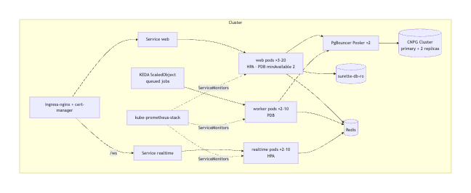
- Zero-downtime rollouts (maxUnavailable: 0, startup, readiness and liveness probes, preStop drain).
- Pods spread across zones; PodDisruptionBudgets keep capacity during node maintenance.
- Pod Security “restricted”: non-root, read-only root filesystem, all capabilities dropped, seccomp.
- NetworkPolicies: default-deny ingress, with only the ingress controller allowed to web/realtime and only Prometheus allowed to metrics ports.
- Secrets come from a Secret managed by External Secrets / Sealed Secrets; there are none in git.
- Overlays: staging (1 replica, single-instance DB) and production (data layer, KEDA, monitoring).

15. CI/CD
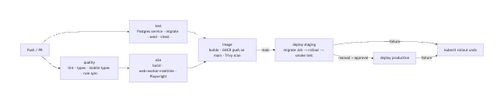
Files: .github/workflows/ci.yml and .github/workflows/deploy.yml. The production deploy needs a person to choose the image and pass the GitHub Environment approval. Required secrets: KUBECONFIG per environment; GHCR uses the built-in GITHUB_TOKEN.

Bugs found by actually running the stack (all fixed)
Found by | Bug | Fix
Docker build | Lock file generated on macOS was missing Linux packages, so npm ci failed in Docker and would have failed in CI | Lock regenerated in the Linux build image; scripts/refresh-lockfile.sh for future changes
Docker run | Upload folder owned by root while the app runs as a non-root user: photo and document uploads would fail | Image creates /data/storage owned by the app user
Docker run | The image health check probed the web port in every role, so worker and realtime were “unhealthy” | Role-aware health check (HEALTH_PORT, HEALTH_PATH)
Docker run | Scripts never exited when Redis was configured (open connection) | Scripts and the worker close the connection
Valkey tests | Redis client rejected commands while connecting, so the first requests after a start silently fell back | Commands wait for the connection, capped at 1 s each
Gateway tests | nginx resolved container addresses once; after a redeploy it sent traffic to addresses that no longer existed (502) | resolver + resolve on upstreams, re-resolved every 10 s
Gateway tests | Security headers sent twice (gateway and app) | Headers come only from the app
Gateway tests | Micro-cached responses replayed a previous request’s X-Request-Id | Gateway hides the app’s copy and sets its own
Accessibility (newer axe) | Logo link and “Ask ops” button text didn’t match their accessible names | Names include the visible text
First GitHub CI runs | Route types missing on a fresh checkout; mobile lock file broken on Linux; image names must be lowercase; Trivy found 3 fixable critical Perl CVEs in the base image | next typegen before type-check; Linux-generated locks; lowercase ghcr.io names; apt-get upgrade in the image

16. Targets and capacity
Targets (SLOs) to hold ourselves to. These are goals, not measurements:
SLO | Target
Availability of public pages and read APIs | 99.9 % monthly
p95 latency, read APIs (cache hit) | < 100 ms
p95 latency, write APIs | < 500 ms
Live update delivery (commit → browser) | < 2 s
Webhook first attempt after commit | < 10 s
Measured (one production-build instance on a laptop, local Postgres, in-process cache, 25 concurrent clients; npm run test:load): cached listings API about 4,000 req/s at 13 ms p99, market API 1,100 req/s at 43 ms p99, server-rendered home page 183 req/s at 205 ms p99, readiness 5,000 req/s, with zero errors. Full table in testing.md. The expected peak for a regional brokerage is in the tens of requests per second, so one instance has large headroom; three replicas are for availability, not load. Re-run against staging hardware before relying on these numbers in production. The first bottleneck under growth will be Postgres connections (PgBouncer), then analytics write volume (partitioning, §11).
Lesson from the load test: readiness originally failed whenever requests were queuing for a database connection. Under a spike, every pod would have reported “not ready” at once and been removed from the load balancer: a self-inflicted outage. Readiness now reflects only “can this pod serve at all” (database reachable, migrations applied). Pool pressure is a metric and an alert, and readiness results are cached for 2 s.

Verification status
Item | Status
Rate limiter (Postgres store), idempotency keys, job queue (SKIP LOCKED, retries, dead letter, dedupe), outbox (rollback safety, single fan-out with concurrent relayers), circuit breaker states and timeouts | Automated tests (web/tests/integration/, web/tests/unit/circuit-breaker.test.ts)
Health/readiness, metrics endpoint, request ids, idempotent replay over HTTP, 429 + Retry-After, WebSocket live update + cross-site rejection | Browser/HTTP tests (web/e2e/platform/)
Worker and realtime processes boot, schedule, relay and serve health/metrics | Run locally
Production next build | Passes
Alert rules in sync between Compose and Kubernetes, runbook for every alert, probes on every Deployment, gateway routing rules | Static tests (web/tests/config/deploy-config.test.ts); all YAML parses
Redis / Valkey backend (rate limits, shared cache, tag invalidation) and Redis outage fallback | Integration tests against local Valkey (tests/integration/redis*.test.ts)
Docker image + Docker Compose stack behind the nginx gateway | Built and run locally (Colima); site, accessibility, health, WebSocket and security tests pass through the gateway
Alert rules / Prometheus config / Alertmanager routing | promtool check rules (20 rules), promtool check config, amtool check-config pass
Kubernetes manifests (staging + production overlays, incl. CloudNativePG, KEDA, Prometheus Operator resources) | Rendered with kubectl kustomize; all 54 resources valid with kubeconform -strict
GitHub Actions CI (quality, tests on Postgres, browser tests, image build + Trivy scan, push to GHCR) | Passing on GitHub
Real Kubernetes cluster, Prometheus/Grafana/Loki containers, deploy workflow | Not run yet (needs hosting)
Load/capacity | Measured locally with autocannon (§16); not yet on staging hardware
Government datasets (Census, BLS, FHFA) | Downloaded and verified (checksums, completeness, plausibility), live-format contract tests pass
Accessibility | axe-core WCAG 2.1 AA audits pass on 15 pages

