Surette Nexus — System and Data Flows
Table of Contents

Surette Nexus — System and Data Flows
How each part of Surette Nexus works step by step: who starts it, which services and tables it touches, what is stored, who can see it, and what happens when something fails. For the infrastructure behind these flows (gateway, queue, caching, scaling, monitoring), see system-design.md.
Status as of 2026-10-16.

1. The big picture
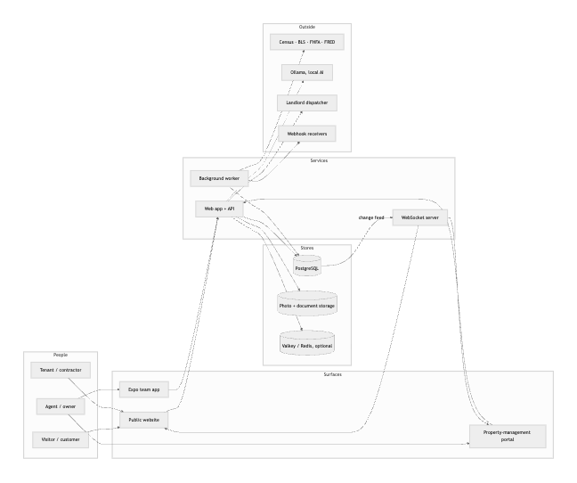

Data inventory
Data | Table(s) | Who can see it | Kept for
Listings and photos | properties, media_assets, storage listings/ | Everyone (published), staff (drafts) | Until deleted by staff
Customer accounts | users (role client) | The customer; their assigned agent; owner | Until the customer deletes it
Staff accounts | users (role agent / admin) | Owner | Until deactivated
Saved homes, searches, comparisons, Dual-Move plans | collections*, saved_searches, search_history, property_comparisons, dual_move_scenarios | The customer (and their agent for shared collections) | Until the customer deletes them or the account
Leads (inquiries) | leads, lead_notes, consent_records | Assigned agent, owner | Until staff delete them
Deals | transactions, transaction_milestones, transaction_tasks | The deal’s agent, owner; the client sees client-visible milestones | Until deleted by the owner
Deal documents | transaction_documents, storage deals/ | The deal’s agent, owner | Until deleted
Email drafts | communication_drafts | The deal’s agent, owner | Until discarded
Website analytics | analytics_events | Owner (full), agents (their listings’ engagement) | Project retention, default 395 days
Market & government data | market_series, market_observations, gov_dataset_imports | Everyone | Replaced on refresh
Audit trail | audit_log (append-only) | Owner | Kept
Events & jobs | outbox_events, jobs | System only | 7 days after completion
Idempotency keys, rate-limit counters | idempotency_keys, rate_limit_counters | System only | 24 hours / 2 hours
Every request runs as a restricted database role with the caller’s identity attached, so the “who can see it” column is enforced by PostgreSQL row-level security, not only by code.

2. A visitor browses the site
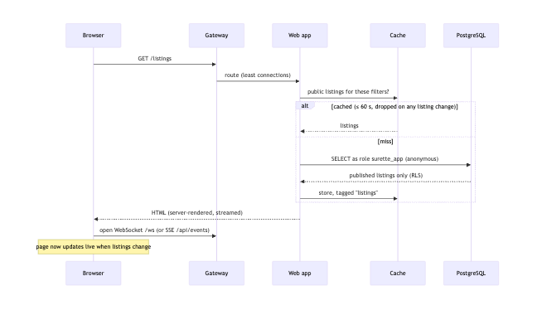
- Pages render on the server. Public data comes from the in-app cache when possible.
- The browser opens one live connection per tab. When a listing or photo changes, the browser receives only the id and re-fetches through the API.
- Images are served as pre-sized WebP renditions (640, 1200 and 2400 px) with a long cache lifetime.
- The analytics tracker loads but sends nothing until the visitor chooses “Allow” (see §9).
If something is down: cache miss → database. Database down → error page, and readiness takes the instance out of the load balancer. WebSocket server down → the browser falls back to SSE.

3. Signing in (two separate entrances)
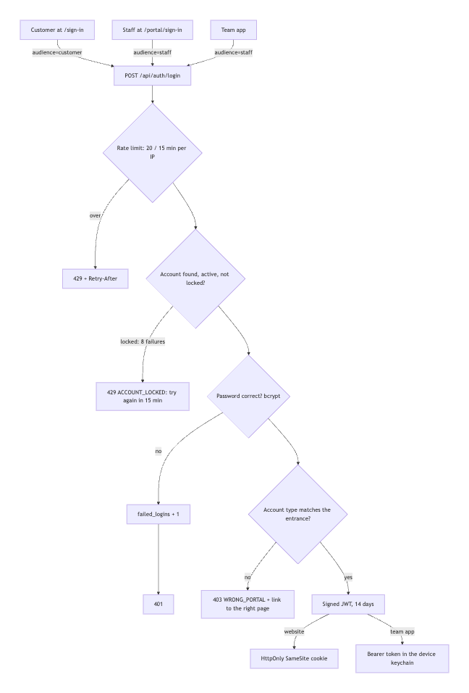
- Every API request re-reads the user row, so deactivation or a role change takes effect immediately.
- Cookie-authenticated writes from another website are refused (CSRF protection in proxy.ts).
- Staff accounts are created only by the owner (Portal → Team) or npm run admin:create.

Customer email confirmation, password reset and Google
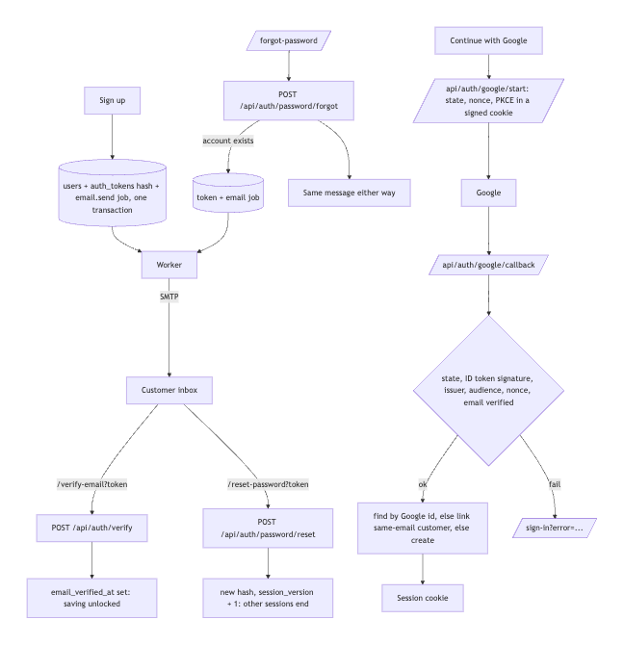

4. A visitor becomes a lead
Leads come from the contact page, showing requests, the AI assistant hand-off and Dual-Move “send to an agent”.
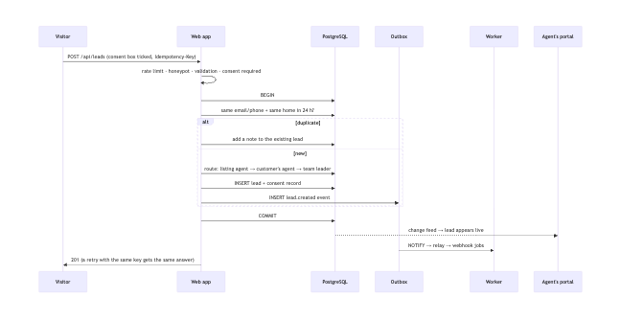
What’s stored: name, email and/or phone, message, explicit preferences, the exact consent text and time. Never stored: anything inferred about the person.

5. The AI assistant (chatbot)
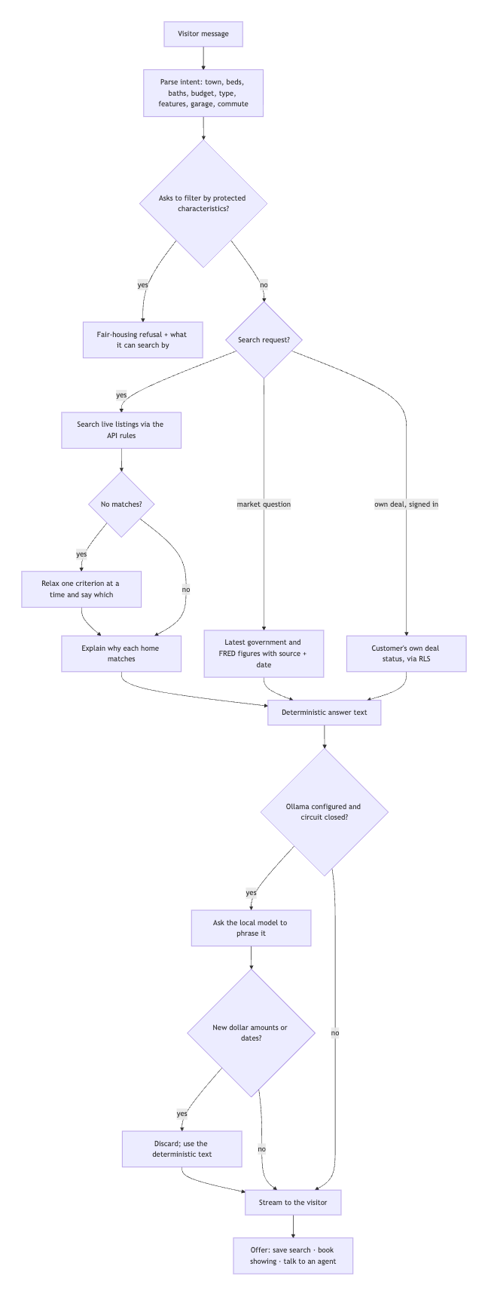
The AI assistant only mentions homes the database returned. AI is optional, runs on your own server and never sees anything the deterministic answer didn’t already contain.

6. Listing and photo upload (portal or team app)
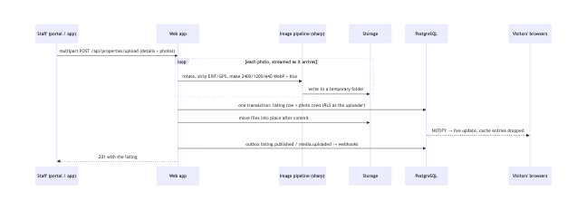
Limits: 40 photos, 30 MB each; JPEG, PNG, WebP, AVIF or HEIC only. Every file is decoded by the image pipeline, so anything that isn’t really an image is rejected.

7. A deal from contract to closing
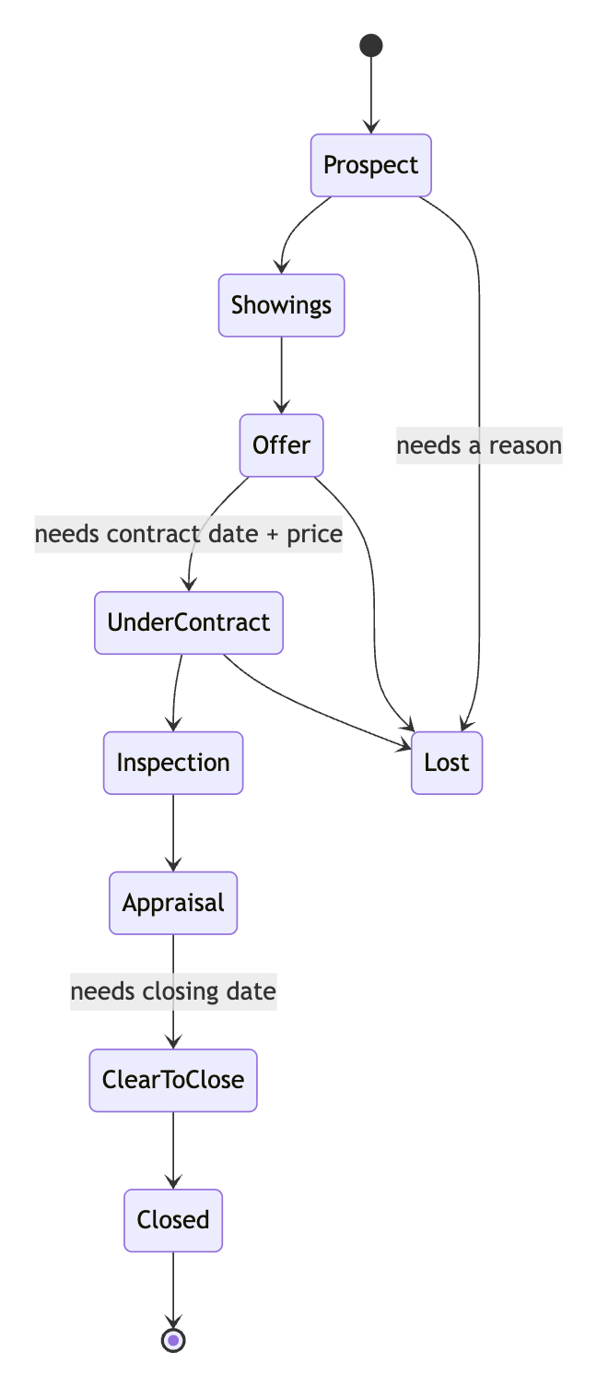
- Create (board or from a lead). The side’s checklist template is applied: each milestone and task gets a rule such as contract+10:roll (10 days after the contract, moved off weekends).
- Move stages. Stage gates block a move until the required dates or price exist.
- Dates change. Rule-based items are recalculated; items someone rescheduled by hand stay put.
- Documents.
  - Upload a PDF or image; the type is checked from the content.
  - Text is scanned for price, deposit, dates and inspection days, each with the page it came from.
  - A person verifies or rejects each value before anything is applied to the deal.
- Emails.
  - Drafts are generated from the deal’s data.
  - A person must approve the text before it can be marked “sent”.
  - Staff send it from their own email; the system never emails clients by itself.
- Record and notify.
  - Every change is written to the append-only audit log.
  - Stage changes emit deal.stage_changed, delivered by webhook.
  - The client sees client-visible milestones in their account.

8. Showing requests
- A visitor picks a slot on a listing (open slots come from /api/showings/slots).
- The request is stored as requested. A database exclusion constraint makes double-booking a confirmed slot impossible.
- The request also creates or updates a lead (§4), with consent.
- The listing agent confirms or declines in the portal. The customer sees the status in their account, and the change is pushed live.

9. Website analytics (first-party, consent-based)
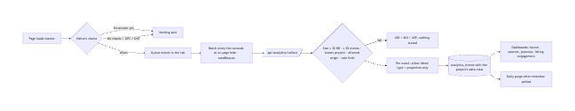
- Projects: nexus-site (production, this website), demo-site (synthetic), e2e (tests). The data class comes from the project, never from the browser.
- Never collected: form contents, names, emails, phone numbers, full IPs, cookies, or cross-site ids.
- Identifiers: a per-tab session id always; a pseudonymous visitor id only after “Allow”.
- Duplicates: resent batches are ignored by event id.

10. Market and government data
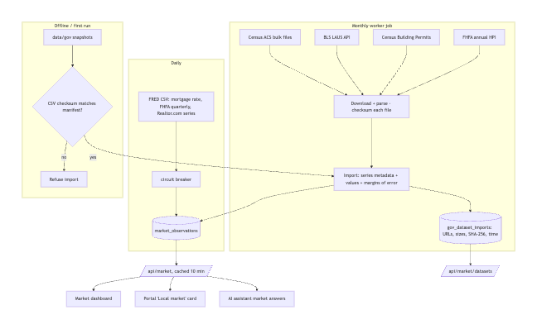
- Downloads fail: previous values stay, and the series records the error. Nothing is estimated.
- Gaps stay gaps: for example, BLS never collected October 2025.
- Census figures: shown with their margin of error.

11. Events, queue and webhooks
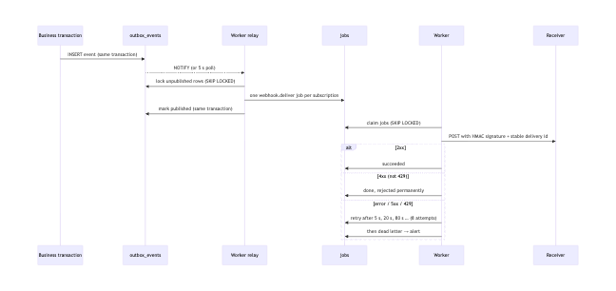
Recurring jobs (scheduled by whichever worker holds the leader lock):
Job | Every | Does
maintenance.cleanup | hour | Clears expired rate-limit counters and idempotency keys; removes old finished jobs and published events
analytics.purge | day | Deletes analytics events past each project’s retention
market.refresh | day | FRED series
govdata.refresh | 30 days | Census, BLS, FHFA downloads

12. Live updates
- A database trigger publishes {table, op, ids, visibility, team} on the surette_events channel after every relevant change, whoever made it.
- Each web and realtime instance keeps one LISTEN connection.
- For each connected client, the shared visibility rules decide whether to forward the event: public listing changes go to everyone; staff changes go to that team’s staff; a customer gets their own showings and deal; collection activity goes to its owner and agent.
- The client re-fetches the changed item through the API, where row-level security applies again.

13. Maintenance requests and contractors
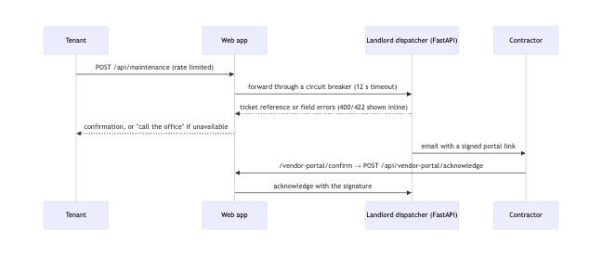
Staff see vendor insurance status in Portal → Vendors (read from the dispatcher).

14. Customer privacy controls
Action | Where | What happens
Change analytics choice | /privacy, banner | Stored in the browser; “No thanks” also removes the visitor id
Export my data | Account → Export | JSON of the account, collections and comments, saved searches, search history, comparisons, Dual-Move scenarios, showings and consent records
Delete my account | Account → Delete (password required) | Account and everything stored for it are deleted. Leads already sent to the team are unlinked; the office can erase those on request
Withdraw contact consent | Ask the office | Consent record updated; staff stop contact

15. When things fail
Failure | What visitors see | What staff see | Recovery
One web instance crashes | Nothing (others serve) | — | Restarted by Docker / Kubernetes
Database unreachable | Error page | Portal unavailable; critical alert | Failover (CloudNativePG) or restart
Worker down | Nothing | Webhooks and refreshes wait; alert after 5 min | Start a worker; queued work drains
Ollama down | Built-in answers | — | Breaker retries every 30 s
Census / BLS / FHFA / FRED down | Last stored data with its date | Series shows its last error | Next scheduled refresh
Dispatcher down | “Call the office” message | Vendors page unavailable | Breaker retries every 30 s
Redis down | Nothing | Warning alert | Falls back to Postgres limits and in-app cache
WebSocket server down | Updates continue over SSE | — | Restart
Traffic spike | Slightly slower pages | Latency and pool alerts | Autoscaling adds web pods

