How to Use this Template
- Make a copy [ File → Make a copy... ]
- Rename this file: “Capstone_Stage1”
- Replace the text in green

Submission Instructions
- After you’ve completed all the sections, download this document as a PDF [ File → Download as PDF ]
- Create a new GitHub repo for the capstone. Name it “Capstone Project”
- Add this document to your repo. Make sure it’s named “Capstone_Stage1.pdf”

Description
Intended User
Features
User Interface Mocks
Screen 1
Screen 2
Key Considerations
How will your app handle data persistence?
Describe any corner cases in the UX.
Describe any libraries you’ll be using and share your reasoning for including them.
Describe how you will implement Google Play Services.
Next Steps: Required Tasks
Task 1: Project Setup
Task 2: Implement UI for Each Activity and Fragment
Task 3: Your Next Task
Task 4: Your Next Task
Task 5: Your Next Task

GitHub Username: Your GitHub username here

E-School

Description

E-School facilitates communication between School, teachers and parents/students. This App can be used by leading schools to put technology in the hands of their teachers, enabling them to very easily communicate with Parents and their students.

Intended User

Parents / Guardians

Features

List the main features of your app. For example:
- Eliminate Miscommunication
- Track school bus
- Regular Updates

User Interface Mocks
These can be created by hand (take a photo of your drawings and insert them in this flow), or using a program like Photoshop or Balsamiq.

Screen 1
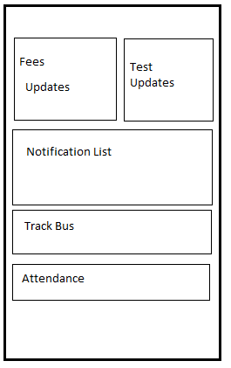

This is the main page of the app which shows the data for the student

Screen 2
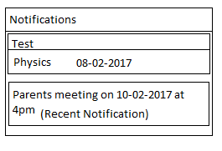

The widget shows the upcoming test and recent notification

Key Considerations

How will your app handle data persistence?

App makes use of content providers for storing attendance data.

Describe any corner cases in the UX.

Describe any libraries you’ll be using and share your reasoning for including them.

Butterknife : used to bind views
DBFlow : used to store data

Describe how you will implement Google Play Services.

- Google Maps: Helps to track School Bus
- Google Analytics : For registering page clicks

Next Steps: Required Tasks

This is the section where you can take the main features of your app (declared above) and decompose them into tangible technical tasks that you can complete incrementally until you have a finished app.

Task 1: Project Setup

Write out the steps you will take to setup and/or configure this project. See previous implementation guides for an example.

You may want to list the subtasks. For example:
- Configure libraries
- Something else

If it helps, imagine you are describing these tasks to a friend who wants to follow along and build this app with you.

- Finalize the functionalities of the App.
  - Fetch Test Results, Attendance , Bus Locations
- Design Database Schema for Attendance
- Create an Android Project
- Create Google Cloud Module

Task 2: Implement Google Cloud module :
- Create end point webservices for fetching fees, attendance, test data.
- Create end point services for fetch bus locations.

Task 3: Implement UI for Each Activity and Fragment

List the subtasks. For example:
- Build UI for MainActivity
- Build UI for Test , Fees Fragments

Task 4: Implement AsyncTask to fetch Fees , Test Data from server

Task 5: Integrate Google Play Services
- Integrate Google Maps.
- Integrate Google Analytics

Task 6: Integrate Widget Provider

