CS 5V81.001: Implementation of data structures and algorithms

**Project 1**

Akshay Thakare (ast140230)

**Description: Implement the skip list data structure, Compare its performance with Java's TreeMap.**

A Skip List is a [data structure](http://en.wikipedia.org/wiki/Data_structure) that allows fast search within an [ordered sequence](http://en.wikipedia.org/wiki/Ordered_sequence) of elements. Fast search is made possible by maintaining a [linked](http://en.wikipedia.org/wiki/Linked_list) hierarchy of subsequences, each skipping over fewer elements.  [http://en.wikipedia.org/wiki/Skip_list]

Skip list consists of nodes linked only in forward direction. A node is made up of data and array of links which points to the next element on that level.

**Classes in the Project:**

1. **SkipListImpl**

Class implementing the SkipNode interface

1. **SkipNode**

Class for creating the node of the list

1. **AlreadyExistsException**

Exception thrown if element to be added is already present.

1. **ListIterator**

Class for creating iterator to iterate over the list.

1. **Tree**

Class implementing TreeSet for adding, removing and checking if an element is present in the list. This class is just for checking the performance of TreeSet with skip list.

1. **FindResult**

Class used to create an object for returning the result of find function. It will return the node whose data is found and the array of visited nodes to reach to this node. This array is used in case of add and remove.

1. **SkipList**

This is an interface which is implemented by SkipListImpl.

**Skip List:**

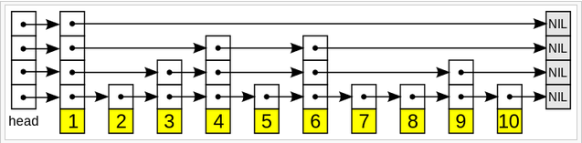

SkipList can be created using SkipList Nodes as follows:

SkipNode Class: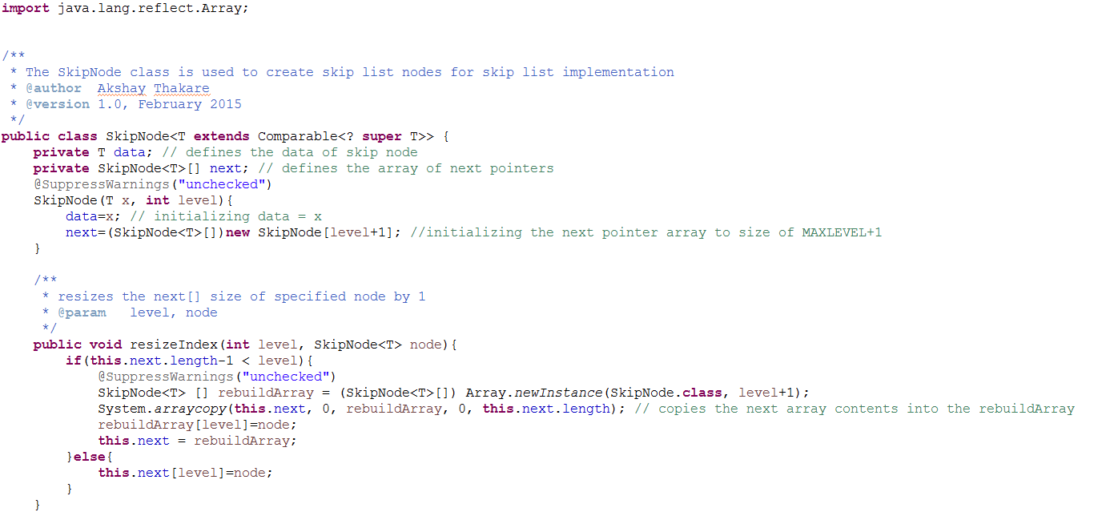

The methods implemented are add ,ceiling ,contains ,findIndex ,first ,floor ,isEmpty ,last ,rebuild ,remove and size.

Comparison with TreeMap:

SkipList gives better performance when compared with TreeMap. If skiplist is implemented with rebuild function then it will further improve its performance.

Comparison Table:

|  |  |  |  |  |  |
| --- | --- | --- | --- | --- | --- |
| Sr No | Input File | Skip List Output | Time taken by Skip List | Tree Set Output  (returned number, Time) | Time taken by Tree Set |
| 1 | Input_50 | 46 | (46, 1451) | 46 | (46, 1751) |
| 2 | Input_100 | 91 | (91, 1632) | 91 | (91, 1715) |
| 3 | Input_200 | 187 | (187, 1416) | 187 | (187, 1688) |
| 4 | Input_1000 | 925 | (925, 1643) | 925 | (925, 1620) |
| 5 | Input_10000 | 221 | (221, 1772) | 221 | (221, 1906) |
| 6 | Input_50000 | 922 | (922, 3481) | 922 | (922, 2782) |