**Name:-Akshay Tiwari**

**Roll no:-53**

**SE-Div:-3**

|  |
| --- |
| Experiment No. 8 |
| Creating GUI with python containing widgets such as labels, textbox, radio, checkboxes and custom dialog boxes |
| Date of Performance: |
| Date of Submission: |

**Experiment No. 8**

**Title:** Creating GUI with python containing widgets such as labels, textbox, radio, checkboxes and custom dialog boxes

**Aim:** To study and create GUI with python containing widgets such as labels, textbox, radio, checkboxes and custom dialog boxes

**Objective:** To introduce GUI, TKinter in python

**Theory:**

Python offers multiple options for developing GUI (Graphical User Interface). Out of all the GUI methods, tkinter is the most commonly used method. It is a standard Python interface to the Tk GUI toolkit shipped with Python. Python with tkinter is the fastest and easiest way to create the GUI applications. Creating a GUI using tkinter is an easy task.

To create a tkinter app:

Importing the module – tkinter

Create the main window (container)

Add any number of widgets to the main window

Apply the event Trigger on the widgets.

Importing tkinter is same as importing any other module in the Python code. Note that the name of the module in Python 2.x is ‘Tkinter’ and in Python 3.x it is ‘tkinter’.

**Code :**-

1)

from tkinter import *

master = Tk()

master.geometry("300x200")

v = StringVar(master, "1")

values = {"Jenil" : "1",

"Krunal" : "2",

"Piyush" : "3",

"SIddhesh" : "4",

"Vishal" : "5"}

for (text, value) in values.items():

Radiobutton(master, text = text, variable = v,

value = value, indicator = 0,

background = "light blue").pack(fill = X, ipady = 5)

mainloop()

**Output:-**

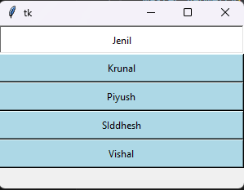

**2)**

import tkinter

from tkinter import ttk

from tkinter import messagebox

def enter_data():

accepted = accept_var.get()

if accepted == "Accepted":

firstname = first_name_entry.get()

lastname = last_name_entry.get()

if firstname and lastname:

title = title_combobox.get()

age = age_spinbox.get()

nationality = nationality_combobox.get()

registration_status = reg_status_var.get()

numcourses = numcourses_spinbox.get()

numsemesters = numsemesters_spinbox.get()

print("First name: ", firstname, "Last name: ", lastname)

print("Title: ", title, "Age: ", age, "Nationality: ", nationality)

print("# Courses: ", numcourses, "# Semesters: ", numsemesters)

print("Registration status", registration_status)

print("------------------------------------------")

else:

tkinter.messagebox.showwarning(title="Error", message="First name and last name are required.")

else:

tkinter.messagebox.showwarning(title="Error", message="You have not accepted the terms")

window = tkinter.Tk()

window.title("Data Entry Form")

frame = tkinter.Frame(window)

frame.pack()

user_info_frame = tkinter.LabelFrame(frame, text="User Information")

user_info_frame.grid(row=0, column=0, padx=20, pady=10)

first_name_label = tkinter.Label(user_info_frame, text="First Name")

first_name_label.grid(row=0, column=0)

last_name_label = tkinter.Label(user_info_frame, text="Last Name")

last_name_label.grid(row=0, column=1)

first_name_entry = tkinter.Entry(user_info_frame)

last_name_entry = tkinter.Entry(user_info_frame)

first_name_entry.grid(row=1, column=0)

last_name_entry.grid(row=1, column=1)

title_label = tkinter.Label(user_info_frame, text="Title")

title_combobox = ttk.Combobox(user_info_frame, values=["", "Mr.", "Ms.", "Dr."])

title_label.grid(row=0, column=2)

title_combobox.grid(row=1, column=2)

age_label = tkinter.Label(user_info_frame, text="Age")

age_spinbox = ttk.Spinbox(user_info_frame, from_=1, to=110)

age_spinbox.set(19)

age_label.grid(row=2, column=0)

age_spinbox.grid(row=3, column=0)

nationality_label = tkinter.Label(user_info_frame, text="Nationality")

nationality_combobox = ttk.Combobox(user_info_frame, values=["India", "United States", "China"])

nationality_label.grid(row=2, column=1)

nationality_combobox.grid(row=3, column=1)

for widget in user_info_frame.winfo_children():

widget.grid_configure(padx=10, pady=5)

courses_frame = tkinter.LabelFrame(frame)

courses_frame.grid(row=1, column=0, sticky="news", padx=20, pady=10)

registered_label = tkinter.Label(courses_frame, text="Registration Status")

reg_status_var = tkinter.StringVar(value="Not Registered")

registered_check = tkinter.Checkbutton(courses_frame, text="Currently Registered",

variable=reg_status_var, onvalue="Registered", offvalue="Not registered")

registered_label.grid(row=0, column=0)

registered_check.grid(row=1, column=0)

numcourses_label = tkinter.Label(courses_frame, text="# Completed Courses")

numcourses_spinbox = tkinter.Spinbox(courses_frame, from_=0, to='infinity')

numcourses_label.grid(row=0, column=1)

numcourses_spinbox.grid(row=1, column=1)

numsemesters_label = tkinter.Label(courses_frame, text="# Semesters")

numsemesters_spinbox = tkinter.Spinbox(courses_frame, from_=0, to="infinity")

numsemesters_label.grid(row=0, column=2)

numsemesters_spinbox.grid(row=1, column=2)

for widget in courses_frame.winfo_children():

widget.grid_configure(padx=10, pady=5)

terms_frame = tkinter.LabelFrame(frame, text="Terms & Conditions")

terms_frame.grid(row=2, column=0, sticky="news", padx=20, pady=10)

accept_var = tkinter.StringVar(value="Not Accepted")

terms_check = tkinter.Checkbutton(terms_frame, text="I accept the terms and conditions.",

variable=accept_var, onvalue="Accepted", offvalue="Not Accepted")

terms_check.grid(row=0, column=0)

button = tkinter.Button(frame, text="Enter data", command=enter_data)

button.grid(row=3, column=0, sticky="news", padx=20, pady=10)

window.mainloop()

**Output:-**

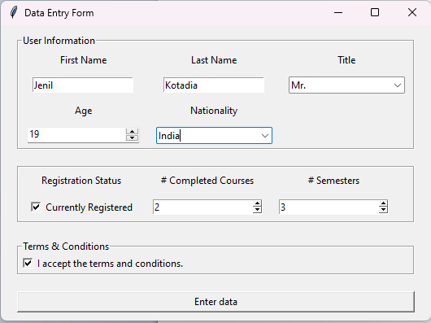

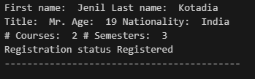

**Conclusion:**

GUI package TKinter has been studied and implemented.