Yokogawa Connection Service Instructions

Description
The Yokogawa Connection Service interacts with Yokogawa’s API and checks the status code received. Based on the received status code, it sets the respective tag on PLC’s DB.

PREREQUISITES
- ATS’s Yokogawa Connection Service Zip file.
- Admin Privilege to run powershell scripts.
- Permit access with PUT/GET communication from remote partner (PLC, HMI, OPC, …) must be checked with Full permission.
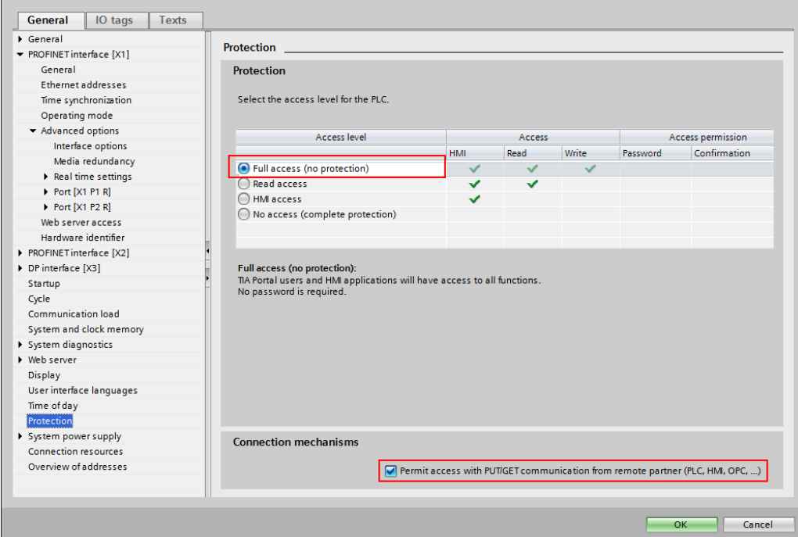
- Optimized Data Block Access should be UNCHECKED.
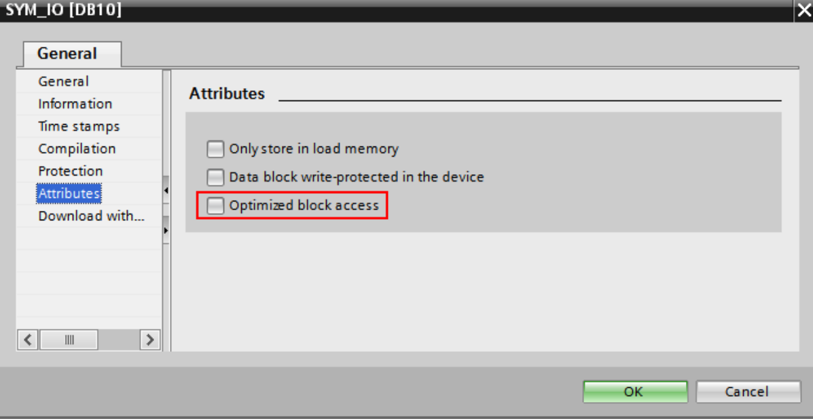

SETUP
Step 1: Extract the zip file and its contents.
Step 2: Edit the config.json file and fill in the keys properly.

Config Key and its purpose
Sr. No | Key Name | Description
1 | ip | The IP address of the PLC (Note: The IP should be static)
2 | namespace | The namespace of the PLC Tag. (Eg. 3)
3 | plc_tag | The tag name inside DB, on which Yokogawa service will act upon. Please the strings in \”\” as the software cannot generate quotes. (Eg. “\“MY_DB\”.\”MY_TAG\””,)
4 | http_verb | No need to modify as of now, not supporting any other request other than GET.
5 | api_request | Specific API endpoint or request name to be called by the connection service.
6 | base_url | Base URL of the API server for Yokogawa integration.
7 | api_key | API key for authentication with the Yokogawa API.
8 | secret_key | Secret key for secure API communication with Yokogawa
9 | yokogawa_api_timeout_sec | Timeout to wait for (in seconds) for the response from Yokogawa API requests.
10 | delay_ms | Delay in milliseconds between consecutive polling.
11 | retry_count | The amount of connection retries on failure of Connect/Read/Write

E.g.,
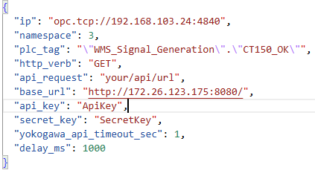

Here the Connection service Pings http://172.22.138.136:8080/ping with timeout of 1s. It updates DB4000.DBX0.6 based on the response from above API.
Note: Rack and Slot are completely optional settings, they default to Rack 0 and Slot 1 of the PLC. Please set it based on your PLC.
Step 3: Run setup.ps1 script with Admin privileges with the help of command:
powershell.exe -ExecutionPolicy Bypass -File .\setup.ps1
Step 4: Press Win key, search for Services, and validate the service “AtsYokogawaConnectionService”.
Step 5: Adjust the Recovery option of the service by Double clicking on the Service name based on your requirements.
After setting the Recovery Click ‘Apply’ and then ‘OK’

E.g.,
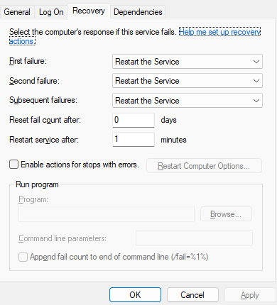

UNINSTALL
Run uninstall.ps1 placed in the folder which you extracted. Run it with the command:
powershell.exe -ExecutionPolicy Bypass -File .\uninstall.ps1

