1. Write a program to Print N to 1 using recursion and also draw the diagram .

Code:

#include <stdio.h>

void recursion(int x);

void main()

{

int N;

printf("Enter N\n");

scanf("%d",&N);

printf("N to 1 numbers are\n");

recursion(N);

}

void recursion(int x)

{

if(x > 0)

{

printf("%d\n",x);

recursion(--x);

}

}

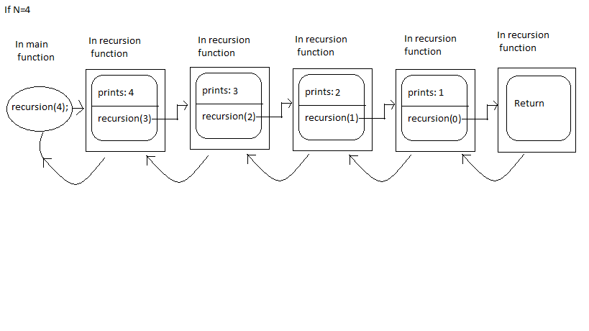

2. Write a program to Print 1 to N using recursion and also draw the diagram.

Code:

#include <stdio.h>

void recursion(int x);

void main()

{

int N;

printf("Enter N\n");

scanf("%d",&N);

printf("1 to N numbers are\n");

recursion(N);

}

void recursion(int x)//rec(3)

{

if(x > 1)

{

recursion(x-1);

}

printf("%d\n",x);

}

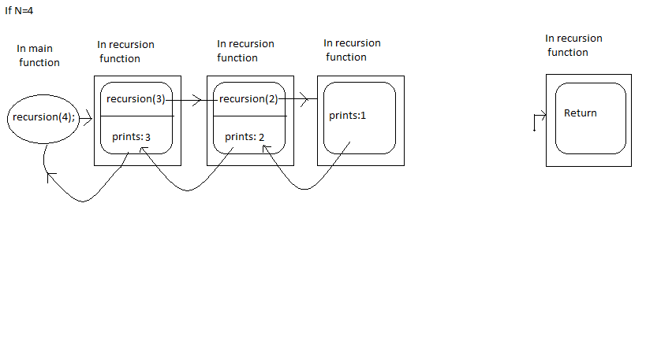

3. Write program to convert Decimal to Binary using recursion.

Code:

#include <stdio.h>

void recursion(int x);

void main()

{

recursion(4);

}

void recursion(int x)

{

if(x > 1)

{

recursion(x/2);

}

printf("%d\n",x%2);

}