**PROJECT IITB_RISC**

E KRITHEESH (200070018)

AKSHAY VERMA (200070005)

ANKITH R (200070006)

GOWTHAM S (20D070031)

**HARDWARE FLOW CHARTS**

ADD:

|  |  |
| --- | --- |
| IR11-9 RF_A1 |  |
| IR8-6 RF_A2 | S1 |
| IR5-3 RF_A3 |  |
| RF_D1 $→$ T1 |  |
| RF_D2 $→$ T2 |  |
| PC $→$ ALU_A |  |
| +1 $→$ ALU_B |  |
| ALU_OUT $→$ PC |  |

|  |  |
| --- | --- |
| T1 $→$ ALU_A |  |
| T2 $→$ ALU_B | S2 |
| ALU_OUT $→$ RF_D3  PC $→$ MEM_A  MEM_D $→ IR$ |  |

$$↓$$

ADC:

|  |  |  |  |  |
| --- | --- | --- | --- | --- |
| PC $→$ ALU_A  +1 $→$ ALU_B  ALU_OUT $→$ PC | | | S3 | |
|  | C | | |  |
| S4 | PC $→$ MEM_A  MEM_D IR | |  |  | | --- | --- | | IR11-9 RF_A1 |  | | IR8-6 RF_A2 | S5 | | IR5-3 RF_A3 |  | | RF_D1 $→$ T1 |  | | RF_D2 $→$ T2 |  | | |  |

|  |  |
| --- | --- |
| T1 $→$ ALU_A |  |
| T2 $→$ ALU_B | S2 |
| ALU_OUT $→$ RF_D3  PC $→$ MEM_A  MEM_D $→ IR$ |  |

$↓$

ADZ:

|  |  |  |  |  |
| --- | --- | --- | --- | --- |
| PC $→$ ALU_A  +1 $→$ ALU_B  ALU_OUT $→$ PC | | | S3 | |
|  | Z | | |  |
| S4 | PC $→$ MEM_A  MEM_D IR | |  | | --- | | IR11-9 RF_A1 | | IR8-6 RF_A2 | | IR5-3 RF_A3 | | RF_D1 $→$ T1 | | RF_D2 $→$ T2 | | | S5 |

|  |  |
| --- | --- |
| T1 $→$ ALU_A |  |
| T2 $→$ ALU_B | S2 |
| ALU_OUT $→$ RF_D3  PC $→$ MEM_A  MEM_D |  |

ADL:

|  |  |
| --- | --- |
| IR11-9 RF_A1  IR8-6 RF_A2  IR5-3 RF_A3  RF_D1 $→$ T1  RF_D2 $→$ T2  PC $→$ ALU_A  +1 $→$ ALU_B  ALU_OUT $→$ PC | S28 |
| $$↓$$ |  |
| T1 $→$ ALU_A  T2 $→$ S1 $→$ ALU_B  ALU_OUT $→$ RF_D3  PC $→$ MEM_A  MEM_D $→ IR$ | S6 |

ADI:

|  |  |
| --- | --- |
| IR11-9 RF_A1  IR8-6 RF_A2  RF_D1 T1  IR5-0 SE16 T2  PC $→$ ALU_A  +1 $→$ ALU_B  ALU_OUT $→$ PC | S7 |
| $$↓$$ |  |
| T1 $→$ ALU_A  T2 $→$ ALU_B  ALU_OUT $→$ RF_D3  PC $→$ MEM_A  MEM_D $→ IR$ | S2 |

NDU:

|  |  |
| --- | --- |
| IR11-9 RF_A1 |  |
| IR8-6 RF_A2 |  |
| IR5-3 RF_A3 |  |
| RF_D1 $→$ T1 | S1 |
| RF_D2 $→$ T2 |  |
| PC $→$ ALU_A |  |
| +1 $→$ ALU_B |  |
| ALU_OUT $→$ PC |  |

|  |  |
| --- | --- |
| T1 $→$ ALU_A |  |
| T2 $→$ ALU_B |  |
| ALU_OUT $→$ RF_D3  PC $→$ MEM_A  MEM_D $→ IR$ | S2 |

$$↓$$

NDC:

|  |  |  |  |
| --- | --- | --- | --- |
| PC $→$ ALU_A  +1 $→$ ALU_B  ALU_OUT $→$ PC | | | S3 |
|  | C | |  |
| S4 | PC $→$ MEM_A  MEM_D IR | |  | | --- | | IR11-9 RF_A1 | | IR8-6 RF_A2 | | IR5-3 RF_A3 | | RF_D1 $→$ T1 | | RF_D2 $→$ T2 | | S5 |

|  |  |
| --- | --- |
| T1 $→$ ALU_A |  |
| T2 $→$ ALU_B |  |
| ALU_OUT $→$ RF_D3  PC $→$ MEM_A  MEM_D $→ IR$ | S2 |

$↓$

NDZ:

|  |  |  |  |
| --- | --- | --- | --- |
| PC $→$ ALU_A  +1 $→$ ALU_B  ALU_OUT $→$ PC | | | S3 |
|  | Z | |  |
| S4 | PC $→$ MEM_A  MEM_D IR | |  | | --- | | IR11-9 RF_A1 | | IR8-6 RF_A2 | | IR5-3 RF_A3 | | RF_D1 $→$ T1 | | RF_D2 T2 | | S5 |

|  |  |
| --- | --- |
| T1 ALU_A |  |
| T2 ALU_B |  |
| ALU_OUT RF_D3  PC $→$ MEM_A  MEM_D $→ IR$ | S2 |

LHI:

|  |  |
| --- | --- |
| IR11-9 RF_A3  IR8-0 S7 RF_D3  PC $→$ ALU_A  +1 $→$ ALU_B  ALU_OUT $→$ PC | S12 |
| $$↓$$ |  |
| PC $→$ MEM_A  MEM_D $→$ IR | S4 |

LW:

|  |  |
| --- | --- |
| IR11-9 RF_A3  IR8-6 RF_A1  IR5-0 SE16 T2  PC $→$ ALU_A  +1 $→$ ALU_B  ALU_OUT $→$ PC | S16 |
| $$↓$$ |  |
| PC $→$ MEM_A  MEM_D $→$ IR  T2 $→$ ALU_B  RF_D1 $→$ ALU_A  ALU_OUT $→$ T1 | S27 |
| $$↓$$ |  |
| T1 $→$ MEM_A  MEM_D $→$ RF_D3 | S17 |

SW:

|  |  |
| --- | --- |
| IR11-9 RF_A2  IR8-6 RF_A1  IR5-0 SE16 T2  PC $→$ ALU_A  +1 $→$ ALU_B  ALU_OUT $→$ PC | S13 |
| $$↓$$ |  |
| PC $→$ MEM_A  MEM_D $→$ IR  T2 $→$ ALU_B  RF_D1 $→$ ALU_A  ALU_OUT $→$ T1 | S14 |
| $$↓$$ |  |
| T1 $→$ MEM_A  RF_D2 $→$ MEM_D | S15 |

LM:

|  |  |
| --- | --- |
| IR11-9 RF_A1  RF_D1 T1  IR8-0 S16 T2  PC $→$ ALU_A  +1 $→$ ALU_B  ALU_OUT PC | S8 |

|  |  |  |  |
| --- | --- | --- | --- |
| PC MEM_A  MEM_D IR | | | S29 |
|  |  | |  |
| S9 | T214-12 ALU_A  +1 ALU_B  ALU_OUT T214-12  T2 S1 T2 | |  | | --- | | T214-12 RF_A3  T2_0 | | T1 $→$ MEM_A, ALU_A  MEM_D $→$ RF_D3  +1 $→$ ALU_B  ALU_OUT $→$ T1 | | S10 |

SM:

|  |  |
| --- | --- |
| IR11-9 RF_A1  RF_D1 T1  IR8-0 T2  PC ALU_A  +1 ALU_B  ALU_OUT PC | S8 |

|  |  |  |  |
| --- | --- | --- | --- |
| PC MEM_A  MEM_D IR | | | S29 |
|  |  | |  |
| S9 | T214-12ALU_A  +1 ALU_B  ALU_OUT T214-12  T2 S1 T2 | |  | | --- | | T214-12 RF_A2 | | T1 $→$ MEM_A, ALU_A  RF_D2 $→$ MEM_D  +1 $→$ ALU_B  ALU_OUT $→$ T1 | | S11 |

JRI:

|  |  |
| --- | --- |
| IR11-9 RF_A1  RF_D1 T1  IR8-0 SE16 T2 | S18 |
| $$↓$$ |  |
| T1 $→$ ALU_A  T2 $→$ ALU_B  ALU_OUT $→$ PC | S19 |
| $$↓$$ |  |
| PC $→$ MEM_A  MEM_D $→$ IR | S4 |

JLR:

|  |  |
| --- | --- |
| IR11-9 RF_A3  IR8-6 RF_A2 | S20 |
| $$↓$$ |  |
| PC $→$ ALU_A  +1 $→$ ALU_B  ALU_OUT $→$ RF_D3  RF_D2 $→$ PC, MEM_A  MEM_D $→$ IR | S21 |

JAL:

|  |  |
| --- | --- |
| IR11-9 RF_A3  IR8-0 SE16 T2  PC $→$ ALU_A  +1 $→$ ALU_B  ALU_OUT $→$ T1 | S22 |
| $$↓$$ |  |
| T1 $→$ RF_D3  PC $→$ ALU_A  T2 $→$ ALU_B  ALU_OUT $→$ PC | S23 |
| $$↓$$ |  |
| PC $→$ MEM_A  MEM_D $→$ IR | S4 |

BEQ:

|  |  |
| --- | --- |
| IR11-9 RF_A1  IR8-6 RF_A2  PC ALU_A  IR5-0 SE16 ALU_B  ALU_OUT $→$ T1 | S24 |

|  |  |  |  |
| --- | --- | --- | --- |
| RF_D1 $→$ ALU_A  RF_D2 $→$ ALU_B | | | S25 |
|  | Z | |  |
| S3 | PC $→$ ALU_A  +1 $→$ ALU_B  ALU_OUT $→$ PC | |  | | --- | | T1 $→$ PC, MEM_A | | MEM_D $→ IR$ | | S26 |

|  |  |
| --- | --- |
| PC $→$ MEM_A  MEM_D $→ IR$ | S4 |

$$↓$$

**DATAPATH**

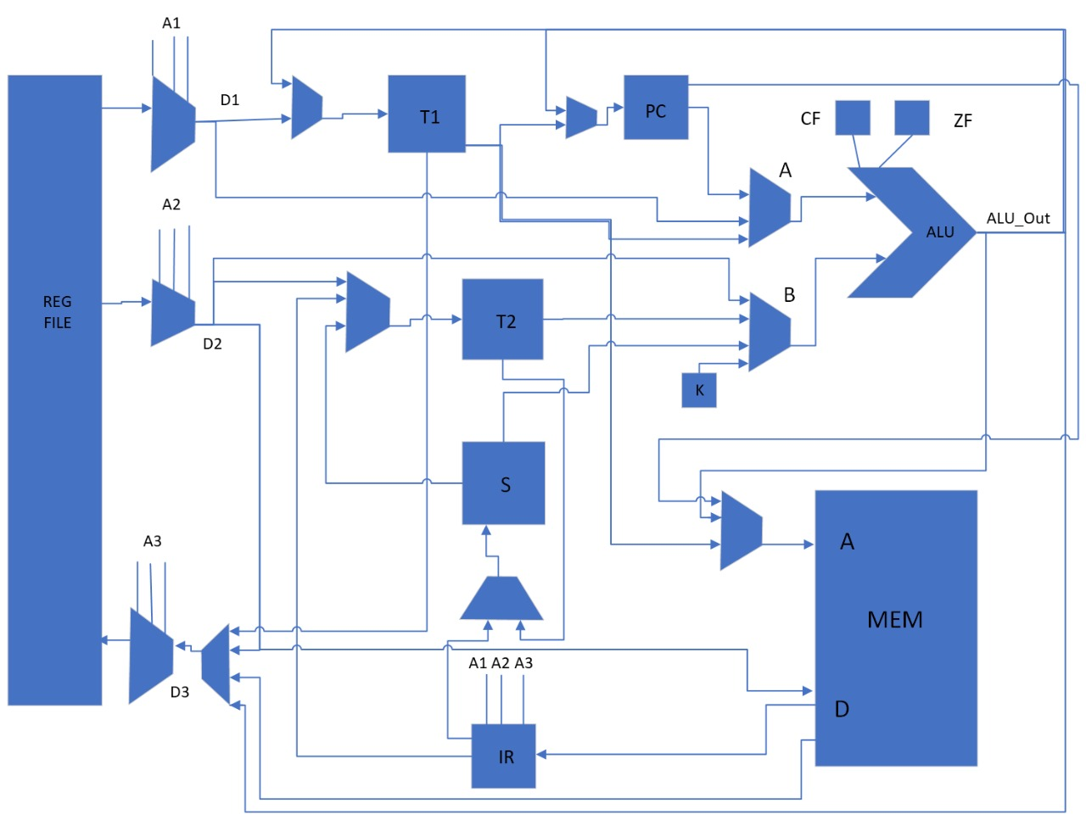

**CONTROL WORD DECODER**

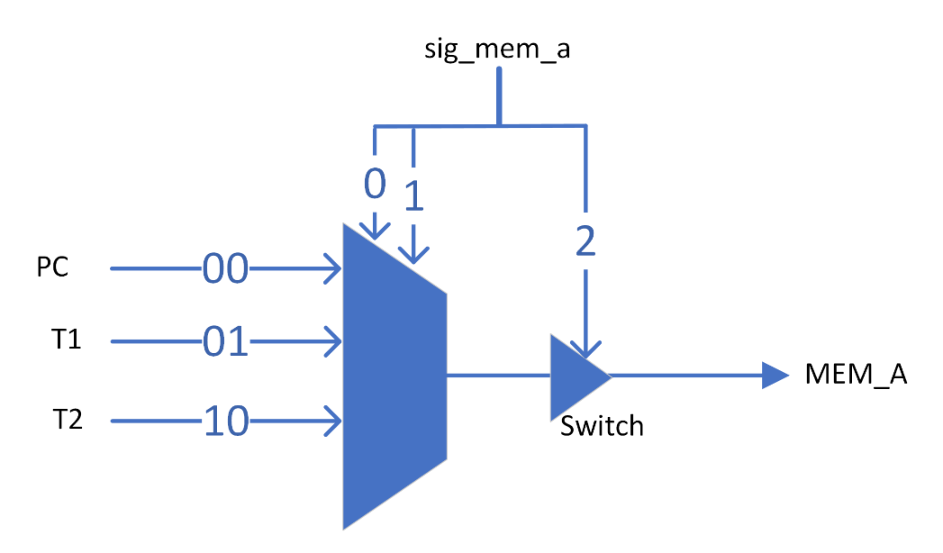MEM_A

|  |  |  |
| --- | --- | --- |
| USAGE IN FLOWCHART | EXAMPLE STATE | CONTROL BITS (PQR) |
| PC → MEM_A | S4 | 000 |
| RF_D2 → PC, MEM_A | S21 | 001 |
| T1 → MEM_A | S26 | 010 |
| T2 → MEM_A | S10 | 100 |
| NONE | S8 | 110 |

Decoder Logic

|  |  |
| --- | --- |
| SIG_MEM_A[1] | $$P.\overline{Q}.\overline{R}+\overline{P}.\overline{Q}.R$$ |
| SIG_MEM_A[2] | $$Q+R$$ |
| SIG_MEM_A[3] | $$\overline{P}.\overline{Q}+\overline{Q}.\overline{R}+\overline{P}.\overline{R}$$ |

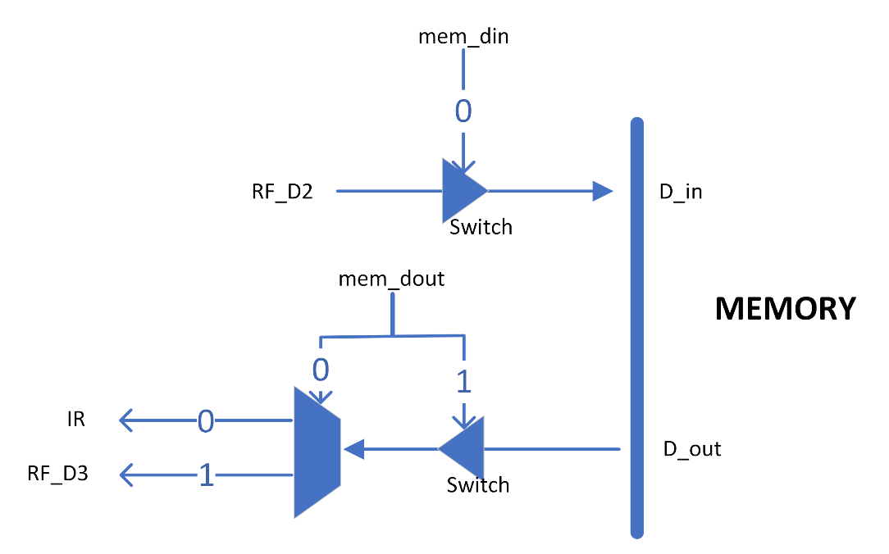MEM_D

|  |  |  |
| --- | --- | --- |
| USAGE IN FLOWCHART | EXAMPLE STATE | CONTROL BITS (PQ) |
| MEM_D → IR | S4 | 00 |
| MEM_D → RF_D3 | S17 | 01 |
| RF_D2 → MEM_D | S15 | 10 |
| NONE | S1 | 11 |

Decoder Logic

|  |  |
| --- | --- |
| SIG_MEM_DIN[1] | $$P.\overline{Q}$$ |
| SIG_MEM_DOUT[2] | $$Q$$ |
| SIG_MEM_DOUT[3] | $$\overline{P}$$ |

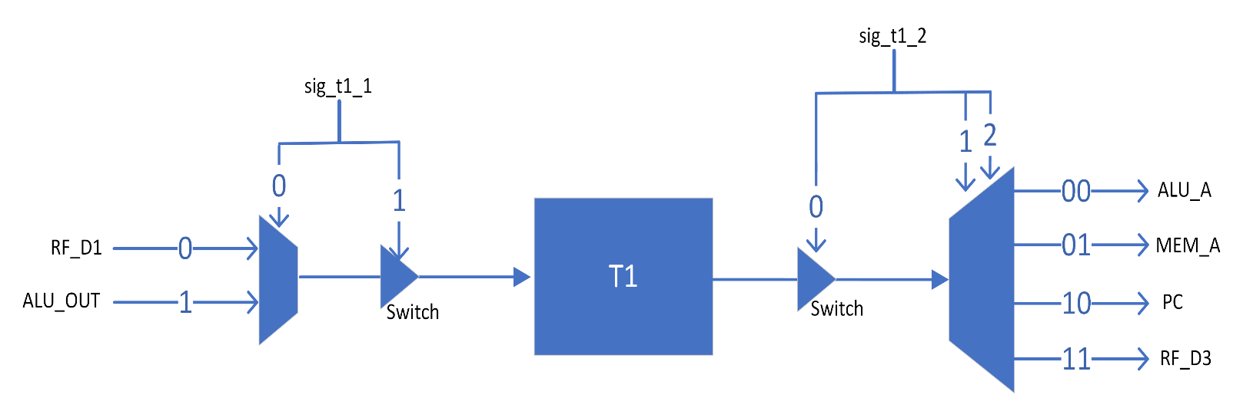T1

|  |  |  |
| --- | --- | --- |
| USAGE IN FLOWCHART | EXAMPLE STATE | CONTROL BITS (PQR) |
| RF_D1 → T1 | S5 | 011 |
| T1 → ALU_A | S2 | 001 |
| ALU_OUT → T1 | S27 | 100 |
| T1 → MEM_A | S17 | 010 |
| T1 → RF_D3 | S23 | 101 |
| T1 → PC, MEM_A | S26 | 110 |
| NONE | S25 | 000 |

Decoder Logic

|  |  |
| --- | --- |
| SIG_T1_1[1] | $$P.\overline{Q}.\overline{R}$$ |
| SIG_T1_1[2] | $$P.\overline{Q}.\overline{R}+\overline{P}.Q.R$$ |
| SIG_T1_2[3] | $$Q xor R$$ |
| SIG_T1_2[4] | $$P(Q xor R)$$ |
| SIG_T1_2[5] | $$\overline{P}(Q xor R)$$ |

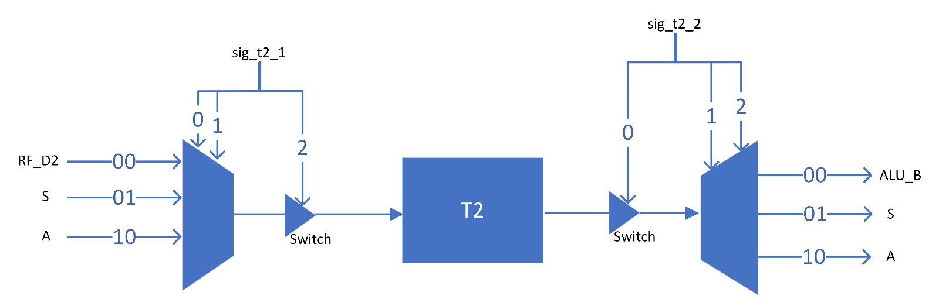T2

|  |  |  |
| --- | --- | --- |
| USAGE IN FLOWCHART | EXAMPLE STATE | CONTROL BITS (PQR) |
| RF_D2 → T2 | S5 | 001 |
| T2 → ALU_B | S2 | 010 |
| T2 → S | S6 | 011 |
| SE16 → T2 | S7 | 100 |
| IR8-0 → T2 | S8 | 110 |
| T2 → S1 → T2 | S9 | 101 |
| T2 → MEM_A, ALU_A  ALU_OUT → T2 | S10 | 111 |
| NONE | S3 | 000 |

Decoder Logic

|  |  |
| --- | --- |
| SIG_T2_1[1] | $$P.Q$$ |
| SIG_T2_1[2] | $$P+\overline{Q}.R$$ |
| SIG_T2_2[3] | $$\overline{P}.Q+Q.R+P.R$$ |
| SIG_T2_2[4] | $$(P xor Q)R$$ |
| SIG_T2_1[5] | $$P(Q xnor R)$$ |

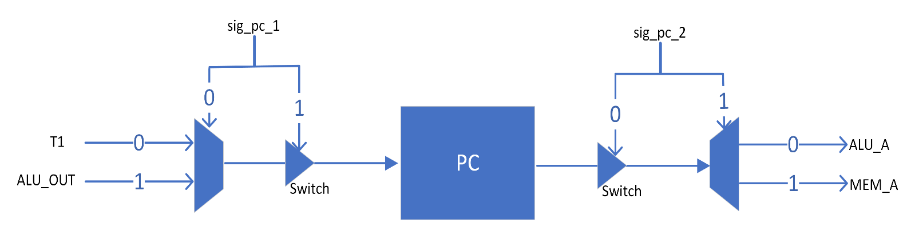PC

|  |  |  |
| --- | --- | --- |
| USAGE IN FLOWCHART | EXAMPLE STATE | CONTROL BITS (PQR) |
| PC → ALU_A  ALU_OUT → PC | S1 | 110 |
| PC → MEM_A | S2 | 010 |
| PC → ALU_A | S22 | 011 |
| ALU_OUT → PC | S19 | 001 |
| T1 → PC | S26 | 100 |
| RF_D2 → PC | S21 | 101 |
| NONE | S5 | 000 |

Decoder Logic

|  |  |
| --- | --- |
| SIG_PC_1[1] | $$\overline{P}.\overline{Q}.R+P.Q.\overline{R}$$ |
| SIG_PC_1[2] | $$P.\overline{R}+\overline{Q}.R$$ |
| SIG_PC_2[3] | $$\overline{P}.Q+Q.\overline{R}$$ |
| SIG_PC_2[4] | $$\overline{P}.Q.\overline{R}$$ |

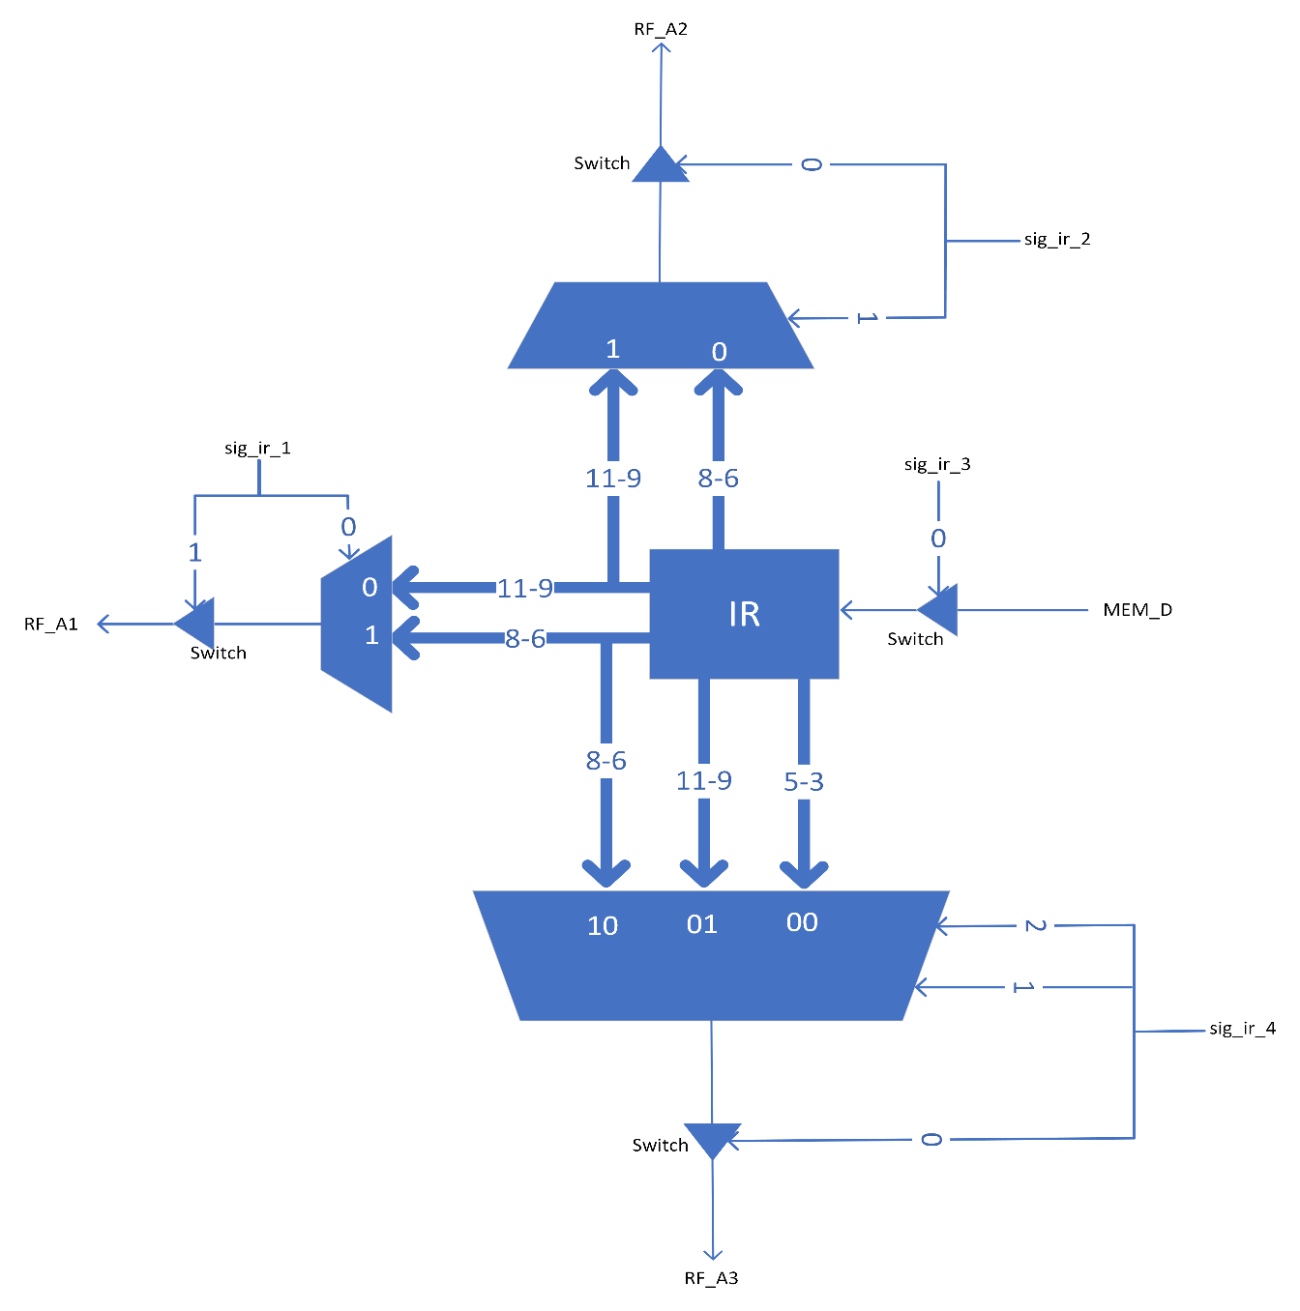IR

|  |  |  |
| --- | --- | --- |
| USAGE IN FLOWCHART | EXAMPLE STATE | CONTROL BITS (PQRS) |
| IR11-9 → RF_A1  IR8-6 → RF_A2  IR5-3 → RF_A3 | S5 | 0001 |
| MEM_D → IR | S4 | 0010 |
| IR11-9 → RF_A1  IR8-6 → RF_A2  IR5-0 → SE16 → T2 | S7 | 0011 |
| IR11-9 → RF_A3  IR8-0 → S7 → RF_D3 | S12 | 0100 |
| IR11-9 → RF_A1  IR8-0 → T2 | S8 | 0110 |
| IR11-9 → RF_A1  IR8-0 → SE16 → T2 | S18 | 0111 |
| IR11-9 → RF_A3  IR8-6 → RF_A2 | S20 | 1000 |
| IR11-9 → RF_A3  IR8-0 → SE16 → T2 | S22 | 1001 |
| IR11-9 → RF_A2  IR8-6 → RF_A1  IR5-0 → SE16 → T2 | S13 | 1011 |
| NONE | S17 | 0000 |

Decoder Logic

|  |  |
| --- | --- |
| SIG_IR_1[1] | $$P+\overline{Q}.S+Q.R$$ |
| SIG_IR_1[2] | $$\overline{P}.\overline{Q}.S+\overline{Q}.R.S+\overline{P}.Q.R$$ |
| SIG_IR_2[3] | $$\overline{P}.\overline{Q}.S+\overline{Q}.R.S+\overline{P}.Q.R.\overline{S}$$ |
| SIG_IR_4[4] | $$P.\overline{Q}.\overline{R}+\overline{P}.Q.\overline{R}.\overline{S}$$ |
| SIG_IR_4[5] | $$\overline{Q}.\overline{R}.S+P.\overline{Q}.\overline{R}+\overline{P}.Q.\overline{R}.\overline{S}$$ |
| SIG_IR_3[6] | $$\overline{P}.\overline{Q}.\overline{R}.S$$ |

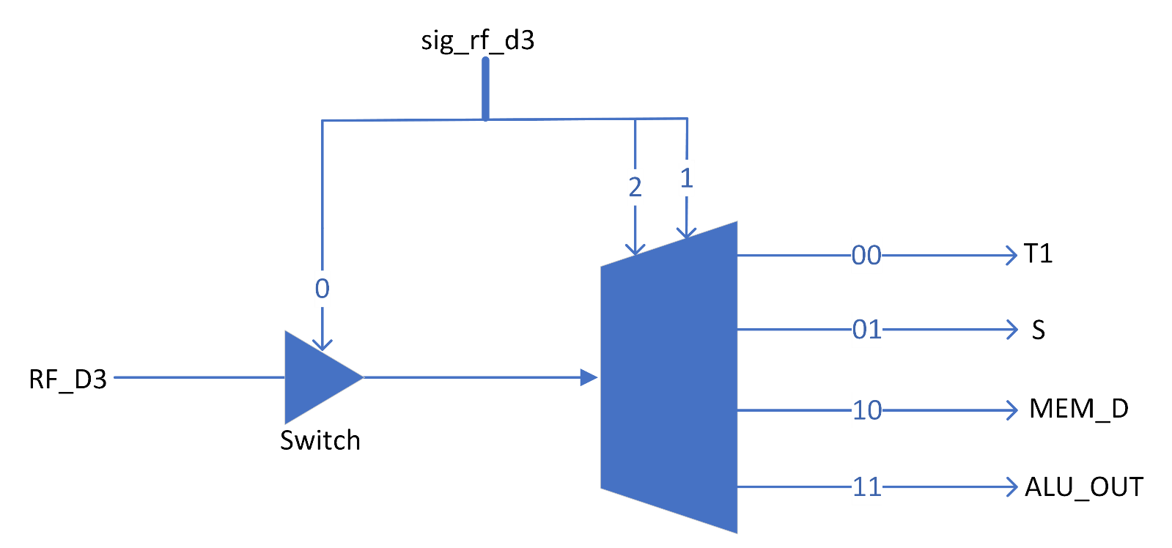RF_D3

|  |  |  |
| --- | --- | --- |
| USAGE IN FLOWCHART | EXAMPLE STATE | CONTROL BITS (PQ) |
| MEM_D → RF_D3 | S10 | 11 |
| ALU_OUT → RF_D3 | S21 | 01 |
| T1 → RF_D3 | S23 | 00 |
| NONE | S4 | 10 |

Decoder Logic

|  |  |
| --- | --- |
| SIG_RF_D3[1] | $$Q$$ |
| SIG_RF_D3[2] | $$\overline{P}.Q$$ |
| SIG_RF_D3[3] | $$\overline{P}+Q$$ |

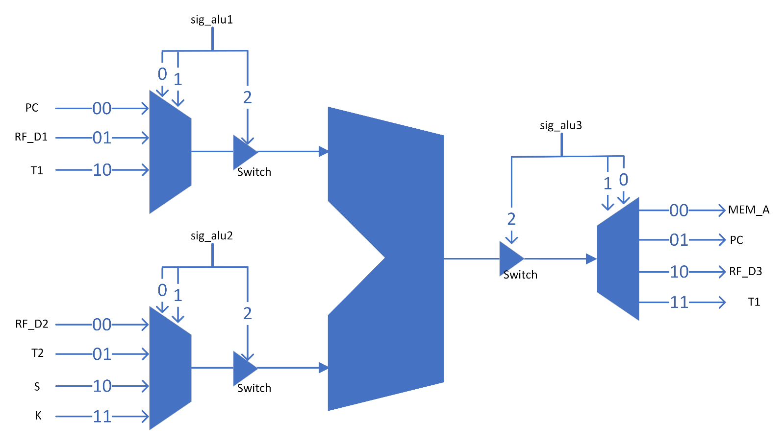ALU

|  |  |  |
| --- | --- | --- |
| USAGE IN FLOWCHART | EXAMPLE STATE | CONTROL BITS (PQRS) |
| PC → ALU_A  +1 → ALU_B  ALU_OUT → PC | S1 | 0000 |
| T1 → ALU_A  T2 → ALU_B  ALU_OUT → RF_D3 | S2 | 0001 |
| T2 → ALU_B  RF_D1 → ALU_A  ALU_OUT → T1 | S27 | 0011 |
| T1 → MEM_A, ALU_A  +1 → ALU_B  ALU_OUT → T1 | S10 | 1011 |
| T1 → ALU_A  T2 → ALU_B  ALU_OUT → PC | S19 | 0100 |
| PC → ALU_A  +1 → ALU_B  ALU_OUT → RF_D3 | S21 | 0101 |
| PC → ALU_A  +1 → ALU_B  ALU_OUT → T1 | S22 | 0110 |
| PC → ALU_A  T2 → ALU_B  ALU_OUT → PC | S23 | 0111 |
| PC → ALU_A  IR5-0 → SE16 → ALU_B  ALU_OUT → T1 | S24 | 1000 |
| RF_D1 → ALU_A  RF_D2 → ALU_B | S25 | 1001 |
| NONE | S4 | 1010 |

Decoder Logic

|  |  |
| --- | --- |
| SIG_ALU1[1] | $$Q.\overline{R}.\overline{S}+P.R.S+\overline{P}.\overline{Q}.\overline{R}.S$$ |
| SIG_ALU1[2] | $$\overline{P}.\overline{Q}.R$$ |
| SIG_ALU1[3] | $$\overline{P}.\overline{R}+\overline{P}.Q+\overline{P}.S+P.\overline{Q}$$ |
| SIG_ALU2[4] | $$\overline{Q}.\overline{R}.\overline{S}+\overline{P}.R.\overline{S}+P.R.S+Q.\overline{R}.S$$ |
| SIG_ALU2[5] | $$\overline{P}+R.S$$ |
| SIG_ALU2[6] | $$\overline{P}.\overline{R}+\overline{P}.Q+\overline{P}.S+P.\overline{Q}$$ |
| SIG_ALU3[7] | $$\overline{P}.\overline{R}+\overline{P}.Q+\overline{Q}.R.S+P.\overline{Q}.\overline{S}$$ |
| SIG_ALU3[8] | $$P.\overline{R}.\overline{S}+\overline{P}.\overline{R}.S+\overline{P}.R.\overline{S}+\overline{Q}.R.S$$ |
| SIG_ALU3[9] | $$\overline{P.}\overline{S}+\overline{R}.\overline{S}+R.S$$ |