I have used Google Colab opensource just to demonstrates the ETL pipeline. The best option is to use cloud like Azure Databricks for real time data loading scenario along with Data factory and other services of cloud if required.

**Github Location:** https://github.com/AkshayWankhade30084/Analytic_solution

**Source**:

<https://www.kaggle.com/datasets/abdullah0a/telecom-customer-churn-insights-for-analysis>

Note: In real time it should be as original. In this task extracted the csv file and used as source just to reduce the time and extract the insights by easiest way.

**HG_Insights_Assignment:**

**sqlite3 has been used as database to create the different tables**

**Approach 1 –**

Just login to google colab by using gmail account and import this notebook.

[**Welcome To Colab - Colab**](https://colab.research.google.com/)

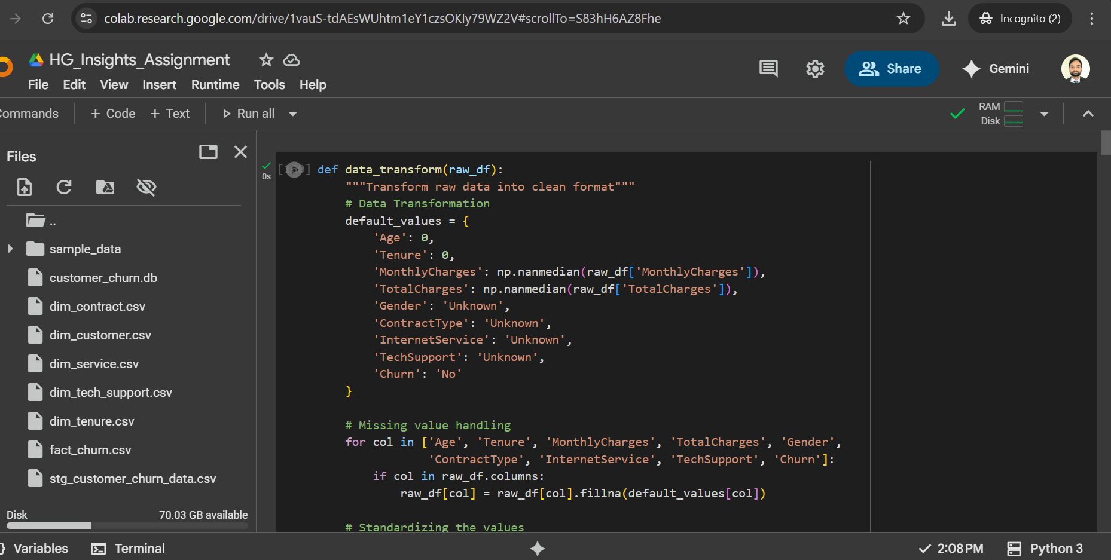

**Approach 2 –**

You can directly import (**HG_Insights_Assignment** ) into data bricks of any cloud or Anaconda and install the Jupiter notebook. Below is set up file.

[**https://www.anaconda.com/products/navigator**](https://www.anaconda.com/products/navigator)

**Approach 3 –**

Install the python and execute HG_Insights_Assignment .py file

[**https://www.python.org/downloads/**](https://www.python.org/downloads/)

**Scheduling:**

You can the azure datafactory pipeline by using custom activity and then set up the trigger to execute it on hourly basis

You can also schedule the workflow inside the data bricks inside the Data bricks

**Note: I do not have permission to install any software or third-party tool including python hence not able to show case you scheduling this file.**

**Reporting:**

Used power bi to showcase the data visualization.

You can install the power bi desktop on local and directly open [churn_customer_Analysis.pbix](https://github.com/AkshayWankhade30084/Analytic_solution/blob/main/churn_customer_Analysis.pbix) file,

Below are some screenshots.

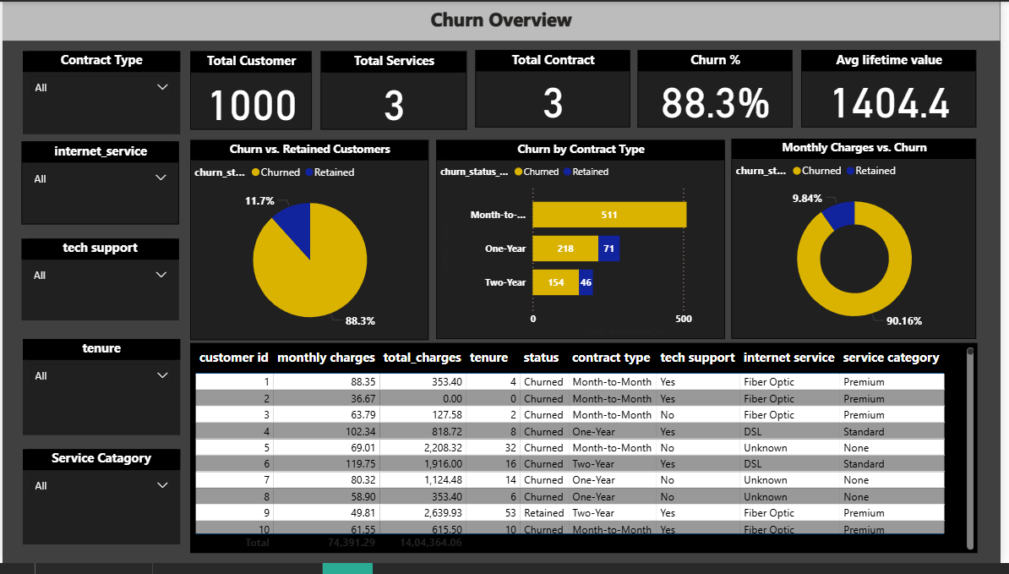

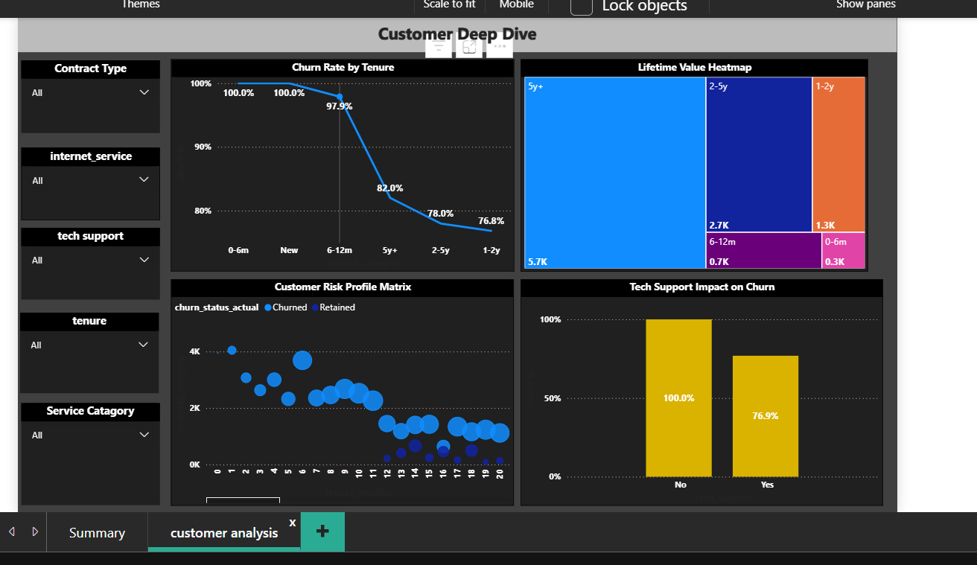

Note: To connect customer_churn.db to power bi need to install ODBC driver. Which is again limitation on my system. Hence exported the table file into csv and published it on github and then connected the power bi to same.