240701031 - AKSHAYA K
EXPERIMENT – 03
SURVEY REPORT ON EMERGING TRENDS IN LOW-CODE APPLICATION DEVELOPMENT

1. AIM
To study the emerging trends in low-code application development, understand how low-code approaches differ from traditional application development, examine their benefits and challenges, and compare existing low-code application development platforms.

2. Traditional application development vs emerging trends in low-code application development
Traditional application development relies mainly on manual programming, where developers design the user interface, implement business logic, connect databases and APIs, test the application, and manage deployment. This approach provides detailed control and is suitable for highly customized and complex systems, but development can require considerable time and programming expertise.
Low-code application development uses visual development environments, drag-and-drop components, pre-built templates, reusable modules, workflow designers and ready-made integrations. It reduces the amount of repetitive code that developers need to write and supports faster development of business applications. Zoho Creator, shown in the supplied reference screenshots, is an example of this approach.
Aspect | Traditional Application Development | Emerging Low-Code Development
Development method | Manual programming using languages, frameworks and libraries. | Visual development using components, templates and configuration with reduced coding.
Development speed | Generally requires more time for implementation and testing of individual components. | Faster for many business applications because of reusable components and visual workflows.
Technical expertise | Usually requires strong programming and software development knowledge. | Can support both professional developers and technically skilled business users.
Customization | Provides extensive control over application architecture and behaviour. | Provides substantial customization within the capabilities and limits of the platform.
Integration | Often requires custom API development and configuration. | Common integrations and connectors are frequently available as built-in features.
Automation | Implemented through custom code, scripts and external tools. | Workflow automation can often be configured visually.
Deployment | May require separate build, server and deployment configuration. | Many platforms provide integrated cloud deployment and application management.
Typical use | Complex, specialized and highly customized applications. | Forms, portals, dashboards, workflows, automation and data-driven business applications.

3. Benefits and Challenges in Low Code.
Benefits:
- Faster application development through visual tools, templates and reusable components.
- Reduced amount of repetitive coding required for common application features.
- Rapid prototyping and easier modification based on user feedback.
- Workflow automation through visual process designers.
- Built-in connectors and integrations can simplify connection with databases and external services.
- Allows professional developers to concentrate on complex business logic while simpler applications can be created with less coding.
- Useful for developing forms, reports, dashboards and other business applications.
Challenges:
- Platform dependency can make applications closely tied to the selected low-code provider.
- Highly specialized requirements may need custom code or may exceed platform capabilities.
- Security, privacy and access-control settings must be configured carefully.
- Large or complex applications may require additional performance optimization and architecture planning.
- Migration between different low-code platforms can be difficult because application models and workflows differ.
- Uncontrolled citizen development can create governance, duplication and maintenance problems.
- Licensing and premium connector costs can affect the total cost of an application.

4. Comparison of existing platforms (tabulation)
The following table compares commonly used low-code and no-code platforms based on their primary focus, features and typical application areas.
Platform | Provider | Primary Focus | Key Features | Automation / Integration | Typical Use
Zoho Creator | Zoho | Business applications | Forms, reports, dashboards, workflows and visual application building | Strong | Business forms, service management and workflow applications
Microsoft Power Apps | Microsoft | Business and enterprise applications | Canvas apps, model-driven apps, connectors and Dataverse | Strong | Enterprise business applications and Microsoft ecosystem solutions
OutSystems | OutSystems | Enterprise application development | Visual development, web/mobile applications and integrations | Strong | Enterprise web and mobile applications
Mendix | Siemens | Enterprise low-code development | Visual modeling, collaboration, integrations and deployment tools | Strong | Enterprise applications and multi-team development
AppSheet | Google | Data-driven applications | No-code app creation, data connections and automation | Strong | Operational and data-centric applications
Salesforce Platform | Salesforce | CRM and business applications | Data model, workflows, application development and integrations | Strong | CRM-related and enterprise business applications
Zoho Creator interface shown in the supplied reference material
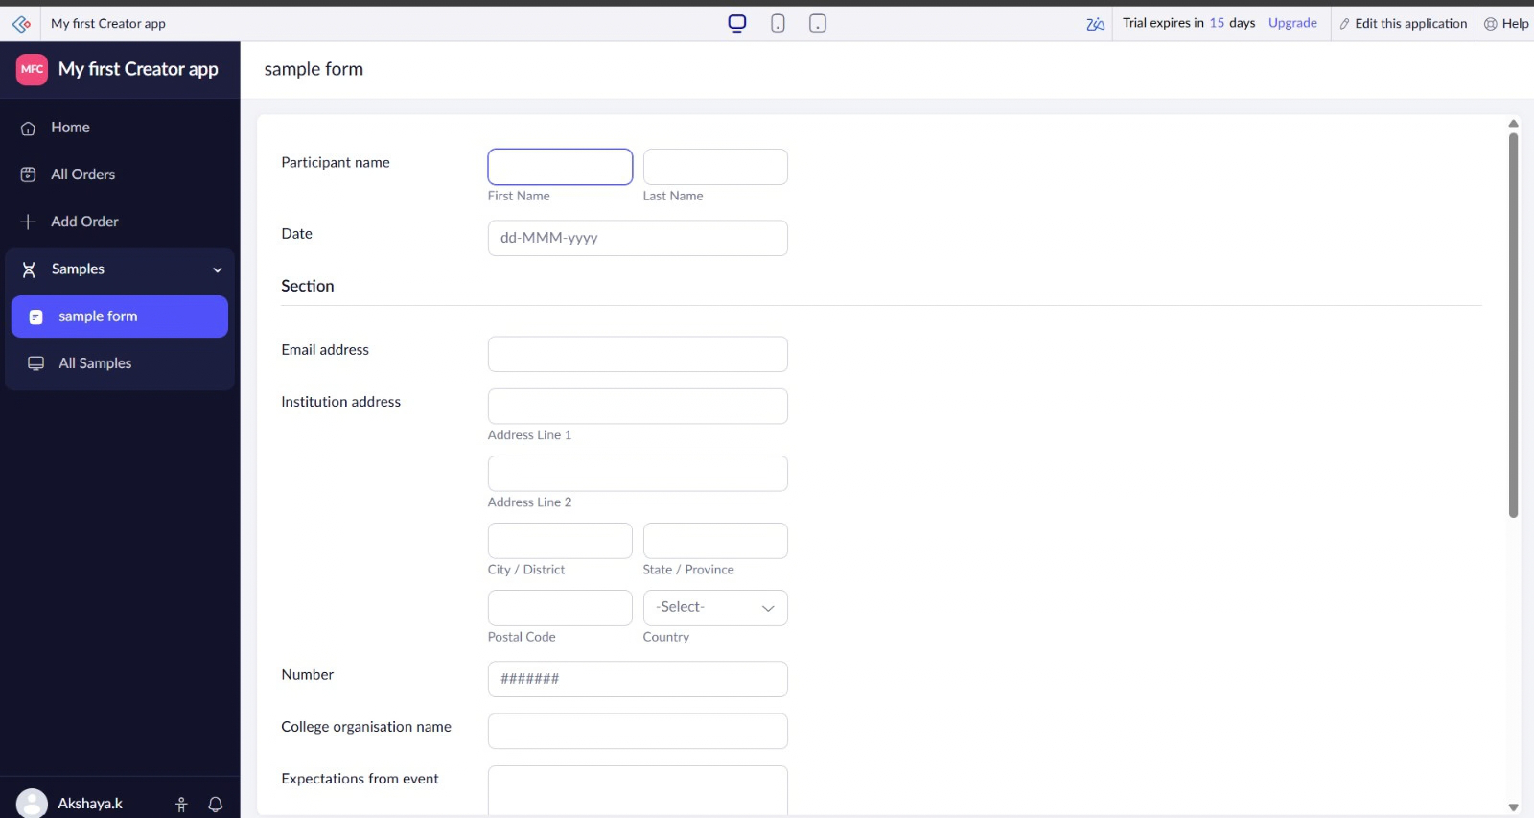
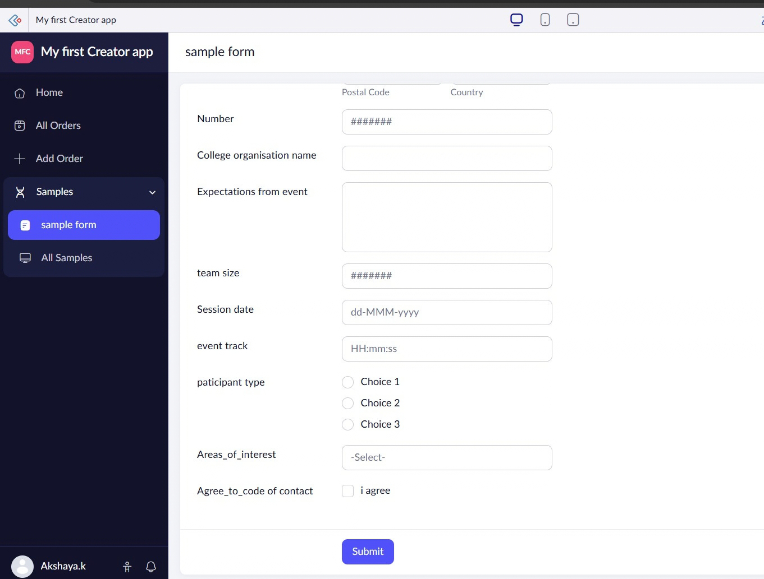

5. result
The survey shows that low-code application development provides a visual and faster approach to building many business applications while reducing repetitive programming effort. The study also shows that low-code platforms offer useful capabilities such as reusable components, workflow automation, integrations, forms, reports and dashboards. At the same time, platform dependency, customization limits, security, governance, performance and licensing considerations remain important when selecting and using a low-code platform. The comparison demonstrates that different platforms focus on different application and organizational requirements.

