65 Questions 90 min 700/1000 pass

www.aws.training 🡪 select exam and date🡪location🡪cost

Request exam accommodations🡪ESL+30 🡪 for extra 30 min.

* Amazon web services is the world’s most comprehensive and broadly adopted **cloud** platform, offering over **200 fully featured services from data centers globally**. Millions of customers-including the fastest growing startups, largest enterprises, and leading government agencies- are using AWS to lower costs, become more agile, and innovative faster.
* **Horizontal scaling**🡪adding extra servers. **Vertical** **scaling**🡪expanding the memory, cpu of the server.
* **Reliability🡪** the ability of workload to perform its intended function correctly and consistently when it’s expected to.
* **Scalability🡪** the ability of the system to increase the resources allocated the match demand.
* **Elasticity🡪**The ability of the system to increase and decrease the resources allocated(usually horizontally)to match demand and it implies automation.
* **Economy of Scale 🡪** AWS has an enormous amount of infrastructure resources and that means they can provide competitive pricing.
* **Cloud infrastructure management benefits🡪** 1.full cost transparency. 2.Mechanical sympathy.3.Ability to switch technologies as demand changes.4.Recover automatically from failure. 5.Ability to experiment. 6.Deploy globally without data center management.
* As long as we use EC2 services, OS patch management on VMs are still a reqiurement after migration.
* AWS data centers are managed by AWS staff and customers are not required to assist with environmental controls.
* All AWS Assests are virtualized from the customer perspective, and while customer can be impacted by the broken hardware, they are not responsible for mitigation.
* Customers have a responsibility to implement their own business continuity plan, but it only involves AWS services and features and not data center foundational hardware.
* TCO-Total Cost of Ownership, all the diff elements that are required as the ownership life cycle of some set of hardware is concerned.
* CapEx🡪Capital Expenditure, upfront payment,maintaince contracts,own the product and predictable costs.
* OpEx🡪Operational Expenditures,subscriptions,pay as you go,operations have their own cost,variable or often unpredictable
* Primary Principles of Cloud Economics🡪1.Pay as you go 2.Save when you commit 3.Pay less using more
* KTLO operations(Keeps the Lights On)🡪1.Any zero sum game operation 2.more os based resources = more operations 3.Prevents corporate agility 4.Doesn’t scale
* TCO (total cost of ownership) can be reduced by 1.Choosing EFS for a shared file system 2.Using RDS for a MySql database 3.Deploying NoSQL table in DynamoDB
* Design Principles🡪1.Stop guessing your capacity needs. 2.Test systems at production scale.3.Automate to make architectural experimentation easier.4.Allow for Evelutionary architectures 5.Drive architectures using data 6.Improve through Game days.
* Well Architected Framework 🡪will teach you how to design,use and manage workloads in the cloud.
* 6 pillars of Well Architected Framework🡪1.Operational Excellence 2.Security 3.Reliability 4.Performance efficiency 5.Cost optimization 6.Sustainability
* Operational Excellence🡪The ability to support development and run workloads effectively,gain insight into their operations, and to continously improve supporting proceses and procedures to deliver business value.1.Perform operations as code 2.Annotated Documentation 3. Make frequent,small,reversible changes. 4.Refine operations procedures frequently 5.Anticipate failure 6.Learn from all operational failures.
* Performance Efficiency🡪The ability to use computing resources efficiently to meet system requirements, and to maintain that efficiency as demand changes and technolohgies evolve.1.Democratize advanced technologies 2.Go global in minutes 3.Use serverless architectures 4.Experiment more often 5.Mechanical sympathy.
* Security🡪The ability to protect data,systems and assests to take advantage of cloud technologies to improve your security. 1.Implement a strong Identity foundation 2.Enable Traceability 3.Apply Security at all layers 4.Automate Security at all layers 5.Protect data at transit and rest 6.Keep people away from data 7.Prepare for Security Events.
* Reliability🡪The ability of a workload to perform its intended function correctly and consistently when it is expected to.This includes the ability to operate and test the workload through its total lifecycle.1.Test recovery procedures 2.Automatically recover from failure 3.Scale horizontally to increase aggregate system availability 4.Stop guessing capacity 5.Manage change in automation.
* Cost optimization🡪The ability to run systems to deliver business value at the lowest price point.1.Adopt a consumption model 2.Measure overall efficiency 3.Stop spending money on data center operations.4.Analyze and attribute expenditure 5.use managed services to reduce cost of ownership.
* Sustainability🡪Ability to focus on environmental impacts,especially enaergy consumption and efficiency, since they are important levers for architects to inform direct action to reduce resource usage.1.Understand your impact 2.Establish sustainability goals. 3.Maximize utilization 4.Anticipate and adopt new,more efficient hardware and software offerings. 5.Use managed services 6.Reduce the downstream impact of your cloud workloads.
* Shared Responsibility model🡪AWS is responsible for 1. Security of the Cloud. 2. Physical and Environmental controls of Data centers. Customer is responsible for 1.Security in the cloud. 2.Region choices 3.Service/feature choice.
* Both AWS and customer are responsible for 1.Patch management 2.Configuration management 3.Awareness and training.
* Customer responsibilities are divided into 3 layers- 1.Infrastructure Services (IAAS) 2.SAAS 3.PAAS
* AWS responsibilities are divided into 3 layers- 1.Infrastructure Services (IAAS) (EC2,VPC,EBS)2.SAAS(S3,DynamoDB,Lambda) 3.PAAS(RDS,Elastic bean stalk,Amazon redshift)
* Auditing and reporting🡪1.Cloudwatch(monitoring service,Collect and persist metrics, Generate alarm and notifications.2.Cloudwatch logs(log monitoring service,collect and persist logs,analyze patterns for anomalies.3.Config(Recording streams,capture changes and configurations,view resource associations,evaluate resources for compliance)4.Cloudtrail(Audit trail of AWS API actions,Log success and failures,Deliver to s3,Deliver to Cloudwatch logs,searchable history,insights event reporting,Management and data event options
* Least privilege concepts🡪1.Role based Access control(RBAC)(Access based on identity,direct attached policies,group membership,instance profiles,federated identities )2.Attribute based access control(ABAC)(Access based on properties,principle tags,resource tags,request properties, policy conditions.)
* ARN(Amazon Resource names)🡪Global Unique identifier.It will have 6 fields-

1.arn

2.Partition🡪aws/aws-cn/aws-us-gov

3.Service🡪ec2/s3/iam

4.Region🡪us-east-1/eu-west-1/ap-south-1

5.account-id🡪12 digit number

6.resource-id🡪user/chad,instance/i-XXXXX,volume/vol-XXXX

* Identity examples🡪12 digit account id,IAM user ARN,IAM role ARN,Specific assumed-role user,federated users(web identity),federated users(SAML),AWS service.
* IAM password policy options🡪1.Minimum length 2.Strength 3.Expiration days 4.Expiration=Admin reset 5.Self reset 6.No password reuse.
* MFA support🡪1.users and roles 2.S3 MFA delete 3.Device:virtual 4.Device:U2F 5.Devices:hardware.
* Root user characteristics🡪1.Email address as user name 2.Generic login url 3.Access to unique tasks.
* Root account unique tasks🡪1.change account settings 2.Activate access to billing and cost management console 3.view billing tax invoices 4.Restore IAM user permissions for only IAM administrator 5.Configure S3 bucket for MFA delete 6.Edit/delete s3 bucket policy with invalid VPC id or VPC Endpoint ID.7.Signup for govcloud.8.Close the account.
* IAM user🡪1.A principle identity, 2.Associated with permissions-group,inline,managed 3.Associated with permission boundary 4.Container for credentials.
* IAM user credentials🡪1.Sign-in credentials 2.Access keys
* IAM Identity policy types🡪1.Managed Policy🡪a.Standalone resources, b.Associated with 1+Iam users,groups,roles. C. Versioned up to 5 revisions, d.AWS or customer managed policies. 2.Inline policy🡪a.Embedded with Iam user , group or role b.No versioning available
* Session policy🡪Parameters passed during creation of temporary session,Use with IAM roles,Use with federated users.
* Network security options-

1.Route tables🡪operate on traffic leaving a subnet and for another subnet or network

2.NACLs(Network access control lists)🡪operate on traffic entering or leaving a subnet.

3.Public subnet🡪Bidirectional internet access via IGW(Internet gateway)

4.Private subnet🡪Outbound internet access via proxy (NAT GW)

5.VPC/VPN only subnet 🡪No internet access or only via VPC/DX

6.Security group ingress rules🡪Operate on inbound initiated traffic.

7. Security group egress rules🡪 Operate on outbound initiated traffic.

8.NAT gateways🡪used to proxy outbound traffic to public or private destinations.

9.Gateway load balancers🡪provide scaling for outbound proxy,router,NAT or other security applications.

10.DNS firewall

11.Firewall manager

12.WAF (web application firewall)

13.Guard duty

* Security documentation types🡪

1.Premium support knowledge center.

2.Security center

3.Security Whitepapers.

4.Security Blog

* AWS trusted Advisor🡪1.Online tool, not a service 2.Cost optimization checks 3.Security checks 4.Fault tolerant checks 5.Performance checks.
* Free security checks in AWS trusted Advisor🡪1.Security groups-specific ports unrestricted. 2.AWS IAM user 3.MFA on root account 4.Amazon EBS public snapshots 5.Amazon RDS public snapshots.
* Premium Security checks🡪1. Security groups unrestricted access 2. Amazon RDS Security group access risk. 3. AWS cloud trail logging 4.Amazon route53 and SPF resource record sets.5.ELB listener security 6.ELB security groups 7.Amazon cloudfront custom ssl certificates in the IAM certificate store.8.Amazon cloudfront ssl certificate on origin server.9.Exposed access keys.10.AWS IAM password policy 11.AWS IAM access key rotation
* Access AWS(Direct credentials)🡪1.HTTP/HTTPS Custom 2.CLI 3.SDK 4.AWS console
* Infrastructure as code (IAC)🡪1.Use SDLC best practices for infrastructure 2.Cloudformation 3.OpsWorks.4.Third party tools(terraform,ansible,saltstack)
* AWS unified CLI🡪 aws <options> <Command> <subcommand> [parameters]
* Cloud deployment models🡪

1.Cloud native🡪1.All infrastructures in the cloud. 2.All applications in the cloud a.Created new b.Migrated from on premises.

2.Hybrid Cloud🡪1.Cloud native resources 2.On-premisis resources 3.Connect cloud resources with internal Systems

3.On-premisis/private cloud🡪1.All infrastructure external to the cloud.2.All applications are external to the cloud.3.bare metal hardware 4.private cloud infrastructure

* Hybrid connectivity options🡪1.Public internet connection 2.Private connection via direct connect (AWS partner data center)3.Encrypted connection via VPN
* AWS data center🡪1.10s of thousands of servers 2.Independent power,A/C and internet 3.Custom network hardware.4.Commodity server and storage hardware 5.No services.
* Data center feature scopes🡪1.Cluster placement group, 2.Dedicated instances 3.Dedicated hosts
* Availability zones🡪1.One or more data centers 2.Scope for infrastructure resources.3.HA building blocks
* Multi AZ-feature scope🡪1.RDS multi-Az 2.Aurora serverless 3.Auto scaling on EC2 4.Elastic load balancer.
* Regions🡪1.Multiple,physically separated AZ 2.Service API endpoints hosted here. 3.Common unit of resource scope
* Region feature scope🡪1.All service API endpoints 2.S3 bucket 3.DynamoDB table 4.Lambda function 5.WAF web acls 6.VPC networks.
* Local zone scope🡪1.VPC subnets 2.EC2 instance 3.EBS volumes 4.RDS database instance 5.Application load balancer.
* Multi-region scope🡪1.AWS backup plan 2.S3 replication 3.RDS read replica DynamoDB global table
* Region selection criteria🡪1.Service Availability 2.Co-locate with users 3.Co-locate with infra 4.Dtaa residency 5.Multi region DR(Disaster recovery)
* Single edge location🡪Separate infrastructure from regions 2. Connected to region networks 3.Scope for global services 4.Used for caching.
* Global scope🡪1.Route 53 for DNS 2.CloudFront distribution for CDN 3.WAF web ACL [4. Lambda@Edge](mailto:4.Lambda@Edge) functions.
* Infrastructure Categories🡪

1.Compute🡪services and resources that execute code.

2.Storage🡪Services and resources for block,file system and object storage.

3.Networking🡪classic networking,DNS,CDN and load balancers.

4.Database🡪Structured storage including relational and NoSQL offerings.

* AWS Compute services🡪

1.Virtual machines.(EC2)

2.Docker and windows container.(ECS,EKS)

3.Serverless functions(lambda)

4.Batch container process(Batch)

5.Website platforms🡪(Beanstalk,Lightsail)

* EC2 basics(Elastic compute cloud)🡪1.AZ scope 2.Virtual machines 3.Flexible resources 4.Flexible OS

1.Processor and memory🡪1.CPU(AMD,intel,Gravitron,M1)

2.Storage🡪Instance storage is directly attached to the EC2 host hardware, EBS(Elastic block storage)is reached via network but presented as local block storage.

* AMI bacis(Amazon machine image)🡪Snapshot of root file system

1.Region scope

2.Root volume snapshot.

3.Launch permissions

4.Block device mappings for non-root volumes.

* EC2 AMI sources🡪1.Community 2.Market place 3.My AMIs
* Ec2 OS tasks🡪1.User account maintenance 2.Disk space maintenance 3.Software package maintenance 4.Security and OS updates
* EC2 resource management🡪1.Instance resize 2.Instance recovery 3.Add/remove EBS storage 4.Add/remove network interfaces.
* EC2 auto scaling🡪1.AZ scope 2.Multi-AZ support 3.Horizontal EC2 scaling
* Auto scaling Architecture(4 primary resources)🡪1.Launch templates 2.Auto scaling groups 3.Scaling polices 4.Scheduled actions.
* Auto scaling types🡪1.Dynamic scaling 2.Predictive scaling
* ELB(Elastic load balancing)🡪1.AZ scope 2.Multi-AZ support 3.Managed Load balancing service 4.Distribute traffic to backend
* Load balancer architecture🡪1.Client sends traffic at Layer 4 or 7 to ELB endpoint. 2.ELB either proxies or passes traffic through to EC2.(target groups)
* Types of LB🡪

1.Application LB 🡪1.Layer 7 only(HTTP,HTTPS) 2.Inbound traffic 3.internet facing or internal only 4.Multiple TLS certs 5.path based routing 6.Redirect support 7.WAF support

ALB use cases🡪 1.Stateless web applications 2.Stateful application servers. 3.Anything using HTTP or HTTPS

2.Network LB🡪1.layer 4 only 2.Inbound traffic 3. internet facing or internal only 4.1 TLS cert 5.TCP and UDP 6.No security group.

NLB use cases🡪 1.TCP applications 2.TCP/UDP combo listners 3.High performance 4.Low latency

3.Gateway LB🡪 1.Layer 3 only 2.Outbound traffic 3.Geneve protocol 4.deploy,manage, and scale virtual applications.

GWLB use cases🡪1.Outbound web traffic 2.Data loss prevention 3.Network intrusion detection and prevention 4.Deep packet inspection.

* Core storage services🡪

1.AWS Block storage service.(EBS)

* + - * Elastic block store basics🡪 1.AZ scope 2.EC2 block storage 3.HDD/SSD(default) 4.OS views as local block device

2.File storage(EFS)

3.Block storage(S3 simple storage service,Glacier)

* + - * + S3 basics🡪1.Region scope 2.Object storage 3.Buckets and objects 4.Designed for durability.
        + S3 security features🡪1.Bucket policy 2.Block public access 3.Bucket/object ACLs

4.Object encryption.

* + - * + S3 lifecycle rules🡪 1.Transition current versions 2.Transition previous versions 3.Expire current versions 4.Delete expired delete markers 5.Delete incomplete multi part uploads.

3.On premises storage(AWS Snow ball,Storage gateway)

* + - * Snowball basics🡪1.Hardware appliance 2.Object store 3.Encrypted at rest 4.Upto 100 Tb capacity.
      * Storage gateway basics🡪1.Virtual appliance 2.Requires direct attached storage (On premises)3.Requires EBS storage (Ec2)
      * Storage gateway types🡪1.S3 file GW 2.FSx file GW 3.Tape GW 4.Volume GW

4.Backups

* Network services in AWS🡪

1.VPC🡪1.Virtual private cloud 2.Region scoped 3.Private network for many AWS resources

* + - * VPC CIDR address🡪1.Largest IPv4 CIDR=/16(65,536 address) 2.Smallest IPv4 CIDR=/28(16 IP address)
      * Subnets🡪1.Contigious range of IP addresses in a VPC 2.AZ scoped 3.Local zone scoped 4.Associate with Route table and Network ACL
      * Subnet types🡪1.Public subnet(Bidirectional internet access via IGW) 2.Private subnet(Outbound internet access via proxy(NAT GW)) 3.VPC/VPN only subnet(No internet access,only via VPN/DX)
      * Route table🡪1.Associate with 1+ subnerts. 2.Evaluated at subnet boundary for outbound traffic 3.Destination CIDR 4.Target GW
      * Internet gateway 🡪1.Attach to VPC 2.AWS public network access 3.AWS service API access 4.Internet access
      * NAT GW🡪1.Deploy into subnet 2.Highly available 3.Use for outbound internet access
      * Network ACLs🡪1.Associate with 1+ subnets 2.Stateless firewall resources 3.Inbound/outbound rules 4.Allows/deny rules 5.Rules evaluated in order.
      * Gateway endpoint🡪1.Attach to VPC 2.S3 and Dynamo DB access 3.Same region resources only 4.Route table entry required
      * Interface endpoint 🡪1.Associated with 1 subnet 2.Associated with 1 security group 3.Associated with 1 AWS service 4.Creates ENI in subnet 5.Overrides DNS
      * VPC peering 🡪1.Attach 2 VPC networks 2.Same region 3.Same account 4.Cross region 5.Cross account 6.No overlapping CIDR
      * VPC Security groups🡪1.Associated with 1+ network interfaces 2.Statefull firewall resource 3.Inbound/outbound rules 4.Default deny 5.Rules evaluated as a whole.
      * Route 53🡪1.Globally scoped 2.DNS service 3.Traditional DNS 4.DNS registrar 5.DNS zones 6.Health checks 7.Resolver endpoints 8.Resolver rules
      * Types of routing🡪1.Simple 2.weighted 3.Latency 4 failover 5.Geo location

2.Network connectivity options (Transit gateway, direct connect,site-site vpn,peering connection,Private link,Resource access manager)

3.Edge services🡪ELB,Cloudfront,Route53,global accelerator,API GW

4.Monitoring and trouble shooting(Flow logs, reachability analyzer,Access logs,TGW network manager)

* + - * Hybrid network connectivity🡪2 types

1.Site-to-site vpn🡪1.Attach to VPC 2.Region scoped 3.Hardware backed 4.IPSEC encryption

2.Direct connect🡪1.On-prem to AWS network connectivity 2.Region scoped 3.Multi region supported(only in US) 4.Requires BGP and 802.1q VLANS

* AWS Database services🡪

1.Relational database services🡪1.RDS 2.Aurora 3.Redshift

Transactional Relational database services🡪1.RDS 2.Aurora

Dataware house service🡪1.Redshift

2.NoSQL database services🡪1.Neptune 2.Keyspaces 2.DocumentDB 4.DynamoDB 5.Elasticache 6.Timestream

Key/Value NoSQL service🡪1.DynamoDb 2.Keyspaces

Graph NoSQL service 🡪Neptune

Document NoSQL service🡪Document DB

Timeseries NoSQL service🡪Timestream

In memory NoSQL service🡪Elasticache

* Relational Database🡪1.Relational database service 2.AZ scope 3.Third party database engines 4.Platform managed by AWS
* RDS engines🡪1.MySQL 2.Microsoft SQL server 3.Oracle DB 4.Postgres 5.MariaDB
* RDS custom engine🡪1.Access to underlying OS 2.SQL server 3.Oracle
* Dynamo DB🡪1.Region scoped 2.managed Nosql 3.Key/value data 4.Serverless
* Dynamo DB features🡪1.ACID support(transactions) 2.SQL support(PartiQL) 3.GSI/LSI 4.DAX(DynamoDB accelerator) 4.Global tables 5.DynamoDB streams
* DynamoDB scaling🡪1.Provisioned capacity 2.Auti scaling 3.Instant scaling
* Redshift🡪1.AZ scoped 2.Cluster nodes 3.1 endpoint 4.Distributed queries 5.Extend DB to S36. Extend DB to RDS
* Redshift DB engine🡪1.Based on postgresSQL 2.Heavily modified
* Technology support documentation🡪

1.Service User guides🡪1.Basics and summaries 2.Features 3.usecases 4.Implementation patterns 5.Operations

2.Service developer guides🡪1.Focused on applications and codes2.Not available for all services3.Available for language SDKs also

3.Best practices*🡪1.General principles 2.Part of well-architected framework 3.No reference architectures

4.Whitepapers🡪1.Compute and storage workloads 2.Underlying technologies

(like nitro) 3.Migration paths 4.Optimizxation patterns

5.AWS blogs🡪1.catagories similar to service categories 2.Long form articles with deep dives and examples 3.Articles are updated periodically

6.AWS support forums🡪1.Must be logged into the AWS console 2.Good for identifying

outages 3.Search for keywords.

* AWS support and partner network🡪

1.AWS abuse notices🡪1.Sent via email 2.Respond within 24hrs(Required!) 3.Compromised

EC2 4.Compromised API keys

2.AWS support scopes🡪1.Basic 2.Developer 3.Business 4.Enterprise(TAM)

3.APN(Amazon partner network)🡪1.global community 2.Official accreditation 3.Certification registry 4.Specific verticals

4.Proserve/Aws professional services🡪1.AWS employees 2.Subject matter experts 3.Focused guidance 4.Architecture reviews 5.Design labs

* AWS trusted advisor🡪(Cost optimization/Performance optimization/Fault tolerance/Security)1.Low utilization amazon EC2 instances 2.Idle LB 3.Amazon RDS idle DB instances 4.Unassociated Elastic IP address 5.amazon route 53 alias resource record sets 6.Large number of rules in an EC2 SG 7.Cloud front content delivery optimization 8.High utilization Amazon ec2 instances.9.amazon EBS snapshots 10.Amazon RDS multi-Az 11.Amazon S3 bucket versioning 12. Autoscaling group health checks
* EC2 pricing models🡪

1.Spot instances🡪1.No guaranteed pricing 2.Pay for unused capacity 3.Volatile 4.Specify maximum bid 5.Attribute selection 6.Multiple instance types 7.Multiple AZ

2.Reserved instances/Saving plans🡪1.Guaranteed pricing for 1-3 years 2.Capacity

guarantee 3.Variable up-front for more discount.4.EC2 saving plans have more

flexibility 5.Compute saving plans for even more flexibility.

3.On demand instances🡪1.Pay as you go 2.No discount 3.No capacity garuntee

4.Dedicated instances🡪1.Dedicated hardware 2.Can share with non dedicated VMs 3.per region fee 4.spot instances 5.reservations 6.on demand

5.Dedicated hosts🡪1.Dedicated hardware 2.single instance type 3.pay for host capacity not instance 4.Reservations 5.On demand

* AWS organizations🡪1.Multiple account management service 2.Organizational unit 3.Centralized account operations
* Benefits🡪

1.Central policy management🡪1.Service control policies 2.AI services opt-out

policies 3.Backup policies 4.Tag policies

2.Organizations delegated administrator accounts

3.Programmatic account creation🡪1.Use the organizations dashboard 2.Use the organizations cli 3.you can also use AWS control tower account factory.

* Cost explorer🡪1.Enable via billing console 2.View 24 month window 3.create reports 4.Filter and sort 5.Cost allocation tag filters.6.Reserved instance reports 7.rightsizing recommendations
* Cost and usage report🡪1.AWS billing report publishing service 2.Most detailed billing data available 3.Deliver to S3 4.Granularity by hour, day or month but updated daily.
* Pricing calculator 🡪1.Create estimates 2.Search by location type 3.Search all services 4.Regional cost differences 5.Not all services are supported
* Pricing API🡪1.Query AWS service prices 2.Current prices only 3.Bulk API query.4.Query API for specific information about services products or pricing
* AWS free tier🡪

1.12 months free (RDS,EC2)

2.Always free(S3,lambda)

3.Trail(Lightsail,guardduty)

* AWS budgets🡪1.Monitor cost 2.Monitor utilization 3.Monitor coverage 4.Passive notifications 5.Active actions 6.Filters same as CE
* Budget actions🡪1.Apply IAM policy to IAM users/groups/roles 2.Apply SCP service control policy to root or OU in organization 3.Stop EC2 or RDS instances in an account.
* Cost allocation tags🡪1.Enable via console or CLI 2.Associates tags with billing 3.Good reason for tag strategy 4.Use in individual accounts 5.Use in management accounts.6.AWS generated tags 7.User defined tags

********************************************************************************

* Minimum volume for IOPS volume= 4gb to 16tb
* By default all VPCs route traffic to each other, vpc subnet maps to single AZ
* SG🡪1. They deny all incoming traffic by default.2. They permit all outgoing traffic by default. 3. You can assign them to EC2 instances.
* There is no limit to the amount of storage for S3.
* CX responsible🡪Configuring a software firewall in the operating system
* default duration of time that CloudFront will keep files at Edge Locations?--> 24 hours
* What is the first action that Elastic Load Balancing takes in the event of an EC2 instance failure?--> It stops sending traffic to the failed instance.
* Which of the following S3 storage classes has the lowest durability rating? Reduced Redundancy
* Which of the following two data flows would be least likely to incur AWS charges? (Choose two.) [Flows inbound to your services](javascript:void(0);) and [Outbound flows between services](javascript:void(0);)
* Which of the following services uses key pairs for access? CloudFront
* What two security measures are recommended for your root user account with AWS? (Choose two.)1. [Delete the access keys.](javascript:void(0);)

2.[Use MFA.](javascript:void(0);)

* What global infrastructure component of AWS serves CloudFront content? Edge Locations
* Which statement about EBS snapshots is true? Before taking a snapshot of a root volume, stop the running instance.
* Which is not considered a benefit of orchestration? Elimination of the need for experimentation
* You delete an AWS S3 bucket and all of the objects inside it. Which statement is true? You can create a new bucket with that name as long as no other S3 customer has now taken the name.
* How is a typical AZ given power in the AWS global infrastructure? Via different grids from independent utilities
* Ensuring that you have traceability is critical in AWS. Traceability typically falls under what AWS design pillar? Security
* Which is not a category of instance types in AWS? Machine Learning
* You are interested in tracking specific API calls against your AWS resources. What service should you use? CloudTrail
* What is a central resource for compliance-related AWS information? Artifact
* Which statement about a default security group is incorrect? The group permits all inbound traffic.
* ____ uses an Edge Location in an AWS region. CloudFront
* From which of the following does Amazon often draw information for certification exam questions? FAQs
* Which of the following is not an example of a client responsibility in the AWS Shared Responsibility model? Virtualization software on the host
* When you are evaluating S3 storage needs for a customer using AWS, which of the following should you should consider? Number of requests per second
* Which of the following is not considered an aspect of agility using AWS? Compliance
* What is the very popular “as a Service” model that permits a cloud provider to make applications available and accessible typically from anywhere? SaaS
* What technology is not fully supported by Route 53? DNSSEC
* Why is automation so easily accommodated in AWS? All actions can be implemented through API calls.
* What minimal level of support gives you access to a TAM? Enterprise
* Amazon is interested in offering you high levels of confidentiality with your data in AWS. What is a key technology area that accommodates this? Encryption
* ____ is an example of a supported scripting language for CloudFormation templates.JSON
* You know you will need five EC2 servers for your application. The workloads will be steady and predictable. In order to save on costs, what pricing model should you consider? Reserved
* How can you perform custom actions when instances launch or terminate as part of Auto Scaling? Add lifecycle hooks
* Which of the following AWS connection methods can be used with an iOS bash shell? Command-line interface
* Which is not a common category of IT security controls in the AWS Shared Responsibility model? Deferred
* What is the result of orchestration? A consolidated process or workflow
* What tool do you use for primary traffic distribution in EC2? ELB
* You need to move an EBS volume into a new AZ. How is this done? Use a snapshot to create the volume in the new AZ
* What is the longest duration of a typical reserved instance contract? 3 years
* Which of the following is a data warehouse solution in AWS? Redshift
* What service category does CloudFront fall under? Networking and content delivery
* You need to migrate a database to AWS. What service could you use to help with this task? AWS DMS
* What is a common use of EBS in AWS? To act as the boot volume for an EC2 server instance
* Which two components of AWS ensure that your cloud implementation offers elasticity? (Choose two.) [Auto Scaling](javascript:void(0);) & [ELB](javascript:void(0);)
* Which of the following is not a common cloud characteristic, as defined by NIST? Dedicated hardware
* Security groups in AWS protect what resources? EC2 instances (through ENIs)
* What aspect of AWS design ensures the operation of your services when a component is no longer functioning? Fault tolerance
* Which of the following is not one of the pillars of the Well-Architected Framework from Amazon? Speed
* Which of the following is true regarding HA in an on-premises data center? It is typically reserved for only the most mission-critical systems or data.
* Where should firewalling be accomplished in a web hosting design in AWS? At all design layers
* Client responsibilities vary in the Shared Responsibility model based on what major factor? Which AWS services the customer chooses to use
* Which of the following is not an example of an Amazon responsibility in the AWS Shared Responsibility model? IAM policies
* Which of the following is not a major contributor to the agility that AWS provides? Governance
* What are two security advantages of working with AWS? (Choose two.) [You can use MFA.](javascript:void(0);) [You retain complete control and ownership of your data resources in a region.](javascript:void(0);)
* IAM can permit access to accounts that have already been authenticated in another domain or application. What is this called? Federation
* What identity in IAM is very similar to a user account but has no credentials associated with it? Role
* What two forms of access can an IAM policy help control for your administrators? [Programmatic](javascript:void(0);) [Management Console](javascript:void(0);)
* In a high security environment, what should you do with privileged user accounts? Use MFA with these accounts
* Amazon seeks out attestations from what types of organizations? (Choose two.) [Independent](javascript:void(0);) [Third party](javascript:void(0);)
* What learning path is recommended for those in compliance roles in your AWS architecture? Auditor learning path
* What is the greatest advantage to the cloud’s emphasis on APIs? Automation
* How does Amazon design each AZ in the AWS global infrastructure? As an independent failure domain
* Which component is not part of the AWS Free Tier program? WAF
* Which is not a type of support plan under AWS? Trial
* How many Auto Scaling groups can you have per region? 20
* You have just created a new default subnet in your VPC. What is the size of this new default subnet? 20
* What security construct is associated with VPC subnets? NACLs
* Which of the following S3 storage classes is the least expensive? Glacier
* What is the longest duration of a typical reserved instance contract? 3years
* Which of the following is not an access control you would feature with S3? Network ACL
* What are two security advantages of working with AWS? (Choose two.) [You can use MFA.](javascript:void(0);) And [You retain complete control and ownership of your data resources in a region.](javascript:void(0);)
* How many discrete data centers are located in an AZ in the AWS global infrastructure? At least one
* How does S3 ensure the durability of your data? Multiple copies of your data are stored in separate Availability Zones.
* Which statement is true regarding dedicated instances versus dedicated hosts? There is a visibility advantage to dedicated hosts.
* What is the greatest advantage to the cloud’s emphasis on APIs? Automation
* Which of the following server types does AWS use as a gateway for privileged access login to its servers? Bastion
* Which two are pillars in the AWS well-architected framework? (Choose two.) [Reliability](javascript:void(0);) and [Performance efficiency](javascript:void(0);)
* You need to migrate a database to AWS. What service could you use to help with this task? AWS DMS
* Which of the following is not an AWS region? EU (Warsaw)

**1.**

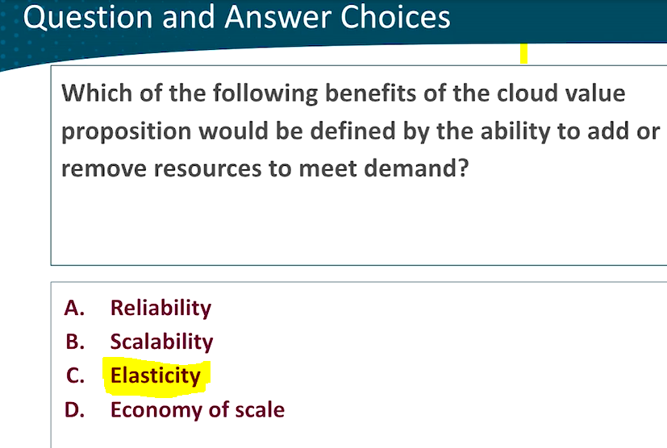

**2.**

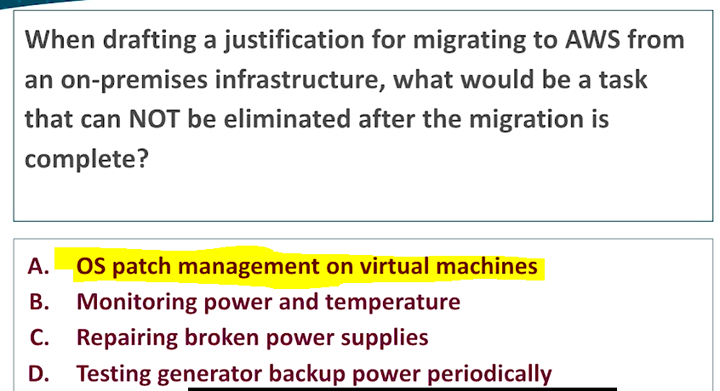

**3.**

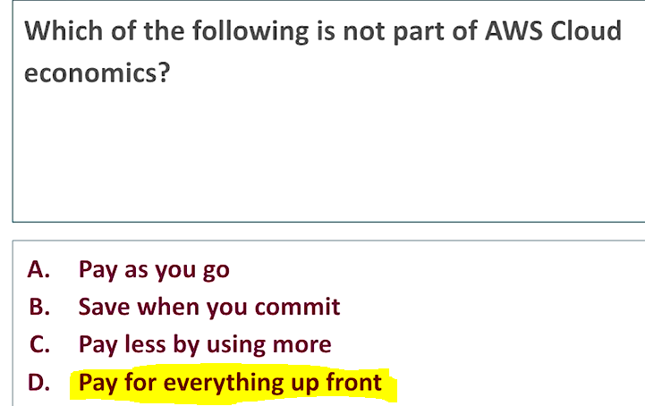

**4.**

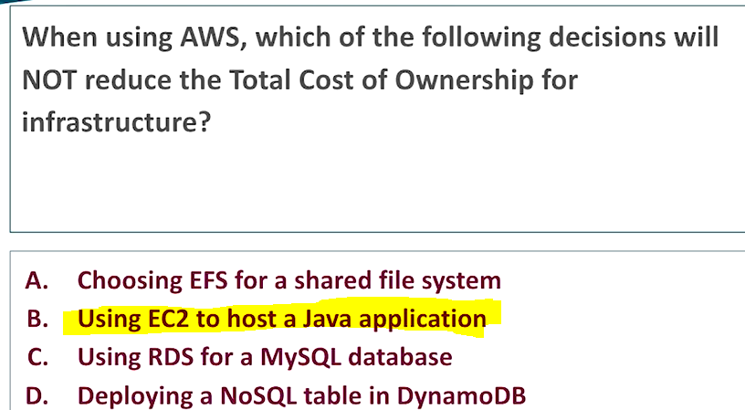

5.

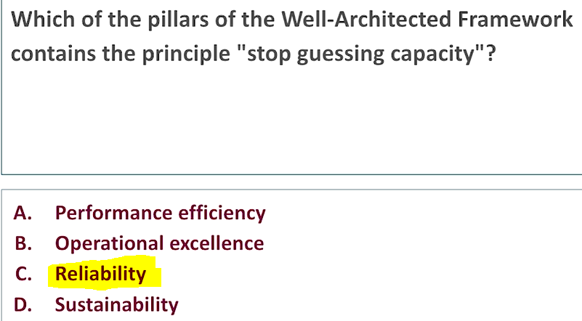

6.

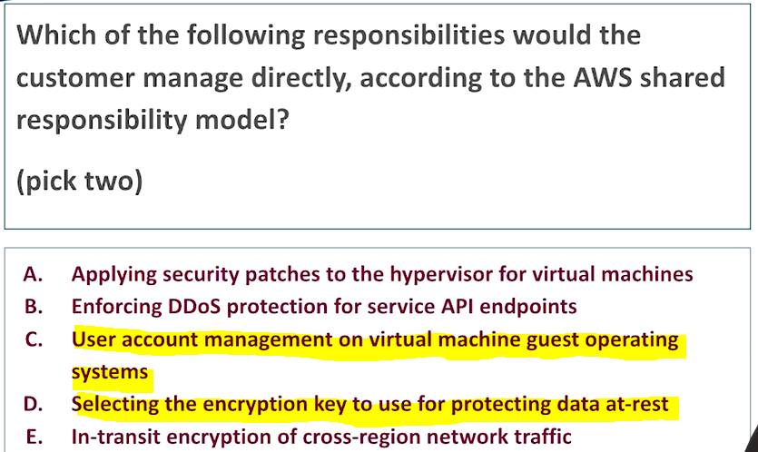

7.

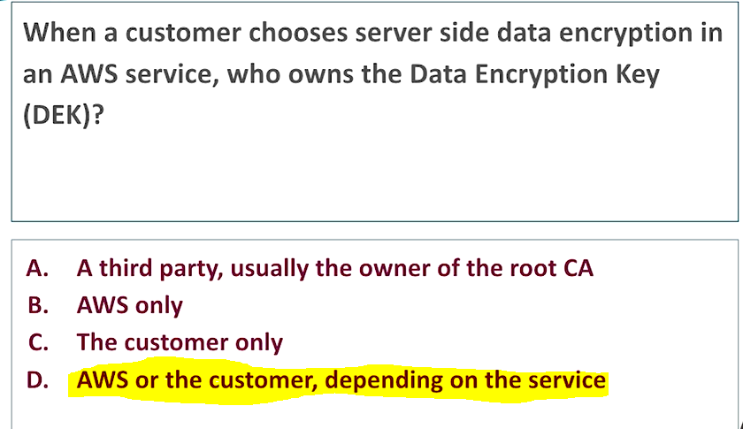

8.

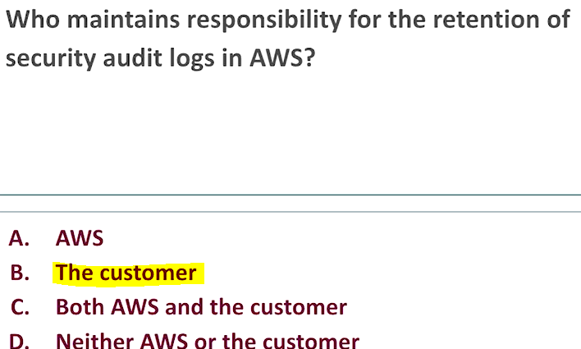

9.

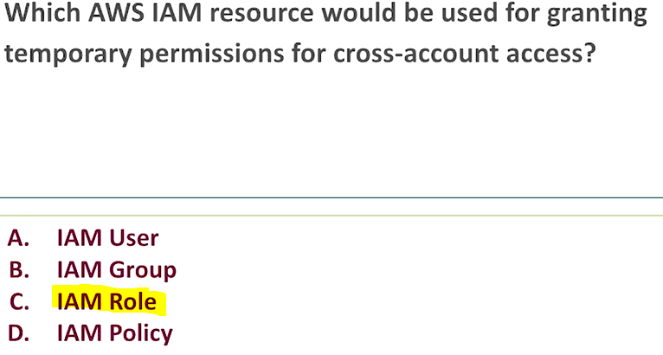

10.

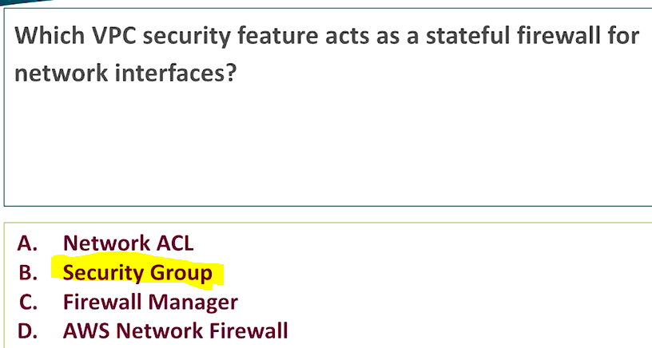

11.

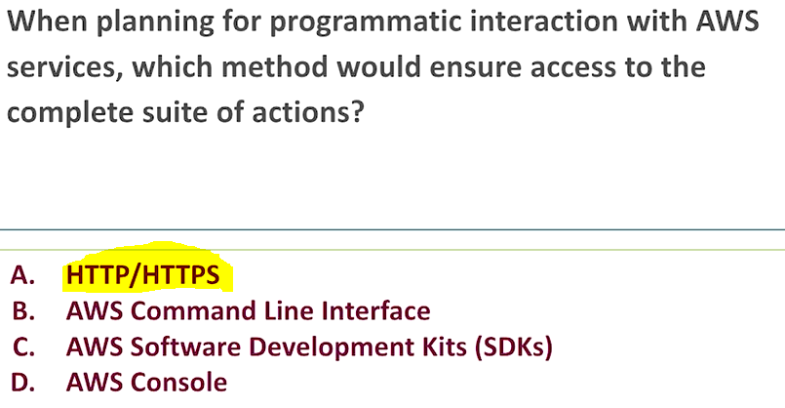

12.

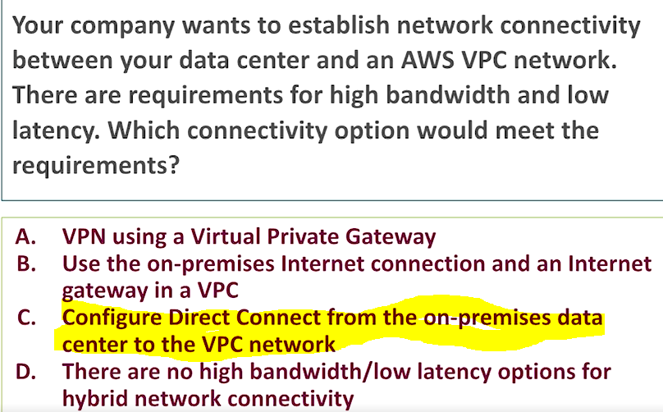

13.

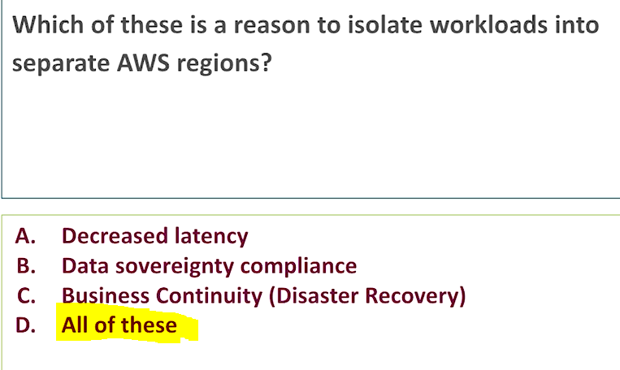

14.

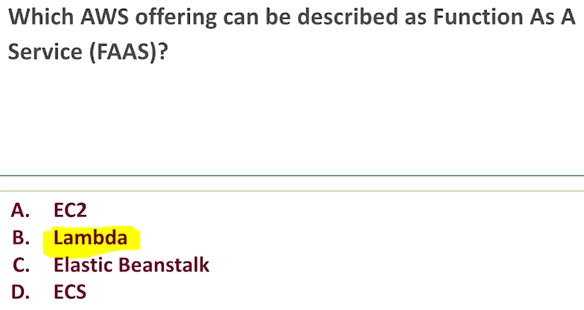

15.

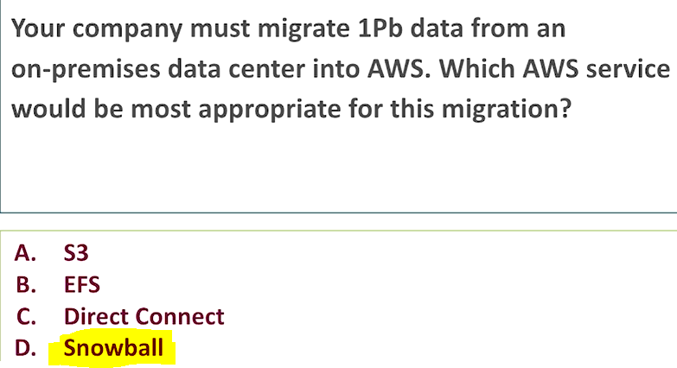

16.

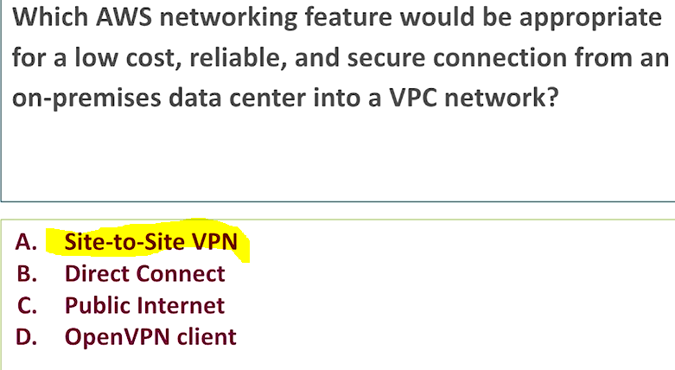

17.

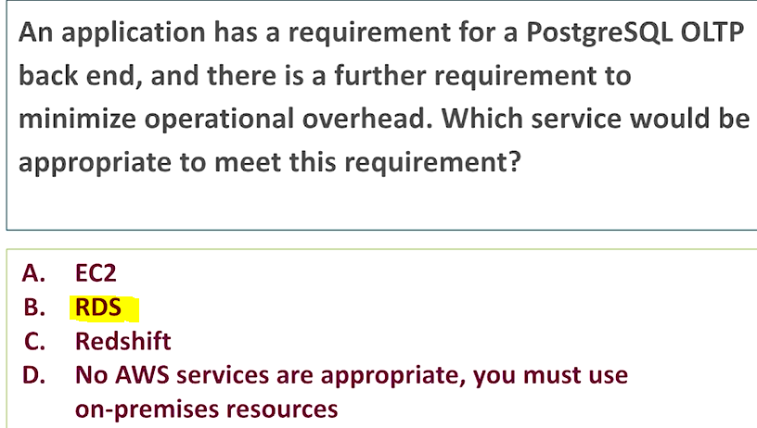

18.

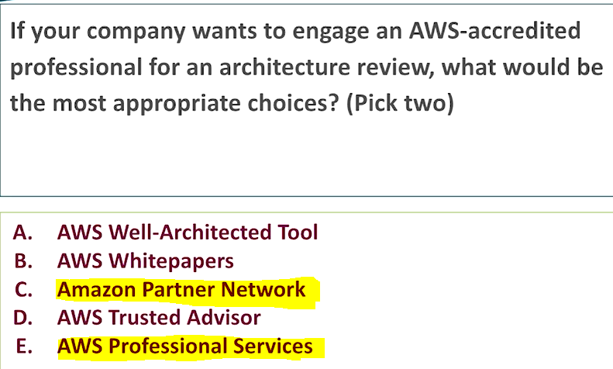

19.

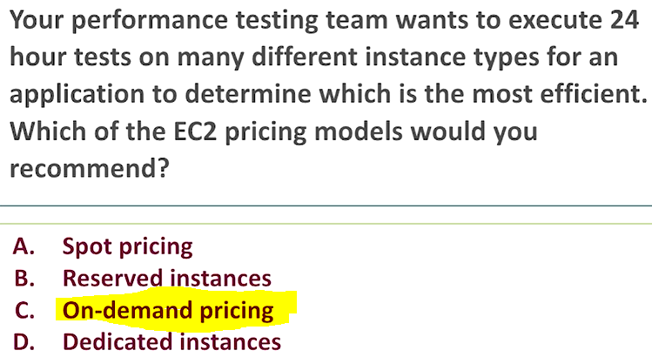

20.

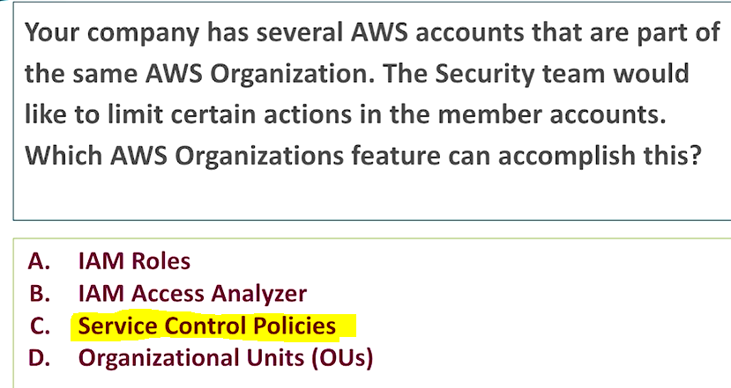

21.

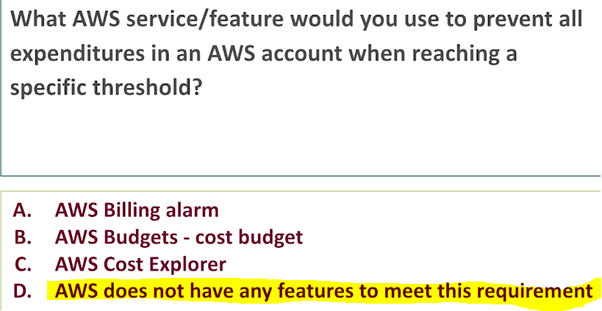

22.

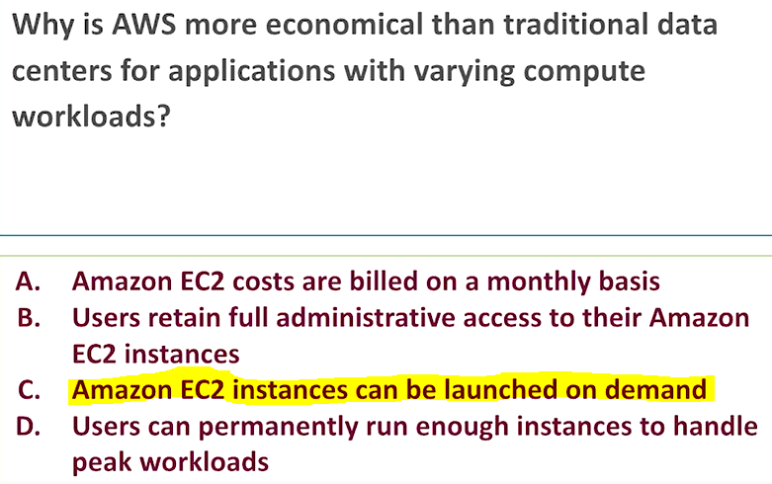

UDEMY

1.You ONLY want to manage Applications and Data. Which type of Cloud Computing model should you use? PaaS

2. Which of the following is NOT one of the Five Characteristics of Cloud Computing?

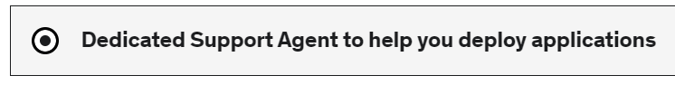

3. Which are the 3 pricing fundamentals of the AWS Cloud?



4. Which of the following options is NOT a point of consideration when choosing an AWS Region? Capacity Availability.

5. Which of the following is NOT an advantage of Cloud Computing? Train ur employee less

6. Which of the following services has a global scope? IAM

7. Which of the following is the definition of Cloud Computing?



8. What defines the distribution of responsibilities for security in the AWS Cloud?



9. A company would like to benefit from the advantages of the Public Cloud but would like to keep sensitive assets in its own infrastructure. Which deployment model should the company use? Hybrid cloud.

10. What is NOT authorized to do on AWS according to the AWS Acceptable Use Policy?



11. What is a proper definition of IAM Roles?



12. Which of the following is an IAM Security Tool? 

13.- What are IAM Policies?



14. Which of the following statements is TRUE?



15. Which principle should you apply regarding IAM Permissions? Grant least privileges

16. How long can you reserve an EC2 Reserved Instance? 1 or 3 years

17. A company would like to deploy a high-performance computing (HPC) application on EC2. Which EC2 instance type should it choose? Compute Optimized

18. Which service can be used to automate image management processes? EC2 image builder.

19. Which of the following is a fully managed native Microsoft Windows file system? FSx

20. What are AMIs NOT used for? Add ur own IP address.

21. Which statement is CORRECT regarding EC2 Instance Store?



22. What is an EBS Snapshot?



23. What is an EBS Volume tied to? AZ

24. What is the main purpose of High Availability in the Cloud?



25. Which AWS offered Load Balancer should you use to handle hundreds of thousands of connections with low latency? Network

26. Changing an EC2 Instance Type from a t3a.medium to a t3a.2xlarge is an example of? Vertical scaling.

27. What can you use to handle quickly and automatically the changing load on your websites and applications by adding compute resources? Auto scaling group.

28. Which of the following statements is INCORRECT regarding Auto Scaling Groups?



29. Which of the following is NOT an Auto Scaling Strategy?Active scaling.

30. Which AWS service offers easy horizontal scaling of compute capacity? ASG

31. Which of the following statements is NOT a feature of Load Balancers? Backend auto scaling.

32. Which S3 Storage Class is the most cost-effective for archiving data with no retrieval time requirement?



33. What hybrid AWS service is used to allow on-premises servers to seamlessly use the AWS Cloud at the storage layer? Storage GW

34. Which of the following is an exabytes-scale data moving service in or out of AWS?Snowmobile

35. What are Objects NOT composed of? Access keys.

36. A research team deployed in a location with low-internet connection would like to move 5 TBs of data to the Cloud. Which service can it use? Snowcone

37. What can you use to define actions to move S3 objects between different storage classes? Lifecycle rules

38. A non-profit organization needs to regularly transfer petabytes of data to the cloud and to have access to local computing capacity. Which service can help with this task?



39. Which S3 Storage Class is suitable for less frequently accessed data, but with rapid access when needed, while keeping a high durability and allowing an Availability Zone failure?



40. You want to create a decentralized blockchain on AWS. Which AWS service would you use? Managed Blockchain.

41. Which AWS service is always serverless and has SQL capabilities?Athena

42. You would like to use a serverless service to prepare data so it can be loaded for analytics. Which service would you use? Glue

43. Which relational database is a proprietary technology from AWS and is cloud-optimized?Aurora

44. You would like to migrate databases to AWS while still being able to use the database during the migration. What service allows you to do this? DMS data migration service

45. How can you create Hadoop clusters to analyze and process a vast amount of data? EMR

46. Which in-memory AWS database can you use to reduce the load off databases and has high performance, low latency? Elastic Cache

47. What is the name of a central repository to store structural and operational metadata for data assets in AWS Glue? Glue data catalog

48. Which of the following databases is a managed service with SQL capability suited for Online Transaction Processing (OLTP)? RDS

49. Which AWS service is an immutable ledger database? QLDB

50. Which AWS service can create complex graphs for fraud detection? Neptune

51. Which AWS serverless service can use machine learning-powered business intelligence to create interactive dashboards such as business analytics? Quicksight

52. A company would like to set up a fully managed MongoDB database. Which AWS database is best-suited for this task? DocumentDB

53. Which exclusive DynamoDB feature is an in-memory cache that can improve your performance up to 10x? Dynamo DB accelerator

54. How do you get charged in AWS Lambda? Per call and per duration

55. You would like to launch Docker containers in AWS without worrying about provisioning or managing any infrastructure. The Docker containers will be used to host a heavy workloads to serve different types of requests. Some requests may need up to 30 minutes to be completed. Which AWS service should you use to run Docker containers in a Serverless way and satisfy the requirements? Fargate

56. A complete cloud beginner would like to create a simple application with predictable pricing. What service should this person use? Lightsail

57. What is the name of the software development platform that allows you to run applications the same way, regardless of where they are run? Docker

58. How would you best describe "event-driven" in AWS Lambda? Happens when needed

59. Which AWS service allows you to launch Docker containers on AWS, but requires you to provision and maintain the infrastructure? ECS

60. Which of the following statements is INCORRECT regarding the definition of the term "serverless"? there are no servers

61. Which of the following statements is NOT a feature of AWS Lambda?



62. A company needs to run thousands of jobs but would like to NOT manage the compute resources. What service can it use? Batch

63. Where should you store your private Docker images so they can be run by ECS or Fargate? Elastic Container registry.

64. Which AWS serverless service can be used by developers to create APIs? API gateway

65. Which AWS managed service allows to automate software deployments to a hybrid mix of EC2 Instances and On-Premises servers? Codedeploy

66. You are a software developer working on a project with your team. You need a secure and reliable version control system to store, share, and collaborate your code with the team. Which AWS service can help the developers? Codecommit

67. You need a unified user interface that gives you visibility, control, and patching capabilities for your EC2 Instances on AWS, as well as for servers running in your on-premises data centers. Which service should you use? Systems manager

68. You need to use Chef or Puppet. Which AWS service should you use? OpsWorks

69. A developer would like to deploy infrastructure on AWS but only knows Python. Which AWS service can assist him? CDK code development kit

70. Which of the following allows you to deploy any AWS Infrastructure as a Code? Cloud formation

71. A new startup would like an online integrated development environment (IDE) to write, run, and debug code. Which AWS service can help with this task? Cloud9

72. Which service is referred to as a Platform as a Service (PaaS)? Elastic beanstalk

73. What is called the declaration of the AWS resources that make up a stack?Cloud formation templates

74. Which of the following services can a developer use to store code dependencies? Code artifact

75. Which serverless service can be used to build code and run tests? Code build

76. CloudFormation and Elastic Beanstalk are free of use. True

77. Which Route 53 Routing Policies would you use to route traffic to multiple resources in proportions that you specify? Weighted routing policy

78. Which service is optimized to deploy ultra-low latency applications to 5G devices? Wavelength

79. You need to enable fast, easy, and secure transfers of files over long distances on S3. Which service would you use? S3 transfer acceleration.

80. What does AWS CloudFront use to improve read performance?



81. Which service can be used to run AWS infrastructure and services on-premises for a hybrid cloud architecture?outposts

82.Which features are available with Route 53?



83. A company using Apache ActiveMQ is migrating to the cloud. Which AWS service can it use to easily set up and operate its message brokers in the cloud? MQ

84. Which service is a fully managed pub/sub messaging service that makes it easy to set up, operate, and send notifications from the cloud, using a push-based system? SNS

85. Which principle is mainly applied when using Amazon SQS or Amazon SNS?



86. Which service allows you to send, store, and receive messages between software components at any volume, without losing messages or requiring other services to be available, using a pull-based system? SQS Simple Queue service

87. Which CloudWatch feature would you use to trigger notifications when a metric reaches a threshold you specify? Cloudwatch alarms

88. Which AWS service helps developers analyze and debug production as well as distributed applications?X-Ray

89. Which AWS service provides alerts and remediation guidance when AWS is experiencing events that may impact you? AWS health dashboard

90. You need to set up metrics monitoring for every service in AWS. Which service would you use? Cloudwatch

91. Which service allows you to inspect, audit, and record events and API calls made within your AWS account? Cloudtrail

92. Which AWS service automatically analyzes code and provides performance recommendations? Code guru

93. How would you describe Amazon CloudWatch Logs?



94. If a resource is deleted in AWS, which service should you use to investigate first? Cloudtrail

95. Your private subnets need to connect to the Internet while still remaining private. Which AWS-managed VPC component allows you to do this? NAT GW

96. Which type of firewall has both ALLOW and DENY rules and operates at the subnet level? NACL

97. You would like to connect hundreds of VPCs and your on-premises data centers together. Which AWS service allows you to do link all these together efficiently? Transit GW

98. Data sitting on an RDS instance would be referred to as? Data at rest

99. Which of the following services can you use to discover and protect your sensitive data in AWS? Macie

100. Which AWS service lets you quickly find the root of potential security issues to take faster actions? Detective

101. A company would like to protect its web applications from common web exploits that may affect availability, compromise security, or consume excessive resources. Which AWS service should they use? WAF

102. Where can you find on-demand access to AWS compliance documentation and AWS agreements? Artifact

103. You want to record configurations and changes over time. Which service allows you to do this? Config

104. A company would like to secure network communications using SSL & TLS certificates. Which AWS service can it use? ACM certificate manager

105. According to the Shared Responsibility Model, who is responsible for Patch Management? AWS & customer

106. You want to centrally automate security checks across several AWS accounts. Which AWS service can you use? Security hub

107. Which of the following services is managed by AWS and is used to manage encryption keys? KMS

108. A company would like to automate security on EC2 instances to assess security and vulnerabilities in these instances. Which AWS service should it use? Inspector

109. Which of the following actions does NOT require the root user?



110. Which service is a threat detection service that continuously monitors for malicious activity and unauthorized behavior to protect your AWS accounts and workloads? Guard duty

111. Which of the following options is NOT a situation where you should contact the AWS Abuse team? Losing ur MFA device

112. A company would like to implement a chatbot that will convert speech-to-text and recognize the customers' intentions. What service should it use? Lex

113. Which fully managed service can deliver highly accurate forecasts? Forecast

114. You would like to find objects, people, text, or scenes in images and videos. What AWS service should you use? Rekognition

115. A start-up would like to rapidly create customized user experiences. Which AWS service can help? Personalize

116. A research team would like to group articles by topics using Natural Language Processing (NLP). Which service should they use? Comprehend

117. A company would like to convert its documents into different languages, with natural and accurate wording. What should they use? Translate

118. A developer would like to build, train, and deploy a machine learning model quickly. Which service can he use? Sage maker

119. Which AWS service makes it easy to convert speech-to-text? Transcribe

120. Which of the following services is a document search service powered by machine learning? Kendra

121. Which tool allows you to centrally manage all users and roles permissions in your organization? Service control policies

122. You would like to automatically set up and govern a secure multi-account AWS environment with best practices for your organization. Which AWS tool can you use? Control Tower

123. A company would like recommendations regarding its performance, security, and fault tolerance. What can it use? Trusted advisor

124. Which of the following is INCORRECT regarding AWS Organizations?



125. What is the most cost-effective option to have 24x7 phone, email, and chat support? Business support plan

126. What do Resource Groups rely on to group your resources? Tags

127. What can you use to get alerts when your costs and usage are exceeding or are forecasted to exceed your budgeting amount? Budgets

128. A company would like to choose the best Savings Plan and forecast its cost in the next 3 months. Which AWS service can help? Cost explorer

129. Which of the following options uses machine learning to recommend optimal AWS resources and therefore reduces costs? Compute optimizer

130. Which services are free to use in AWS?



131. When you reserve, the larger the upfront payment, the smaller the discount.



132. Which of the following is NOT a pricing factor in S3? Data transfer into S3

133. Which of the following options can provide up to 66% discount compared to On-demand for a commitment to a consistent amount of usage for 1 or 3 years and offers the possibility to change EC2 instances family type? Compute savings plan

134. You are running an on-demand Linux EC2 instance, what timing is applied regarding billing? Pay per second

135. Which pricing model allows you to minimize risks, predictably manage budgets, and comply with long-term requirements, and is available for EC2, DynamoDB, ElastiCache, RDS, and Redshift? Save when u reserve

136. Which RDS pricing option is the most cost-effective if you need capacity for 3 years? Reserved instances

137. A company would like to use their on-premises Microsoft Active Directory to connect to its AWS resources. Which service can it use? Directory services

138. which AWS service allows you to create temporary, limited-privilege credentials for your AWS resources? STS Security token service

139. A company just created a new mobile application and wants to add a simple and secure user sign-up, sign-in, and access control. Which AWS service can it use? Cognito

140. A company would like to centrally manage access to multiple AWS accounts and business applications. Which service can it use? Single sign-on

141. You would like to convert an S3 file so it can be played on users’ devices. Which AWS service can help? Elastic transcoder

142. You would like to access desktop applications through a browser. Which AWS service would you use?AppStream 2.0

143. Which AWS service can be used to test your application across real desktop browsers and mobile devices? Device Farm

144. Which AWS service is serverless and lets you connect billions of devices to the AWS Cloud? IoT Core

145. A hybrid company would like to provision desktops to their employees so they can access securely both the AWS Cloud and their data centers. Which AWS service can help?WorkSpaces

146. Auto Scaling in EC2 and DynamoDB are examples of? Horizontal scaling

147. 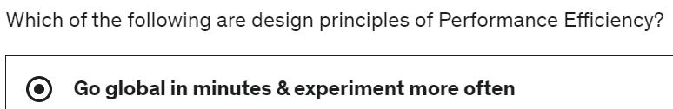

148. Which of the following is NOT an AWS Partner Network (APN) type? APN services partners.

149. Which AWS service is the key to Operational Excellence? Cloud formation

150. AWS Cost Explorer and AWS Trusted Advisor are services examples of which Well-Architected Framework pillar? Cost optimization

151. Implementing Security Groups, NACLs, KMS, or CloudTrail reflects which Well-Architected Framework Pillar? Security

35. Top of Form

Bottom of Form