Machine Learning Operations (AIMLCZG523)
Assignment 1: End-to-End ML Model Development, CI/CD and Production Deployment
CardioRisk: Heart Disease Risk Prediction as a Monitored API
Item | Details
Student | Akshaya Panda
Roll number | 2025AE05728
Dataset | UCI Heart Disease, Cleveland subset (303 patients, 13 features, binary target)
Code repository | https://github.com/Akshaya-Panda/Assignment-MLOPS
Container image | ghcr.io/akshaya-panda/assignment-mlops:latest
Stack | Python 3.12, scikit-learn 1.9, MLflow 3.17, FastAPI, Docker, Kubernetes, Prometheus, Grafana, GitHub Actions
Date | October 2026

1. Summary
The project builds a binary classifier that predicts the presence of heart disease from routine clinical measurements, then takes it through the full MLOps lifecycle: checksum-verified data acquisition and EDA, a single reproducible scikit-learn pipeline, a tuned comparison of three model families tracked in MLflow, a 58-test suite, a four-stage GitHub Actions pipeline that publishes a smoke-tested container image, a hardened Kubernetes deployment behind a LoadBalancer, and Prometheus/Grafana monitoring with alert rules.
Model | CV ROC-AUC (5-fold) | CV recall | Test ROC-AUC | Test accuracy | Test recall
Logistic Regression (champion) | 0.909 ± 0.016 | 0.819 | 0.957 | 0.869 | 0.929
Random Forest | 0.894 ± 0.021 | 0.774 | 0.944 | 0.885 | 0.893
Gradient Boosting | 0.883 ± 0.025 | 0.765 | 0.958 | 0.902 | 0.929
The champion was selected on mean cross-validated ROC-AUC only, so the hold-out test set remains an unbiased final estimate. On 61 unseen patients it misses 2 of 28 cases of disease.

2. System architecture
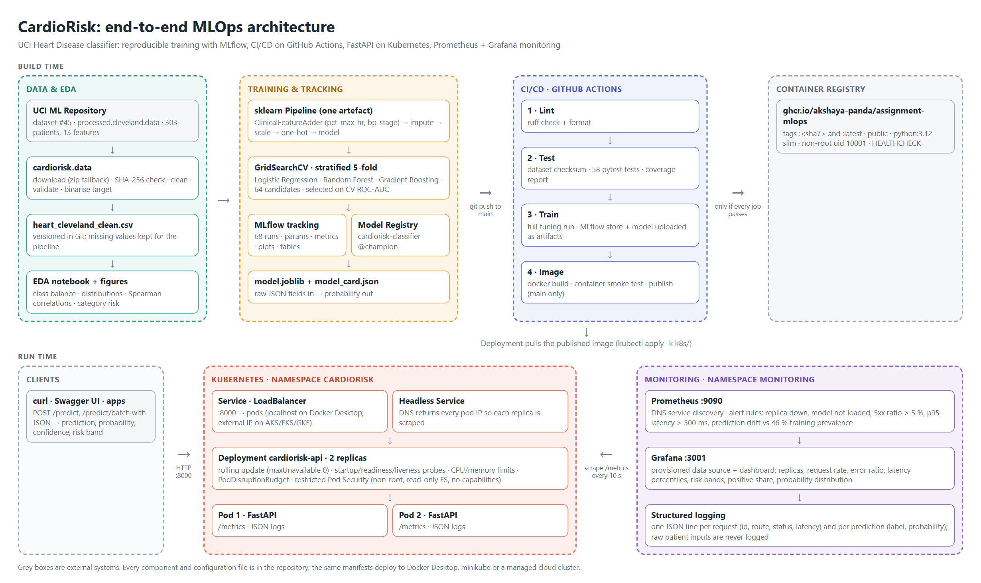
Figure 1. Build-time and run-time architecture. Every component and configuration is code in the repository.
Build time: the data module downloads and verifies the dataset; training tunes three model families and logs every run to MLflow; a push to main triggers the CI/CD pipeline, which retrains from scratch and publishes the image to GitHub Container Registry only if lint, tests, training and a live container smoke test all pass. Run time: a two-replica Deployment serves the API behind a LoadBalancer service. Prometheus discovers each pod through a headless service and Grafana visualises service and model health.

3. Setup and installation
- Clone the repository and create an environment (Python 3.11 or 3.12): git clone https://github.com/Akshaya-Panda/Assignment-MLOPS.git, python -m venv .venv, activate it, then pip install -r requirements.txt.
- Acquire data and run EDA: python -m cardiorisk.data (download, SHA-256 check, clean) and python -m cardiorisk.eda; execute the notebook with python -m nbconvert --execute --inplace notebooks/01_eda.ipynb.
- Train and register models: python -m cardiorisk.train (about 2 minutes). Browse runs with mlflow ui --backend-store-uri sqlite:///mlflow.db.
- Test: ruff check . and pytest --cov=cardiorisk --cov=app.
- Serve in Docker: docker build -t cardiorisk-api:1.0.0 ., docker run -p 8000:8000 cardiorisk-api:1.0.0, then bash scripts/smoke_test.sh.
- Deploy with monitoring: bash scripts/k8s_deploy.sh on any kubectl context (Docker Desktop, minikube with minikube tunnel, or a cloud cluster).
Access for local testing (Docker Desktop): API documentation at http://127.0.0.1:8000/docs, Prometheus at http://127.0.0.1:9090, Grafana at http://127.0.0.1:3001 (read-only without login). The API is not exposed publicly; the published image can be run anywhere with docker run -p 8000:8000 ghcr.io/akshaya-panda/assignment-mlops:latest.

4. Data acquisition and exploratory analysis
The raw file processed.cleveland.data is downloaded from the UCI repository (zip archive as fallback) and verified against a pinned SHA-256 hash. Cleaning parses ? as missing, coerces types, binarises the target (num > 0), sets physiologically implausible values and invalid category codes to missing, and removes duplicates. The 6 missing cells (4 in ca, 2 in thal) are deliberately not imputed in the cleaned CSV: imputation is part of the model pipeline and fitted per training fold, which prevents test-set leakage and lets the API accept these fields as optional.
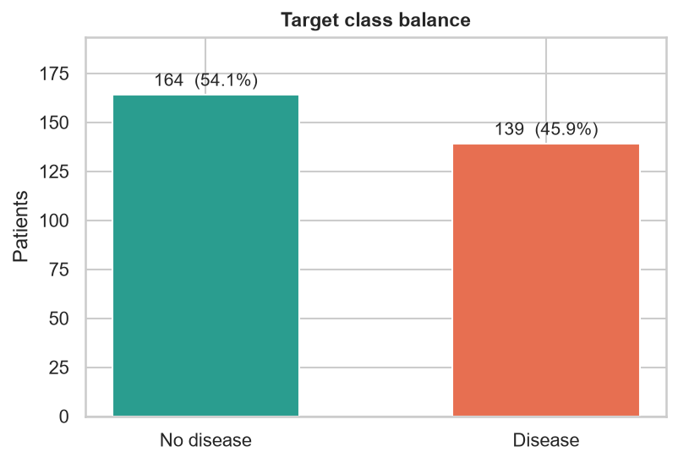 | 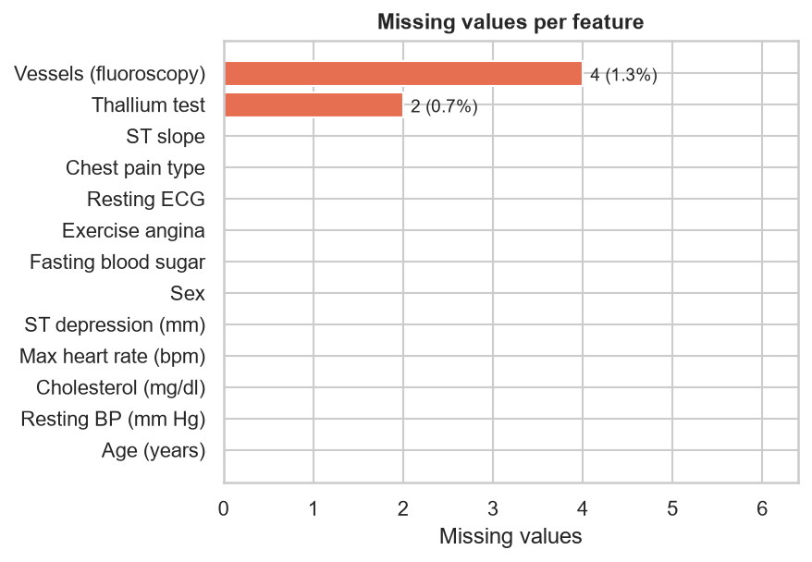
Figure 2. Class balance (164 negative, 139 positive) and missing values per feature.
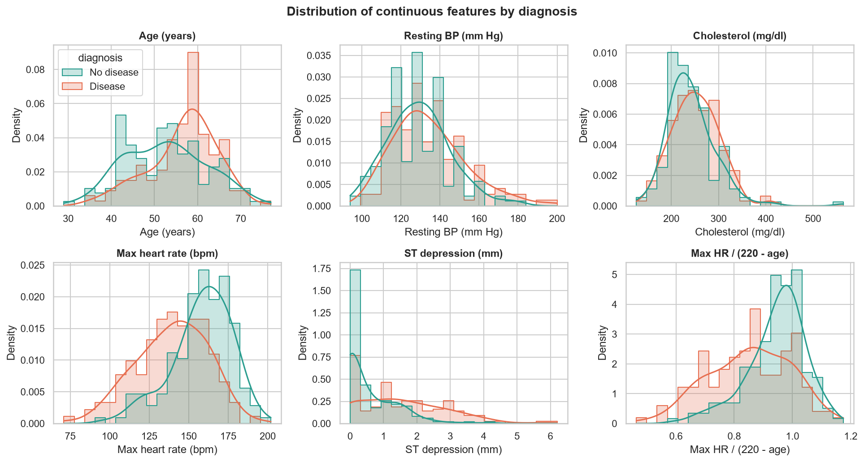
Figure 3. Continuous features by diagnosis. The engineered ratio thalach / (220 - age) separates the classes.
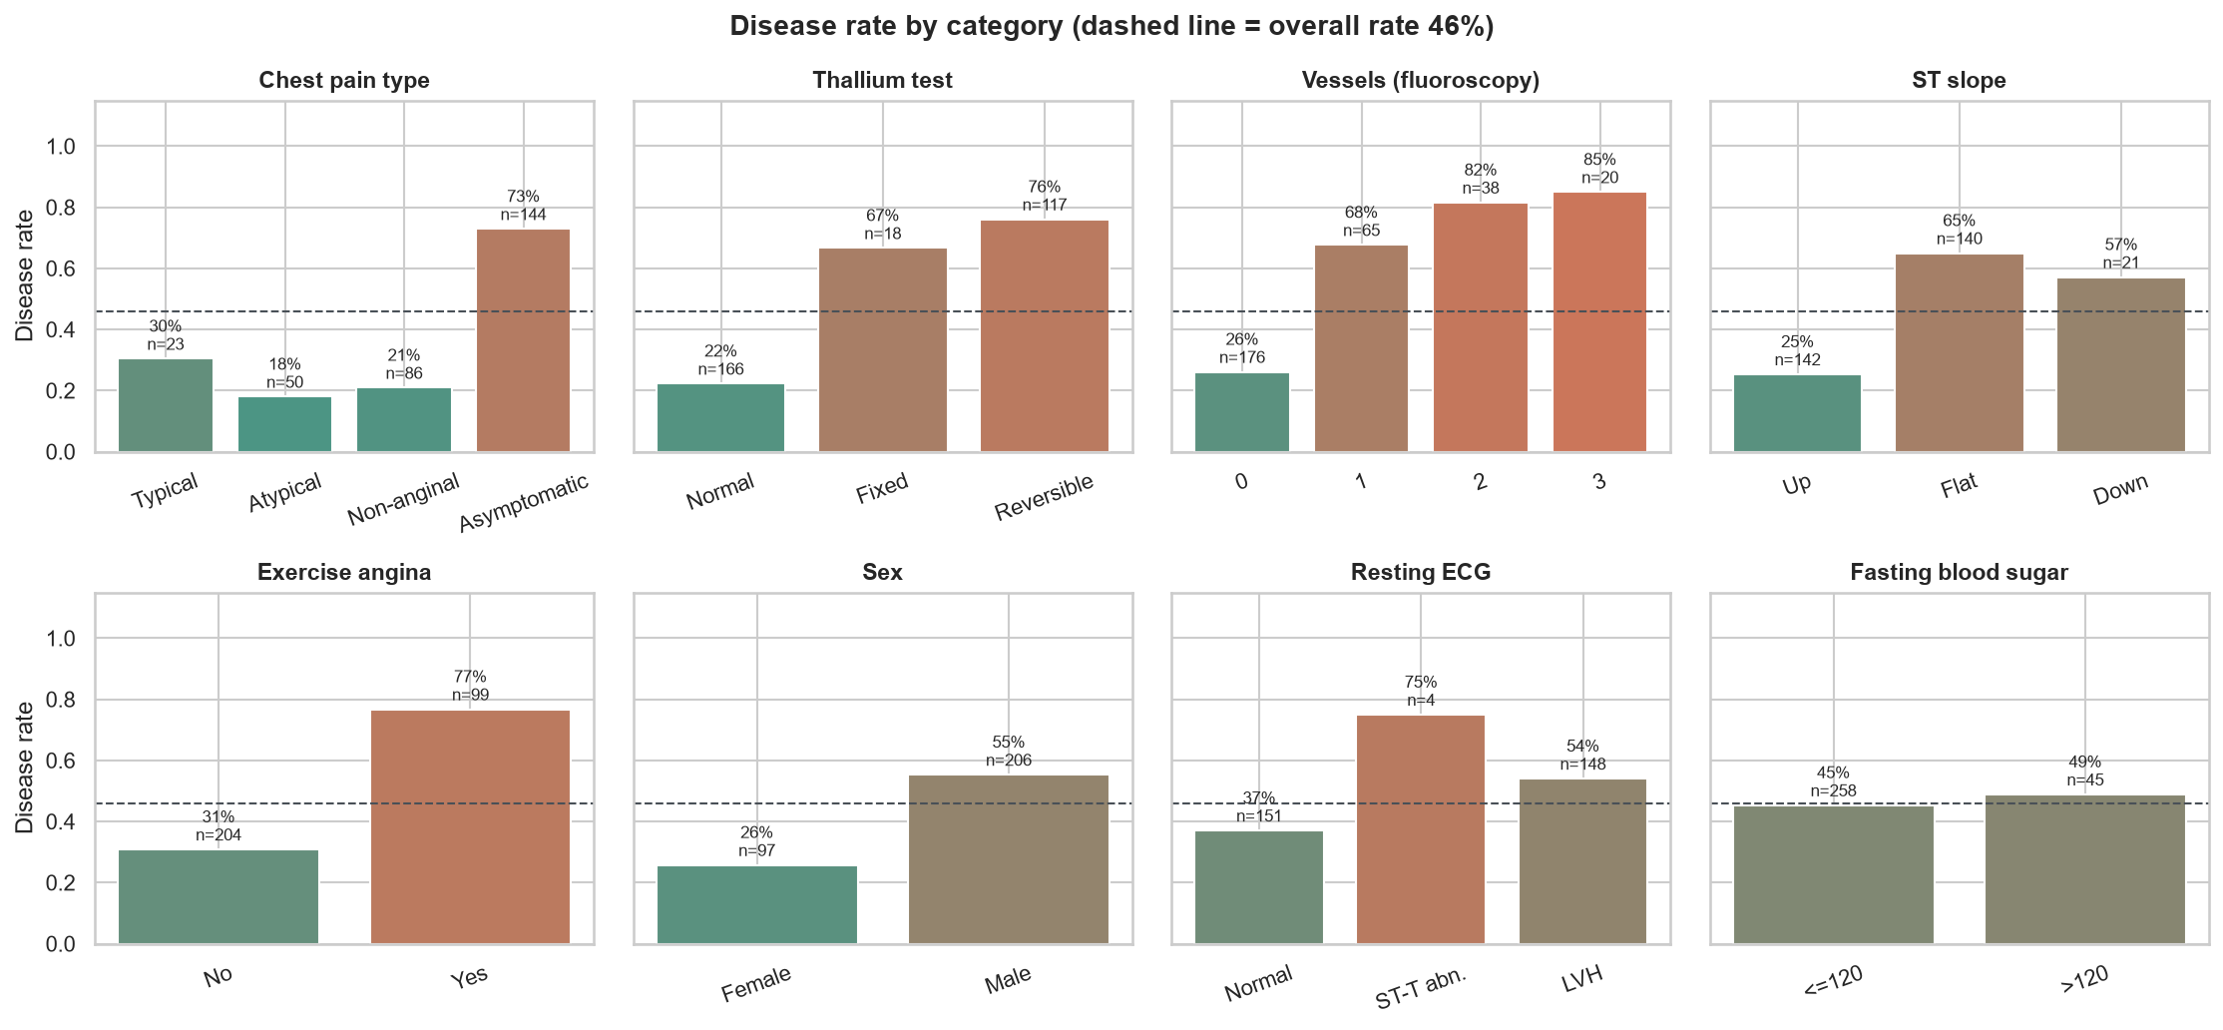
Figure 4. Disease rate per category (dashed line: overall rate 46 %).
Key findings:
- Stress-test and imaging features dominate: thal (Spearman 0.52), ca (0.49), cp (0.47), exang (0.43), oldpeak (0.41) and thalach (-0.42). Fasting blood sugar is uninformative (0.03).
- Asymptomatic chest pain carries a 73 % disease rate, against 18 to 30 % for the other types; one or more vessels on fluoroscopy raises it to 68 to 85 %.
- Diseased patients are older and reach a lower maximum heart rate. Because maximum heart rate falls with age, the age-normalised ratio was engineered as a feature.
- No feature pair exceeds |rho| = 0.6, so all 13 features are kept and regularisation is left to tuning.

5. Feature engineering and model development
Group | Columns | Transformation
Numeric | age, trestbps, chol, thalach, oldpeak, ca | median imputation, standard scaling
Engineered | pct_max_hr = thalach / (220 - age); bp_stage (ACC/AHA 2017, 0 to 3) | custom ClinicalFeatureAdder, then as numeric
Binary | sex, fbs, exang | most-frequent imputation
Nominal | cp, restecg, slope, thal | most-frequent imputation, one-hot (unknown codes ignored)
The adder, the ColumnTransformer and the estimator form one scikit-learn Pipeline, so raw JSON fields go in and probabilities come out identically in training, the CLI and the API.
Model | Grid (candidates) | Best parameters
Logistic Regression (saga) | C {0.01, 0.1, 1, 10} x l1_ratio {0, 0.5, 1} x class_weight (24) | C = 1.0, l1_ratio = 0.5 (elastic net), balanced
Random Forest (300 trees) | max_depth x min_samples_leaf x max_features x class_weight (24) | max_depth None, min_samples_leaf 4, max_features 0.5
Gradient Boosting | n_estimators x learning_rate x max_depth x subsample (16) | 100 trees, learning_rate 0.03, depth 2, subsample 0.8
Data are split 80/20 with stratification (242 training, 61 test patients). Each candidate is scored by stratified 5-fold cross-validation on accuracy, precision, recall, F1 and ROC-AUC, refitting on ROC-AUC because it is threshold-independent and robust to the mild imbalance. Recall is reported alongside it because a missed diagnosis is costlier than a false alarm. Logistic regression wins on CV ROC-AUC and also shows the smallest train/validation gap (0.932 vs 0.909), whereas the random forest overfits (0.985 vs 0.894).
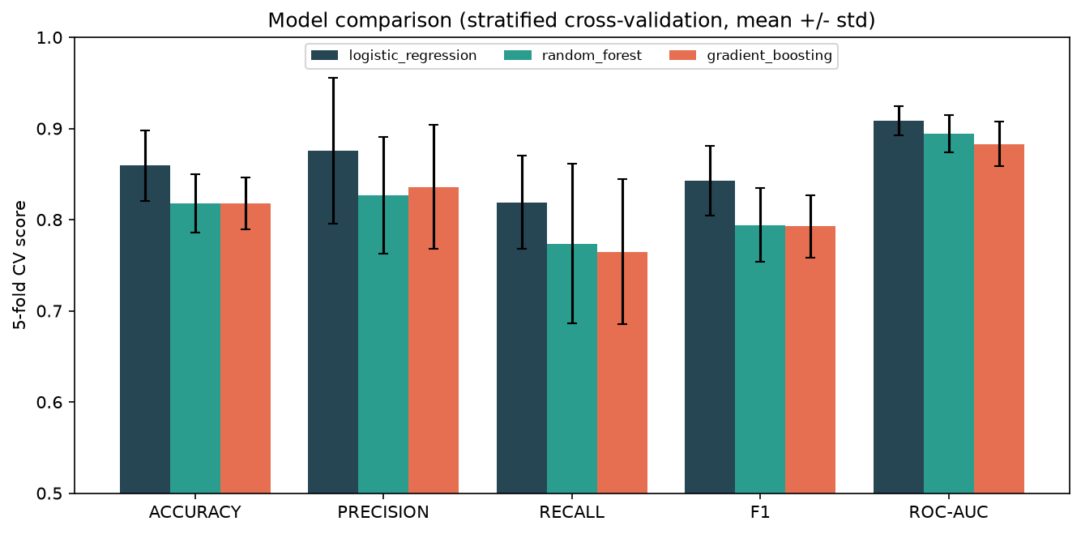
Figure 5. Cross-validated metrics (mean +/- std) of the best configuration of each model family.
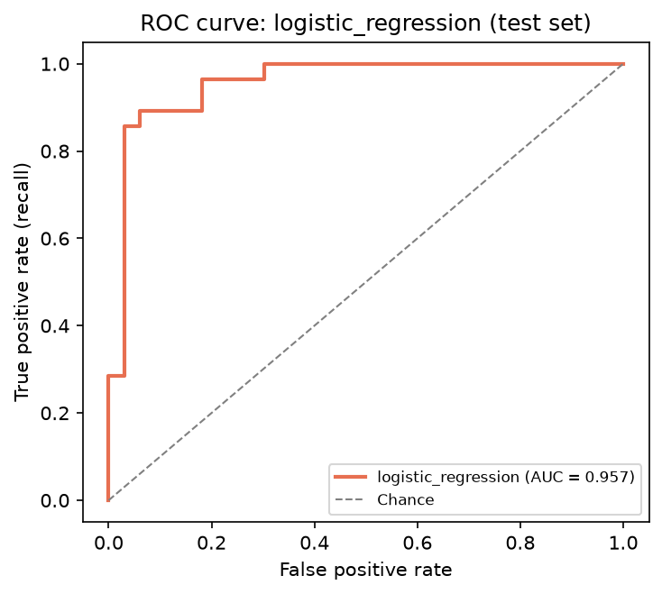 | 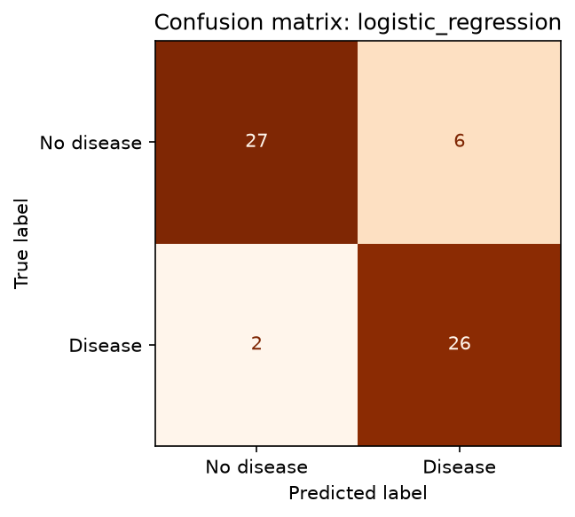
Figure 6. Champion on the hold-out test set: ROC curve (AUC 0.957) and confusion matrix (26 TP, 27 TN, 6 FP, 2 FN).
Permutation importance on the test set confirms the EDA: shuffling ca lowers ROC-AUC by 0.10, followed by cp (0.04), then slope, thal, thalach and oldpeak (about 0.01 each).

6. Experiment tracking with MLflow
MLflow (SQLite backend, local artifact store) records 68 runs per training execution. Each model family has a parent run holding the best parameters, CV mean and standard deviation, test metrics, ROC/PR/confusion/permutation-importance plots, the full CV results table and the serialised model with signature and input example. Each of the 64 grid candidates is a nested child run with its own parameters and CV metrics, which makes the tuning process auditable. A model-selection run stores the comparison table and chart. The champion is registered as cardiorisk-classifier and tagged with the alias champion. Runs are tagged with the data hash, git commit and package version.
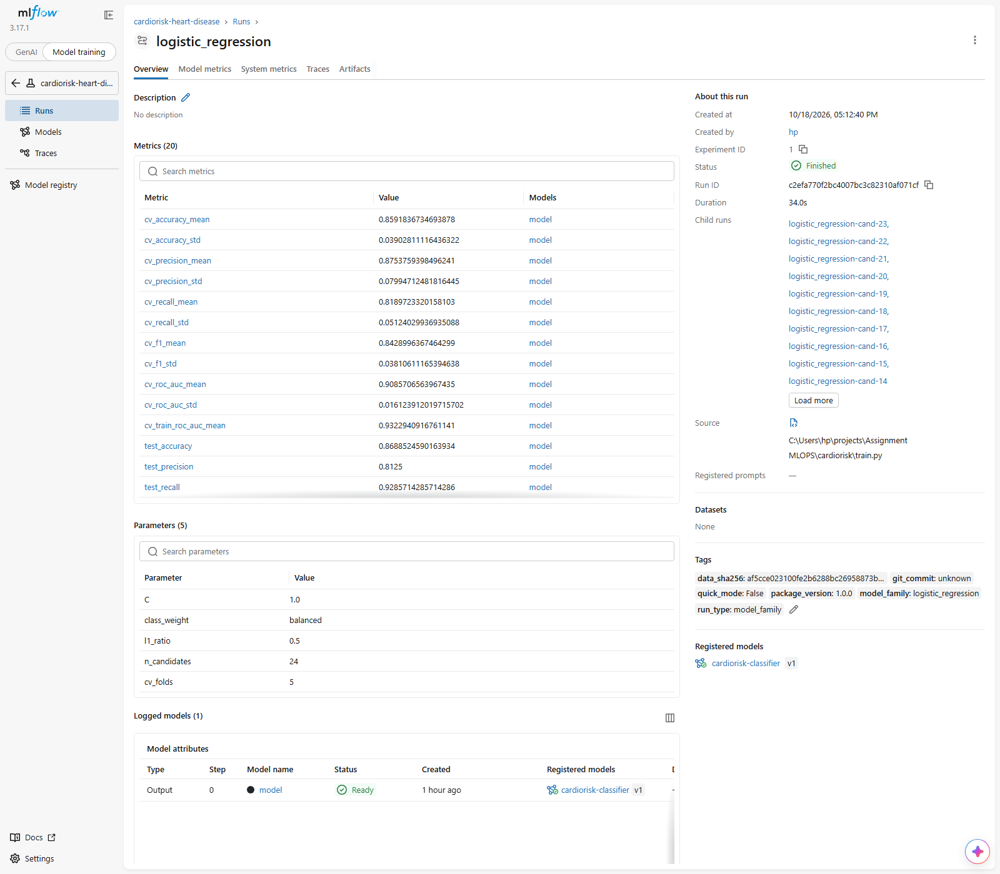
Figure 7. Champion run: 20 metrics, 5 parameters, provenance tags, child runs and the registered model.
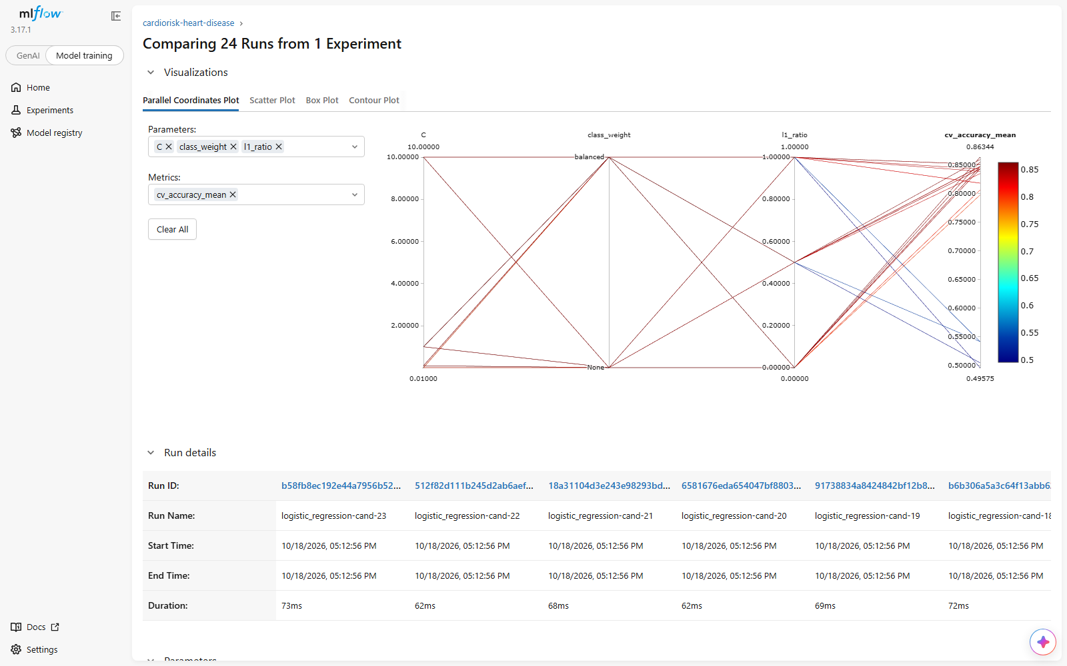 | 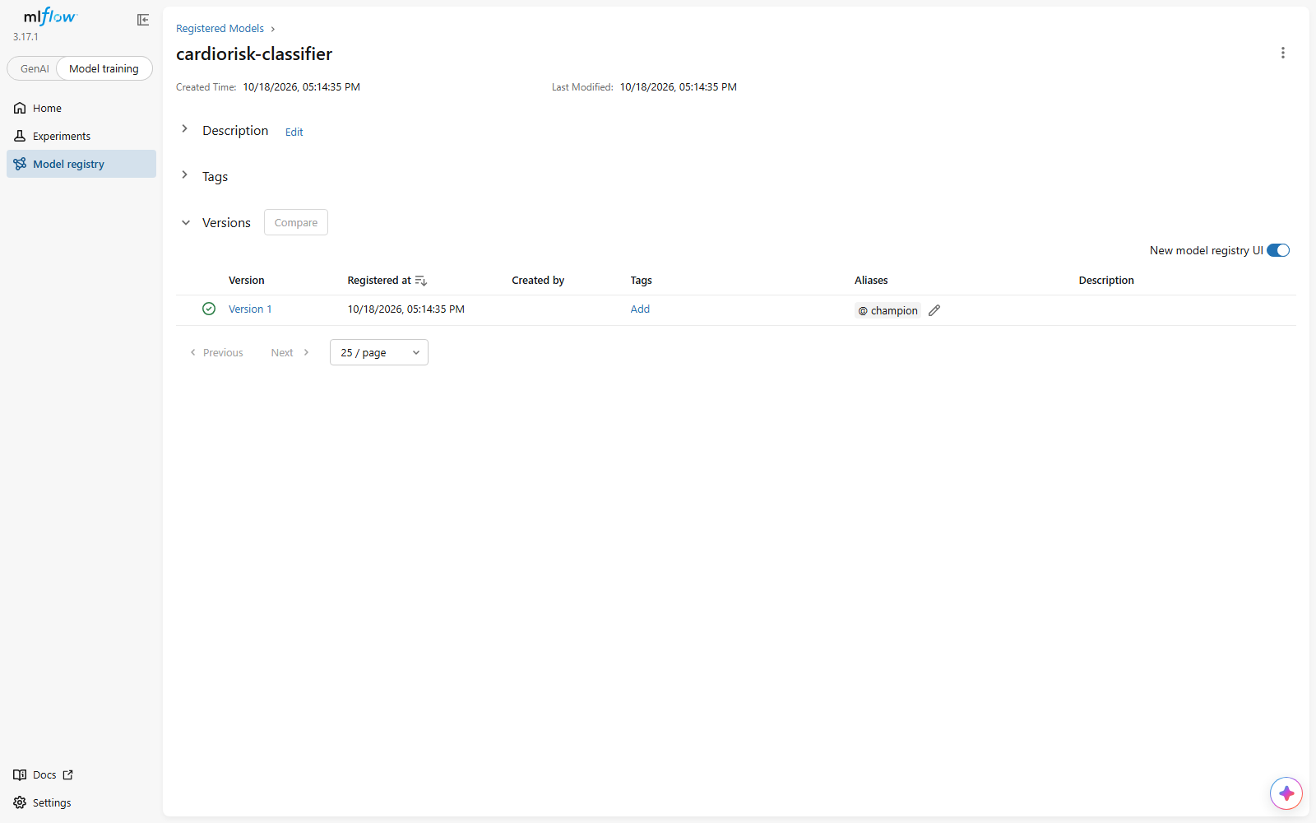
Figure 8. Tuning trace of the 24 logistic-regression candidates, and the registered model with the champion alias.

7. Model packaging and reproducibility
- Formats: the fitted pipeline is exported to models/model.joblib for serving and logged to MLflow in the skops format (no arbitrary pickle code; only the project's transformer and sklearn's tree structure are explicitly trusted).
- Model card: models/model_card.json records version, family, parameters, CV and test metrics, decision threshold, feature list, data SHA-256, git commit, Python and scikit-learn versions.
- Environment: pinned requirements.txt (full) and requirements-serve.txt (API image only).
- Determinism: fixed seeds and checksum-verified input. Training on the Windows laptop (Python 3.11) and on the Linux lab machine (Python 3.12) produced identical CV and test metrics; the CI runner retrains from a clean environment on every push.

8. CI/CD pipeline and automated testing
Test module | Tests | Covers
test_data.py | 15 | parsing of ?, target binarisation, invalid codes and ranges, duplicates, schema validation, checksum rejection, zip fallback
test_features.py | 14 | pct_max_hr and bp_stage values and thresholds, NaN propagation, no input mutation, output shape, unseen categories, scaling
test_model.py | 14 | metric correctness, grid parameter validity, learning signal, missing optional fields, serialisation round trip, end-to-end training run
test_api.py | 15 | health/readiness, prediction contract, request IDs, 422 validation cases, batch limits, metrics, behaviour without a model
The GitHub Actions workflow runs four chained jobs on every push and pull request: lint (ruff check and format), test (dataset acquisition with checksum, pytest with coverage), train (full tuning run) and image (docker build, container start, smoke test of /health, /ready, /predict, 422 validation and /metrics). A failing step stops the chain and is annotated in the run log. Every job uploads its outputs as artifacts: JUnit and coverage reports, the trained model with the MLflow store and reports, and Docker build and container logs. On main only, the image is pushed to GitHub Container Registry tagged with the commit SHA and latest, which makes the pipeline continuous delivery. Runners are pinned to Ubuntu 24.04.
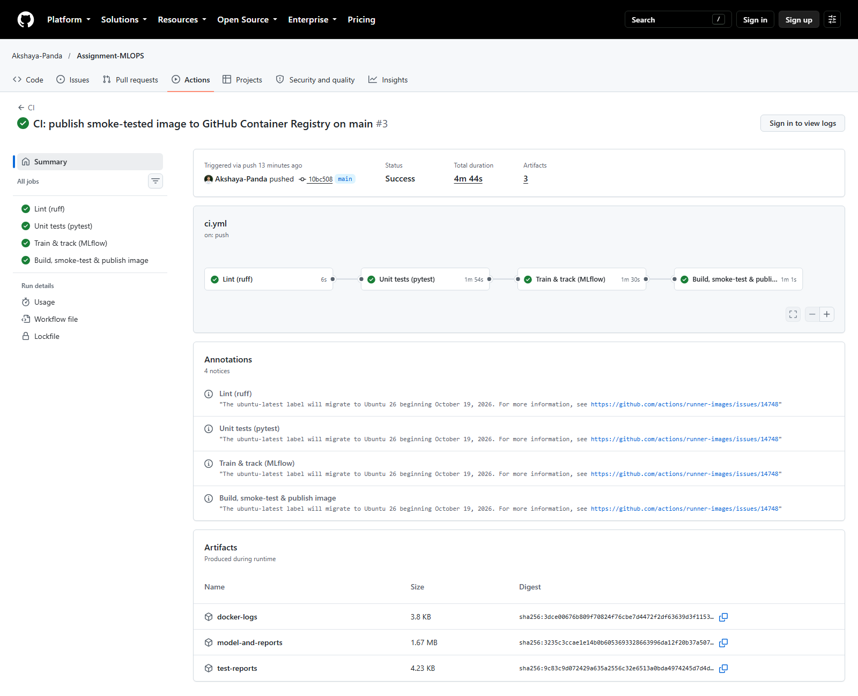
Figure 9. Successful pipeline run: four jobs, annotations and uploaded artifacts.

9. Model containerisation
The serving image (python:3.12-slim) installs only the runtime dependencies, copies the package, API and model, and runs as an unprivileged user (uid 10001) with a Docker HEALTHCHECK. The FastAPI service exposes POST /predict (one patient), POST /predict/batch (up to 100), /health (liveness), /ready (readiness, 503 without a model), /model-info, /metrics and interactive /docs. Input validation reuses the data-cleaning plausibility rules, rejects unknown fields and accepts ca/thal as optional. Each response returns the prediction, label, disease probability, confidence (probability of the predicted class), risk band, model version and request ID. One worker runs per container so in-process Prometheus metrics stay correct, and the service scales through replicas.
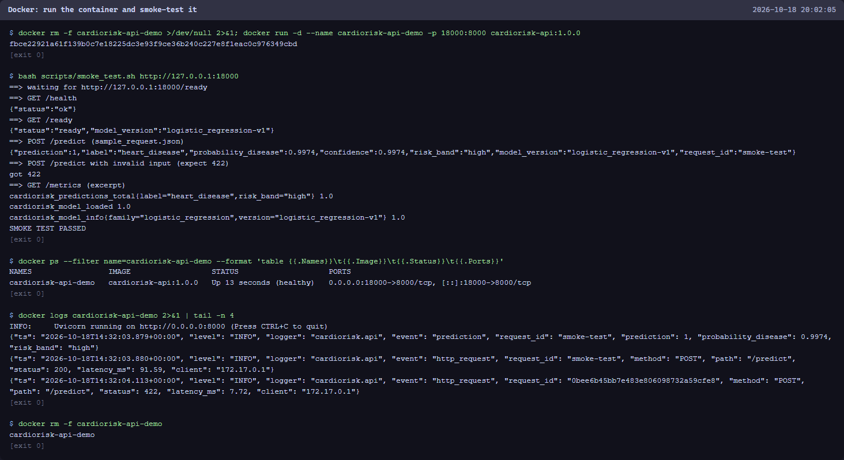
Figure 10. Container run and smoke test (real terminal output): healthy, non-root, JSON logs.

10. Production deployment on Kubernetes
The manifests in k8s/ (applied with kubectl apply -k k8s/ or scripts/k8s_deploy.sh) create a namespace that enforces the restricted Pod Security Standard, a ConfigMap, and a two-replica Deployment of the published image with zero-downtime rolling updates (maxUnavailable 0), startup, readiness and liveness probes, CPU and memory requests and limits, a read-only root filesystem with all capabilities dropped, and a PodDisruptionBudget. A LoadBalancer service exposes port 8000 (published on localhost by Docker Desktop; an external IP on AKS, EKS or GKE) and a headless service gives Prometheus every pod address. The deployment was verified on Docker Desktop Kubernetes v1.34.
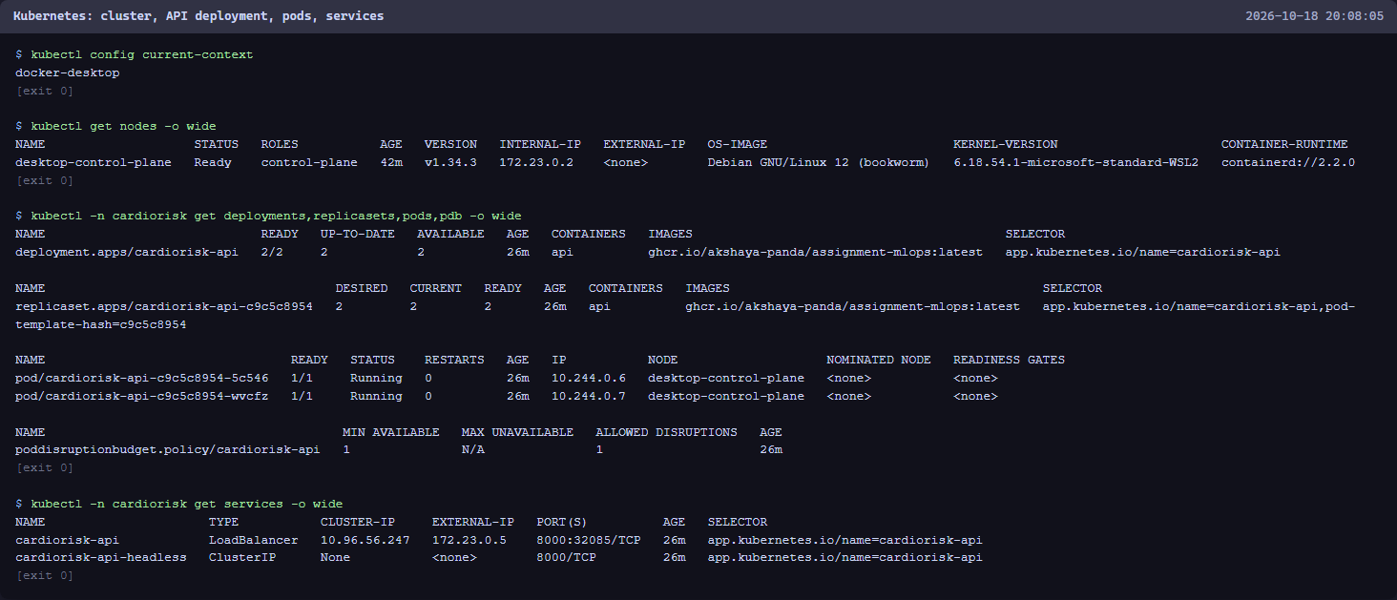
Figure 11. Cluster, Deployment (2/2 ready), pods, PodDisruptionBudget and services, including the LoadBalancer.
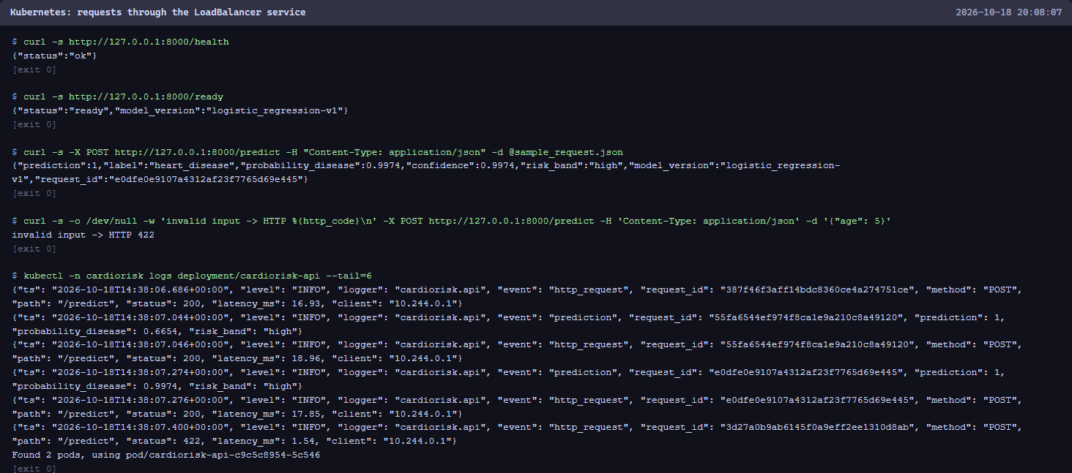
Figure 12. Endpoint verification through the LoadBalancer, including a rejected invalid request and pod logs.

11. Monitoring and logging
Logging: every request produces one JSON line (timestamp, request ID, method, path, status, latency, client) and every prediction one line with label, probability and risk band. Raw clinical inputs are never logged, because they are health data. Metrics: request count and latency histograms per route template, in-flight requests, predictions per label and risk band, a histogram of predicted probabilities, inference time and model-loaded/model-info gauges. Prometheus scrapes each replica every 10 seconds and evaluates five alert rules: replica down, model not loaded, 5xx ratio above 5 %, p95 /predict latency above 500 ms, and prediction drift (positive share far from the 46 % training prevalence). Grafana is provisioned as code with the data source and a 14-panel dashboard. Under generated load (valid, invalid and batch requests) both replicas served about 4 requests per second with 0 % server errors, a p95 latency near 50 ms, and a positive-prediction share matching the training prevalence.
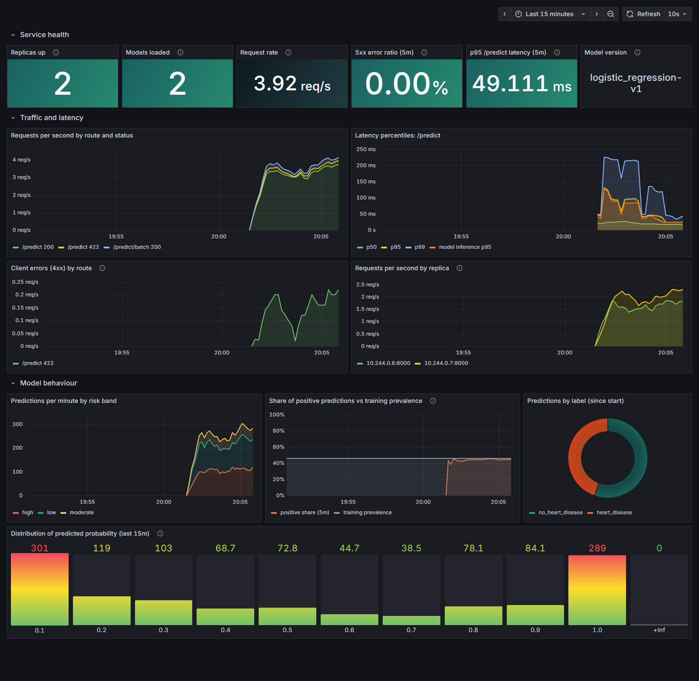
Figure 13. Grafana dashboard under load: service health, traffic and latency, and model behaviour.
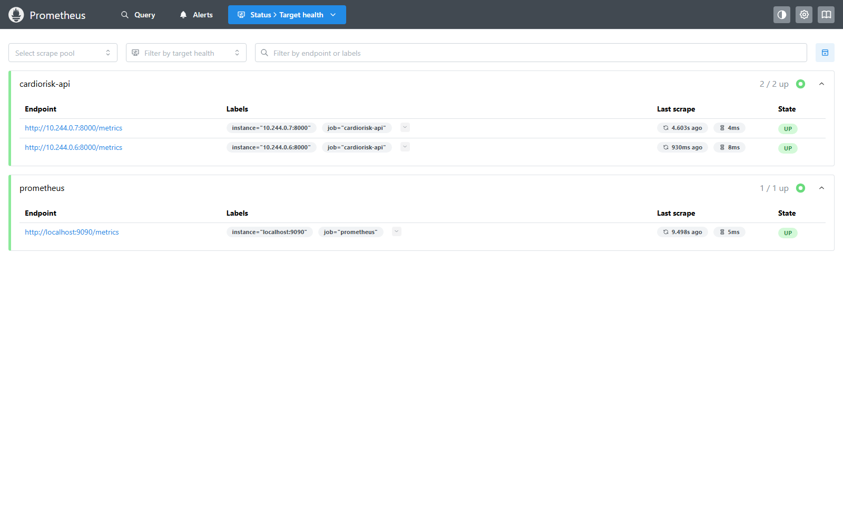
Figure 14. Prometheus target health: both API replicas discovered through DNS and up.

12. Conclusions, limitations and future work
The pipeline meets every production-readiness requirement of the brief. It installs from a clean environment using the requirements file (on every CI run on a fresh Ubuntu runner, and on the BITS Linux lab machine), the model serves correctly in an isolated container with automated build and smoke-test proof, and the CI pipeline fails with clear logs on any lint, test, training or container error.
- Data: 303 patients from one hospital (1988) is small and dated; with 61 test patients the test metrics carry wide confidence intervals, so cross-validated metrics are the primary basis for comparison.
- Scope: severity levels 1 to 4 are merged into one positive class; fairness across sex and age was not evaluated; drift monitoring watches the prediction mix, not input distributions.
- Next steps: probability calibration and a recall-oriented decision threshold, per-feature drift tests (for example Evidently), Gateway API or Ingress with TLS and authentication, horizontal pod autoscaling on request rate, and promotion of registry versions through staging before production.

13. Links and evidence
Repository: https://github.com/Akshaya-Panda/Assignment-MLOPS
CI/CD runs: https://github.com/Akshaya-Panda/Assignment-MLOPS/actions
Container image: ghcr.io/akshaya-panda/assignment-mlops (tags: commit SHA, latest)
Evidence (screenshots/) | Shows
mlflow_01 to mlflow_11 | experiment runs, 64 nested grid-search runs, champion run, plots, model comparison, registry
api_01 to api_04 | Swagger UI, live /predict request and response, model card, Prometheus metrics
tests_01, docker_01, docker_02 | lint and 58 passing tests with coverage, image build, container run and smoke test
github_01 to github_07 | workflow history, pipeline graph, each job, published container package
k8s_01 to k8s_04 | cluster and workloads, rollout and probes, LoadBalancer requests, monitoring namespace
grafana_01, grafana_02, prometheus_01 to _03 | dashboard under load, scrape targets, alert rules, request-rate query

