**Medical Record System with a unique Medical ID**

The idea of having a Medical ID and all the information under one roof is always a better way to access the information anytime and anywhere in a matter of few seconds. Thus, we are proposing a system that consists of all the medical history of a person which is accessible through a unique Medical ID.

In a growing population, maintaining a manual record of data for every person is a hassle. If it is lost then the loss is irrecoverable. Hence, digitizing the records is very essential. We are doing it by developing an application that not only stores the medical history but also makes use of it for a lot of other purposes.

A unique ID for a person and with this ID the medical history of the person can be accessed across all the digitalized hospitals, pharmaceuticals and banks. We make sure that the access to the medical history is limited to protect the privacy of the person.

1. The process starts from storing the basic medical details such as blood group, various allergies, vaccines taken by the person and updating it regularly. The medical history of the person is stored from the time of birth to his current visitto the hospital.
2. It also extends by holding a prescription about the recent medical emergency and with the same ID the pharmaceutical can give medicines. We have an expiration period for each of the prescription so medicines are given accordingly.
3. In case a person meets with an accident, the bio metrics of the person can be used to get the medical id through which the whole medical history is accessed.

Some additional features we are trying to bring in are:

1. Community blood drive – if any person is in need of blood then the people who are in the location will get an alert.
2. Organ donation – with the medical history present with our system we find what are the healthy organs that the person can donate and collaborate it if the person is willing to donate.
3. Medical Loan/ Granting loan with having health condition as a criterion – analysis based on the health condition is done to grant a medical loan.
4. Genetic match making – the process of checking biological compatibility between couples.

An extension of the project is to identify the credibility of the person, this number is also linked to the number of accounts, number of credit card a person holds and this information can be used by any bank to identify if the person is credible to take another credit card or a loan.

Akruni

Niranjhani vasudevan 001278797

Krupa shankar sundarajan 001811303

Akshaya Suresh 001853905

**Object Model :**

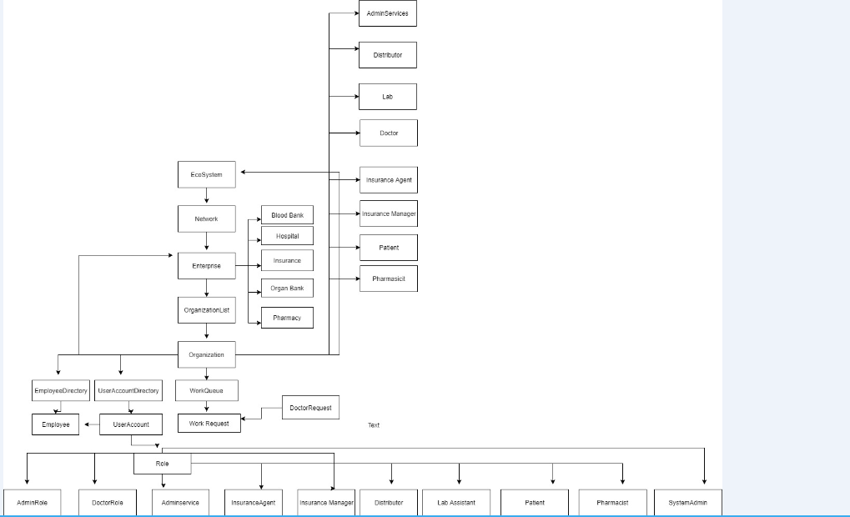

**Akshaya Suresh:**

1. Organ bank

* Patient registers to donate organ
* Check whether the donor is registered or not.
* If organ is healthy, store it in collections
* Match the organ with the request database and approve it

1. Pharmacy

* Pharmacist can view the prescription.
* If the prescription is valid then deliver the medicine

**Krupa Shankar:**

1. Blood Bank:

* Patient registers for blood bank.
* Blood bank receives request from hospital for blood.
* The blood bank sends alerts to patients registered.

1. Patient:

* Can modify his own profile
* Registers for blood bank
* Registers for hospital to get alerts about mobile van
* Gives referral for organ donation.

**Niranjhani Vasudevan:**

1. Doctor :

* Doctor creates patient prescription record
* Maintains history.
* Gives request to insurance company in case of emergency
* Request for lab tests
* Referral for organ donation.

1. Insurance:

* Doctor request for health insurance plan for the admitted patient.
* Insurance asks for documents to be included for claiming money.
* Doctor produces the bill.
* Insurance company approves it