EXPERIMENT -15

Aim: To create a snapshot of a virtual machine (VM) using VMware Workstation on and verify its functionality by reverting to the snapshot or creating and running a cloned VM.
Procedure :
Step 1: Launch VMware Worksta on
1. Open VMware Workstation on your system.
2. Select the virtual machine you wish to manage from the le panel.
Step 2: Shut Down the Virtual Machine
• Shut down the VM to ensure a clean snapshot (optional but recommended).
Step 3: Take a Snapshot
1. Click on the VM menu.
2. Select Snapshot → Take Snapshot.
3. Enter a name (e.g., "Before Update") and an optional description.
4. Click Take Snapshot to save the VM's current state.
Step 4: Make System Changes (Optional)
• Start the VM and install so ware or make system changes for testing purposes.
Step 5: Revert to the Snapshot
1. Go to VM → Snapshot → Snapshot Manager.
2. Select your previously saved snapshot.
3. Click Go To to restore the VM to that state.
Step 6: Clone the VM (Optional Alternative)
1. Shut down the VM again.
2. Go to VM → Manage → Clone.
3. Choose:
o Clone from Snapshot (to use saved snapshot)
o Create a Full Clone (for independent use)
4. Name and save the clone in your desired location.
Step 7: Run the Cloned VM
• Power on the cloned VM and verify that it runs as expected, matching the state of the snapshot.
IMPLEMENTATION:

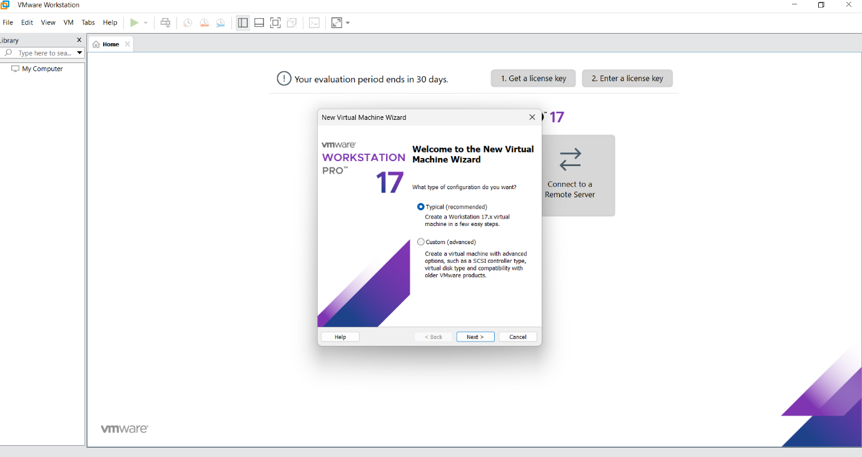

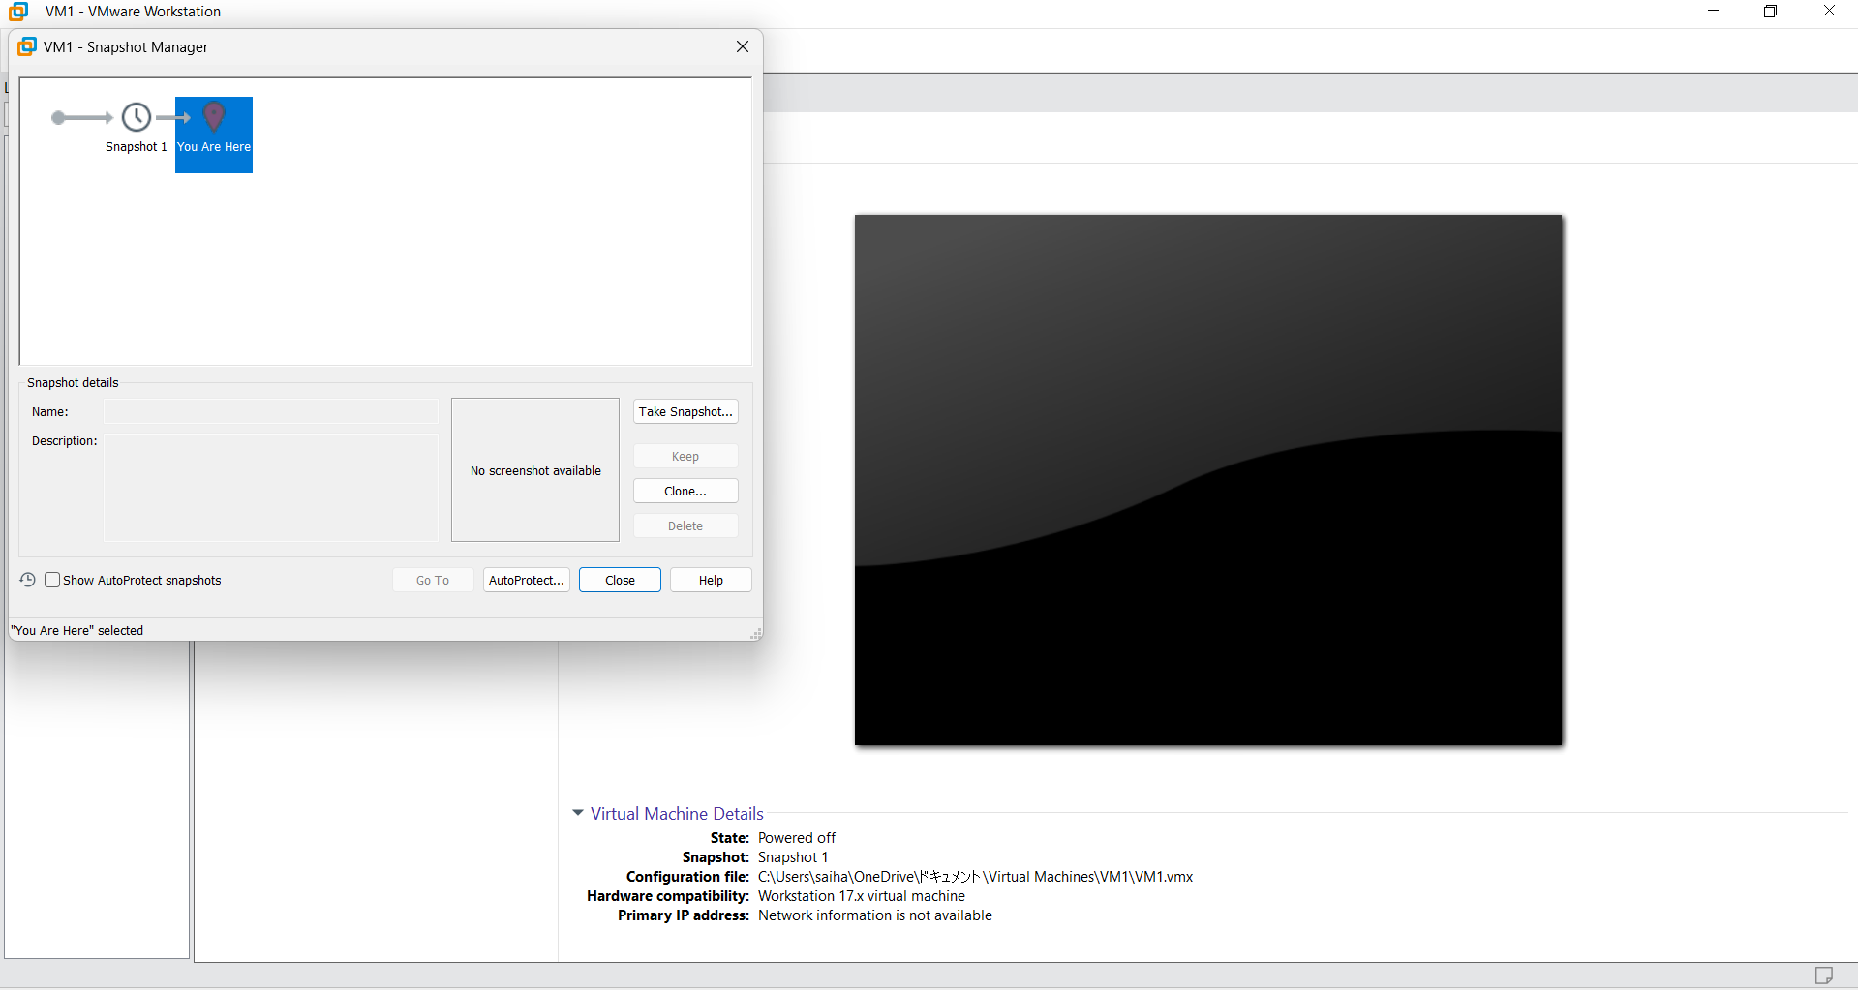

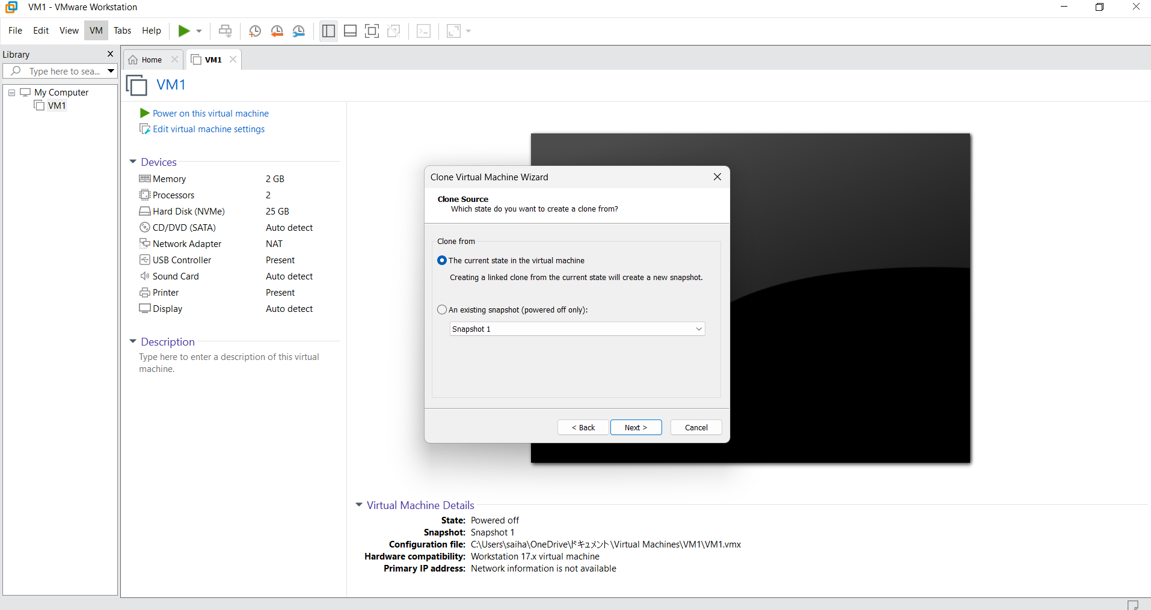

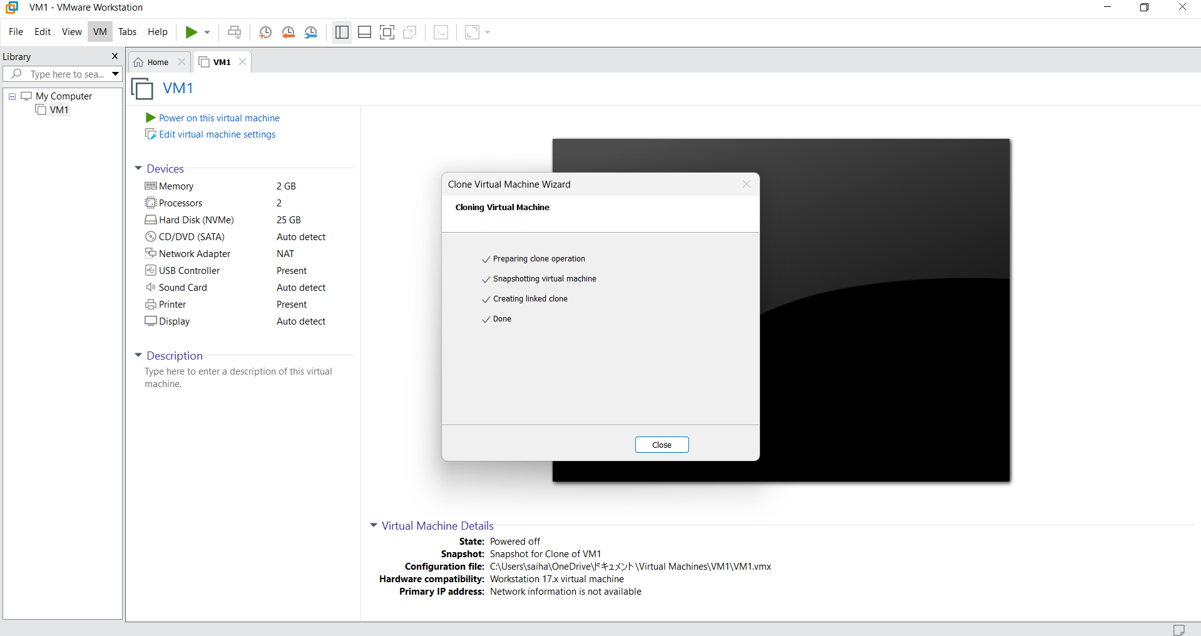

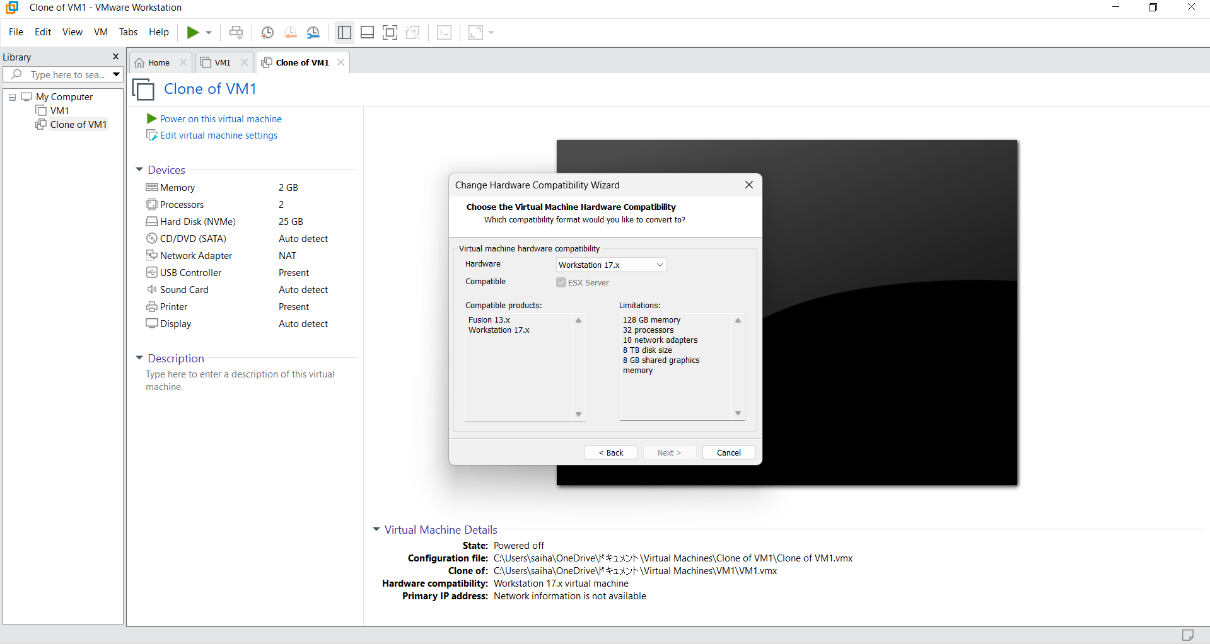

Result :
The virtual machine snapshot was successfully created. The system was reverted to the snapshot state without data loss. Additionally, a cloned VM was created and verified to run correctly from the selected snapshot state.

