EXP18. DEMONSTRATE INFRASTRUCTURE AS A SERVICE (IAAS) BY CREATING A VIRTUAL MACHINE USING A PUBLIC CLOUD SERVICE PROVIDER (AZURE), CONFIGURE WITH REQUIRED MEMORY AND CPU.
AIM:
To demonstrate infrastructure as a service (iaas) by creating a virtual machine using a
public cloud service provider (azure), configure with required memory and cpu.
PROCEDURE:
STEP1: CREATE AN ACCOUNT IN MICROSOFT AZURE.
STEP2: GOTO RESOURCE GROUPAND CREATE A RESOURCE GROUP.
STEP3: GIVE NECESSARY THINGS FOR RESOURCE GROUP.
STEP4: CREATE AVIRTUAL NETWORK FOR TO CREATE AVIRTUALMACHINE .
STEP5: NOW CREATE A VIRTUAL MACHINE WITH UR IPADDRESS ANUSERNAME AND
PASSWORD FOR YOUR VIRTUAL MACINE.
STEP6: AND YOUR VIRTUAL MACHINE IS DEPLOYED.
STEP7: NOW CONNECT THE VIRTUAL MACHINE AND DOWNLOAD THE RDP FILETO OPEN YOUR
WINDOWS VIRTUAL MACHINE.
STEP8: NOW RESIZE THE VIRTUAL MACHINE SIZE.
STEP9: CREATED ANEW WINDOWS VIRTUAL MACHINE
IMPLEMENTATION:
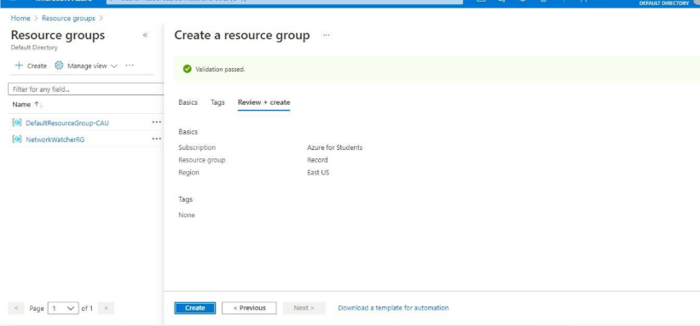

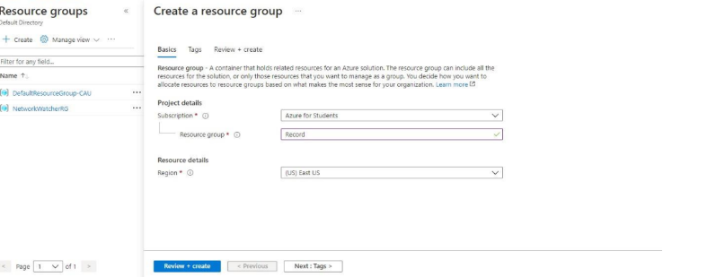

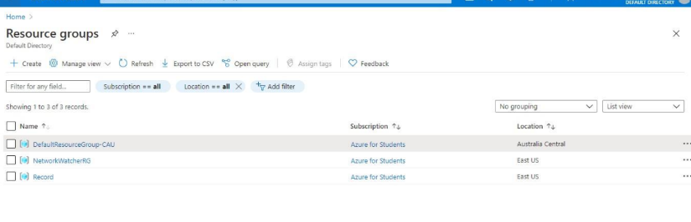

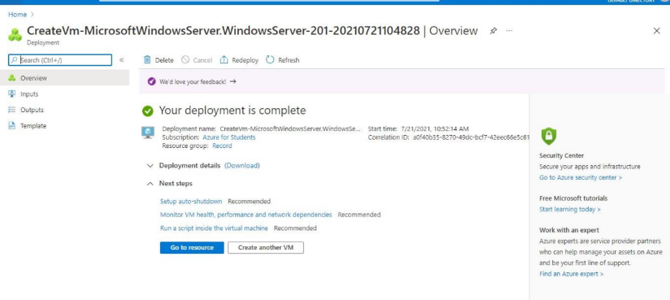

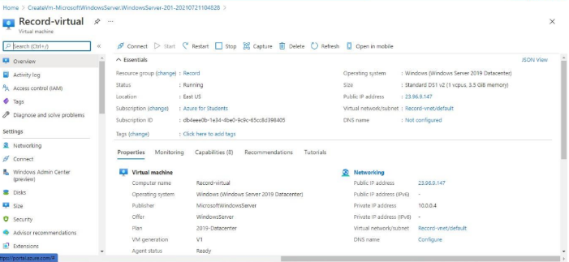

RESULT:
Infrastructure as a service (iaas) by creating a virtual machine using a
public cloud service provider (azure), configure with required memory and cpu has been demonstrated.

