LAB:
1) In sliding puzzle, it consists of a 3x3 grid with eight numbered tiles and one empty space. The goal of the
puzzle is to rearrange the tiles from their initial, scrambled state to a goal state where the numbers are
ordered from 1 to 8, with the empty space in the bottom-right corner. Implement the same using python.
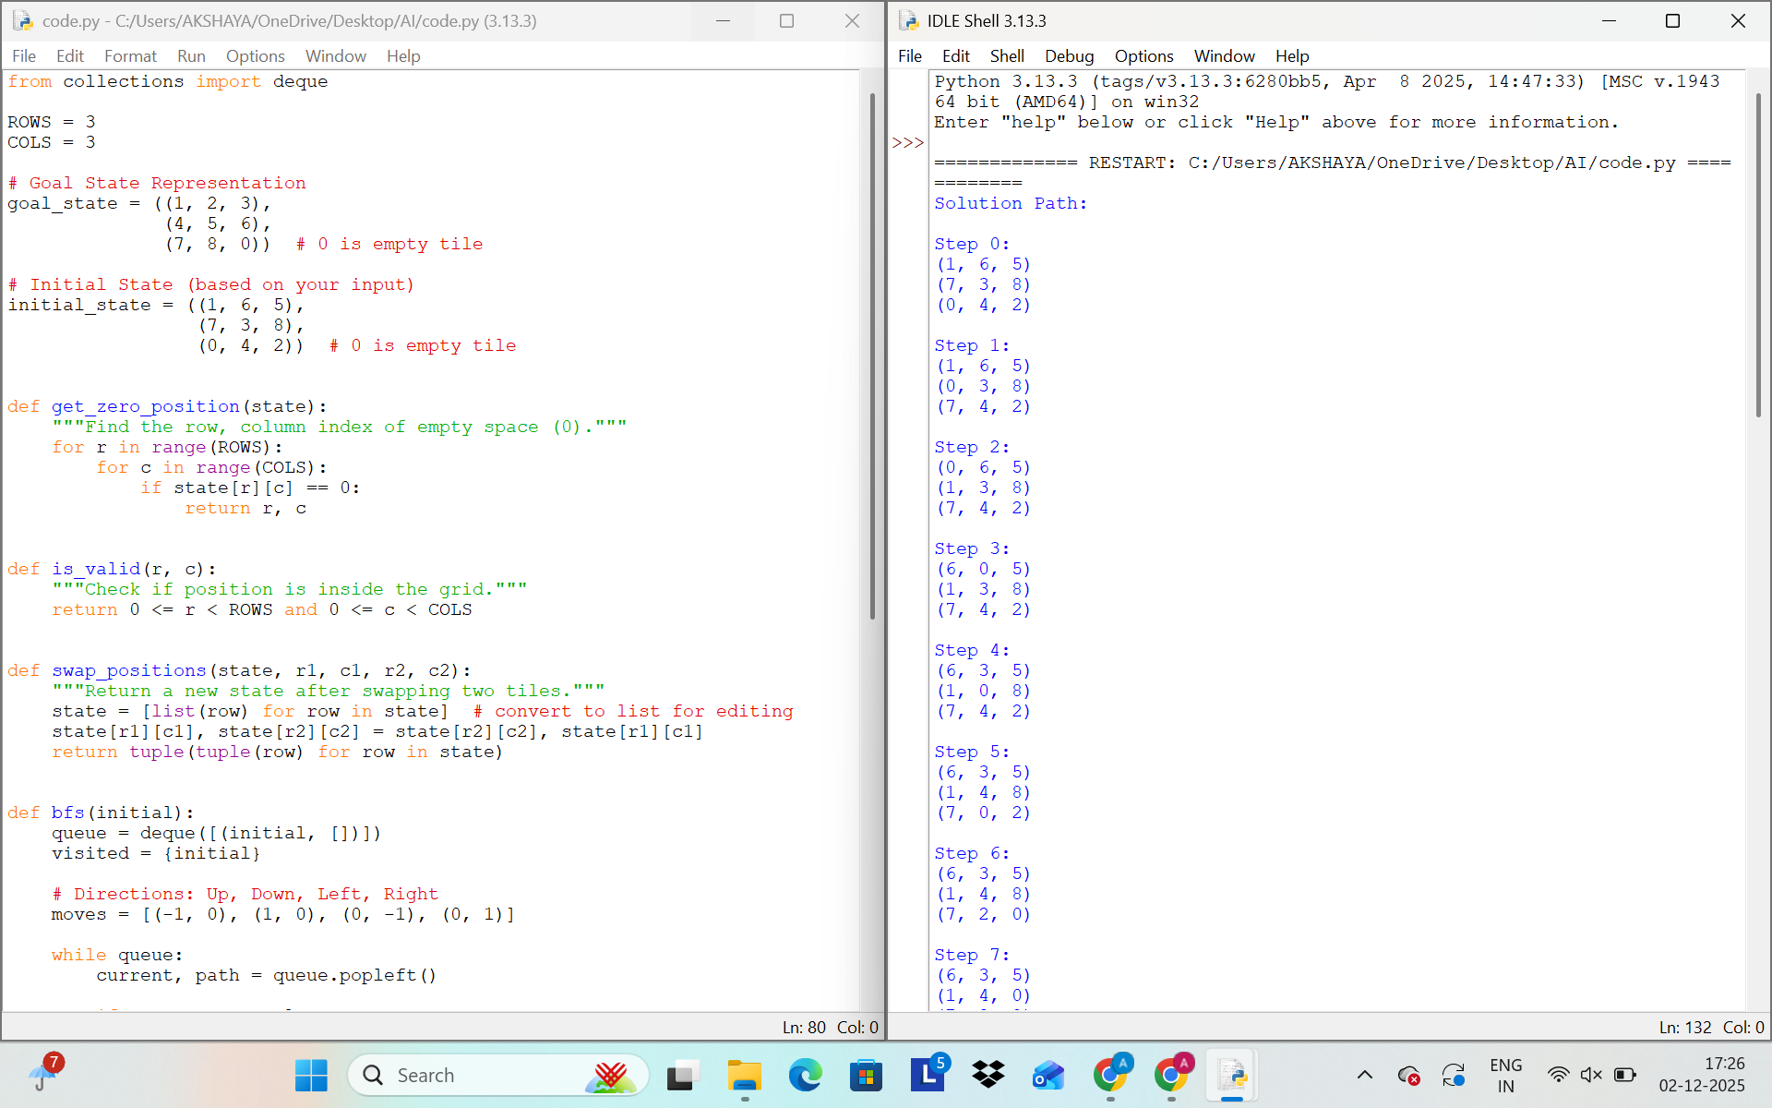
2) The Towers of Hanoi problem involves three pegs (A, B, C) and a number of disks of different sizes that
can slide onto any peg. The puzzle starts with all the disks stacked on one peg in order of decreasing size,
with the largest at the bottom.
The objective of the problem is to move the entire stack to another peg, following these rules:
a) Only one disk can be moved at a time.
b) Each move consists of taking the upper disk from one of the stacks and placing it on top of another
stack.
c) No disk may be placed on top of a smaller disk.
Implement the above Towers of Hanoi problem using Python.
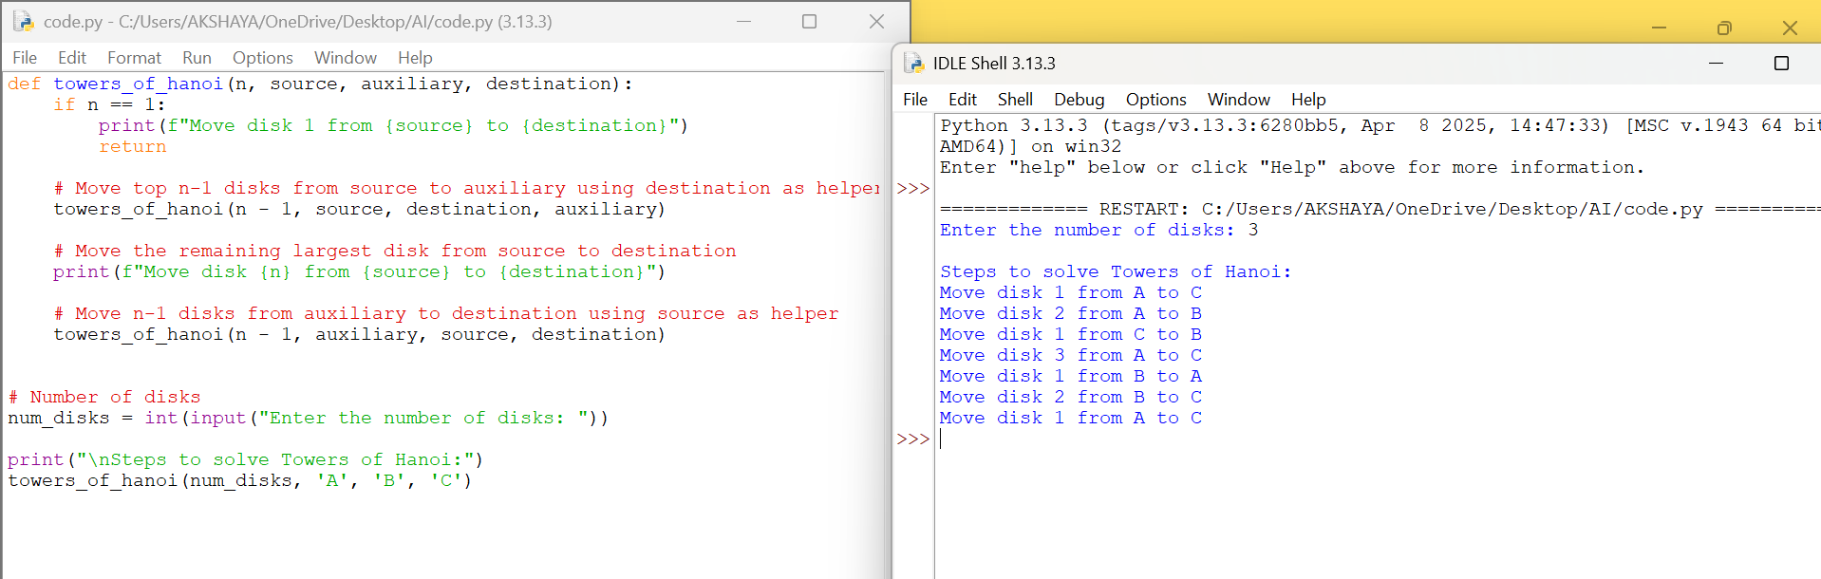
3) Implement a Python program to perform Breadth-First Search (BFS) on a graph. The program should:
• Represent the graph using an adjacency list.
• Start the traversal from a given source node.
• Print the order in which the nodes are visited
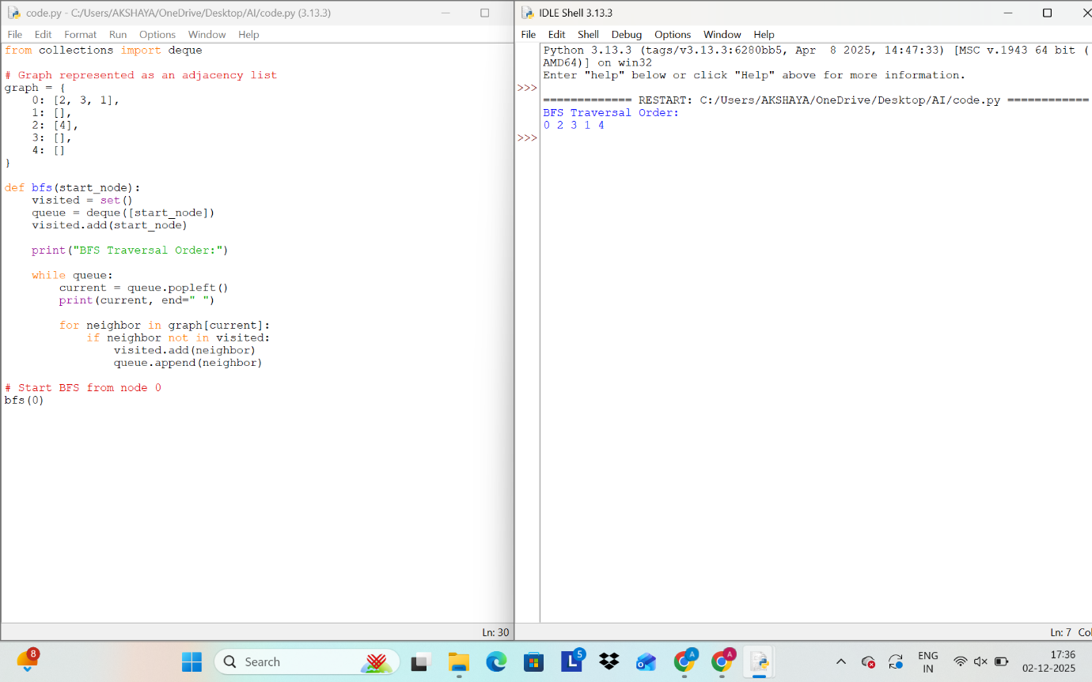
4) The Monkey and Banana problem is a classic artificial intelligence problem where a monkey needs to
navigate through a room to reach a bunch of bananas hanging from the ceiling. The monkey has to move
a box to stand on it to reach the bananas. Implement the above scenario using python.
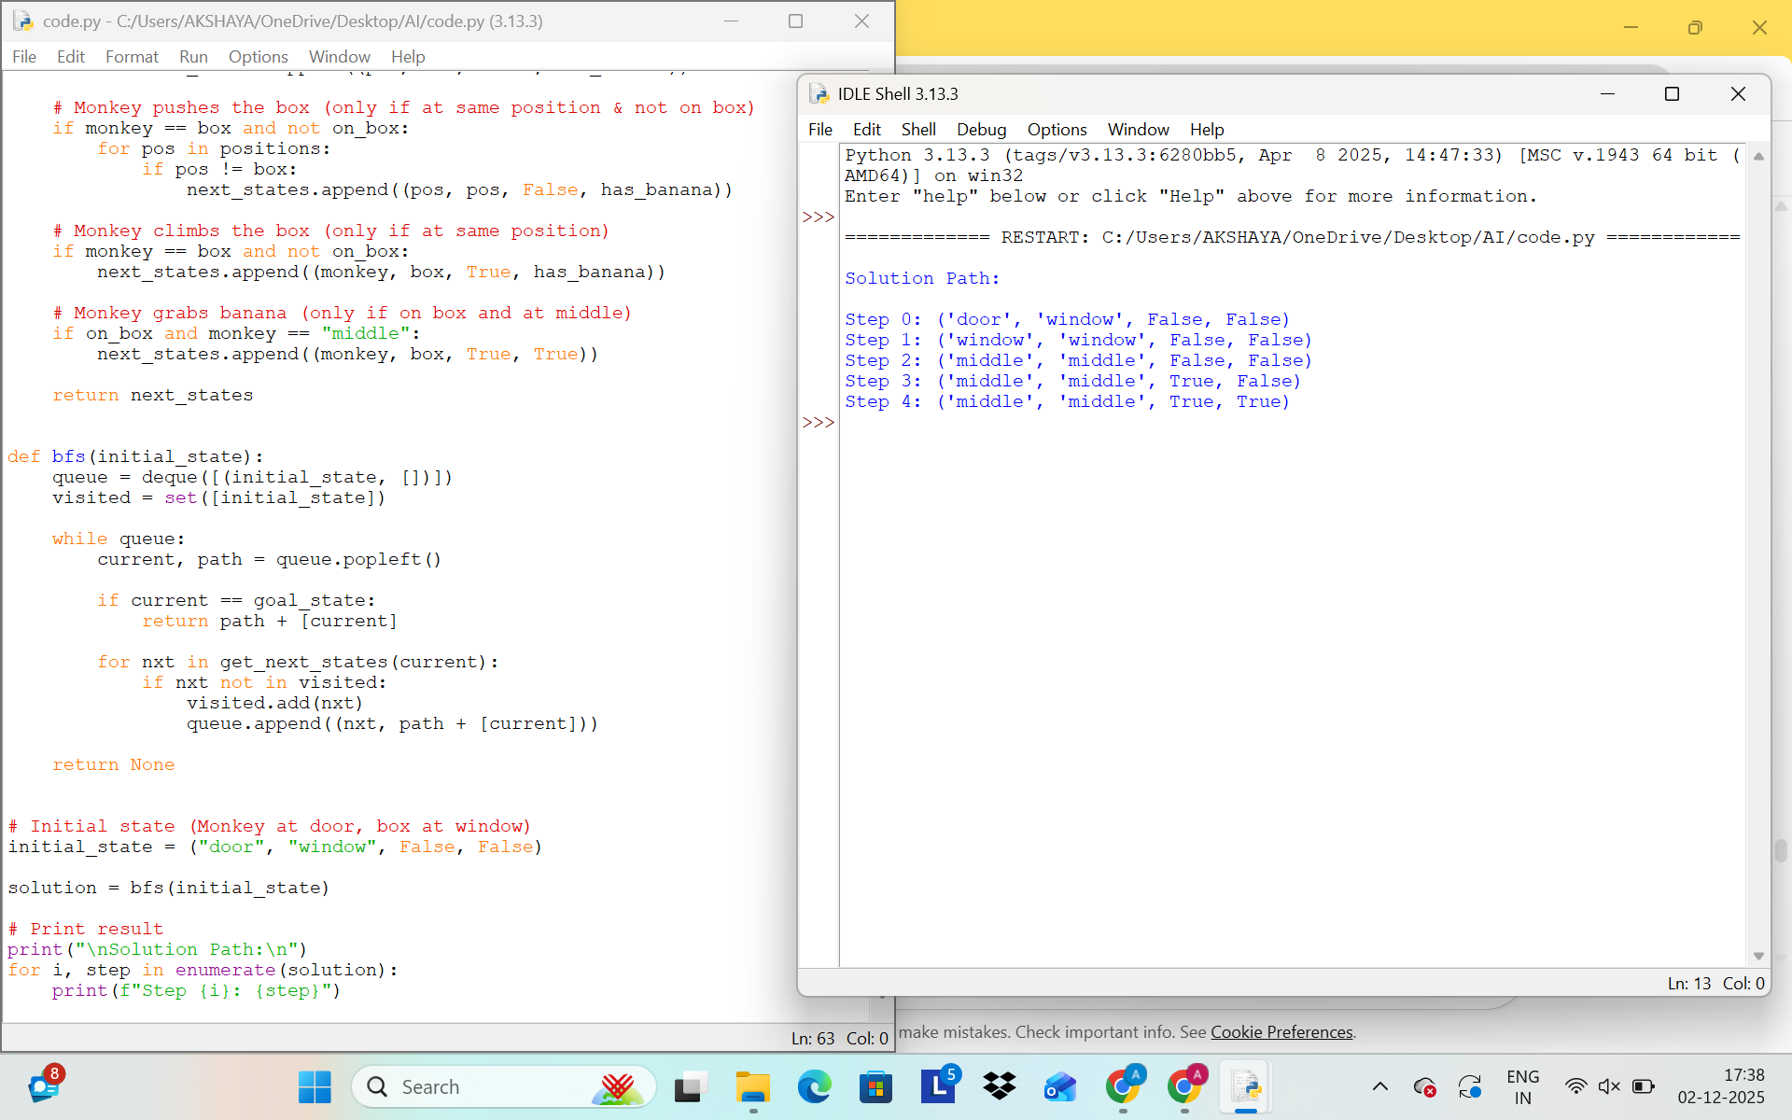
5) Write the python program to place eight queens on an 8 x 8 chessboard in such a way that no two queens
threaten each other. In other words, no two queens can share the same row, column, or diagonal. Use
backtracking to explore different possibilities and ensures that no two queens threaten each other.
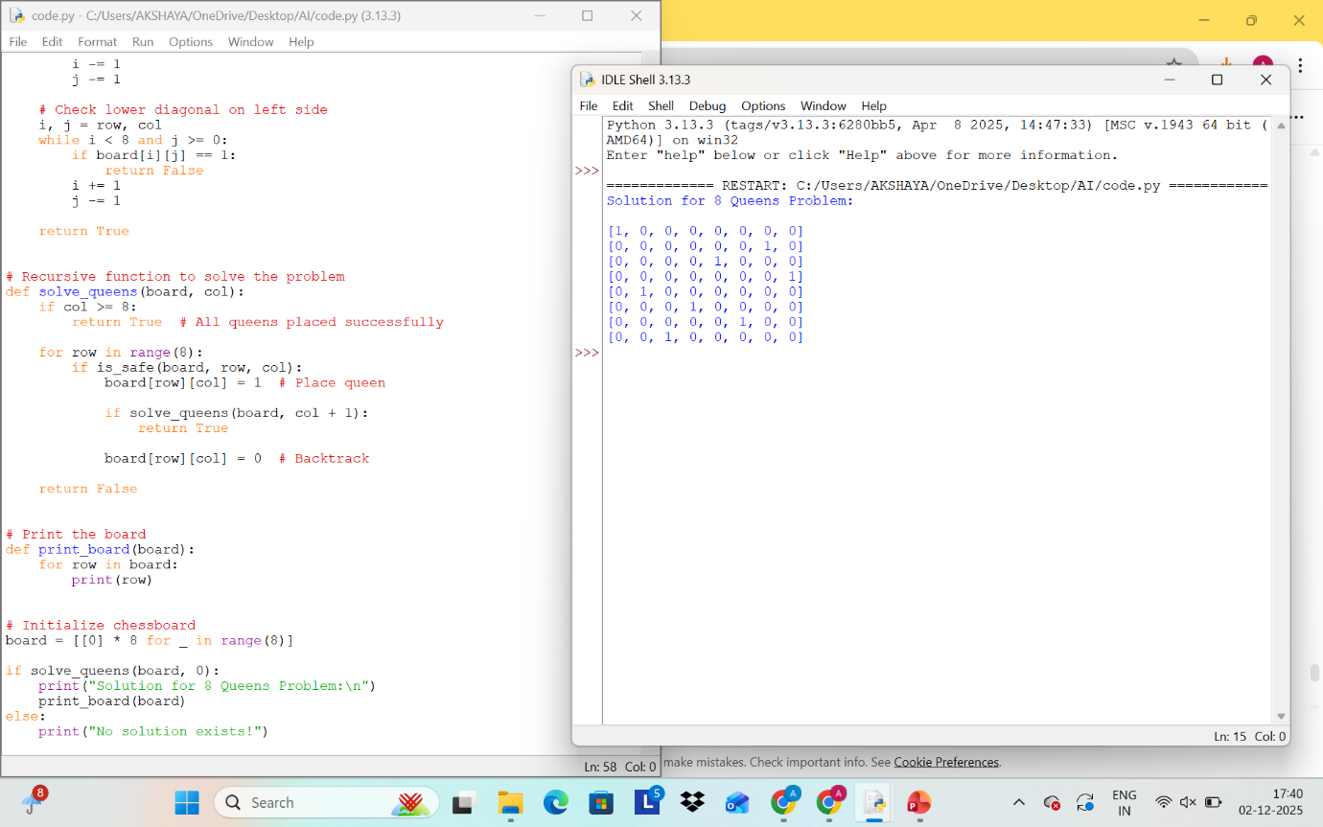

6) Implement a Python program to perform Depth-First Search (DFS) on a graph. The program should:
• Represent the graph using an adjacency list.
• Traverse the graph starting from a given source node.
• Print the order in which the nodes are visited.
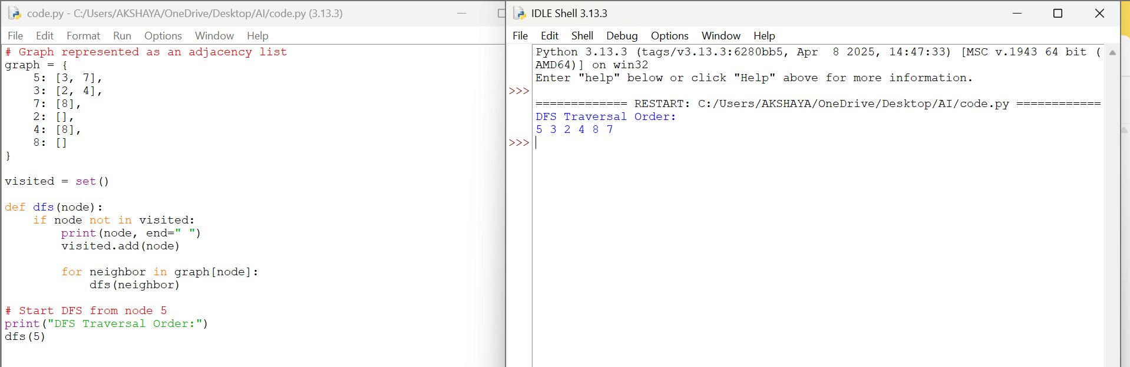
7) Solve the given problem using python. Consider a Water Jug problem: You are given two jugs, a 4-gallon
one and a 3-gallon one. Neither has any measuring marker on it. There is a pump that can be used to fill
the jugs with water. How can you get exactly 2 gallons of water into the 4-gallon jug? Explicit
Assumptions: A jug can be filled from the pump, water can be poured out of a jug onto the ground, water
can be poured from one jug to another and that there are no other measuring devices available.
