**AI ASSISTED CODING**

**ASSIGNMENT-7.4**

Name: Perala Akshaya

HT NO.:2403A51264

Batch No.: 11

# Task 1:

* Introduce a buggy Python function that calculates the factorial of a number using recursion. Use Copilot or Cursor AI to detect and fix the logical or syntax errors.

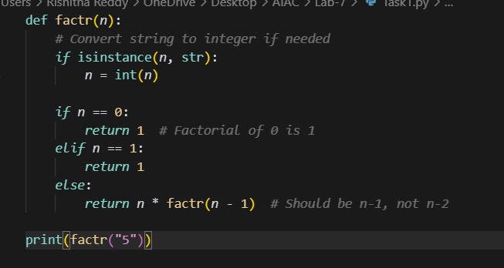

OUTPUT:



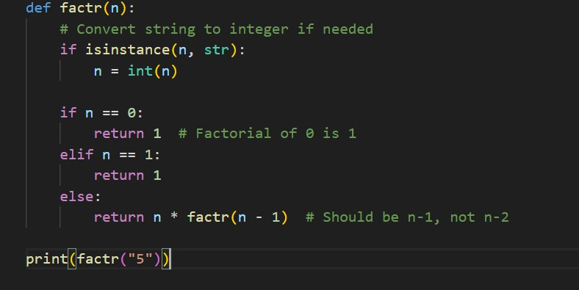

OUTPUT:

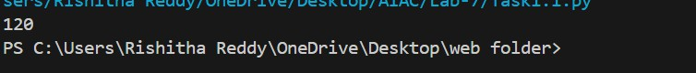

# Task 2:

* Provide a list sorting function that fails due to a type error (e.g., sorting list with mixed integers and strings). Prompt AI to detect the issue and fix the code for consistent sorting**.**

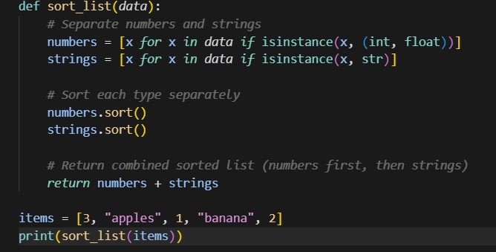

OUTPUT:

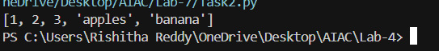

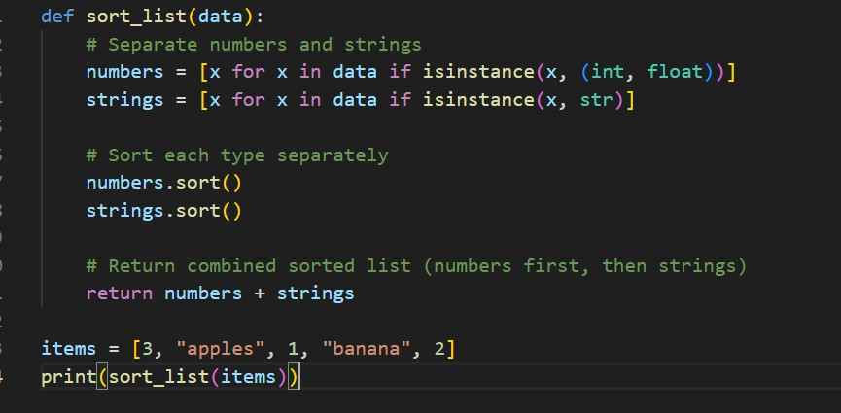

OUTPUT:

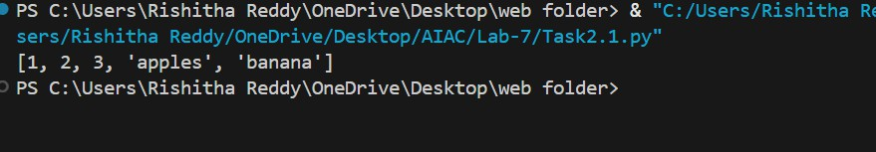

# Task 3:

* Write a Python snippet for file handling that opens a file but forgets to close it. Ask Copilot or Cursor AI to improve it using the best practice (e.g., with open() block).

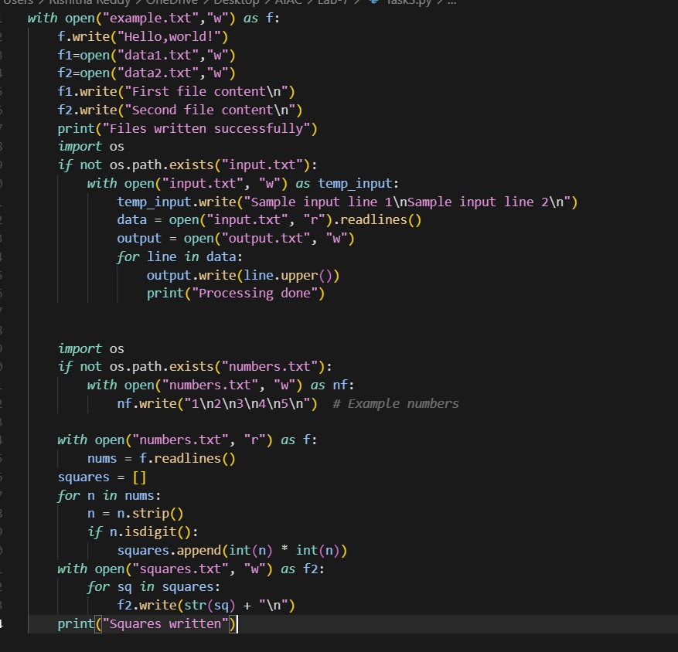

# OUTPUT:

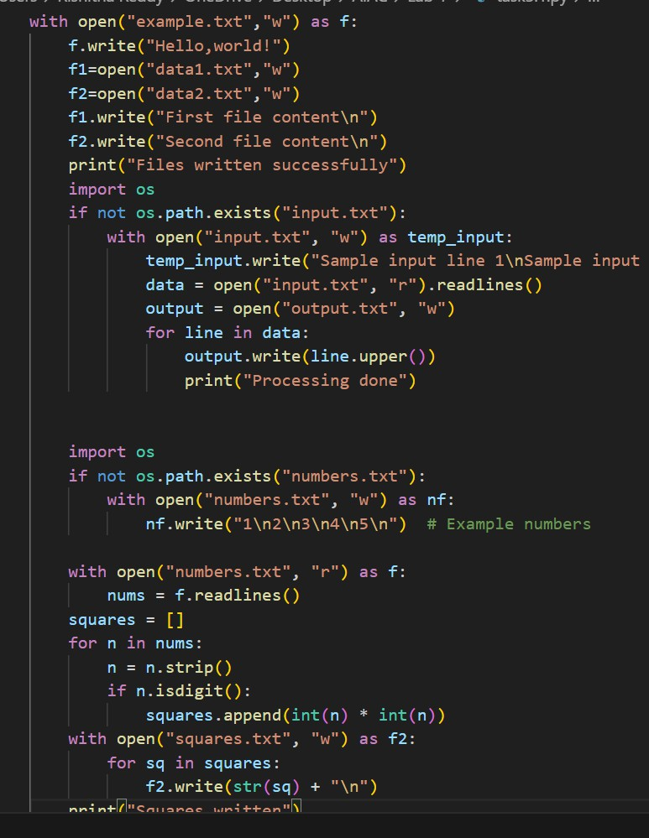

OUTPUT:

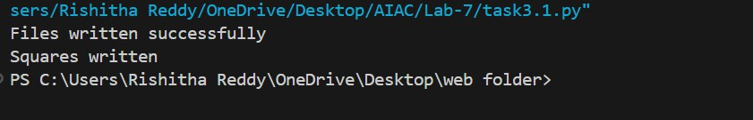

# Task 4:

* Provide a piece of code with a ZeroDivisionError inside a loop. Ask AI to add error handling using try-except and continue execution safely.

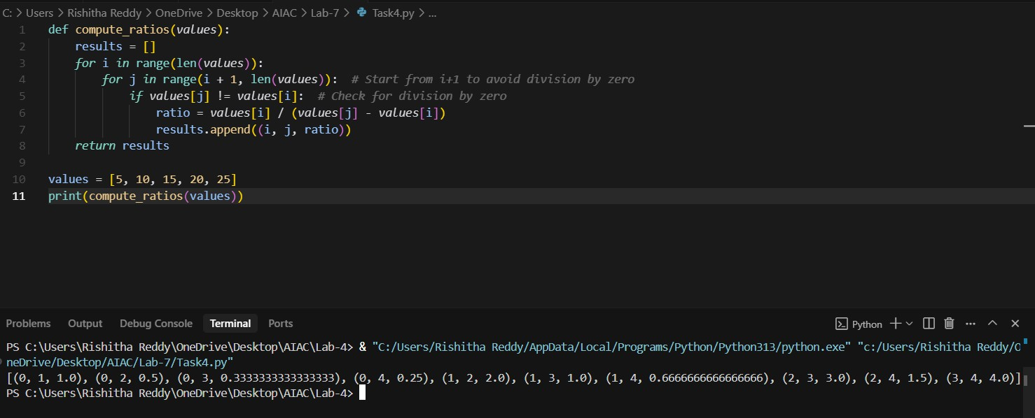

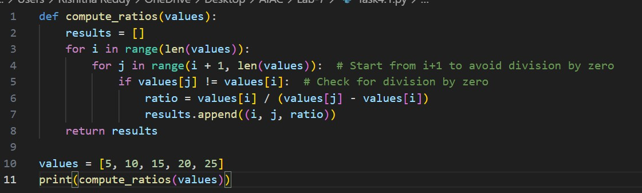

OUTPUT:



# Task 5:

* Include a buggy class definition with incorrect init parameters or attribute references. Ask AI to analyze and correct the constructor and attribute usage

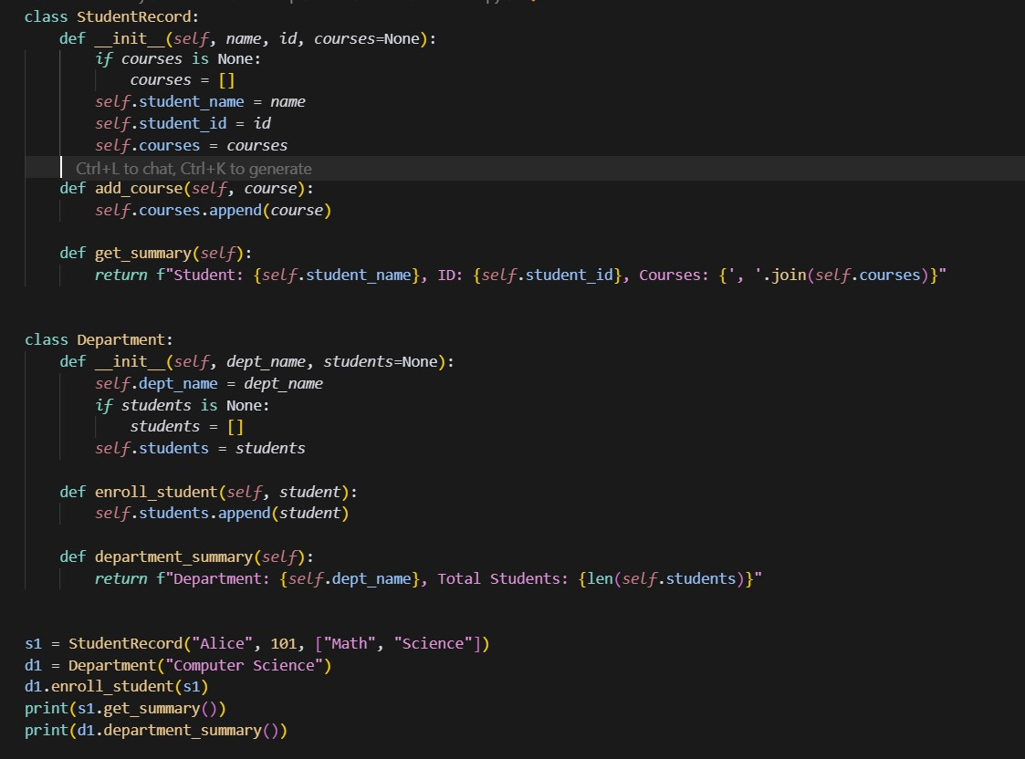

OUTPUT:

