**AI ASSISTED CODING**

ASSIGNMENT-8.2

Name: Perala Akshaya

HT NO.: 2403A51264

Batch No.:11

TASK – 1

Use AI to generate test cases for a function is_prime(n) and then implement the  
function.  
Requirements:  
• Only integers > 1 can be prime.  
•  
Check edge cases: 0, 1, 2, negative numbers, and large primes.

Expected Output 1  
• A working prime checker that passes AI-generated tests using edge  
coverage

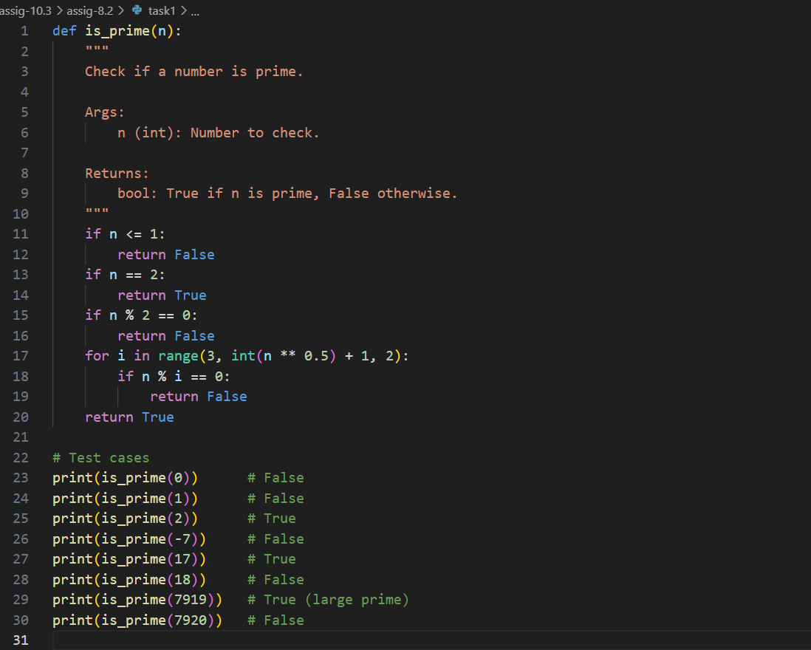

OUTPUT:

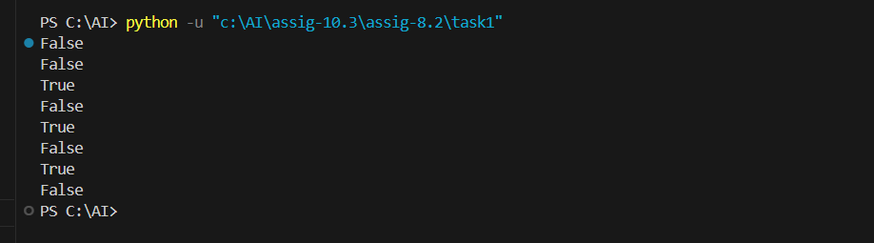

TASK – 2  
• Ask AI to generate test cases for celsius_to_fahrenheit(c) and fahrenheit_to_celsius(f).  
Requirements  
• Validate known pairs: 0°C = 32°F, 100°C = 212°F.  
• Include decimals and invalid inputs like strings or None  
Expected Output 2  
Dual conversion functions with complete test coverage and safe type handling

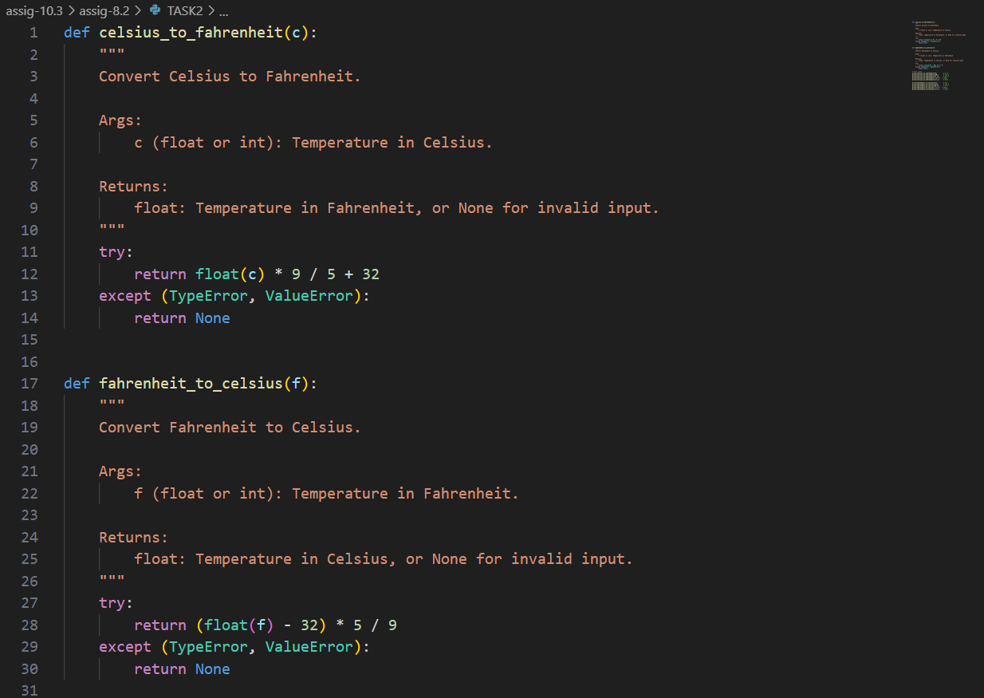

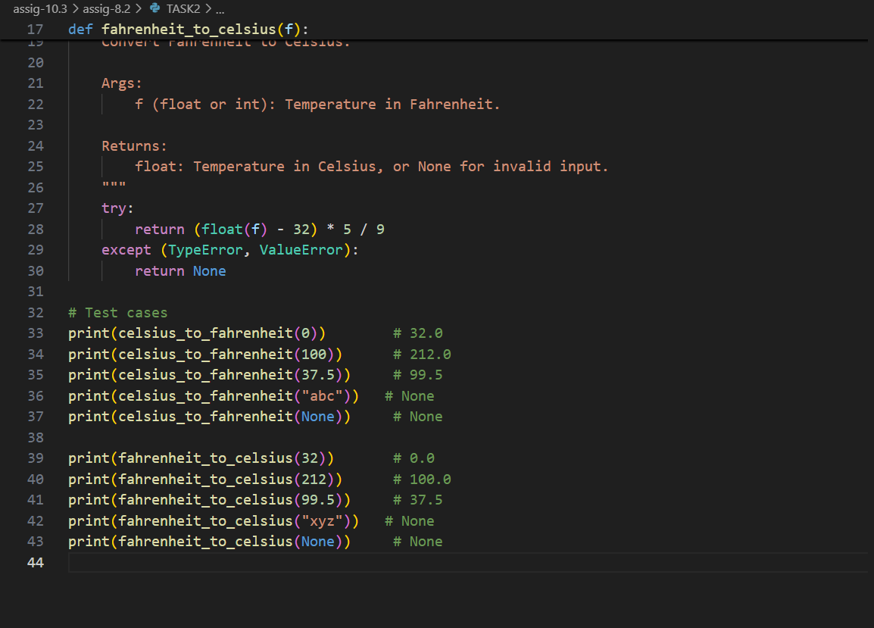

OUTPUT:

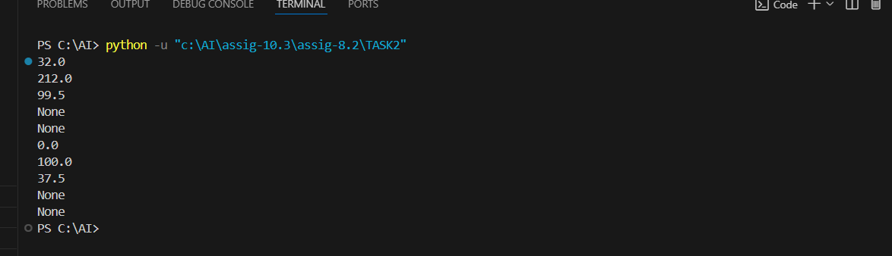

TASK – 3

Use AI to write test cases for a function count_words(text) that returns the number of  
words in a sentence.  
Requirement  
Handle normal text, multiple spaces, punctuation, and empty strings.

Expected Output 3  
Accurate word count with robust test case validation.

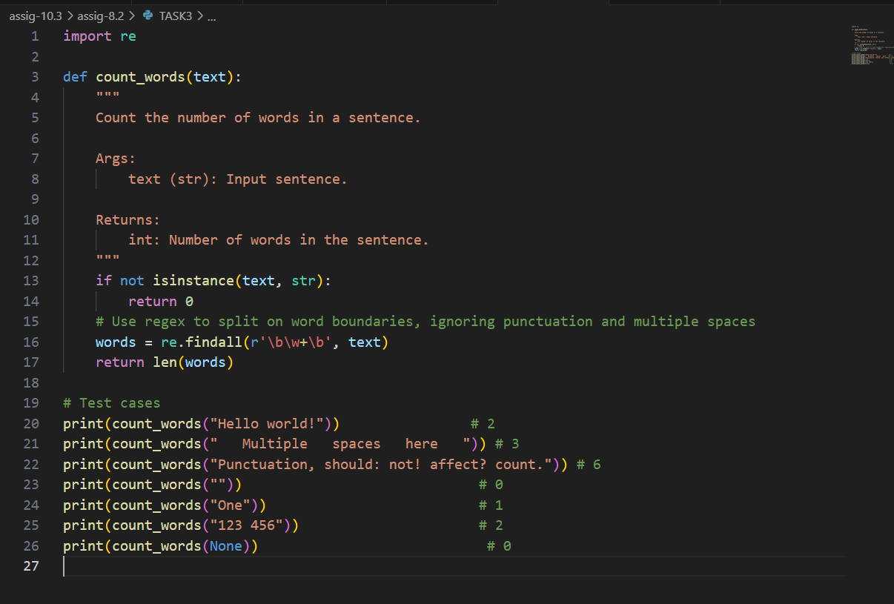

OUTPUT:

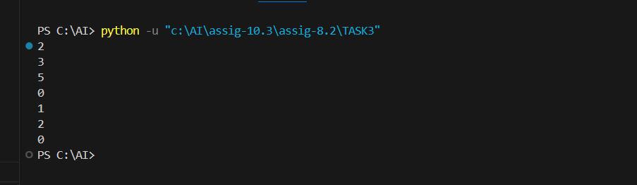

TASK – 4  
• Generate test cases for a BankAccount class with:  
Methods:  
deposit(amount)  
withdraw(amount)  
check_balance()  
Requirements:  
• Negative deposits/withdrawals should raise an error.  
• Cannot withdraw more than balance.  
Expected Output#4  
• AI-generated test suite with a robust class that handles all test cases.

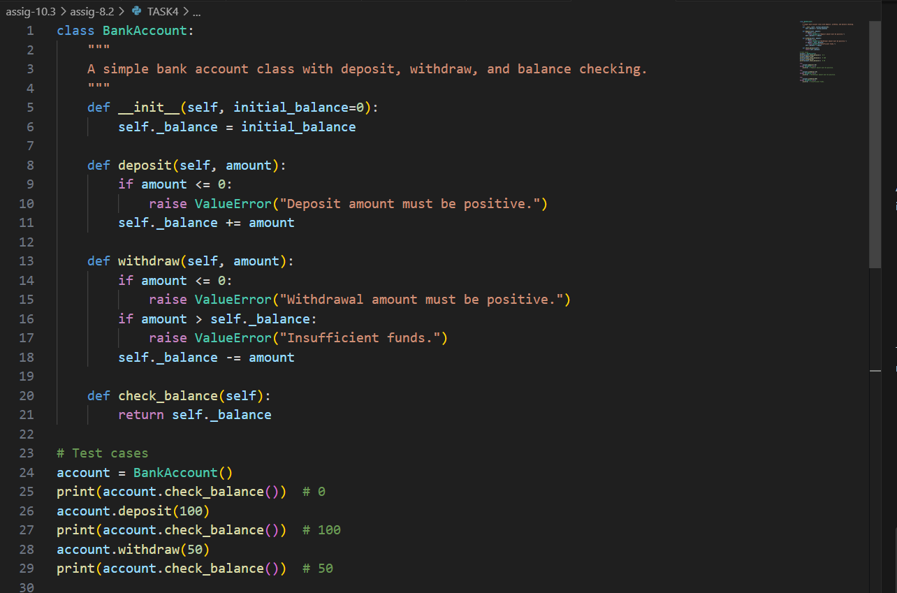

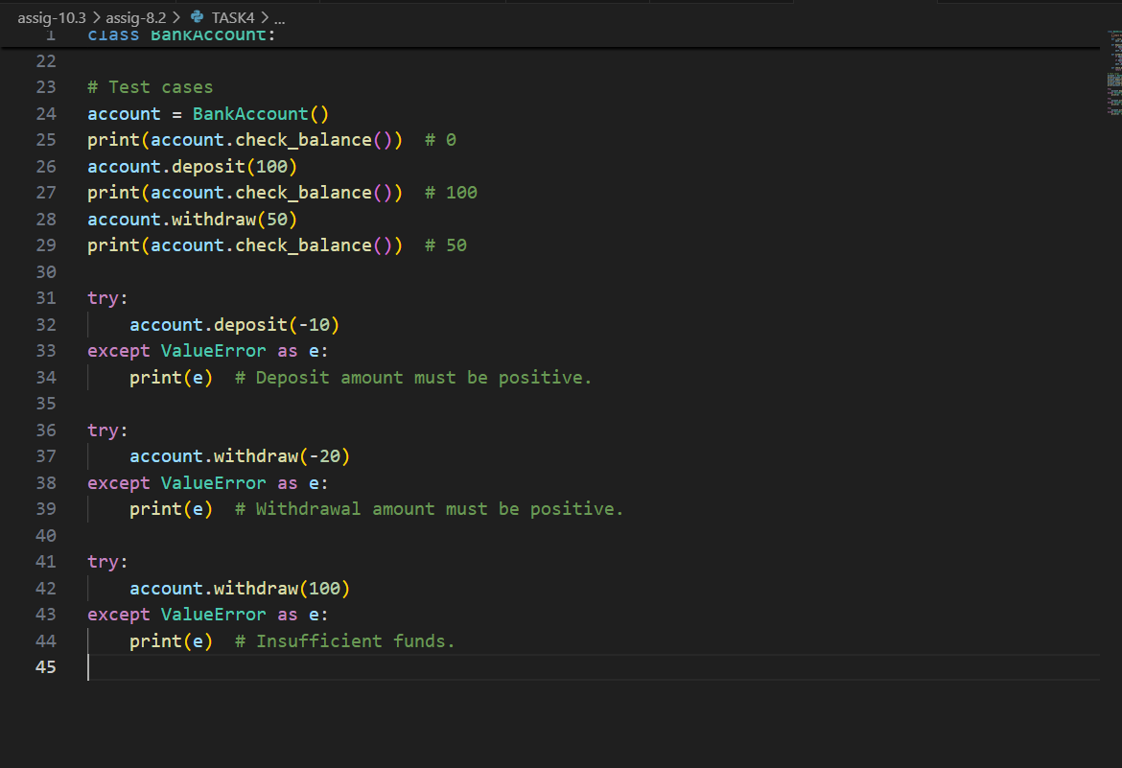

OUTPUT:

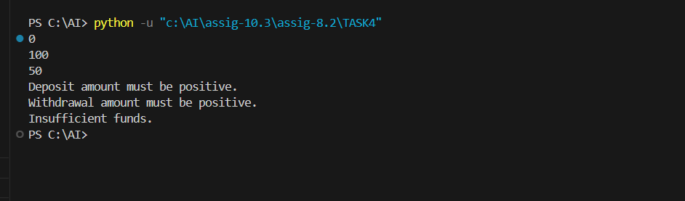

TASK – 5

Generate test cases for is_number_palindrome(num), which checks if an integer reads  
the same backward.  
Examples:  
121 → True  
123 → False  
0, negative numbers → handled gracefully

Expected Output 5  
• Number-based palindrome checker function validated against test cases.

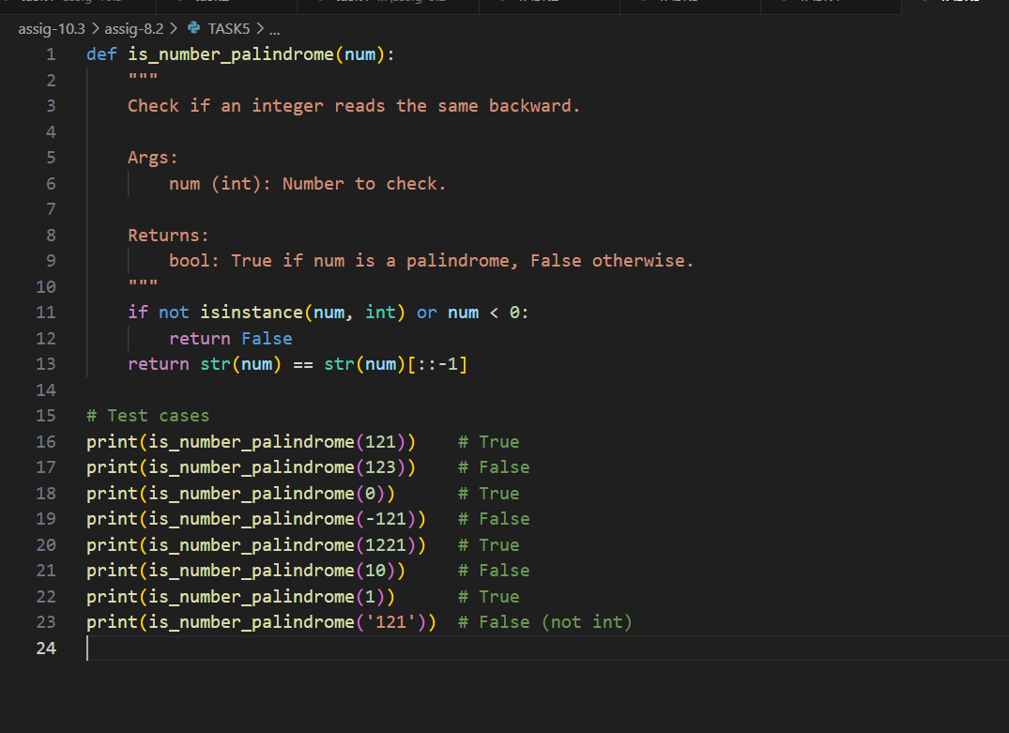

OUTPUT:

