**AI ASSISTED CODING**

**ASSIGNMENT-8.3**

Name: Perala Akshaya

HT NO.:2403A51264

Batch No.:11

# Task Description#1

Use AI to generate test cases for is_valid_email(email) and then implement the validator function.

# Requirements:

* Must contain @ and . characters.
* Must not start or end with special characters.
* Should not allow multiple @.

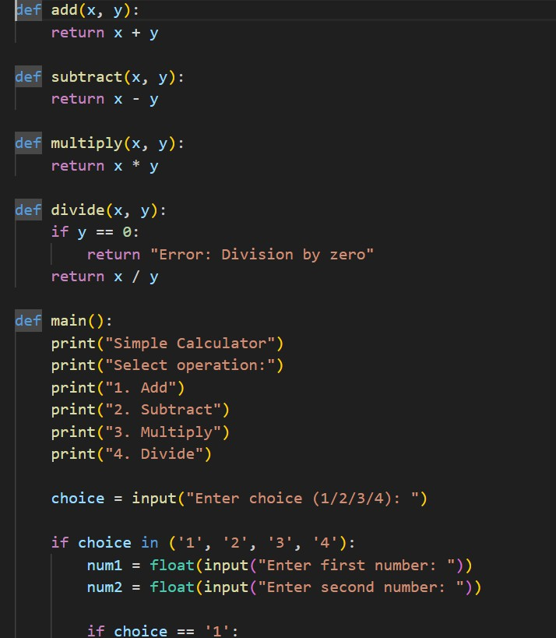

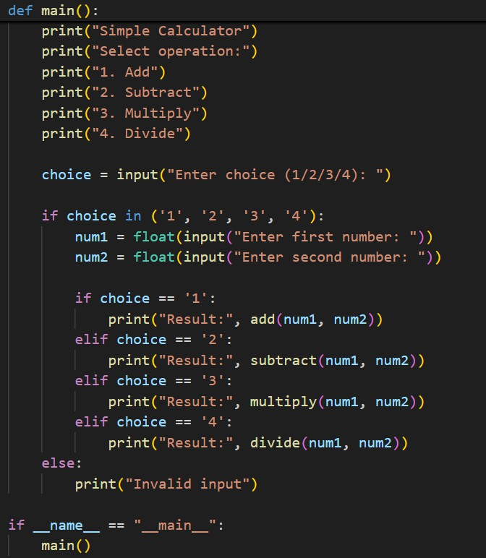

OUTPUT:

