AI ASSISTED CODING

ASSIGNMENT-10.1

Name: Perala Akshaya HT NO.:2403a51264

Batch No.:11

**TASK 1**

**GIVEN CODE-**

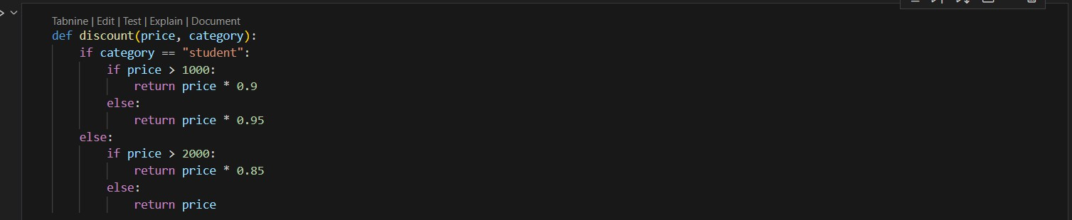

**PROMPT-**

For the above code simplify and refactor for readability.

**AI GENERATED CODE-**

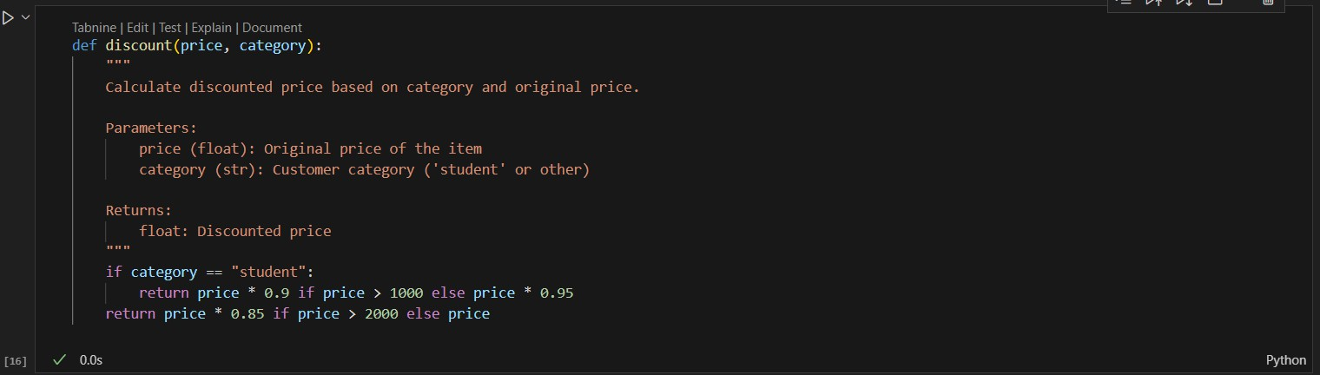

**TASK 2**

**GIVEN CODE-**

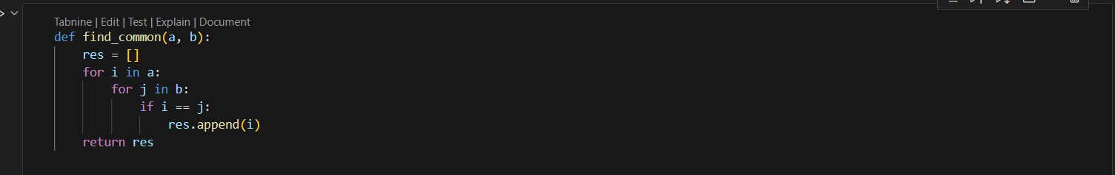

**PROMPT-**

Refactor and optimize the above code.

**AI GENERATED CODE-**

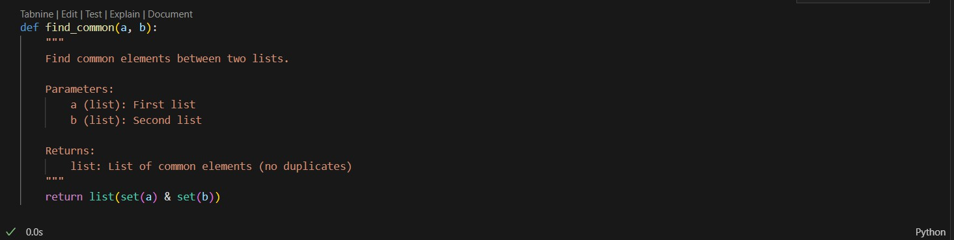

**TASK 3**

**GIVEN CODE-**

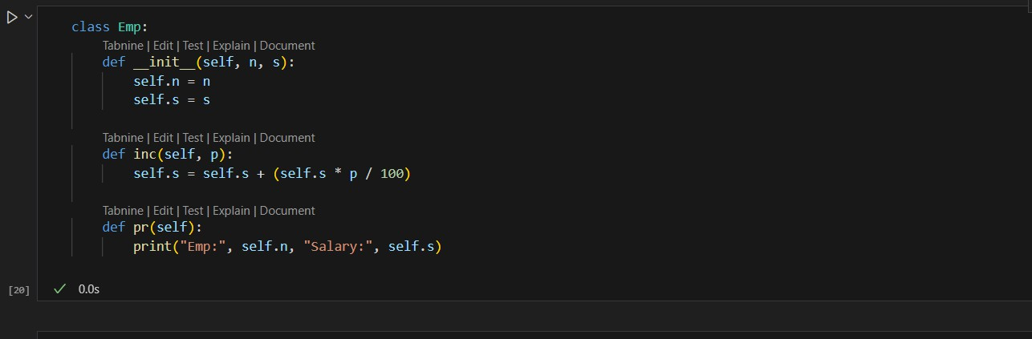

**PROMPT-**

For the above code improve Naming conventions, Encapsulation, Readability C maintainability.

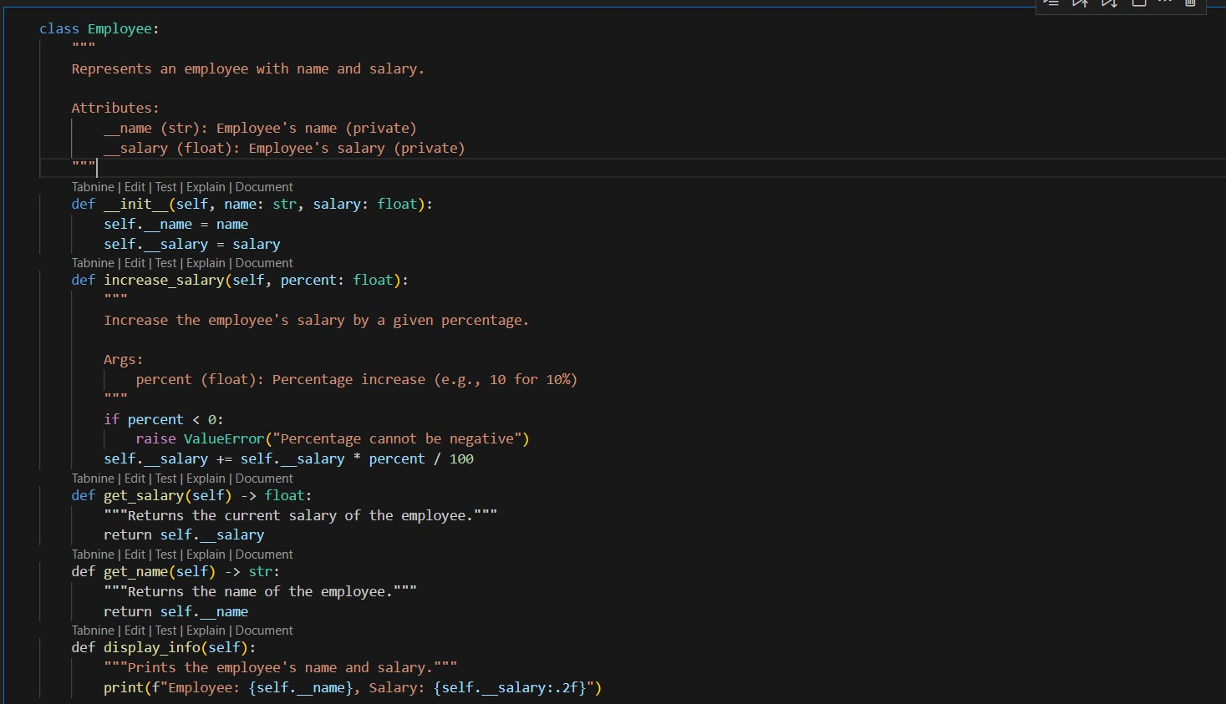

**TASK 4**

**GIVEN CODE-**

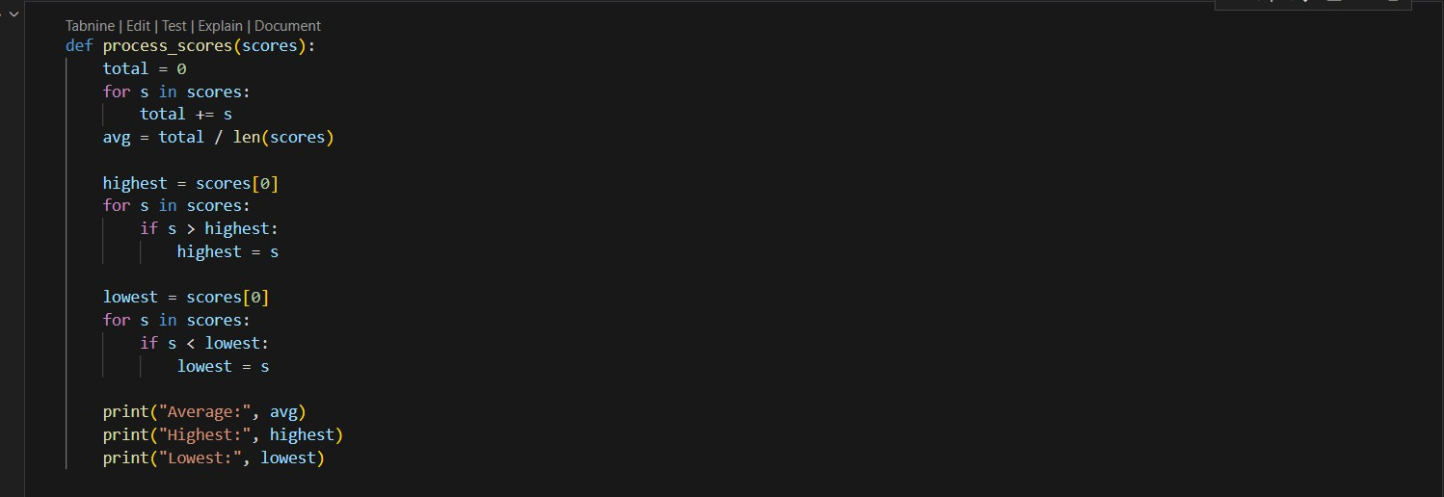

**PROMPT-**

Break the code into smaller helper functions.

**AI GENERATED CODE-**

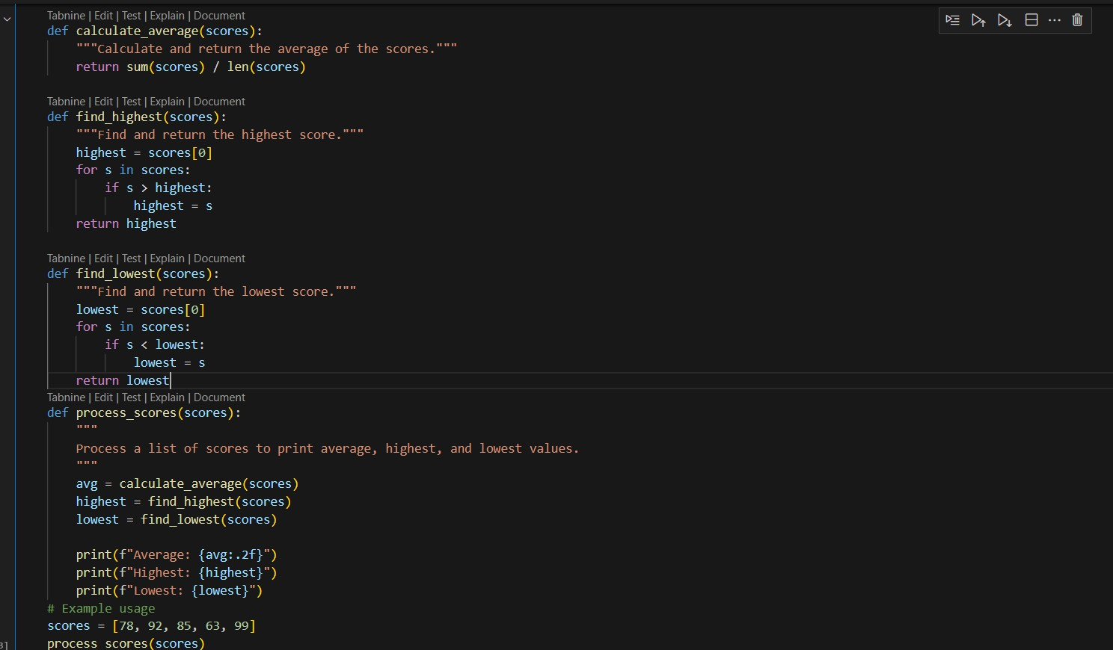

**OUTPUT-**



**TASK 5**

**GIVEN CODE-**

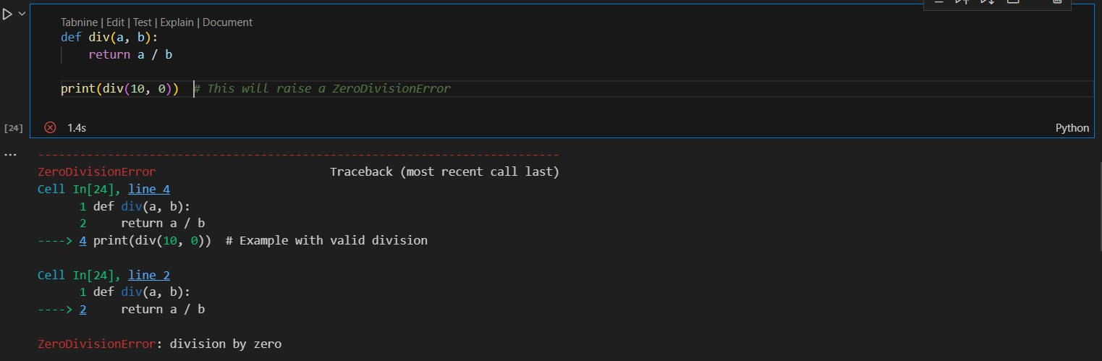

**PROMPT-**

For the above code improve error handling, naming, and readability.

**AI GENERATED CODE-**

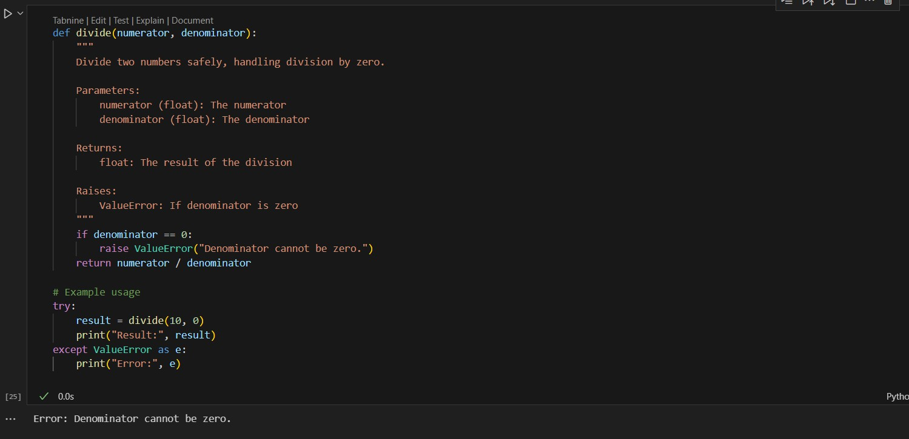

**TASK 6**

**GIVEN CODE-**

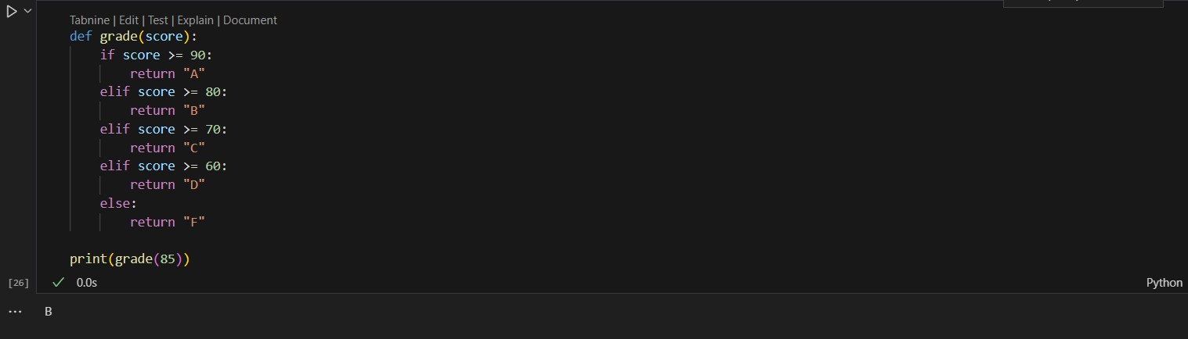

**PROMPT-**

Simplify overly complex logic.

**AI GENERATED CODE-**

