**AI ASSISTED CODING**

**ASSIGNMENT-9.2**

Name: Perala Akshaya

HT NO: 2403A51264

Batch No.: 11

**Task – 1**

Task: Use AI to add Google-style docstrings to all functions in a  
given Python script.  
• Instructions:  
o Prompt AI to generate docstrings without providing any  
input-output examples.  
o Ensure each docstring includes:  
▪ Function description  
▪ Parameters with type hints  
▪ Return values with type hints  
▪ Example usage  
o Review the generated docstrings for accuracy and  
formatting.

Expected Output 1:  
o A Python script with all functions documented using  
correctly formatted Google-style docstrings.

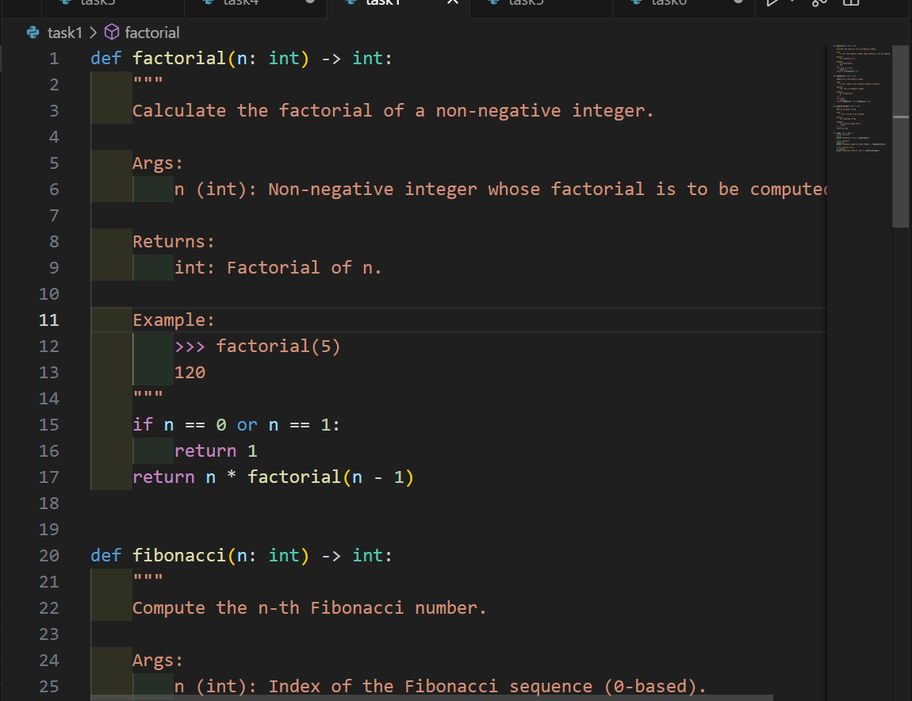

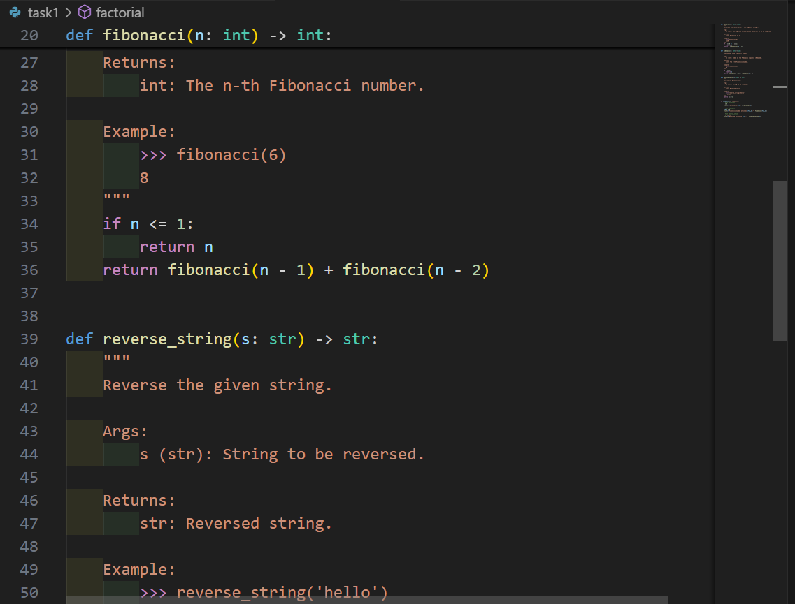

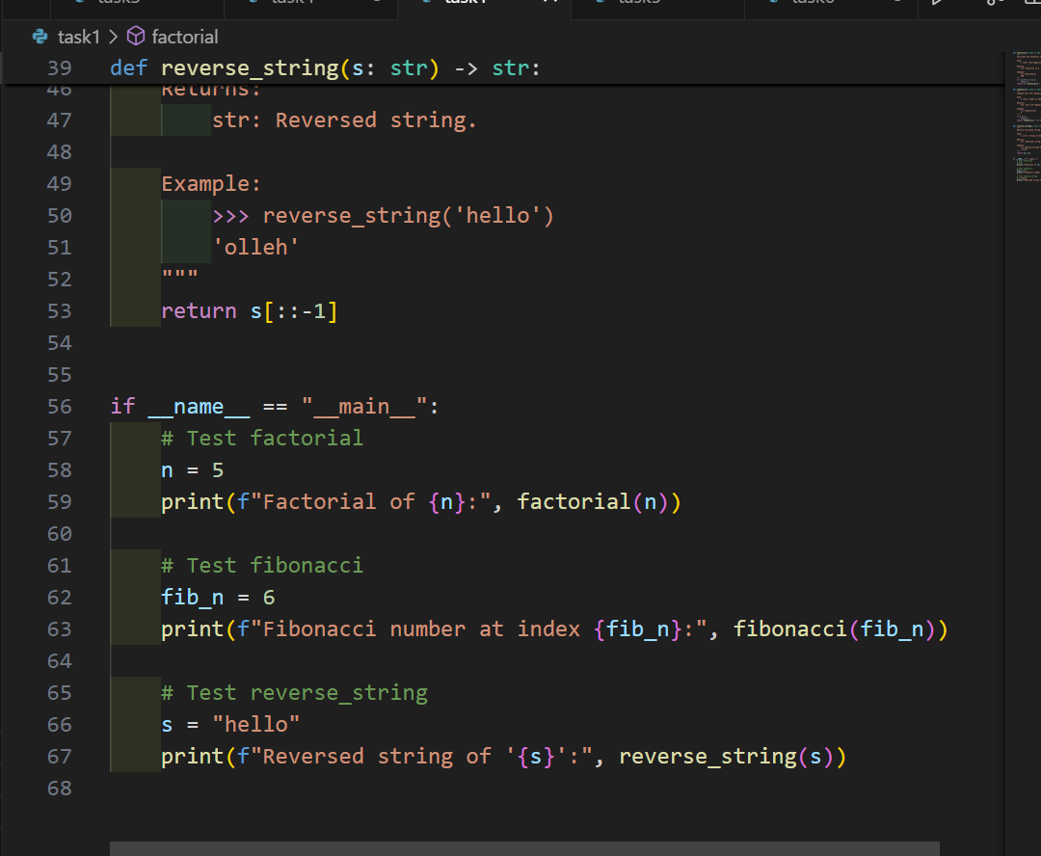

OUTPUT:

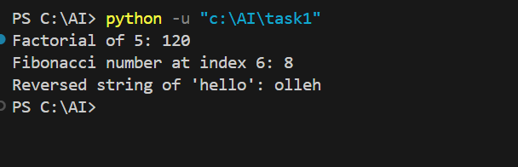

**Task – 2**

Task: Use AI to add meaningful inline comments to a Python  
program explaining only complex logic parts.  
• Instructions:  
o Provide a Python script without comments to the AI.  
o Instruct AI to skip obvious syntax explanations andfocus  
only on tricky or non-intuitive code sections.  
o Verify that comments improve code readability and  
maintainability.

Expected Output 2:  
o Python code with concise, context-aware inline comments  
for complex logic blocks.

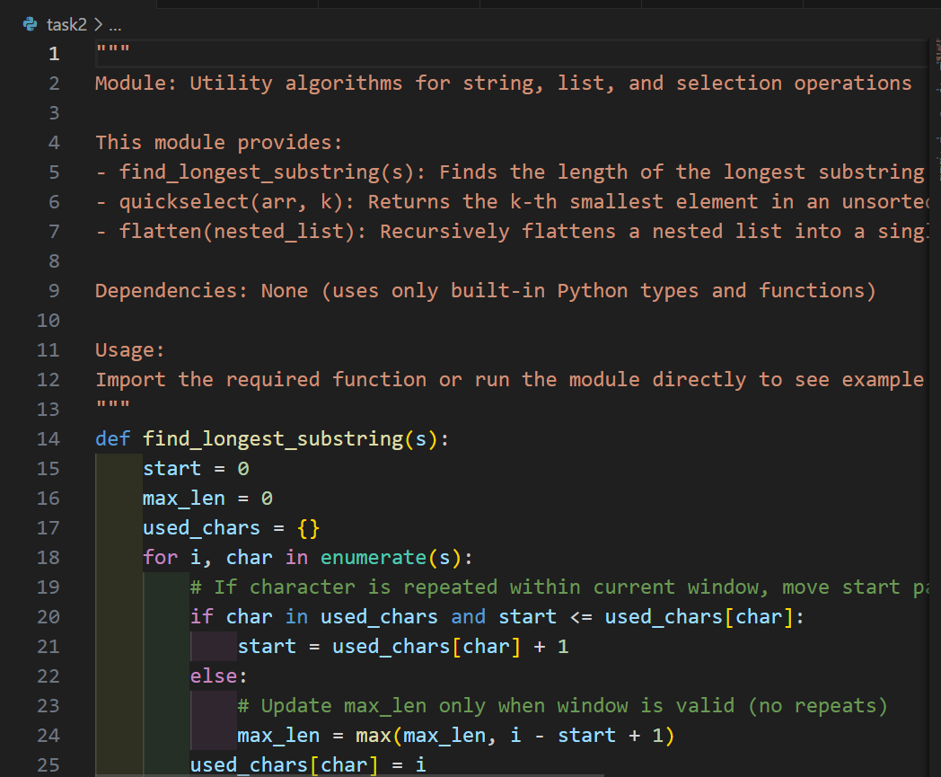

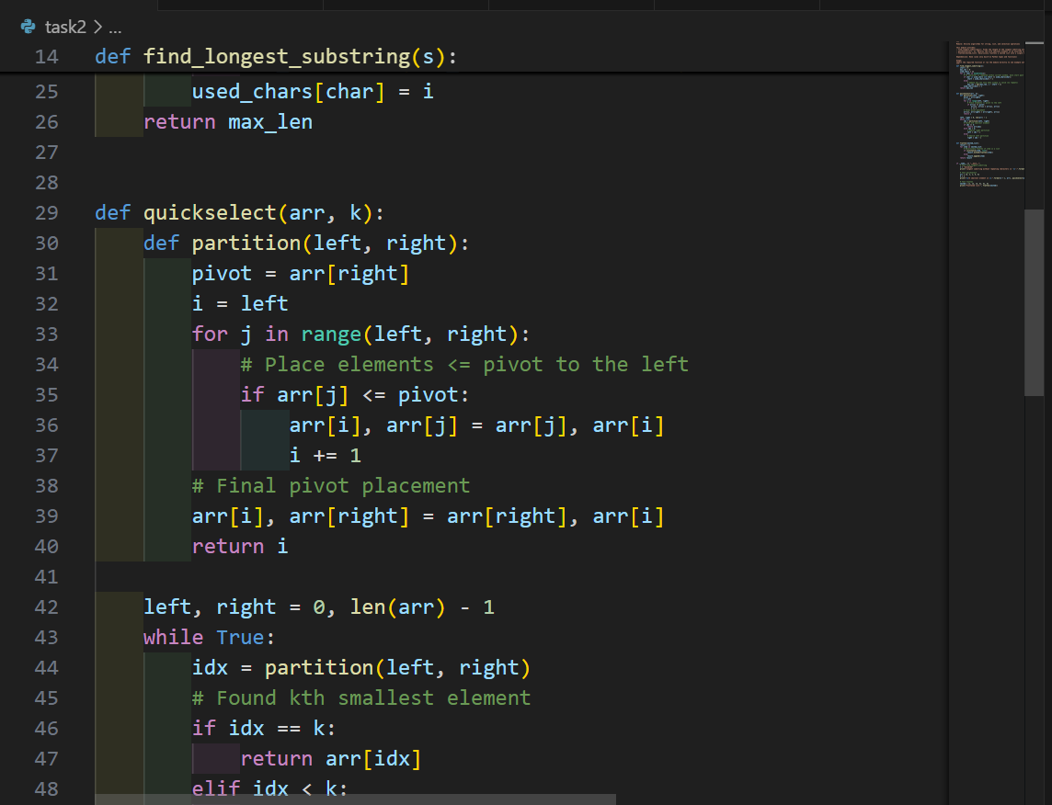

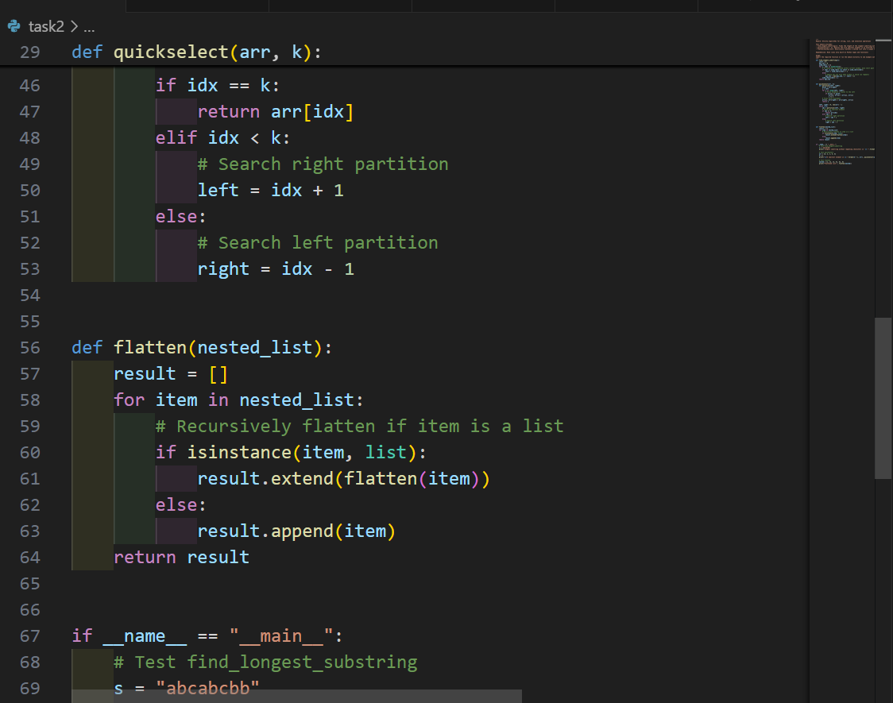

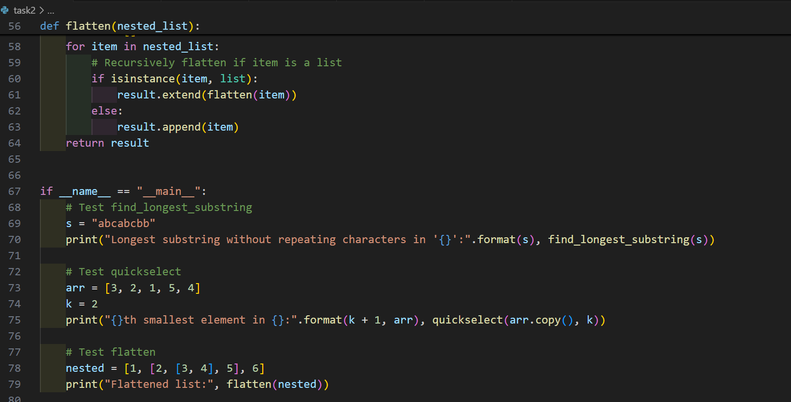

OUTPUT:

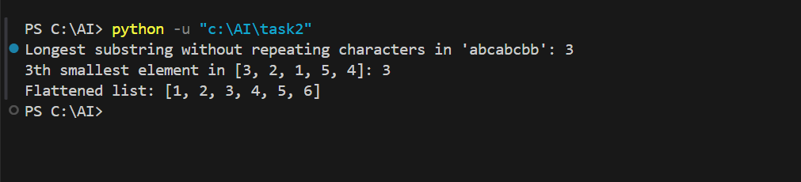

**Task – 3**

Task: Use AI to create a module-level docstring summarizing the  
purpose, dependencies, and main functions/classes of a Python  
file.

• Instructions:  
o Supply the entire Python file to AI.  
o Instruct AI to write a single multi-line docstring at the top  
of the file.  
o Ensure the docstring clearly describes functionality and  
usage without rewriting the entire code.

Expected Output 3:  
o A complete, clear, and concise module-level docstring at  
the beginning of the file.

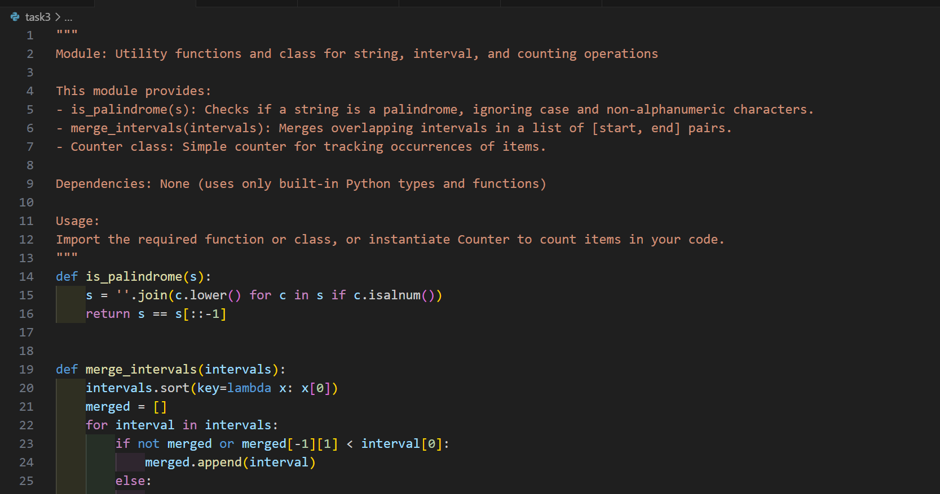

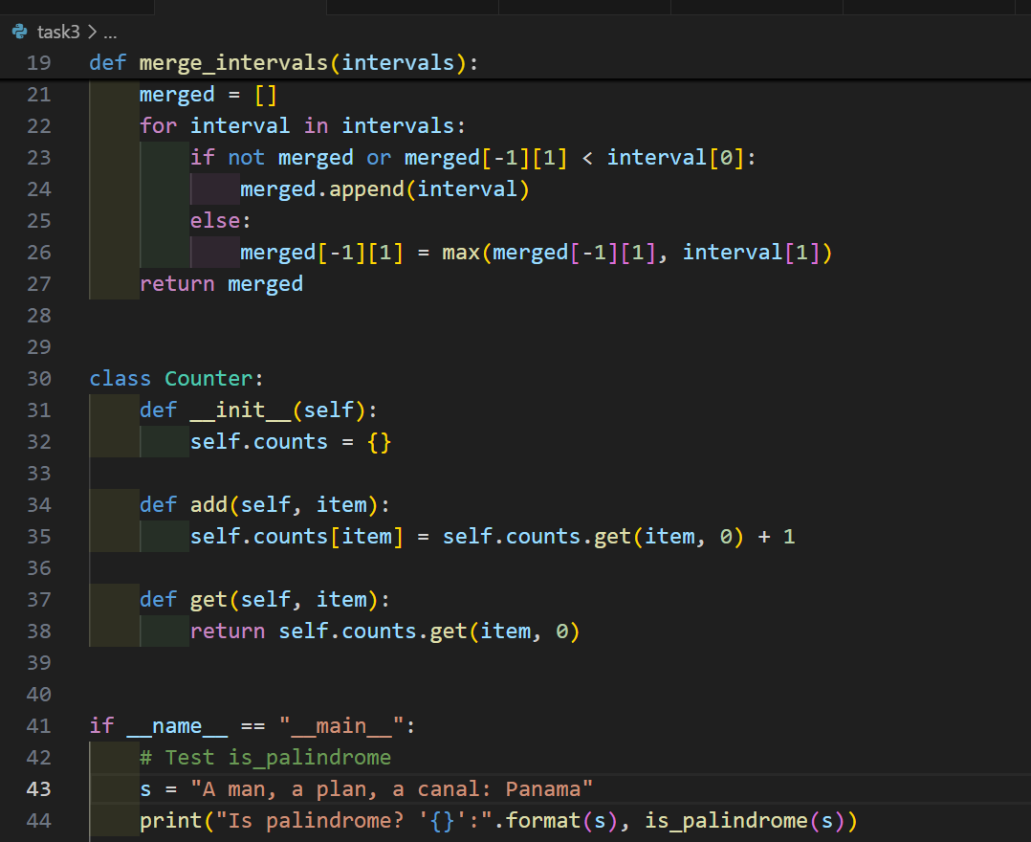 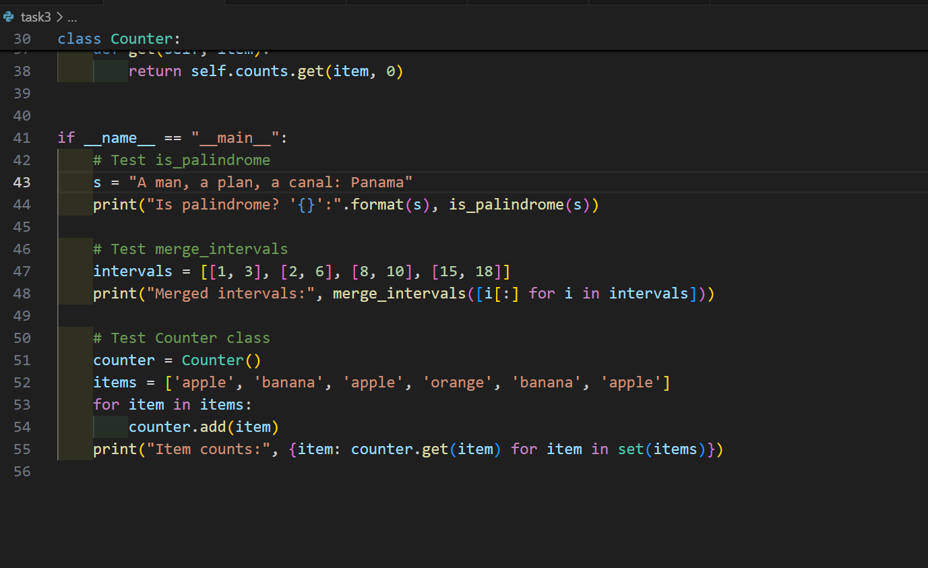

OUTPUT:

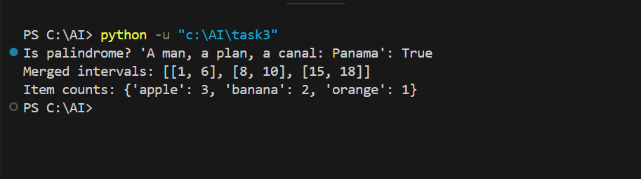

**Task – 4**

Task: Use AI to transform existing inline comments into  
structured function docstrings following Google style.  
• Instructions:  
o Provide AI with Python code containing inline comments.  
o Ask AI to move relevant details from comments into  
function docstrings.  
o Verify that the new docstrings keep the meaning intact  
while improving structure.

Expected Output 4:  
o Python code with comments replaced by clear,  
standardized docstrings.

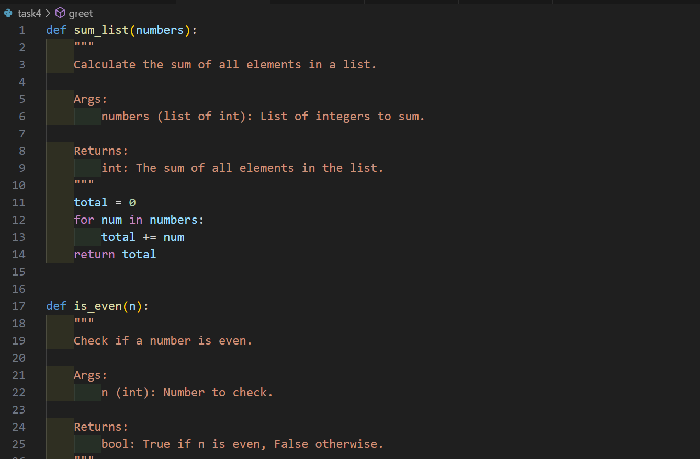

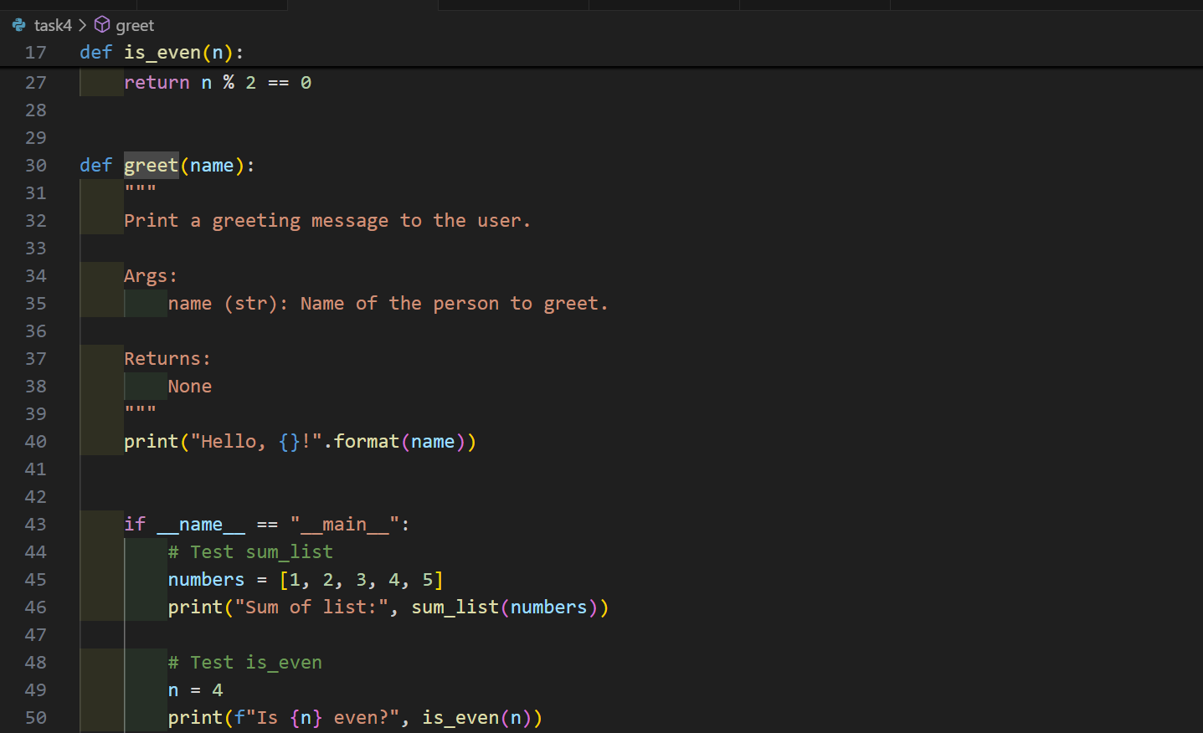

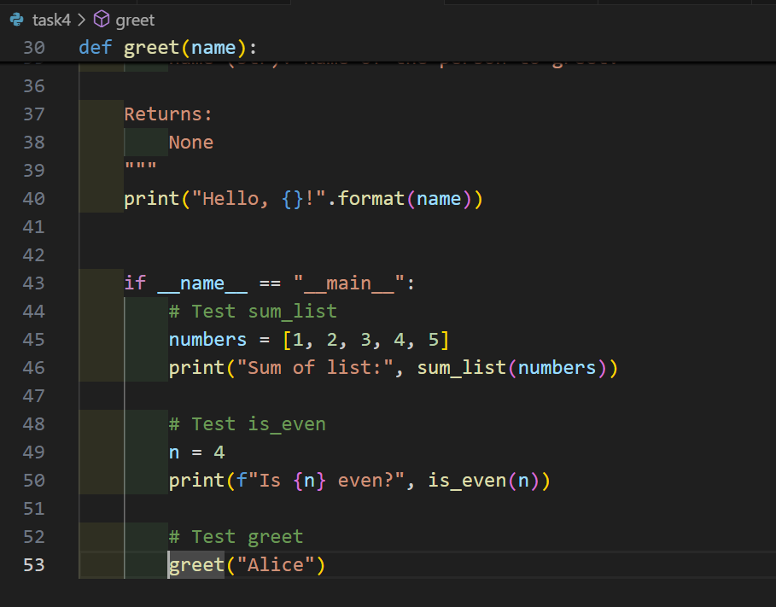

OUTPUT:

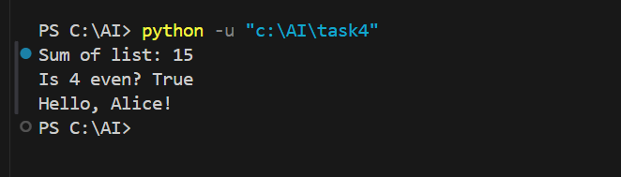

**Task – 5**

Task: Use AI to identify and correct inaccuracies in existing  
docstrings.  
• Instructions:  
o Provide Python code with outdated or incorrect  
docstrings.  
o Instruct AI to rewrite each docstring to match the current  
code behavior.  
o Ensure corrections follow Google-style formatting.

Expected Output 5:  
o Python file with updated, accurate, and standardized  
docstrings.

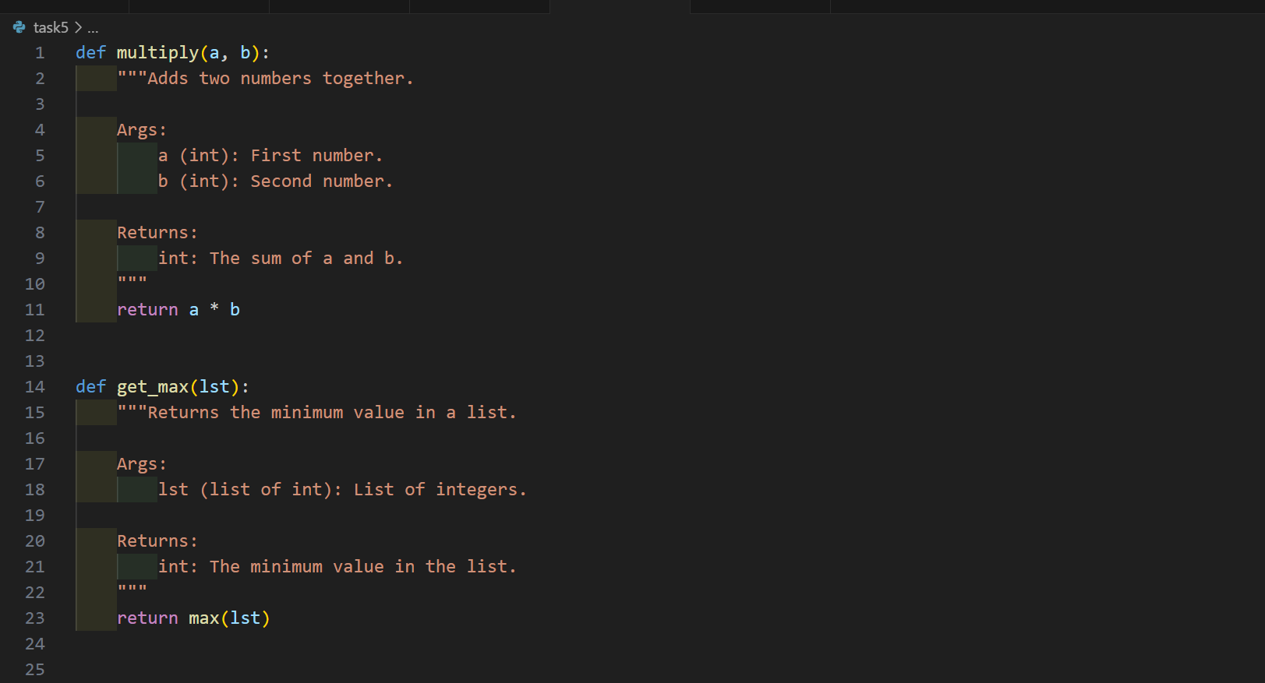

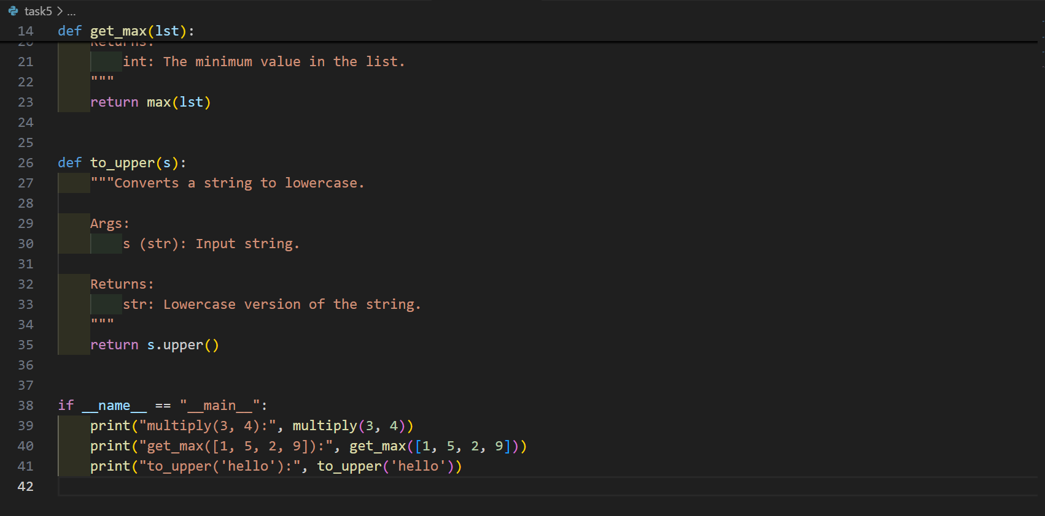

OUTPUT:

