AI ASSISTED CODING

ASSIGNMENT-7.1

Name : Perala Akshaya

HT NO.: 2403A51264

Batch No.: 11

TASK – 1

Prompt:

Syntax Error – Missing Parentheses in Print Statement.

Task: Provide a Python snippet with a missing parenthesis in a print

statement (e.g., print "Hello"). Use AI to detect and fix the syntax error.

# Bug: Missing parentheses in print statement

def greet():

print "Hello, AI Debugging Lab!"

greet()

Requirements:

• Run the given code to observe the error.

• Apply AI suggestions to correct the syntax.

• Use at least 3 assert test cases to confirm the corrected code

works.

Expected Output 1:

• Corrected code with proper syntax and AI explanation

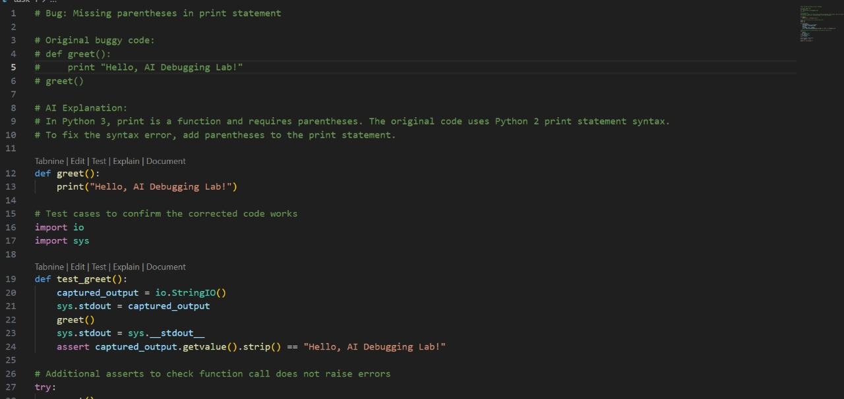

OUTPUT:

TASK– 2

Logic Error – Incorrect Condition in If Statement  
Prompt:

Task: Supply a function where an if-condition mistakenly uses = instead  
of ==. Let AI identify and fix the issue.  
# Bug: Using assignment (=) instead of comparison (==)  
def check_number(n):  
if n = 10:  
return "Ten"  
else:  
return "Not Ten"

Requirements:  
• Ask AI to explain why this causes a bug.  
• Correct the code and verify with 3 assert test cases.

Expected Output 2:  
• Corrected code using == with explanation and successful test  
execution.

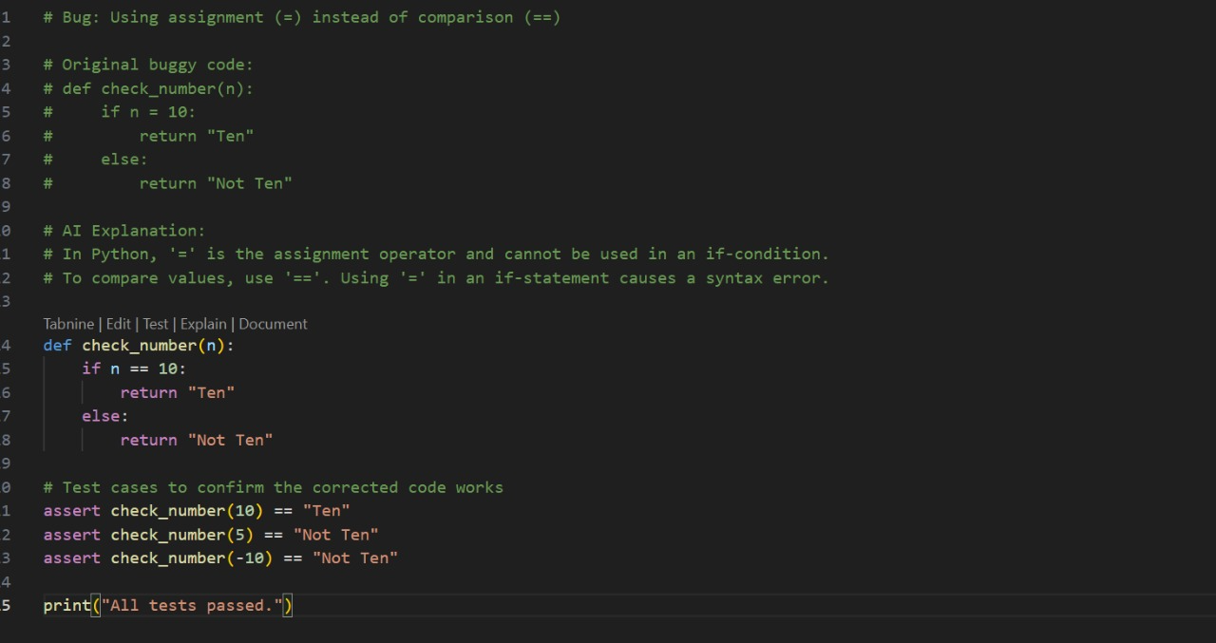

OUTPUT:

TASK – 3

Prompt:

Runtime Error – File Not Found  
Task: Provide code that attempts to open a non-existent file and crashes.  
Use AI to apply safe error handling.  
# Bug: Program crashes if file is missing  
def read_file(filename):  
with open(filename, 'r') as f:  
return f.read()  
print(read_file("nonexistent.txt"))  
Requirements:  
• Implement a try-except block suggested by AI.  
• Add a user-friendly error message.  
• Test with at least 3 scenarios: file exists, file missing, invalid  
path.  
Expected Output 3:  
• Safe file handling with exception management.

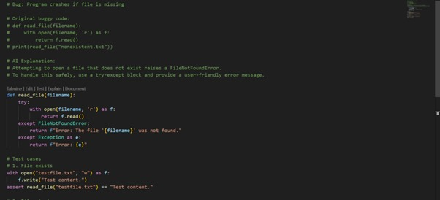

OUTPUT:

TASK – 4

Prompt:

Attribute Error – Calling a Non-Existent Method

Task: Give a class where a non-existent method is called (e.g.,  
obj.undefined_method()). Use AI to debug and fix.  
# Bug: Calling an undefined method  
class Car:  
def start(self):  
return "Car started"  
my_car = Car()  
print(my_car.drive()) # drive() is not defined  
Requirements:  
• Students must analyze whether to define the missing method or  
correct the method call.  
• Use 3 assert tests to confirm the corrected class works.  
Expected Output #4:  
• Corrected class with clear AI explanation.

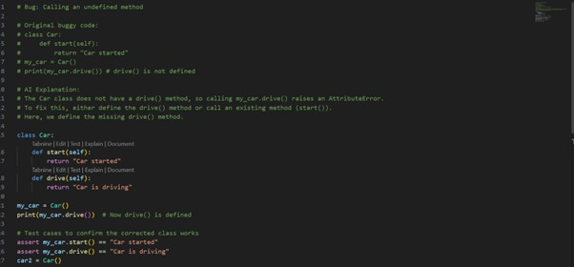

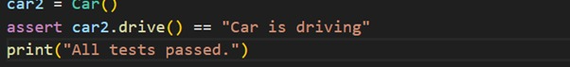

OUTPUT:

TASK – 5

Prompt:

Type Error – Mixing Strings and Integers in Addition

Task: Provide code that adds an integer and string ("5" + 2) causing a  
TypeError. Use AI to resolve the bug.  
# Bug: TypeError due to mixing string and integer  
def add_five(value):  
return value + 5  
print(add_five("10"))  
Requirements:  
• Ask AI for two solutions: type casting and string concatenation.  
• Validate with 3 assert test cases.  
Expected Output #5:  
• Corrected code that runs successfully for multiple inputs.

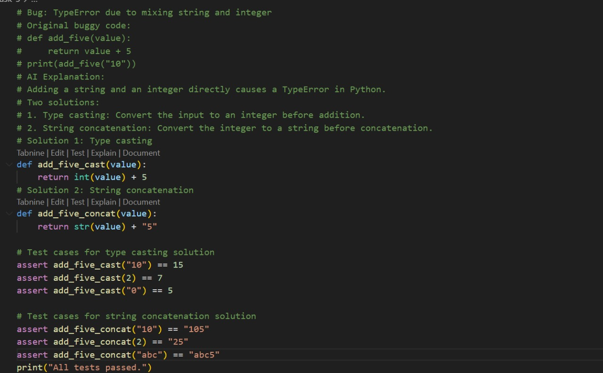

OUTPUT:

