**AI ASSISTED CODING**

**ASSIGNMENT-6**

Name: Perala Akshaya

HT NO.: 2403A51264

Batch no.: 11

Prompt 1:

Create a Python class named Employee with attributes: name, id, and salary. Include a method to calculate the yearly salary.

Test 1:

* Use AI to create an Employee class with attributes (name, id, salary) and a method to calculate yearly salary.
* Instructions:
  + Prompt AI to generate the Employee class.
  + Analyze the generated code for correctness and structure.
  + Ask AI to add a method to give a bonus and recalculate salary.

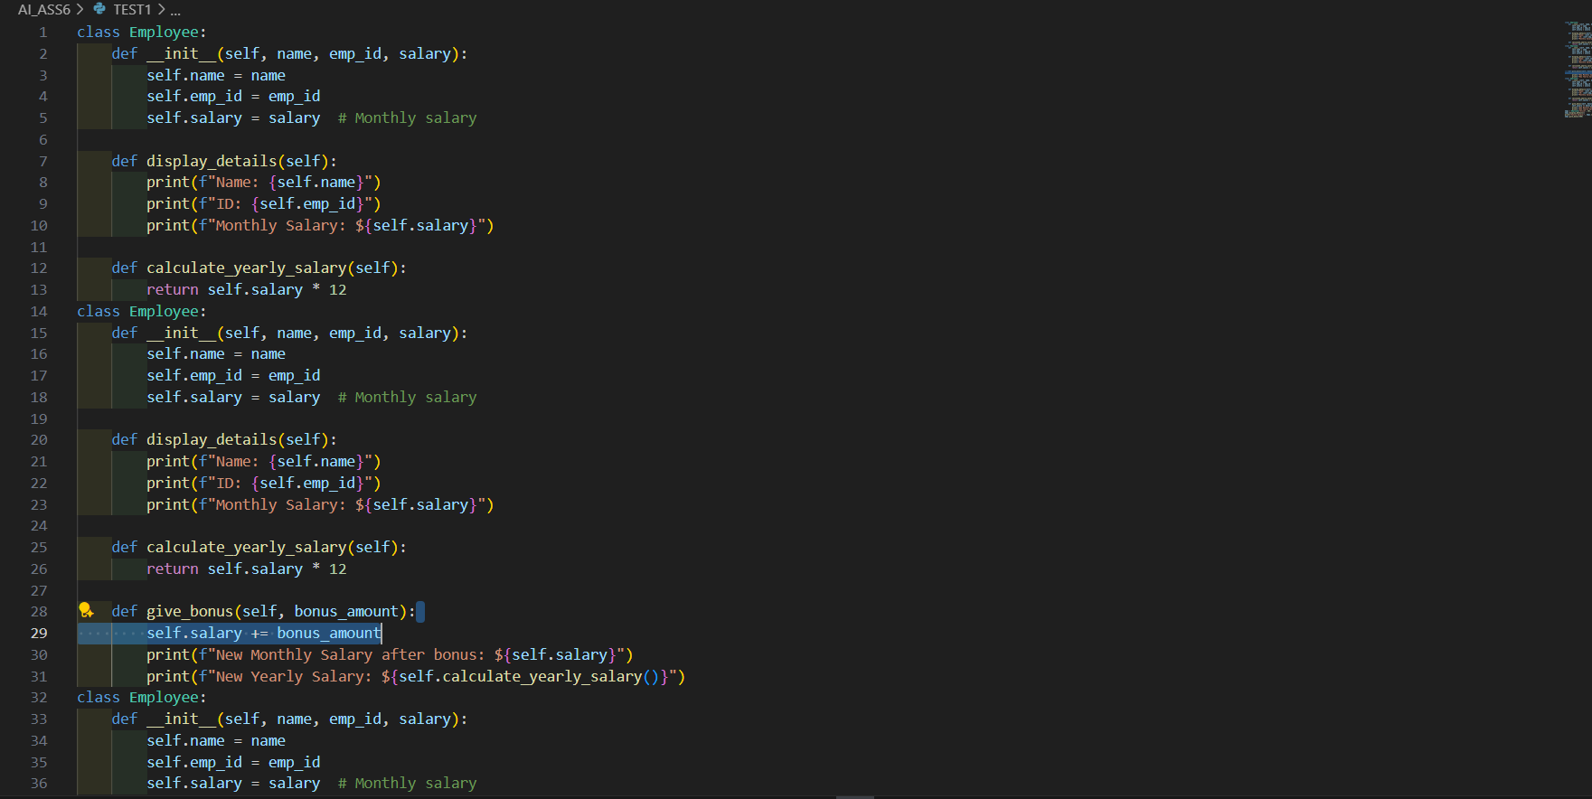

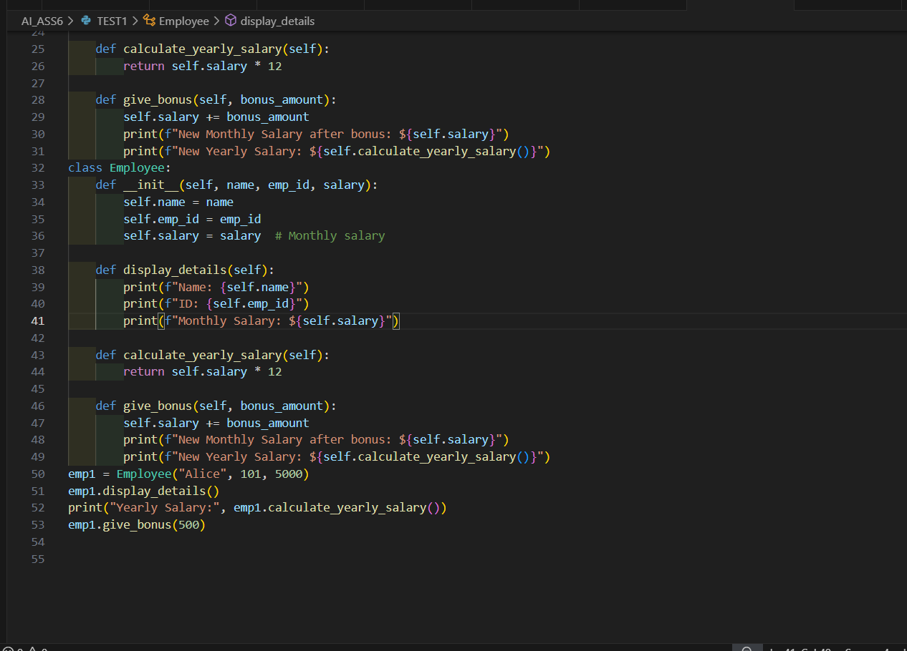

OUTPUT:

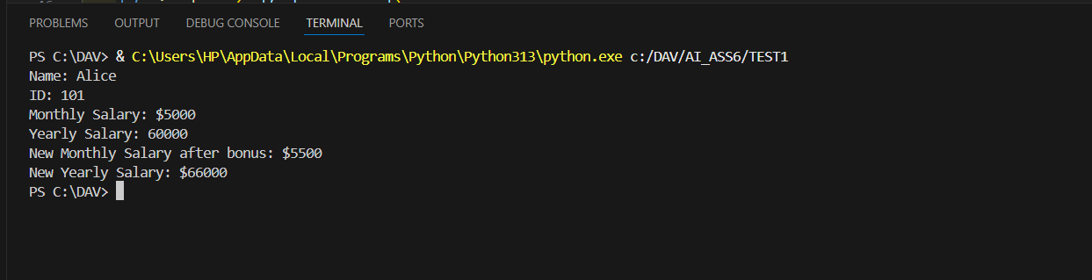

Prompt 2:

Write a Python function that displays all Automorphic numbers between 1 and 1000 using a for loop.

Test 2:

* Task: Prompt AI to generate a function that displays all Automorphic numbers between 1 and 1000 using a for loop.
* Instructions:
  + Get AI-generated code to list Automorphic numbers using a for loop.
  + Analyze the correctness and efficiency of the generated logic.
  + Ask AI to regenerate using a while loop and compare both implementations.

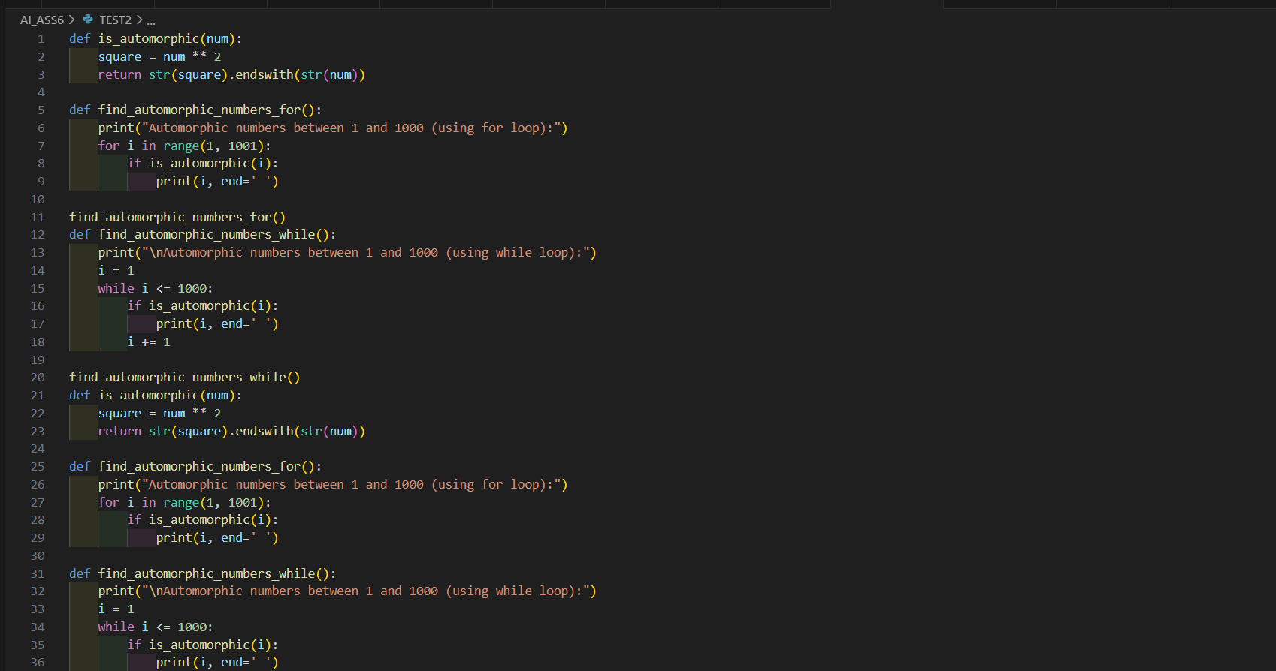

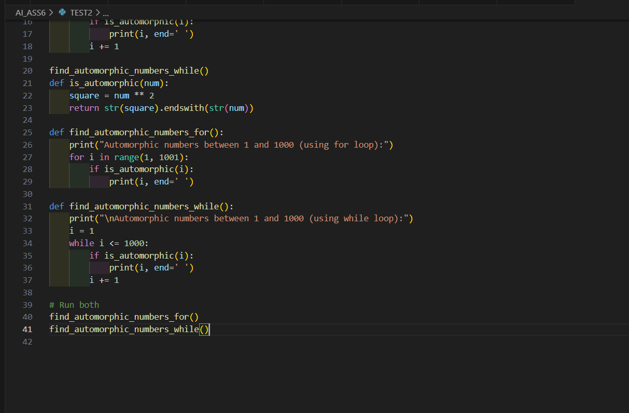

OUTPUT:

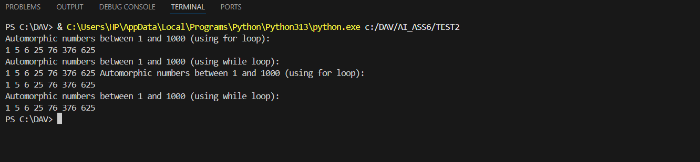

Prompt 3:

Write a Python function using nested if-elif-else statements that classifies user feedback (1–5 rating) into Positive, Neutral, or Negative.

Test 3:

* Task: Ask AI to write nested if-elif-else conditions to classify online shopping feedback as Positive, Neutral, or Negative based on a numerical rating (1–5).
* Instructions:
  + Generate initial code using nested if-elif-else.
  + Analyze correctness and readability.
  + Ask AI to rewrite using dictionary-based or match-case structure.

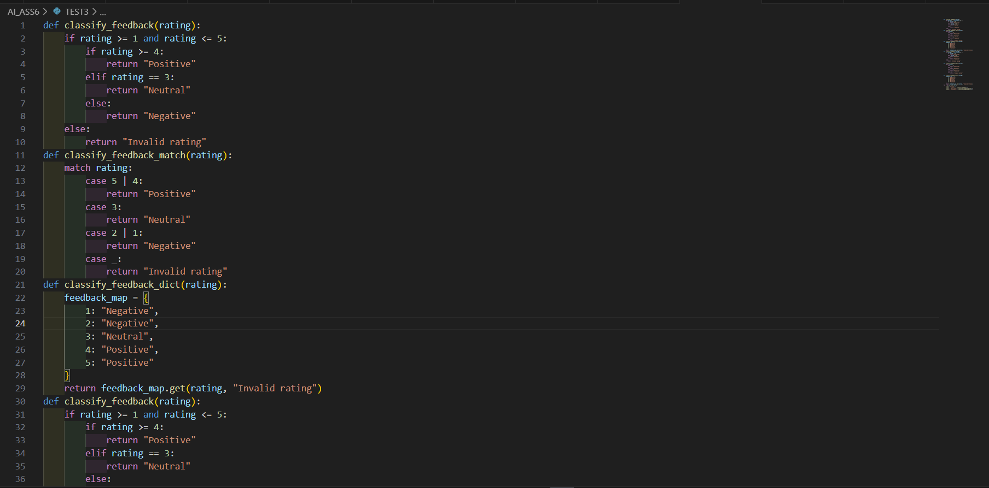

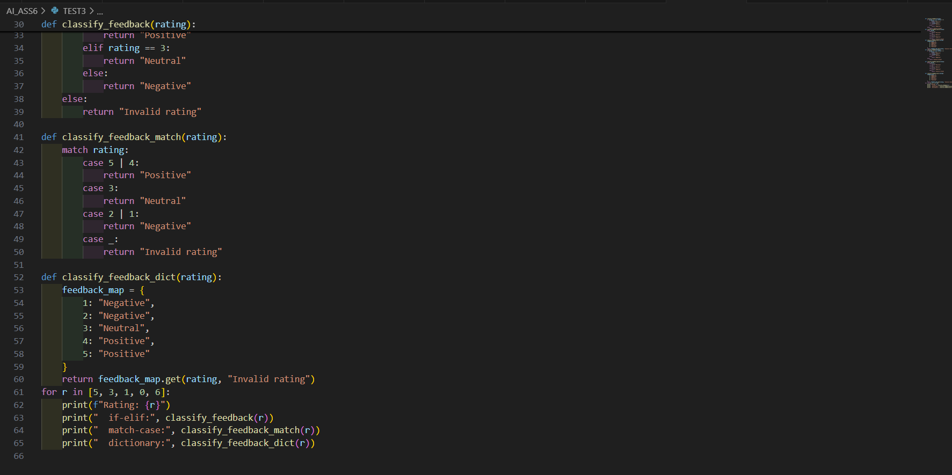

OUTPUT:

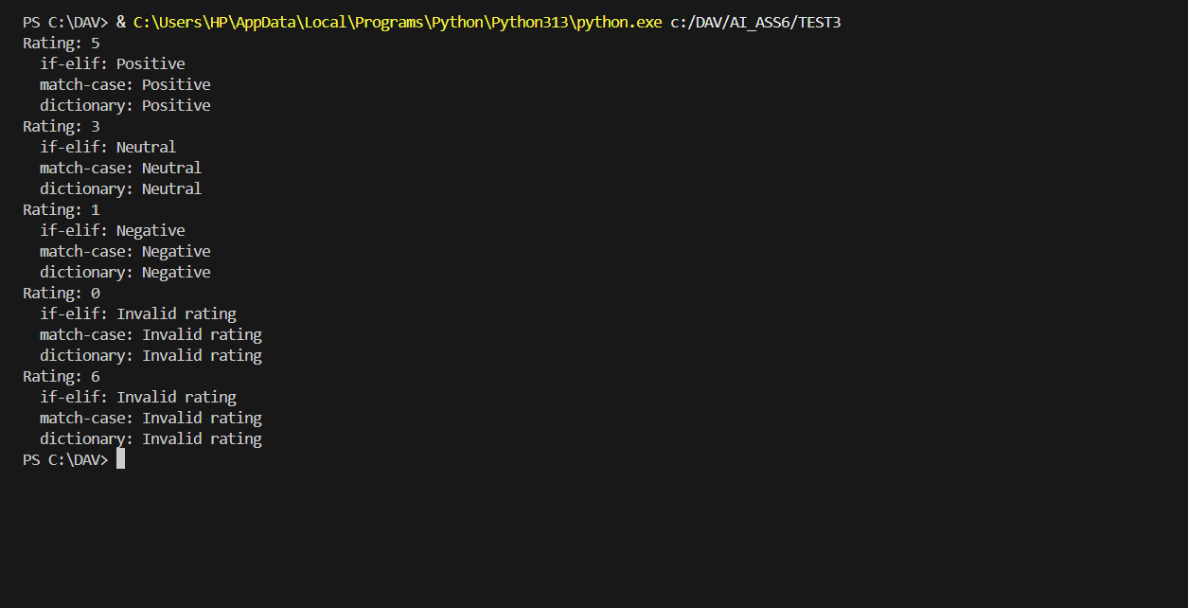

Prompt 4:

Write a Python function that prints all prime numbers between two user-specified numbers using a for loop.

Test 4:

* Task: Generate a function using AI that displays all prime numbers within a user-specified range (e.g., 1 to 500).
* Instructions:
  + Get AI-generated code to list all primes using a for loop.
  + Analyze the correctness and efficiency of the prime-checking logic.
  + Ask AI to regenerate an optimized version (e.g., using the square root method).

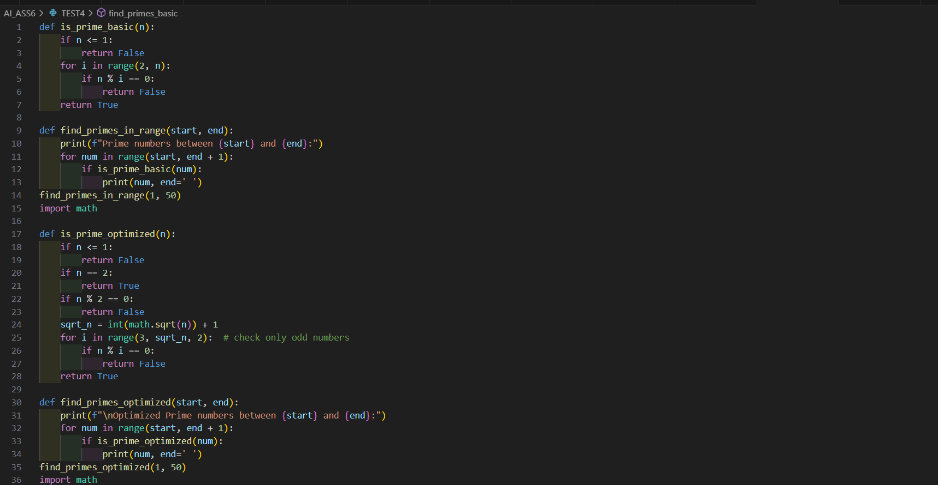

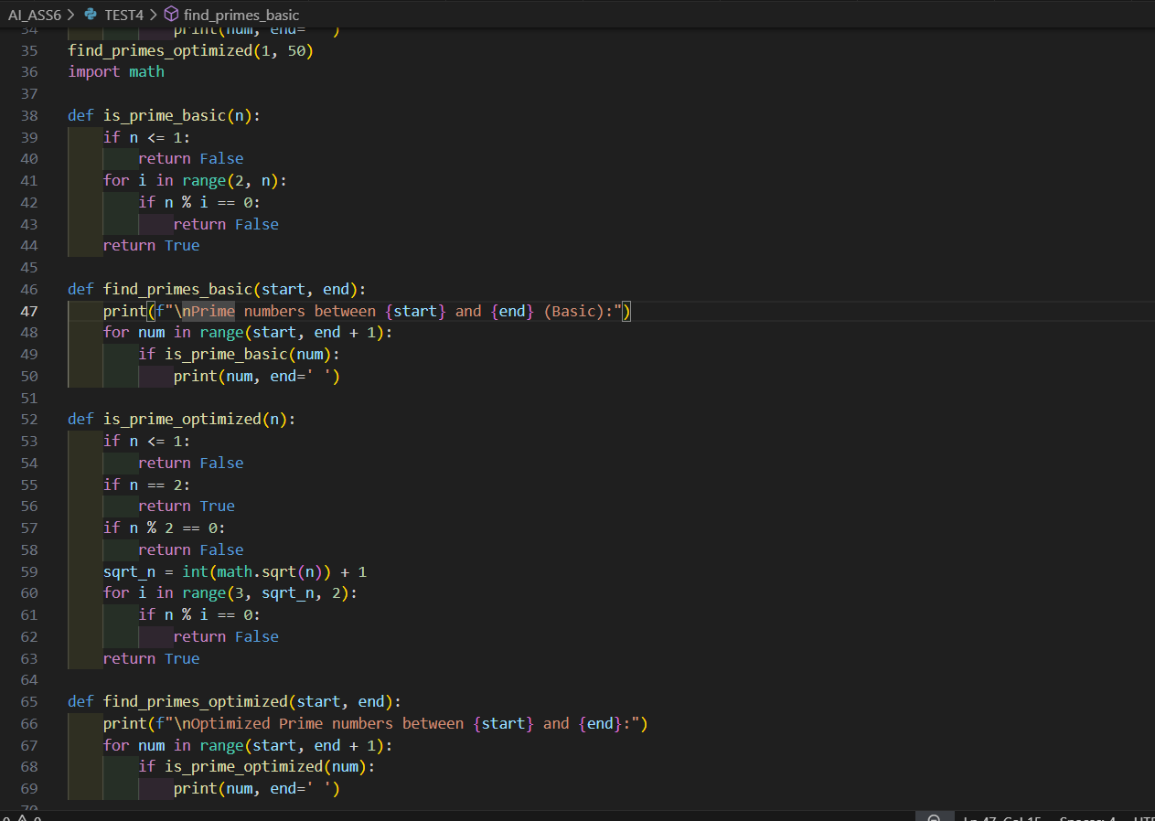

OUTPUT:

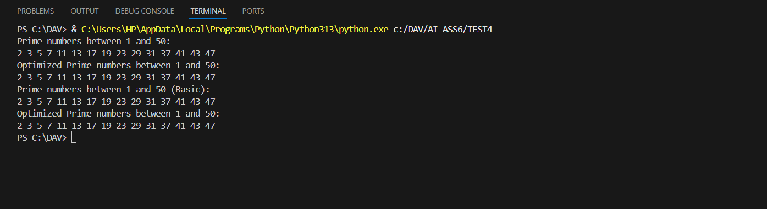

Prompt 5:

Create a Python class called Library with methods to add_book(), issue_book(), and display_books().

Test 5:

* Task: Use AI to build a Library class with methods to add_book(), issue_book(), and display_books().
* Instructions:
  + Generate Library class code using AI.
  + Analyze if methods handle edge cases (e.g., issuing unavailable books).
  + Ask AI to add comments and documentation.

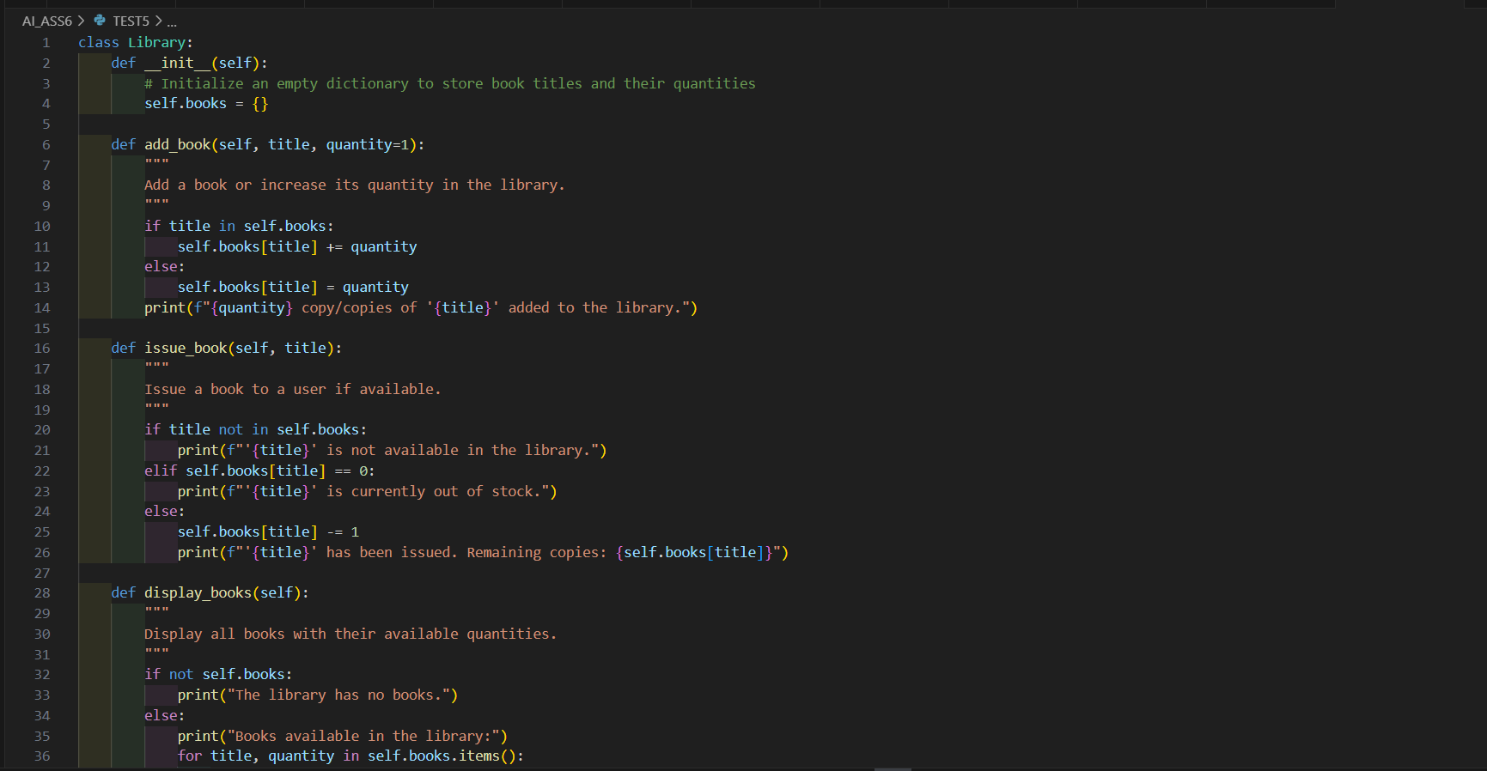

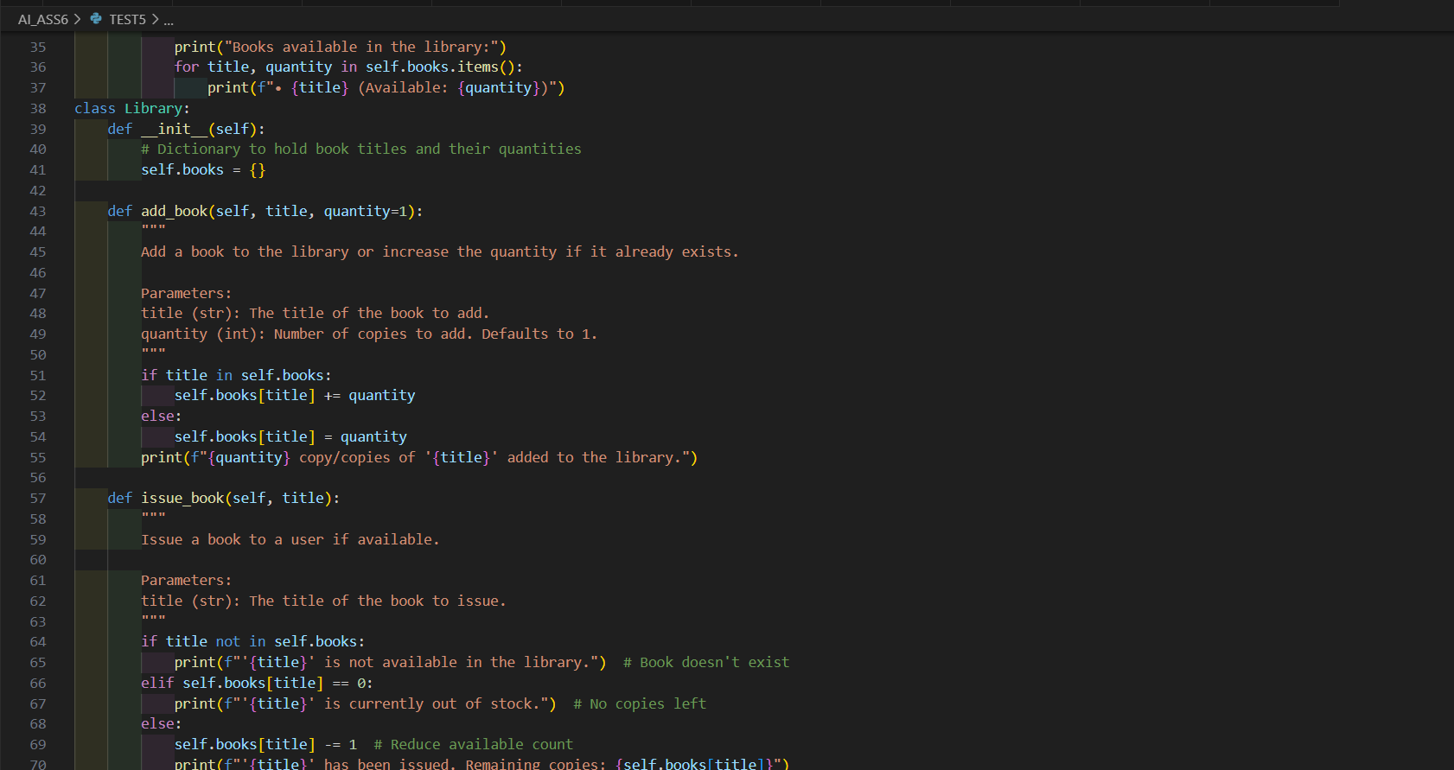

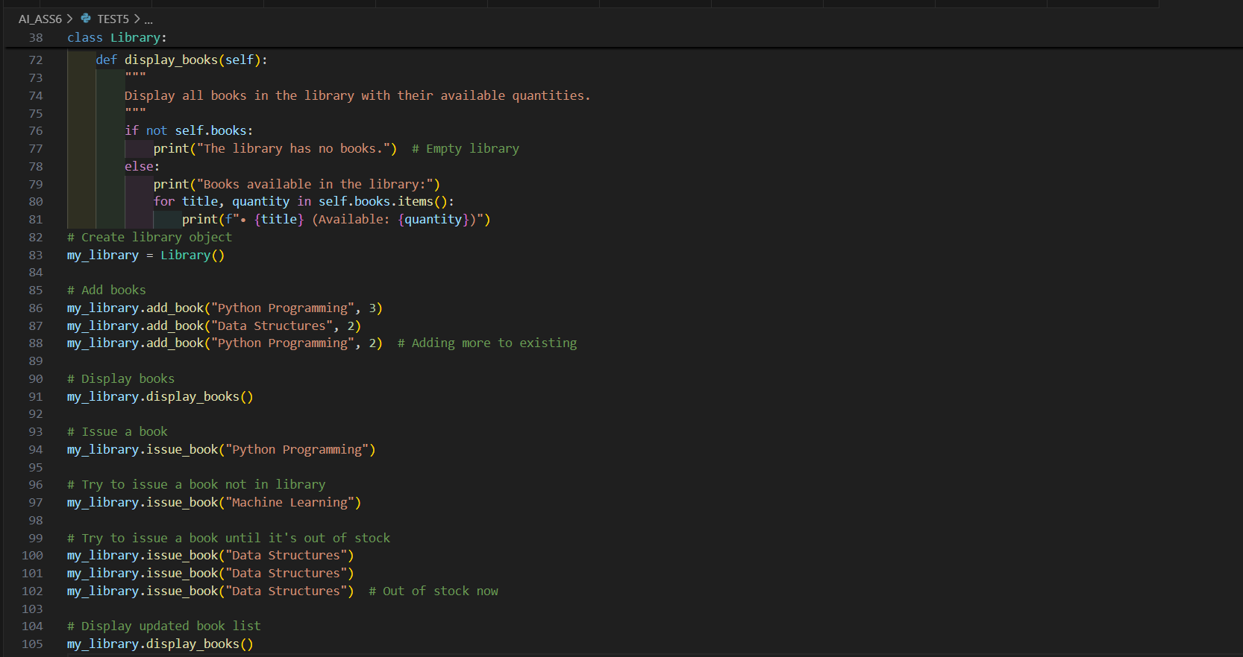

OUTPUT:

