**AI ASSISTED CODING**

**ASSIGNMENT-4.5**

*NAME: Perala Akshaya*

*HTNO: 2403A51264*

*Batch no.: 11*

**Prompt**:

Create 10 short email samples. Each email should belong to one of these categories: Billing, Technical Support, Feedback, Others.

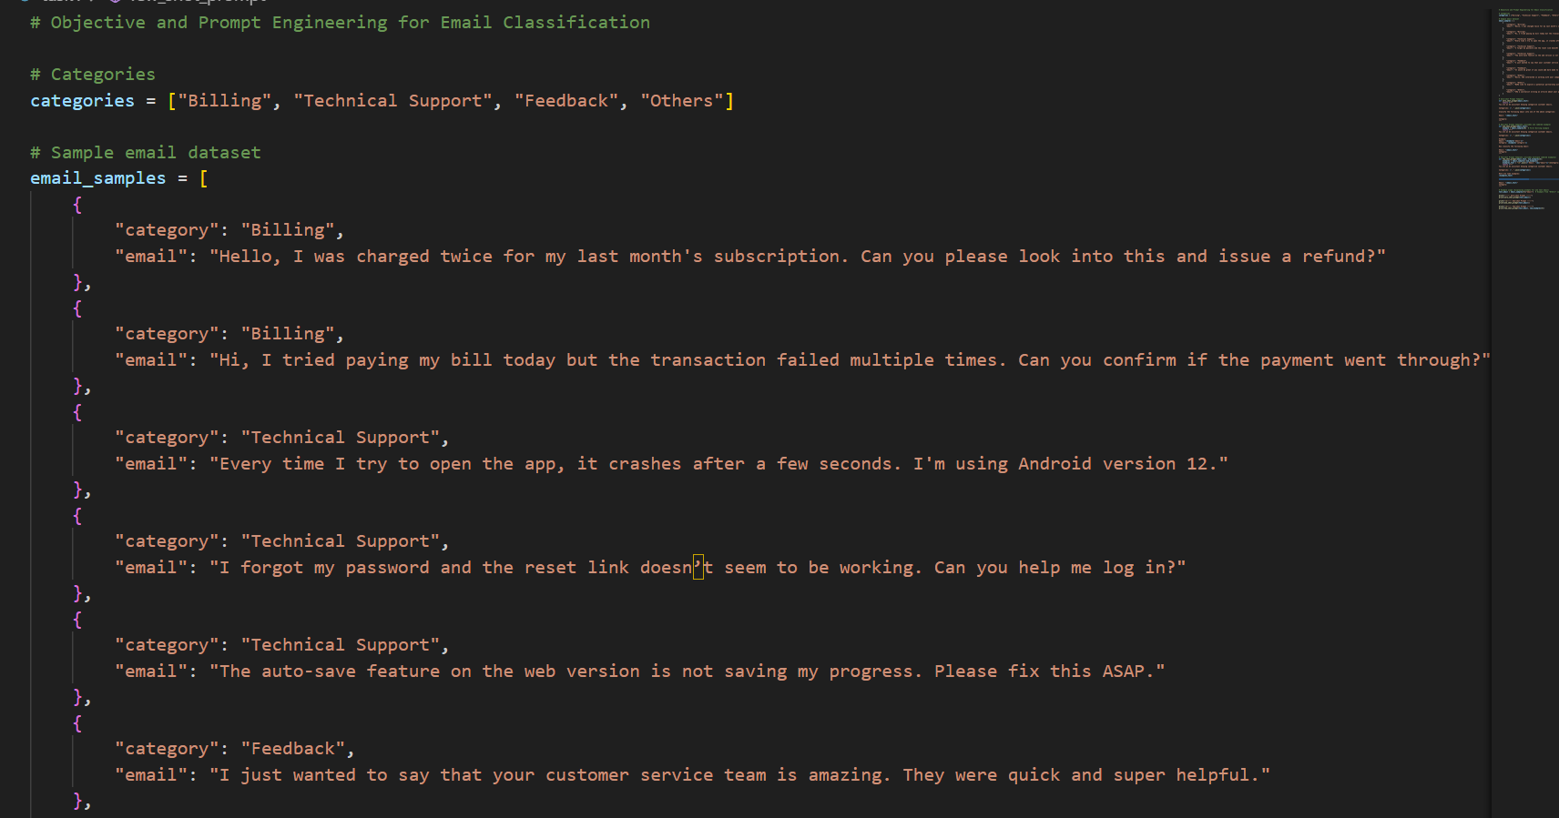

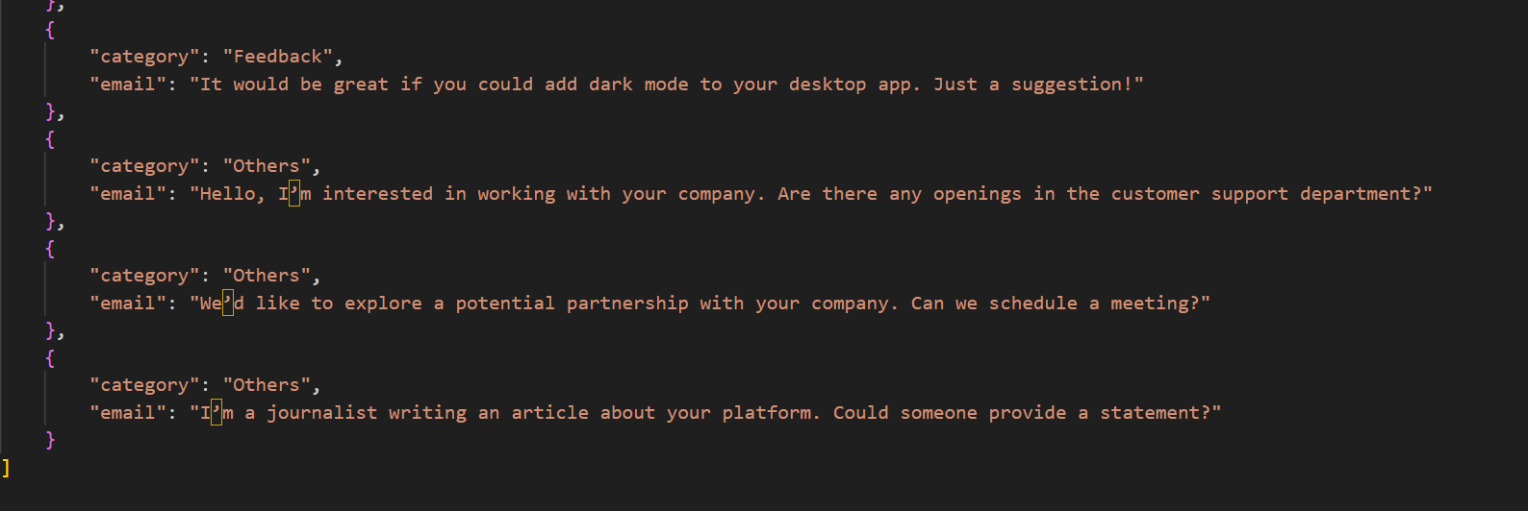

**Zero-shot Prompt:**

Classify the following email into one of the following categories: Billing, Technical Support, Feedback, Others.

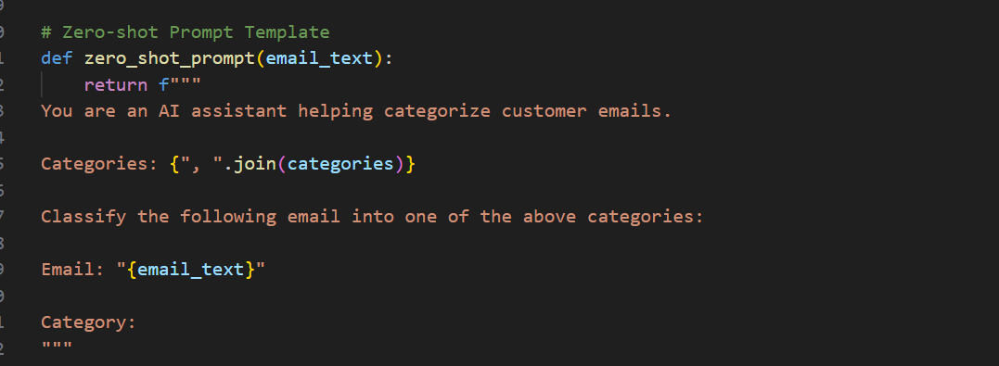

**One-shot Prompt:**

Classify the following email into one of the following categories: Billing, Technical Support, Feedback, Others.

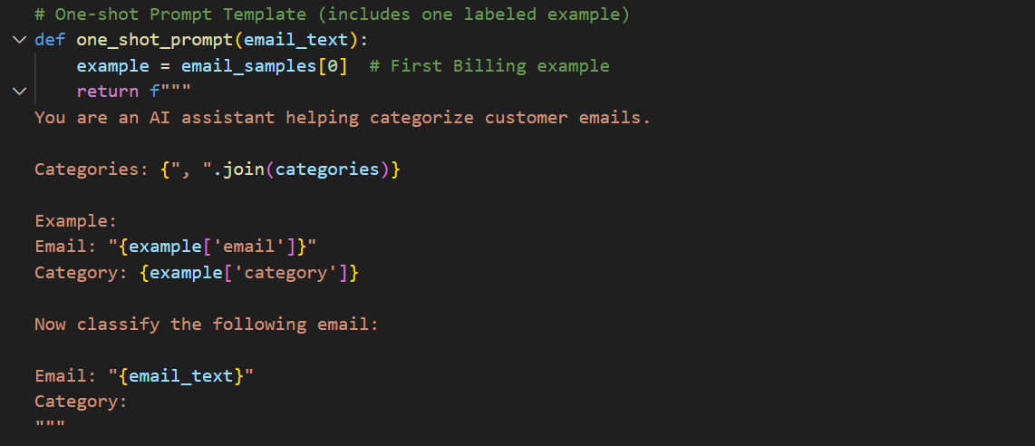

**Few-shot Prompt:**

Classify the following email into one of the following categories: Billing, Technical Support, Feedback, Others.

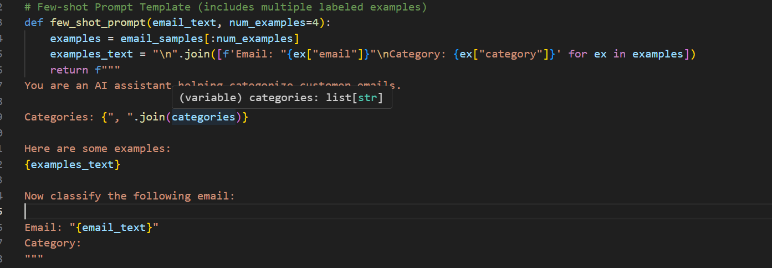

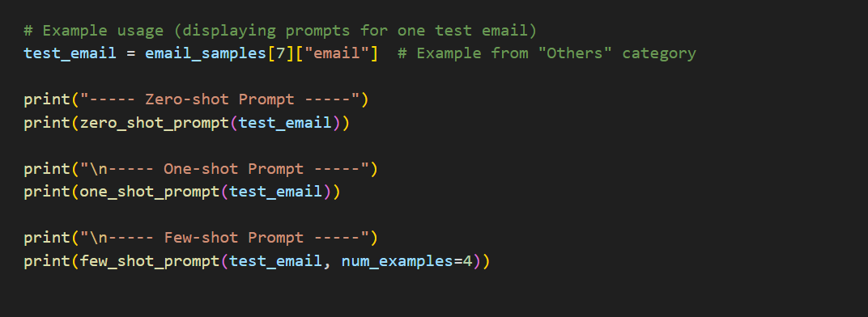

**Output:**

