**AI ASSISTED CODING**

**LAB TEST-1**

Name: Perala Akshaya

HT NO.: 2403A51264

Batch No.: 11

**1)**write a python code to calculate the sum of odd and even numbersin a given list.using zero shot promt.

**Prompt:**

Write a Python function that calculates and prints the sum of odd and even numbers in a given list.

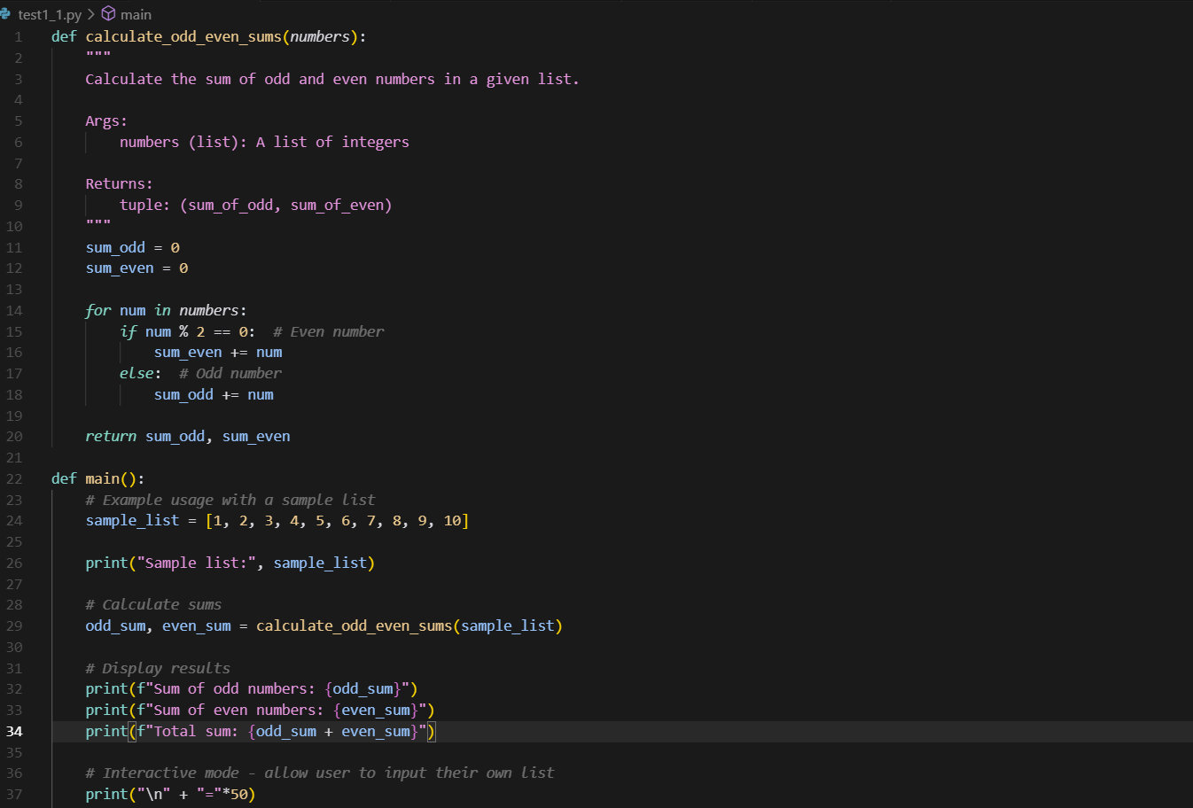

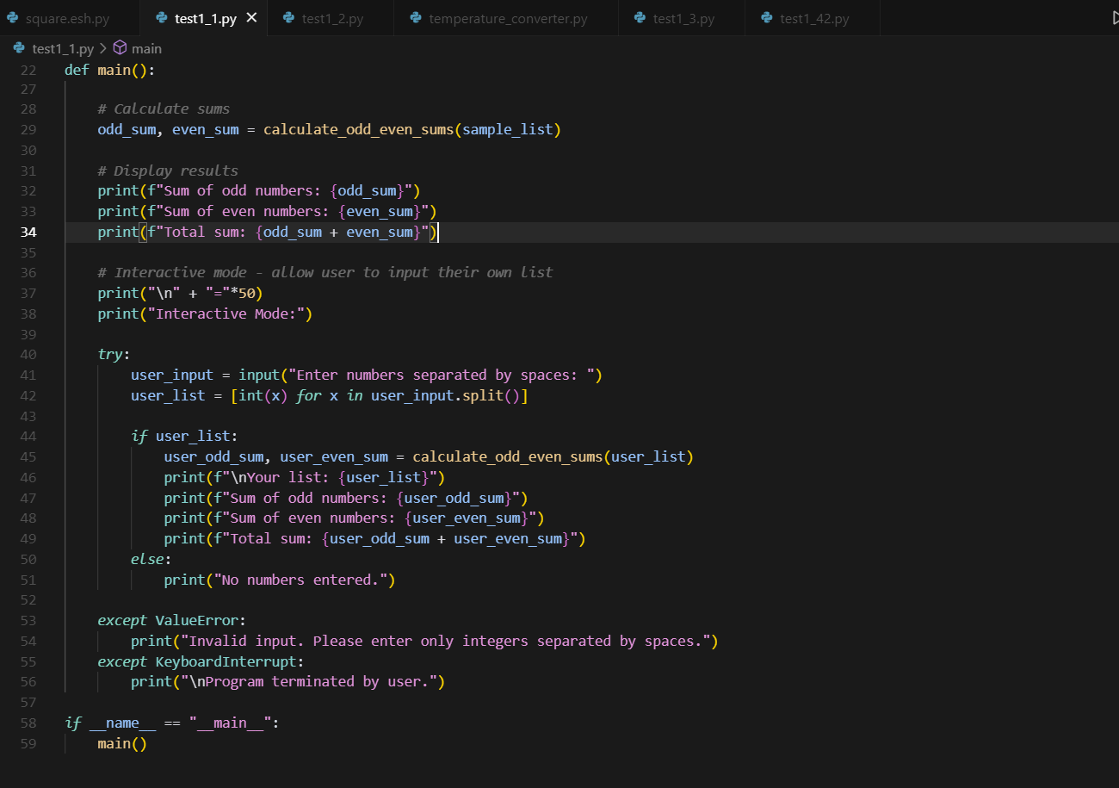

**OUTPUT:**

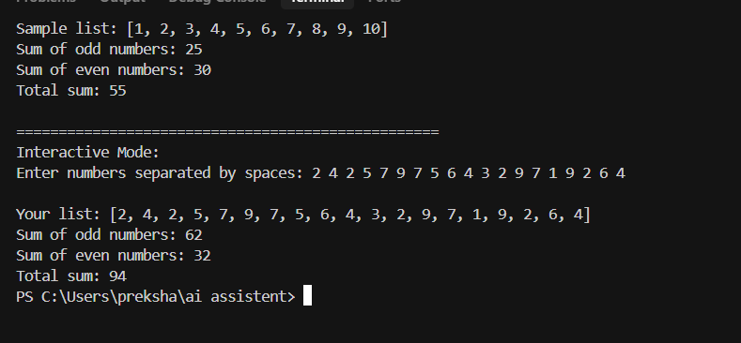

**2)** write a python code for a given list of integers,remove duplicates and print the sorted result.use one shot promting.

**Promt:** Given a list of integers, remove duplicates and print the sorted result.

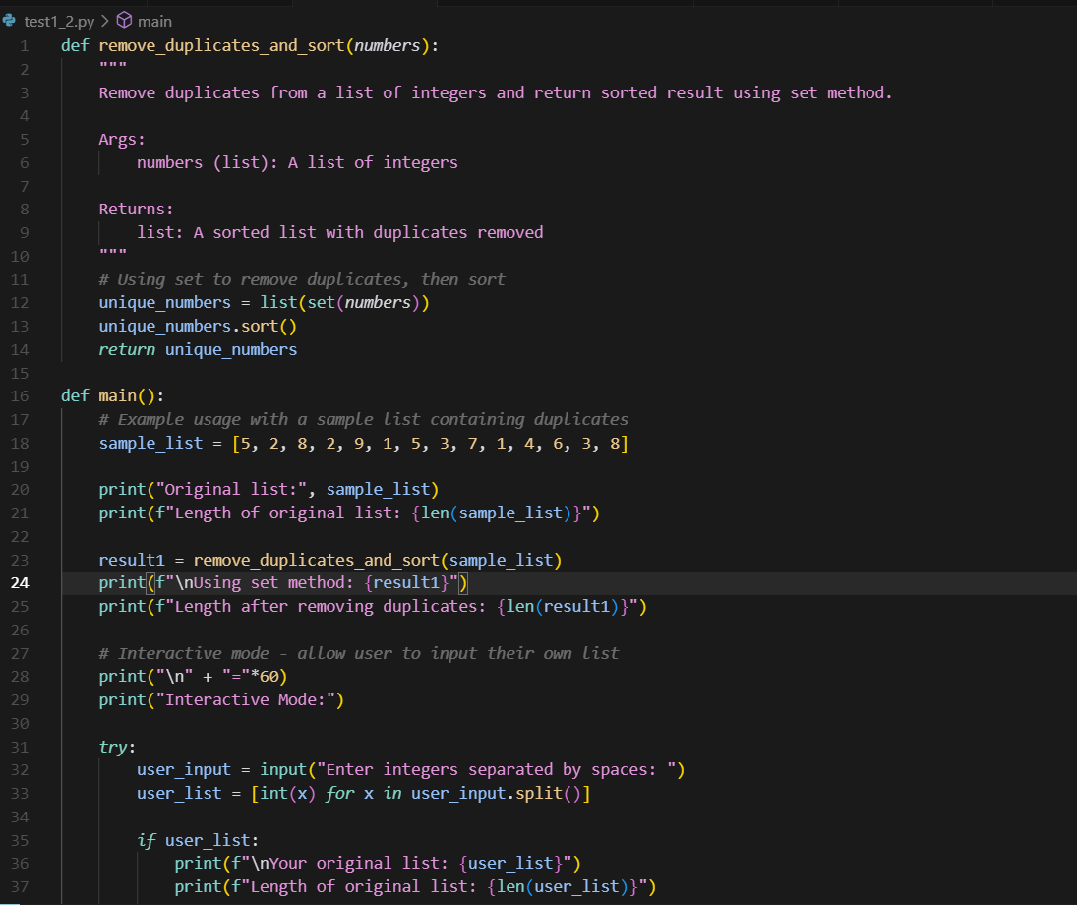

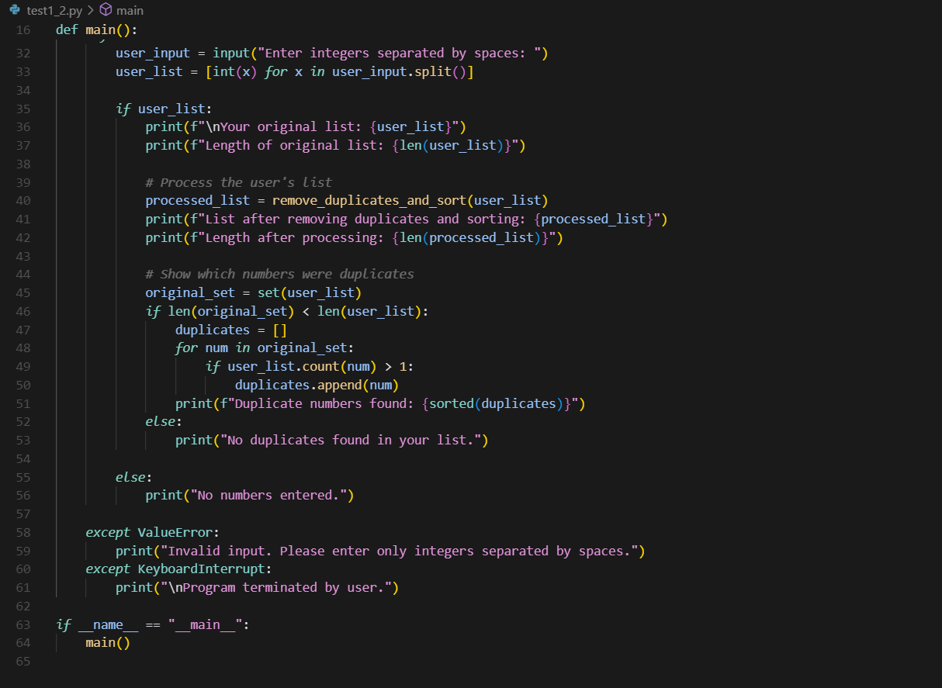

**Output:**

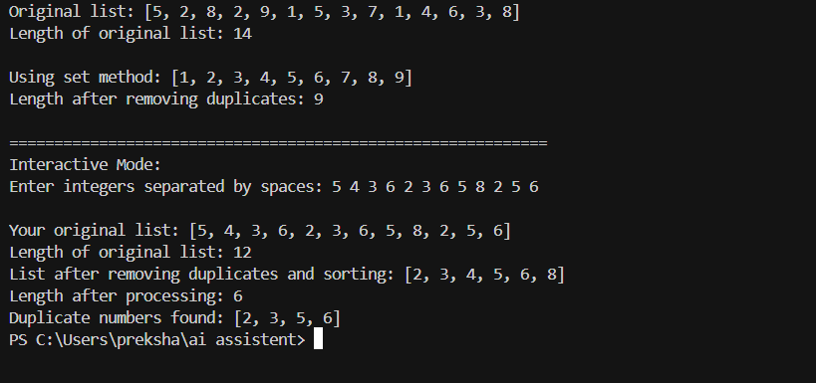

**3)** write a python function that converts the temperture between celsius,fahrenheit and kalvin based on user choice.Use few shot promiting**.**

**Prompt**: Write a Python function that converts temperature between Celsius, Fahrenheit, and Kelvin based on user choice.

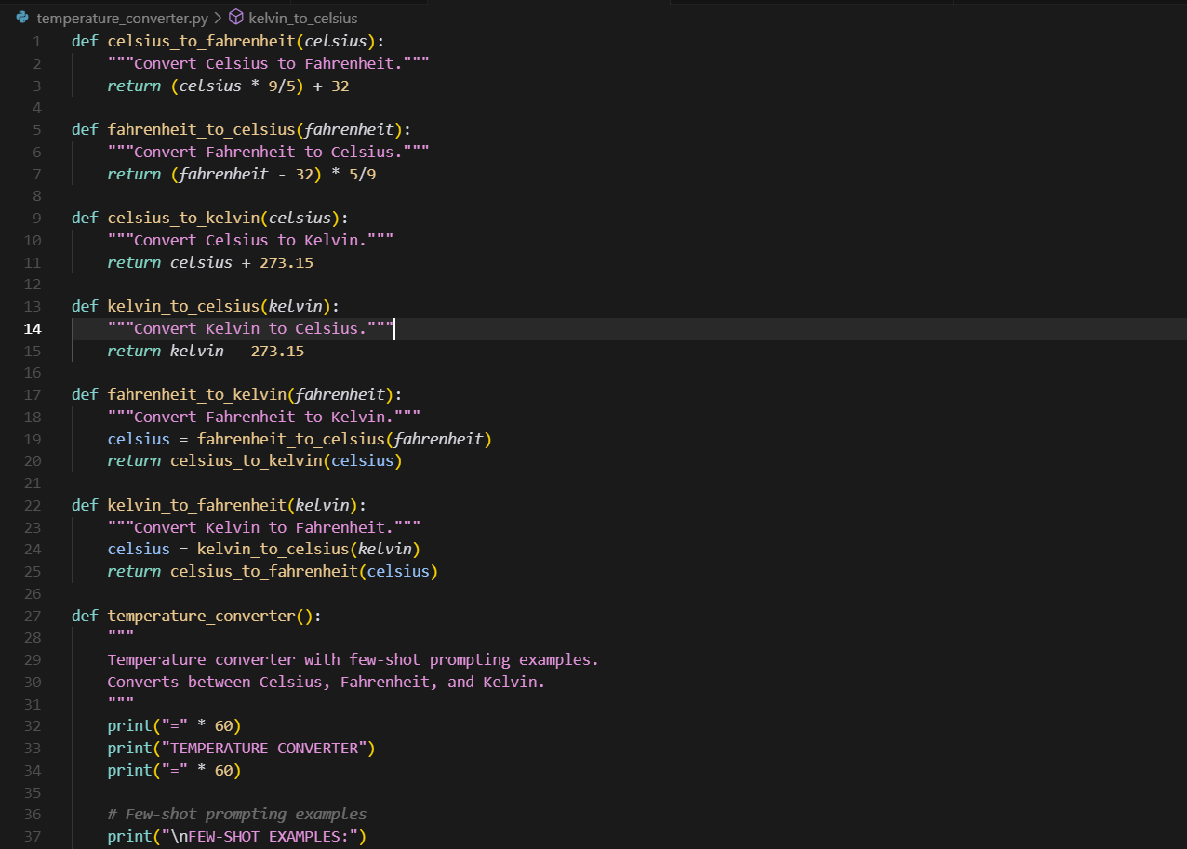

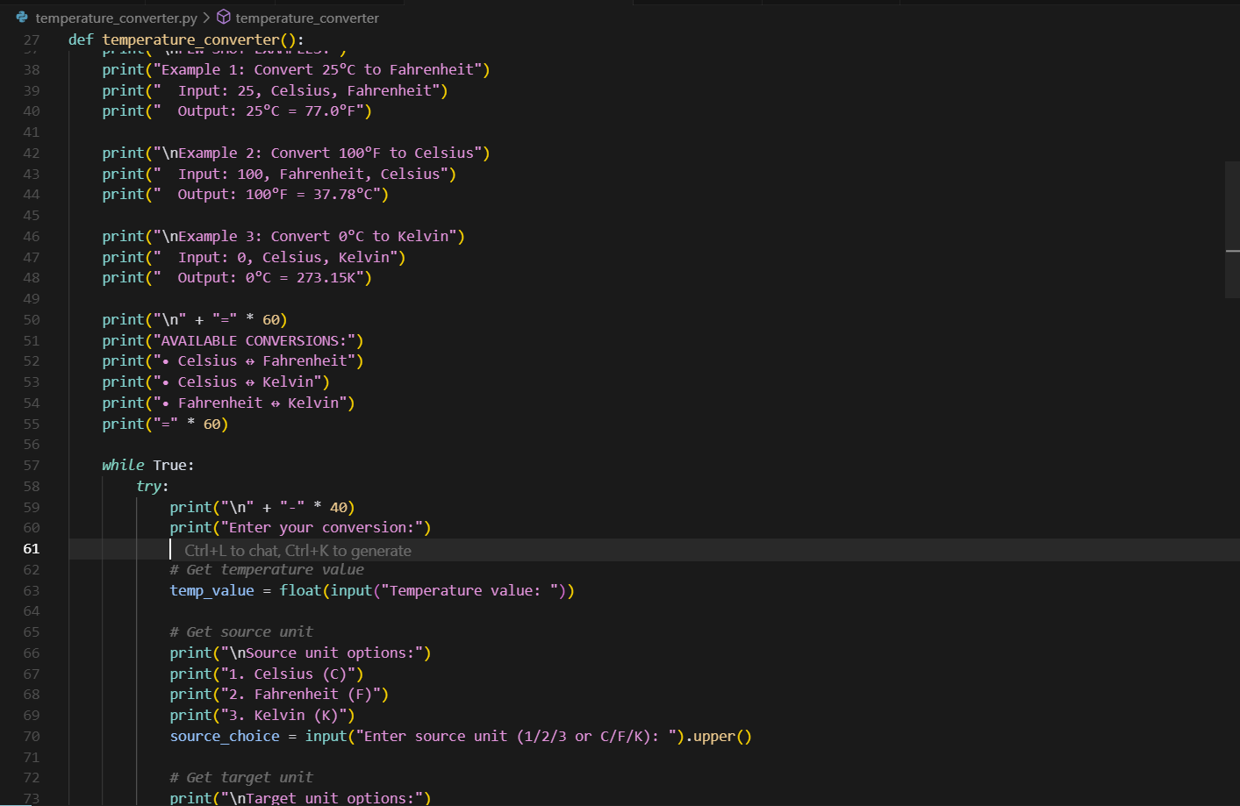

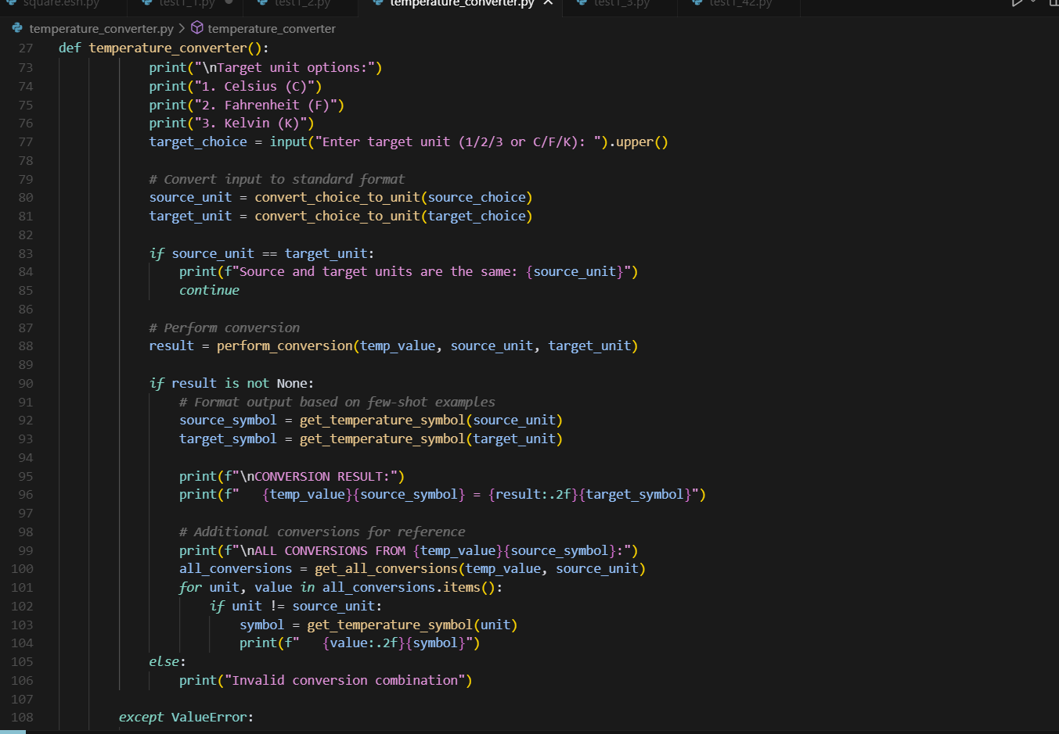

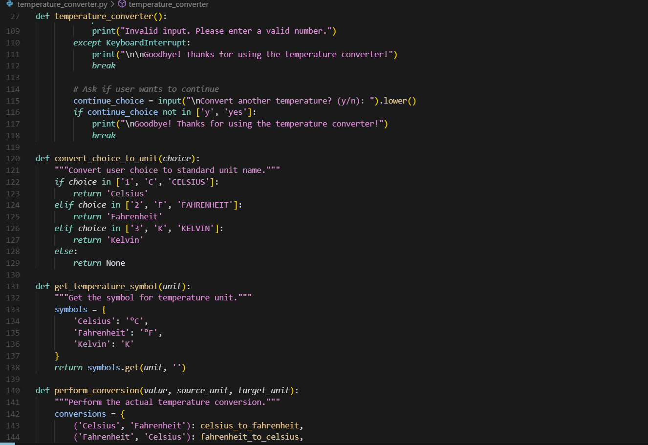

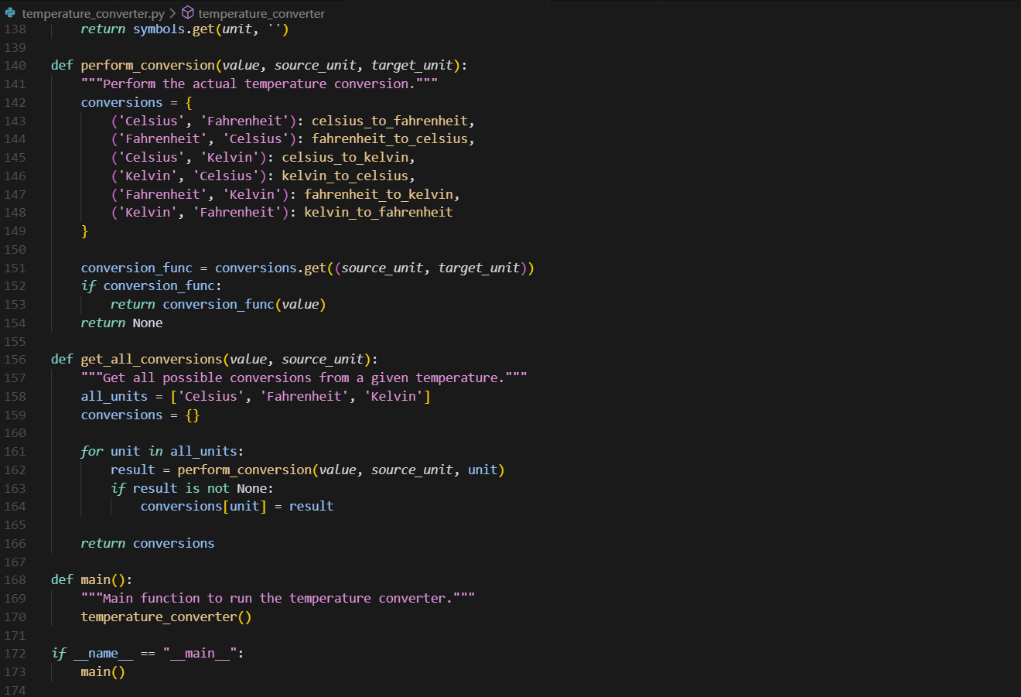

**OUTPUT:**

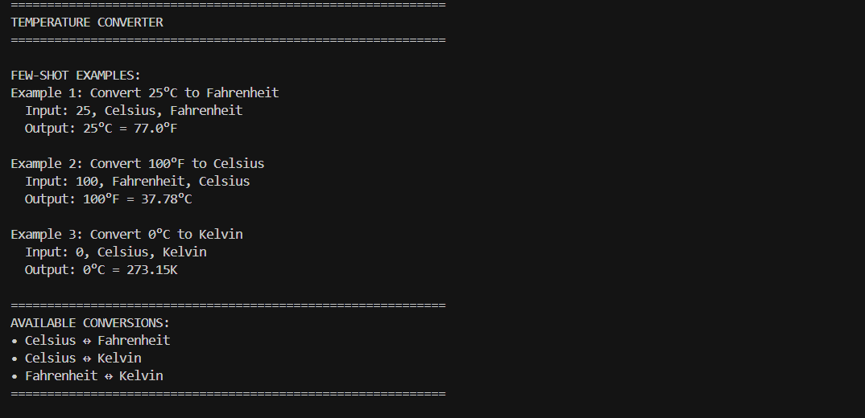

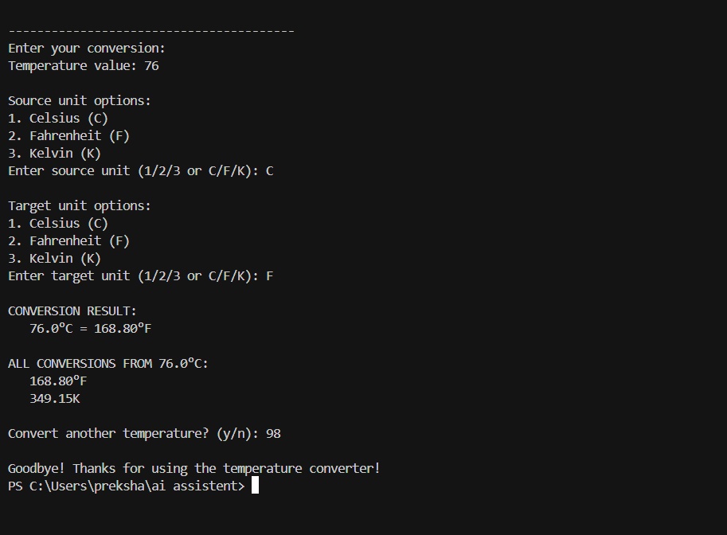

**4**) Write a python function to remove the punctuaion,convert to lowercase, and remove stop words from a given text.use zero shot promting.

**Prompt:** Write a Python function that takes a string, removes punctuation, converts it to lowercase, and removes stop words.

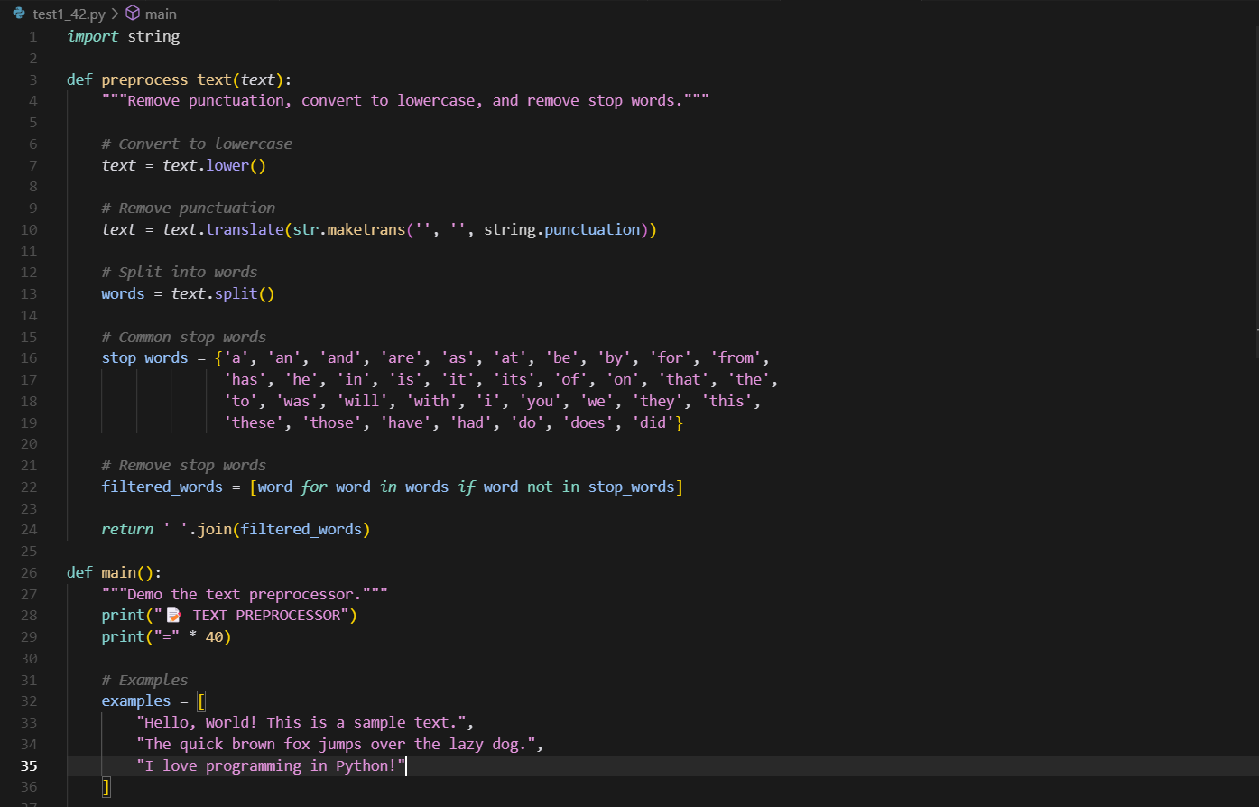

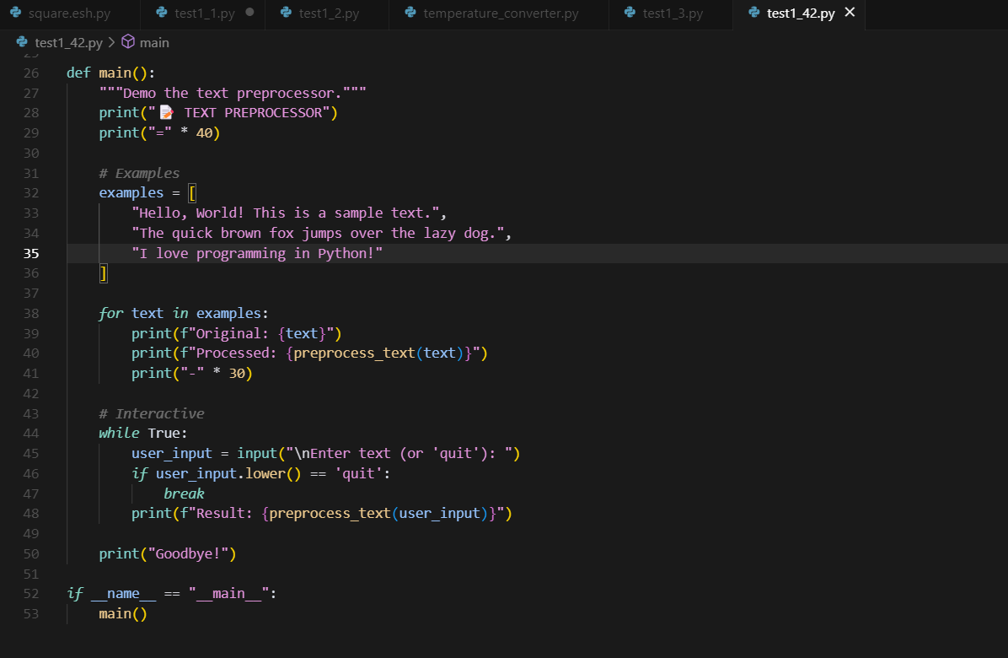

**OUTPUT:**

